|  |
| --- |
| ExpanExpanding the commercial building disclosure programding the Commercial Building Disclosure Program  *Feasibility of mandatory disclosure of energy ratings for most commercial buildings including expanding the CBD Program*  Final Report for the Department of Climate Change, Energy, the Environment and Water |
| **March 2024**  **KPMG.com.au** |

# Executive Summary

The Australian Government has legislated to reduce emissions across the economy by 43 per cent by 2030, reaching net zero by 2050. To achieve these commitments all sectors must have credible emissions reduction pathways, and the built environment sector may be required to make a stronger contribution compared to other harder to abate sectors such as agriculture and heavy industry. There are various benefits of reducing energy consumption from this sector, including limiting future network infrastructure build, improving grid reliability and stability, and ultimately enabling lower cost electrification of other parts of the economy. Energy efficiency measures also generally have short payback periods, meaning these measures can contribute to emissions and energy affordability objectives if properly designed. In addition to reducing energy use and emissions, the policies assessed in this report were found to have substantial net benefit for building owners.

KPMG was engaged to assess the feasibility around options to expand the Commercial Buildings Disclosure (CBD) program.

## Findings

The CBD program is performing well when compared with other programs internationally. Its expansion promises to be the best placed tool to achieve the task of reducing Australia’s commercial building sector emissions to net zero by 2050.

This report considers the benefits and approaches for expanding mandatory disclosure of National Australian Built Environment Rating System (NABERS) energy ratings to more building types in Australia, under the CBD program. It considers a range of policy options taken from international and Australian contexts.

Based on the assessment of international and Australian policy options, discussions with the Department of Climate Change, Energy, the Environment and Water (the Department) and the views of an expert reference group, three policies from original seven options were identified to proceed to a feasibility assessment for further investigation. The priority policies are:

* **Tailored sectoral disclosure (Policy 2)** - This policy presents an option for large-scale disclosure, whilst accounting for the building size and relative maturity of different sectors, with thresholds set with further analysis of emissions and compliance trade-offs.
* **NABERS-star rating minimum energy performance standard (MEPS) for offices (Policy 4) –** This policy has a smaller, more targeted coverage, but greater certainty of outcomes as it requires buildings meet a certain standard. Currently, this policy would largely lift a subset of low performing buildings to align with most large and newer buildings. This could possibly be expanded to other building types later, based on sub-sector maturity and experience with disclosure, so the broader potential for emissions reduction is further improved.
* **Scope 1 Disclosure (Policy 5) -** This policy is simple, low cost and easy to implement. It also provides potential additional value of filling a small data gap that currently exists in the NABERS assessment. It is consistent with the new net zero emissions focus for Federal regulation, and trends in finance provision. Although it is anticipated to have low impact, a more detailed assessment would help clarify this, as well as other costs and benefits this option would bring.

These three policies are not mutually exclusive, and a package of measures which signals progressive expansion of disclosure and then MEPS over time is likely to have considerable additional benefits, both in speed and quantum, than the sum of the parts.

## Recommendation

Based on the feasibility assessment of the three policy options, all three policies have significant merits and should be considered further by the Government through a formal cost-benefit analysis and regulatory impact assessment process, including stakeholder engagement. We provide a suggested roadmap for change to incorporate all three policy options over the next ten years, which can be updated after formal analysis and broader stakeholder engagement.

### A roadmap for change

There is the opportunity to expand building regulation in a systematic way that builds to transform the energy and emissions performance of the sector, while being sensitive to the levels of readiness and maturity in smaller buildings and some non-residential building sectors.

This involves reform on several dimensions:

* expanding the *scope* of disclosure requirements from the current focus on larger office buildings owned by corporations to a progressively wider set of building types and ownership structures
* *deepening* building regulation from the current focus on disclosure to MEPS, to reduce the tail of low performing buildings
* phasing these reforms in a way that *builds the maturity and implementation capacity* of different building sizes and types, while working to build capacity and tools.

A roadmap for progressive expansion of CBD in building types and sizes is proposed (Figure 1), along with phased implementation of MEPS. Actions are timed to make a significant contribution to emissions reduction in the 2030s, while being sensitive to the NABERS maturity in different segments of commercial buildings and phasing implementation as capacity grows and more information is available. Such a roadmap will build energy and emissions performance over time, though clear signalling now has potential to bring activity and benefits forward and reduce implementation costs, as owners anticipate and undertake improvements optimally. Feedback from an expert reference group suggests there may be variance within some of the building sectors below that could vary the generalised approach to rolling out mandatory disclosure or MEPS. For example, in higher education there are some sub-sectors such as large universities that could develop maturity and regulated disclosure more quickly than would be suggested by NABERS maturity, given voluntary developments in the sector.

**Figure 1: High level-roadmap for how CBD program could be expanded.**

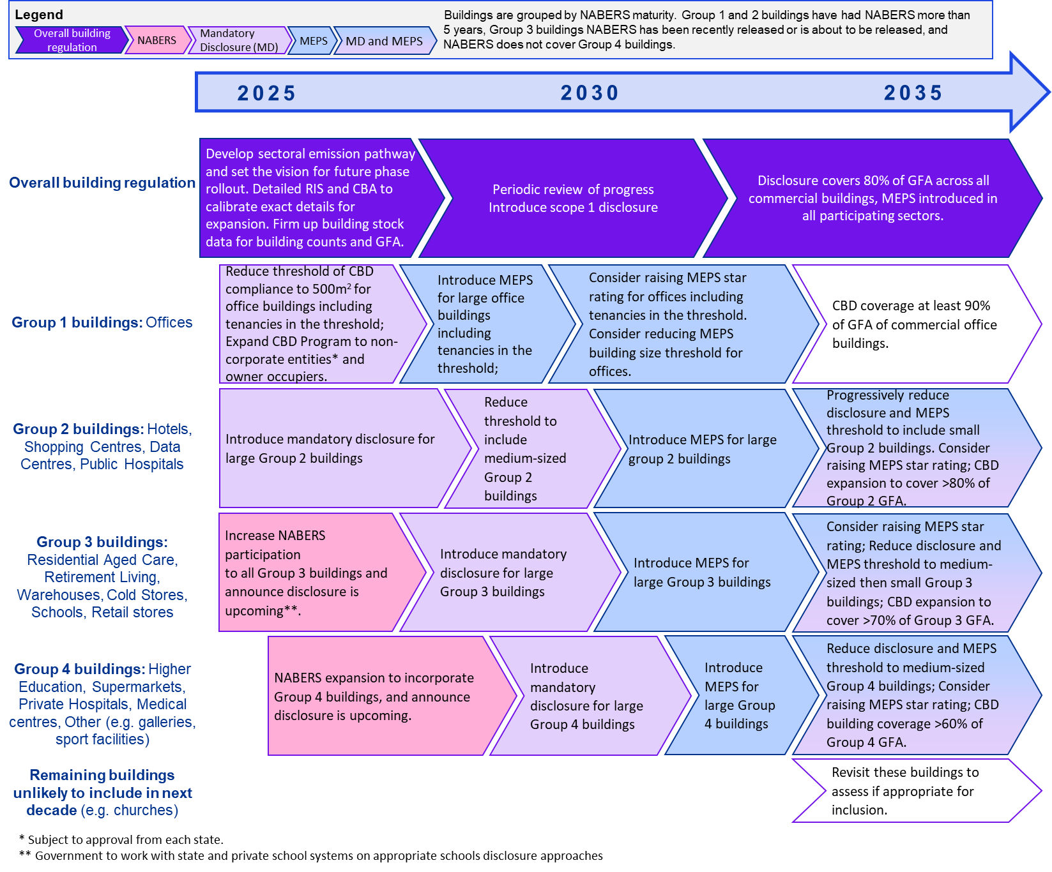

Link to text version of Figure 1 [Appendix 11 Table 32] .

The following general principles were considered while developing this roadmap for change:

* prioritising early expansion in scope to larger building types where NABERS ratings tools are available
* pursuing coverage of all significant commercial buildings sectors over time, eventually covering a large proportion of their emissions and energy use with effective regulation.
* phasing in MEPS to building types that have first been subject to disclosure requirements.
* specific details on timing, size thresholds, trigger points and disclosure/consideration requirements following more detailed cost benefit analysis, regulatory impact statement (RIS) and industry consultations.

The roadmap principles are outlined in Figure 2.

**Figure 2: Roadmap principles**

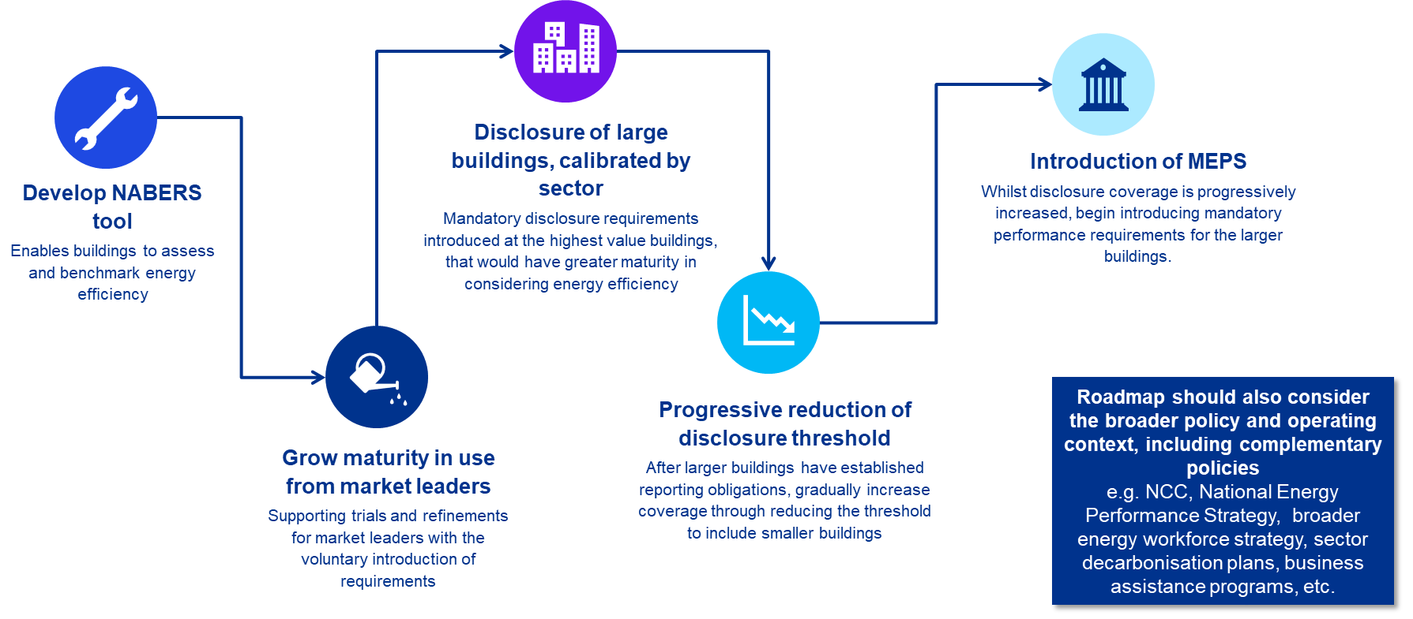

Link to text version of Figure 2.

Consultation with an expert panel indicated that a goal of 80% mandatory disclosure coverage across non-residential buildings by 2035 is a suitable level of ambition and that industry capacity is available. The expansion in disclosure is considered the single most important element of the above package, as it provides a pathway for sectoral transformation. Based on this goal and the above principles, KPMG developed the high-level illustrative roadmap above. Note this roadmap is illustrative, and detailed analysis and considerations would need to be made about the specific elements of a formal roadmap. There may be practical issues that need to be worked through, including an exemption framework, and understanding implementation capacity at an industry and regulatory level. Such an approach has potential to ensure the building sector makes a significant contribution to achieving Australia’s net zero ambition while constraining energy bills.

## Background

### Policy assessment process

KPMG assessed seven possible policies to drive commercial building energy efficiency and emissions reduction, based upon analysis of current international and Australian policies and programs. These policies represent both changes to the existing disclosure framework and new regulatory requirements for covered buildings to achieve a MEPS of a nominated star rating. Each policy was assessed against a high-level criteria exploring the emissions impact, strength of signal, compliance cost and ease of implementation. The seven policies, and their assessments are presented in Table 1 overleaf.

**Table 1: High level assessment of seven policies**

|  |  |  |  |  |
| --- | --- | --- | --- | --- |
| Policy description | Emissions impact | Strength of signal | Compliance cost | Implementation ease |
| 1. Blanket disclosure policy for all commercial buildings over 1,000m2 |  |  | $$$$ | TickTick |
| 1. Tailored sectoral disclosure policy |  |  | $$ | TickTick |
| 1. Reduce the current CBD threshold for all offices to buildings over 500m2 |  |  | $$ | tickticktick |
| 1. A MEPS for offices over 1000m2 based on a NABERS-star rating |  |  | $$$$ | ticktick |
| 1. In the existing CBD program require offices to breakdown their scope 1 emissions |  |  | $ | TickTickTickTick |
| 1. Introduce a MEPS for lighting in offices |  |  | $ | TickTick |
| 1. Phase out fossil fuel boilers in all commercial buildings. |  |  | $$$$ | Tick |

### The Australian Context

Over the past 12 years, the CBD program has driven improvements in energy efficiency across the stock of office buildings with net lettable area (NLA) larger than 1,000m2. The CBD program is an energy disclosure program that places a requirement for building owners and operators to conduct a National Australian Built Environment Rating System (NABERS) rating and a lighting energy efficiency assessment, to help prospective buyers and tenants understand their future energy consumption, bills and possible opportunities to reduce both energy consumption and bills. The program mandates public disclosure of energy efficiency to prospective buyers and tenants of the building, and incentivises building owners to improve their efficiency, driven through market competition. The program has been very successful to date, with NABERS reporting a 29 per cent improvement in energy intensity for buildings covered under the program.

In Australia, non-residential buildings contribute around 10 per cent of total emissions in the economy, most of this outside the office sub-sector, representing a significant opportunity to decarbonise. From a regulatory perspective, energy efficiency in commercial buildings have largely been driven by a set of requirements across the National Construction Code (NCC), the CBD program, and the *Greenhouse and Energy Minimum Standards Act 2012* (GEMS Act), and a range of incentives offered by both state and territory governments including white label energy efficiency schemes. These regulatory programs are complemented by a number of voluntary programs such as NABERS, Climate Active and the Green Star rating scheme. The inclusion of emissions reduction objectives in legislation, and the forthcoming National Energy Performance Strategy and sectoral decarbonisation plan for the built environment, provides a good opportunity build on Australia’s successful regulatory foundation.

### International trends

Government policy around commercial building energy efficiency have been accelerating in several countries internationally. Europe, in particular, has made a concerted effort to introduce disclosure requirements, MEPS and fossil fuel boiler phase-outs. These policies have often been introduced across a broader non-residential building stock, rather than just focussed on offices which is the current scope of the CBD program. These policies are often introduced as part of wider building efficiency and emissions reform packages, including providing support to building owners and tenants. While the scale of the regulation being implemented internationally is larger than that currently in place in Australia, the reliance on attribute compliance measurement (which is easier to implement at scale) has likely limited effectiveness. Many countries are now opting for performance-based compliance measurement (like NABERS) as it is seen to be more effective (though it requires greater attention to phasing to implement at scale).

**Figure 3: High level overview of building energy global disclosure requirements**

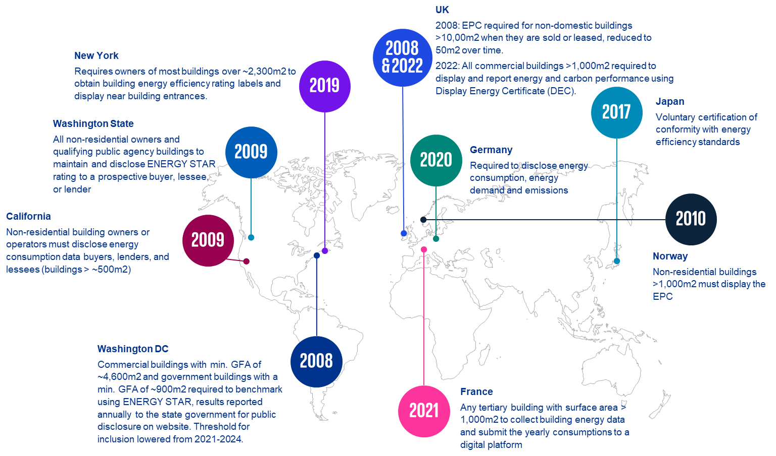

Link to text version of Figure 3 [Appendix 11 Table 33].

The international policy scan revealed several key considerations for the Australian context including:

* Reinforcing the strengths of the existing NABERS regulatory and standards environment extant in Australia
* Disclosure policies should be considered for a broader portion of the building stock, and have the greatest potential to drive sectoral transformation
* MEPS have a role to play to ensure the steady decarbonisation of the sector, by improving the low‑performing tail in the building stock
* Consideration should be given to the broader suite of policies that accompany disclosure and MEPS policies, including changes to the national construction standards, and adjustment support mechanisms for building owners, tenants and consumers, and enhancing flows of sustainable finance to the sector.

### Assessment of priority policies

A high-level feasibility assessment was conducted an indication of the relative costs and benefits of each policy at a ‘per-building’ level. Significant data constraints were encountered and emphasised which makes it difficult to arrive at aggregate costs at this stage. Such an analysis requires both a stronger data base, and detailed analysis of the capacity and speed at which sector capability and compliance with regulation could be ramped up. Hence, this assessment does not constitute a formal cost-benefit analysis or business case, but rather is intended to provide some bounds to support further consideration of each policy.

All policies were explored over a 20-year period, assuming a 5 per cent discount rate. The analysis included five broad categories of costs and benefits, namely:

* Program development and enforcement costs for the Government
* Compliance costs for building owners and operators
* Upgrade costs to improve energy efficiency
* Emissions savings, costed at a social cost of carbon of $280/t CO2e (as proposed by the US EPA and consistent with consideration in the Australian National Construction Code)
* Energy bill savings for consumers.

Figure 4 below presents the high‑level results for the most extensive of these measures, the expansion of CBD, stratified into large and small buildings.

**Figure 4: Net position for the average building covered by Tailored Sectoral Disclosure policy over 20 years**

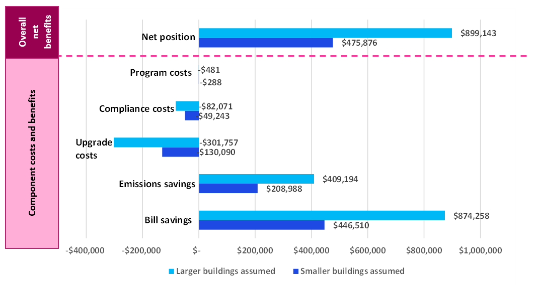

Link to text version of Figure 4 [Appendix 11 Table 34].

The *Tailored Sectoral Disclosure* policy achieved a net benefit for building owners ranging from around $365,000 to $663,000 over a 20-year period. This range is based on different underlying assumptions on building sizes, as input data on the existing building stock provides quantity estimates in size ranges. This policy could form the foundations of a strong policy suite as it represents the most expansive of the policies explored, in that it has implications for many sectors of the economy and would cover the widest range of buildings. This means that the benefits of the policy are more transformative for the economy encouraging sectors that had not previously been exposed to building energy efficiency standards and regulation to consider changes. It would also make the most significant impact on emissions and energy usage. Additionally, the expansion of benchmarking and disclosure requirements under this policy could also establish a framework for other institutions such as banks and lenders to drive energy efficiency improvements. The finance sector has ambitious sustainability and considerations incorporate as part of its lending targets, and a sector-wide framework are likely to reinforce the impact of regulatory change. The aggregate benefit would depend on precise implementation coverage of any expansion, but initial commencement with larger buildings in relatively mature sub-sectors could produce substantial energy, emissions and net economic benefits.

In considering this policy a sensitivity analysis was conducted to explore the impact of moving from annual disclosure requirements to disclosure once every two years. The overall net benefit was found to be reduced by 46-53 per cent based on likely lower take up of low/no cost opportunities.

*A NABERS star rating MEPS for offices* was also found to provide a substantial net benefit for building owners, ranging from $1.1 million to $1.8 million over a 20-year period, depending on the average size of the office buildings. While this net benefit is larger per building than the results outlined above for the CBD expansion, this proposal targets a much lower population of buildings, generally smaller in size and energy use - that is, this policy targets a subset of buildings with low efficiency ratings, seeking to lift this tail to align better with larger and more modern buildings. There is evidence nonetheless of a large benefit under this policy because many star rating improvements can be achieved with relatively low or no-cost operational improvements, and capital upgrade costs are limited by the fact that the most significant star-increases are in the smallest building size categories. The aggregate cost and benefits of this policy is limited by the high proportion of larger buildings that are already rated 5 stars and above.

**Table 2: Breakdown of NABERS rating by building size**

|  |  |  |  |
| --- | --- | --- | --- |
|  | 1,000 - 5,000m2 | 5,000-20,000 m2 | >20,000m2 |
| **% 2 Star or less** | 26% | 7% | 1% |
| **% 3 Star** | 16% | 10% | 2% |
| **% 4 Star** | 24% | 21% | 9% |
| **% 5 Star or above** | 35% | 61% | 87% |

The feasibility assessment for the *Scope 1 disclosure* policy revealed a modest net benefit for building owners ranging from around $3,100 to $5,200 over a 20-year period, depending on the average size of the underlying buildings. As this reform is a relatively light touch, it was assumed that the additional disclosure of detailed scope 1 emissions would result in a 0.5 per cent reduction in energy consumption and emissions per annum, and this improvement is the result of zero-cost operational improvements. The costs incurred for this policy assessment are largely centred on system uplift of the NABERS/BEEC policy, and costs to support the additional reporting requirements and some ongoing maintenance costs. *Scope 1 disclosure policy* needs to be considered in the context of other changes, including the NABERS renewable energy indicator, the Montreal Protocol, which is phasing out refrigerants globally, and other drivers of increasing electrification of buildings.

## Table of Contents

Executive Summary 1

1 Introduction 14

1.1 Purpose and Scope 14

1.2 CBD program 14

1.3 Policy approaches to improving building energy and emissions performance 14

2 Australian Policies and Standards 15

2.1 Energy performance of Australia’s non-residential building stock 15

2.2 Energy Efficiency and emissions regulation relating to commercial buildings 17

2.3 Other Policies Affecting Building Performance 18

2.4 Assessment of Existing Non-Residential Buildings policies 20

3 Trends in Global Energy Regulation for Commercial Buildings 21

3.1 Background and purpose of the global research 21

3.2 Key highlights from international schemes 22

3.3 Approaches to disclosure 24

3.4 Minimum Energy Performance Standards (MEPS) 31

3.5 Broader policy context for building regulations 34

3.6 Outcomes from Regulation and Other Policy Levers 36

4 Considerations for Australia 42

5 Initial options assessment 43

5.1 Overview 43

5.2 Design considerations for policy options 43

5.3 Description of options 45

5.4 Initial assessment criteria 49

5.5 Assessment of options 50

6 Feasibility assessment 56

6.1 Analysis approach 56

6.2 Limitations for analysis 57

6.3 Overview of benefits 58

6.4 Overview of costs 59

6.5 Feasibility assessment results 60

7 Future roadmap 66

8 Conclusion 69

9 Appendices 70

9.1 Appendix 1: Framework of government levers influencing behaviour 70

9.2 Appendix 2: Australian Buildings Data used in this report 71

9.3 Appendix 3: Australian building stock breakdown by emissions, ratings and standards 72

9.4 Appendix 4: Australian building stock breakdown including data centres, hotels and shopping centres 75

9.5 Appendix 5: Analysis of Datasets 76

9.6 Appendix 6: Option 2 – Tailored sectoral disclosure - coverage methodology 78

9.7 Appendix 7: Australian relevant policies and initiatives 83

9.8 Appendix 8: Summary information from international research 85

9.9 Appendix 9: Detail on Energy Star and EPCs 92

9.10 Appendix 10: Examples of energy rating displays 95

9.11 Appendix 11: Accessibility supported information for charts and infographics 98

Index of Tables

Table 1: High level assessment of seven policies 4

Table 2: Breakdown of NABERS rating by building size 7

Table 3: Australian policies and initiatives influencing the building sector 17

Table 4: Minimum Energy Performance Standards for Government Buildings > 2,000 m2 17,17F17F17F17F 19

Table 5: Minimum Energy Performance Standards for Government Buildings < 2,000 m2 18,18F18F18F18F 19

Table 6: Broad trends in the international scan relating to disclosure and MEPS 22

Table 7: Examples of Building Rating Schemes in different jurisdictions32,F32F32F32F 25

Table 8: Disclosure requirements by jurisdiction 26

Table 9: Implementation of MEPS for existing buildings 33

Table 10: Building energy, emissions changes from policy introduction 37

Table 11: Adoption of rating schemes 38

Table 12: Blanket disclosure 45

Table 13: Tailored sectoral disclosure 46

Table 14: Office 500 47

Table 15: Start Rating MEPS for offices 47

Table 16: Scope 1 disclosure 48

Table 17: Lighting MEPS 48

Table 18: Fossil fuel boiler phase out 49

Table 19: Assessment of options 50

Table 20: Application of Energy Conservation Measures based on building size 59

Table 21: Assumed compliance cost for disclosure 60

Table 22: Breakdown of NABERS rating by building size161F161F161F161F 63

Table 23: Framework of government levers influencing behaviour 70

Table 24: Scope 1 Natural Gas Emissions and Scope 2 Emissions by Building Type169F169F169F169F169F169F 72

Table 25: FY2021 Non-residential Building Count, Expanded (Strategy Policy Research, 2022) 75

Table 26: Summary of commercial office building count and area (m2) of different datasets 76

Table 27: Sectoral heatmap assessment 78

Table 28: Distribution of buildings in each sector 82

Table 29: Australian Energy and Emission Policies and initiatives to influence the commercial built environment 83

Table 30: High level findings from international research (focus on commercial buildings) 85

Table 31: Disclosure rating system by jurisdiction including rationale behind implementation 90

Table 32: Details of Figure 1 and Figure 24 - High level-roadmap for how CBD program could be expanded between 2025 and 2035 98

Table 33: Details of Figure 3- High level overview of building energy global disclosure requirements 99

Table 34: Data for Figure 4 - Net position for the average building covered by Tailored Sectoral Disclosure policy over 20 years 99

Table 35: Data for Figure 5 - 2020 Non-residential Building GFA by Space Use Type 99

Table 36: Data for Figure 6 - 2020 Non-residential Building Total Energy Consumption by Space Use Type 100

Table 37: Details for Figure 7 - Major milestones by state, territory and Australian governments to improve emission profiles 100

Table 38: Data for Figure 8 - Average Energy Intensity Across for All Non-residential Building Space Use Types and Total Greenhouse Gas Emissions for Non-Residential Building Space Use Types, 2012 to 2020 101

Table 39: Figure 14 - Approximate costs and benefits of Tailored sectorial disclosure policy over 20 years for the average building (Smaller building size assumed) 102

Table 40: Figure 15 - Approximate costs and benefits of Tailored sectorial disclosure policy over 20 years for the average building (Larger building size assumed) 102

Table 41: Figure 16 - Approximate costs and benefits of Star-rating MEPS for Offices policy over 20 years for the average building (Smaller building size assumed) 102

Table 42: Figure 17 - Approximate costs and benefits of Star-rating MEPS for Offices policy over 20 years for the average building (Larger building size assumed) 102

Table 43: Figure 18 - Cost of upgrading NABERS ratings by building size 103

Table 44: Figure 19 - Approximate cost and benefits of scope 1 disclosure policy over 20 years for the average building (Smaller building size assumed) 103

Table 45: Figure 20 - Approximate cost and benefits of scope 1 disclosure policy over 20 years for the average building (Larger building size assumed) 103

Index of Figures

Figure 1: High level-roadmap for how CBD program could be expanded. 2

Figure 2: Roadmap principles 3

Figure 3: High level overview of building energy global disclosure requirements 5

Figure 4: Net position for the average building covered by Tailored Sectoral Disclosure policy over 20 years 6

Figure 5: 2020 Non-residential Building GFA by Space Use Type 16

Figure 6: 2020 Non-residential Building Total Energy Consumption by Space Use Type 16

Figure 7: Major milestones by state, territory and Australian governments to improve emission profiles 18

Figure 8: Average Energy Intensity Across for All Non-residential Building Space Use Types and Total Greenhouse Gas Emissions for Non-Residential Building Space Use Types, 2012 to 2020 20

Figure 9: High level overview of building energy global disclosure requirements including year of introduction (from regions of focus in the research) 26

Figure 10: Impact of MEPS embedded in framework of practical and financial support to drive renovation 31

Figure 11: Energy savings from ENERGY STAR scheme by building type (US) 38

Figure 12: Other benefits to the ENERGY STAR scheme in the US 39

Figure 13: Feasibility assessment approach 56

Figure 14: Approximate costs and benefits of Tailored Sectoral Disclosure policy for the average building covered by the policy over 20 years (Smaller building size assumed) 60

Figure 15: Approximate costs and benefits of Tailored Sectoral Disclosure policy for the average building covered by the policy over 20 years (Larger building size assumed) 61

Figure 16: Approximate costs and benefits of Star-rating MEPS for Offices policy for the average building covered by the policy over 20 years (Smaller building size assumed) 62

Figure 17: Approximate costs and benefits of Star-rating MEPS for Offices policy for the average building covered by the policy over 20 years (Larger building size assumed) 62

Figure 18: Cost of upgrading NABERS ratings by building size 63

Figure 19: Approximate costs and benefits of Scope 1 disclosure policy for the average building covered by the policy over 20 years (Smaller building size assumed) 64

Figure 20: Approximate costs and benefits of Scope 1 disclosure policy for the average building covered by the policy over 20 years (Larger building size assumed) 64

[Figure 21: Illustrative NABERS Renewable Energy Indicator 65](https://kpmgaust.sharepoint.com/sites/AU-BuildingEnergyRatings/Shared%20Documents/General/5%20Report/Archive/DCCEEW_Buildings%20Final%20Draft%20Report%201Feb24.docx#_Toc157687026)

Figure 22: Roadmap principles 66

Figure 23: Adoption curve for regulation 67

Figure 24: High-level roadmap for CBD Program expansion 68

Figure 25: Total current NABERS Ratings, by Premise Type, FY2023, Australia 73

Figure 26: Total current NABERS Ratings, Other by Premise Type, FY2023, Australia 73

Figure 27: Number of Individual Buildings Rated, by Rating Type, FY14 to FY20 74

Figure 28: Example of EPCs used in the UK 94

**Glossary of terms and abbreviations**

|  |  |
| --- | --- |
| **Term** | **Definition** |
| ACT | Australian Capital Territory |
| BEEC | Building Energy Efficiency Certificate |
| BEED Act | Building Energy Efficiency Disclosure Act 2010 |
| Building Stock | Building stock is defined as the collection of physical structures that make up the built environment. The term can refer to either the number of buildings or the total floor area of buildings, categorised by building type or total. |
| CBBS | Commercial Building Baseline Study |
| CBD | Commercial Building Disclosure |
| Non-residential Buildings | Commercial, industrial or government buildings. |
| DCCEEW | Department of Climate Change, Energy, the Environment and Water |
| ECM | Energy Conservation Measures |
| EEIS | Energy Efficiency Improvement Scheme |
| EEGO | Energy Efficiency in Government Operations |
| EPC | Energy Performance Certificate |
| ERF | Emissions Reduction Fund |
| EUAs | Environmental Upgrade Agreements |
| FY | Financial Year (refers to the year ending on 30th June) |
| GFA | Gross floor area. A building's floor area in square metres, typically measured as the entire area inside the external walls on each floor. |
| GBCA | Green Building Council of Australia |
| GBF | Green Building Fund |
| GEMS | Greenhouse and Energy Minimum Standards |
| GHG | Greenhouse gas |
| HVAC | Heating, Ventilation and Air Conditioning |
| MEPS | Minimum Energy Performance Standard |
| NABERS | National Australian Built Environment Ratings System |
| NCC | National Construction Code |
| NEPP | National Energy Productivity Plan |
| NGGI | National Greenhouse Gas Inventory |
| NSW | New South Wales |
| PJ | Petajoules |
| QLD | Queensland |
| ROI | Return on Investment |
| SBRC | Sustainable Buildings Research Centre |
| TLA | Tenancy Lighting Assessment |
| VIC | Victoria |

Disclaimer

|  |
| --- |
| **General Disclaimer**  The information contained herein is of a general nature and is not intended to address the circumstances of any particular individual or entity. Although we endeavour to provide accurate and timely information, there can be no guarantee that such information is accurate as of the date it is received or that it will continue to be accurate in the future. No one should act on such information without appropriate professional advice after a thorough examination of the particular situation.  **Inherent Limitations**  This report has been prepared as outlined with the Department of Climate Change, Energy, the Environment and Water, in the scope section of the engagement letter dated 15 March 2023. The services provided in connection with this engagement comprise an advisory engagement, which is not subject to assurance or other standards issued by the Australian Auditing and Assurance Standards Board and, consequently no opinions or conclusions intended to convey assurance have been expressed.  No warranty of completeness, accuracy or reliability is given in relation to the statements and representations made by, and the information and documentation provided by the Department of Climate Change, Energy, the Environment and Water stakeholders consulted as part of the process.  KPMG have indicated within this report the sources of the information provided. We have not sought to independently verify those sources unless otherwise noted within the report.  KPMG is under no obligation in any circumstance to update this report, in either oral or written form, for events occurring after the report has been issued in final form.  The findings in this report have been formed on the above basis. |

Acknowledgment of Aboriginal and Torres Strait Islander communities

|  |
| --- |
| KPMG acknowledges Aboriginal and Torres Strait Islander peoples as the First Peoples of Australia. We pay our respects to Elders past, present, and future as the Traditional Custodians of the land, water and skies of where we work.  At KPMG, our future is one where all Australians are united by a shared, honest, and complete understanding of our past, present, and future. We are committed to making this future a reality. Our story celebrates and acknowledges that the cultures, histories, rights, and voices of Aboriginal and Torres Strait Islander People are heard, understood, respected, and celebrated.  Australia’s First Peoples continue to hold distinctive cultural, spiritual, physical and economical relationships with their land, water and skies. We take our obligations to the land and environments in which we operate seriously.  We look forward to making our contribution towards a new future for Aboriginal and Torres Strait Islander peoples so that they can chart a strong future for themselves, their families and communities. We believe we can achieve much more together than we can apart. |

©2023 KPMG, an Australian partnership and a member firm of the KPMG global organisation of independent member firms affiliated with KPMG International Limited, a private English company limited by guarantee. All rights reserved. The KPMG name and logo are trademarks used under license by the independent member firms of the KPMG global organisation.

**Document Classification: KPMG Confidential**

Liability limited by a scheme approved under Professional Standards Legislation.

# Introduction

## Purpose and Scope

The Australian Government has set ambitious legislative targets to reduce emissions across the economy by 43 per cent by 2030 and reach net zero by 2050. To achieve these commitments all sectors must have credible emissions reduction pathways, and the built environment sector has the opportunity to make a strong contribution that builds over time. Reducing energy consumption from this sector can limit the network infrastructure build, improve grid reliability and stability, which could enable lower cost electrification of other parts of the economy. Energy efficiency measures also generally having short payback periods, meaning these measures can contribute to emissions and energy affordability objectives if properly designed.

The Department of Climate Change, Energy, the Environment and Water (**DCCEEW**) engaged KPMG to explore options for how the Commercial Building Disclosure (**CBD**) program could be expanded. This includes expanding mandatory disclosure of energy ratings to include all categories of commercial buildings in Australia, and if there is the opportunity to introduce minimum energy performance standards (**MEPS**). The project involves background research from Australia and internationally on disclosure of building energy efficiency schemes, and assessment of options for expanding the CBD program in Australia.

This Report summarises findings from Australian and international building research, identifies a long list of policy options for Australia and presents a feasibility assessment of the three most prospective policies. Finally, the report concludes with a view of the potential roadmap to progress and implement the policies over the next decade.

## CBD program

The decarbonisation journey of office buildings in Australia began in 1999 with the introduction of the voluntary rating scheme National Australian Built Environment Rating System (**NABERS**). Decarbonisation accelerated with the introduction of the *Building Energy Efficiency Disclosure Act 2010* (**BEED Act**). This established the CBD Program to improve building energy efficiency and reduce GHG emissions. The CBD Program mandates owners of commercial office spaces greater than 1000 square metres to disclose the NABERS star rating (without green power) on advertising and provide a Building Energy Efficiency Certificate (**BEEC**) which includes a NABERS certificate and tenancy lighting assessment (**TLA**) upon sale, lease or sublease.

From 2011 to 2019 the CBD program reduced energy intensity (MJ/m2) of participating commercial office buildings by 27 per cent and lowered energy bills by $82MF0F0F0F0F0F0F0F0F0F[1] Commercial office buildings (Class 5)1F1F1F1F1F1F1F1F[2] account for 16 per cent2F2F2F2F2F2F2F2F[3] of the non-residential buildings stock and a fifth of the total commercial building sector greenhouse gas emissions, raising the question of whether cost effective benefits can be secured by expanding into other sectors and building classes (Class 3, 6, 8 and 9).

The Australian Government’s landmark *Climate Change Act 2022* and Climate Change (Consequential Amendments) Bill 20223F3F3F3F3F3F3F3F[4] has legislated emission reduction targets of 43 per cent by 2030 and net zero emissions by 2050. The legislation may provide additional regulatory levers and raises questions about whether the explicit focus on emissions and a legislated pathway to net zero also warrants changes in policy approaches. Opportunities for expansion and improvements in disclosure and other regulation should be considered as Australia explores ways to reduce GHG emissions and mitigate climate change.

## Policy approaches to improving building energy and emissions performance

There are several policy levers available to influence energy and emissions performance. Examples include incentives for owners to purchase more energy efficient equipment and lighting, government procurement, mandatory disclosure of energy performance (current program), and minimum energy performance standards (for example lighting efficiency requirements). These can involve different aggregate benefits and costs, and distributional and timing impacts on owners, tenants, other market participants and final consumers. Ideally, policies will promote significant change (reduced energy and emissions) with minimal impact on building owners and/or tenants – and different levers will bring different trade-offs. Tables in the Appendices provides further detail on the policy approaches.

# Australian Policies and Standards

## Energy performance of Australia’s non-residential building stock4F4F4F4F4F4F4F4F[5]

The energy performance of Australia’s non-residential building stock varies according to age, location, and building type with the energy consumption from electricity and gas accounting for 9.4 per cent of Australia’s total emissions (in FY2020)5F5F5F5F5F5F5F5F[6].

Improving energy efficiency and implementing new technologies in buildings has many benefits that will drive buildings towards electrification and is an essential step to achieve Net Zero 2050. Energy efficiency results in reduced demand on the electricity network and therefore enhanced energy security and affordability for the network, while also benefitting the facility behind the meter (**BTM**) with improved occupant comfort and health, reduced site operational expenses and carbon emissions.6F6F6F6F6F6F6F6F[7] Additionally, by electrifying building services such as space heating and domestic hot water (**DHW**) it positions the facility to be net zero ready.

The Australian government supports the development of legislative Acts, standards, programs, and other novel approaches to improving energy efficiency in commercial, residential, and government buildings (a full list of initiatives are detailed in Appendix 8: Australian relevant policies and initiatives). Establishing a thorough understanding of the existing non-residential building stock and their energy efficiency performance is particularly valuable as it forms the basis to explore the possible improvements that could be made through the introduction of new or expanded policies.

### Breakdown of Building Types

In FY 2020 there were approximately 1.04 million non-residential buildings in Australia containing 830 million square metres of gross floor area (**GFA**) and growing at a rate of 2 per cent growth per annum7F7F7F7F7F7F7F7F[8] Data from the Commercial Buildings Baseline Study (**CBBS**) shows that in 2020 the most common purposes for the non-residential building stock were commercial offices (16 per cent) and warehouses (16 per cent), each having a GFA of 19 per cent and 17 per cent, respectively, with hotels, transport, retail and factories also being major categories. Figure 5 overleaf provides a breakdown of building types by count and GFA in 2020.

### Operational Energy Consumption

In FY 2020 the total non-residential building energy use was 267 petajoules (**PJ**), including 227 PJ of electricity (85 per cent) and 40 PJ of gas (15 per cent).8F8F8F8F8F8F8F8F[9] Data from the CBBS shows that in 2020 Australia’s non-residential building stock accounted for 23.8 per cent of Australia’s total electricity consumption. Key findings show that within commercial buildings, electricity accounts for 85 per cent of total energy end-use consumption, the majority of which is attributed to HVAC (60 per cent) and lighting (10 per cent). Gas consumption is responsible for 15 per cent of total energy end-use consumption and is primarily used for space heating (12 per cent) and domestic hot water (3 per cent). Figure 6 overleaf displays the comparison between electricity consumption and gas consumption across non-residential building stock by GFA in 2020. The distribution of electricity and gas consumption was typically the same for each space use type, with offices consuming the most energy (26 to 27 per cent), followed by retail (17 per cent), short term accommodation (15 per cent) and entertainment (9 per cent) buildings.

### Emissions

By applying the national scope 2 emissions factor for electricity and the national scope 1 emissions factor for gas19F9F9F9F9F9F9F9F[10] against the 2020 non-residential building energy consumption data (summarised in Appendices), it is calculated that building end-uses of energy are responsible for 45 Mt CO2-e.

**Figure 5: 2020 Non-residential Building GFA by Space Use Type**

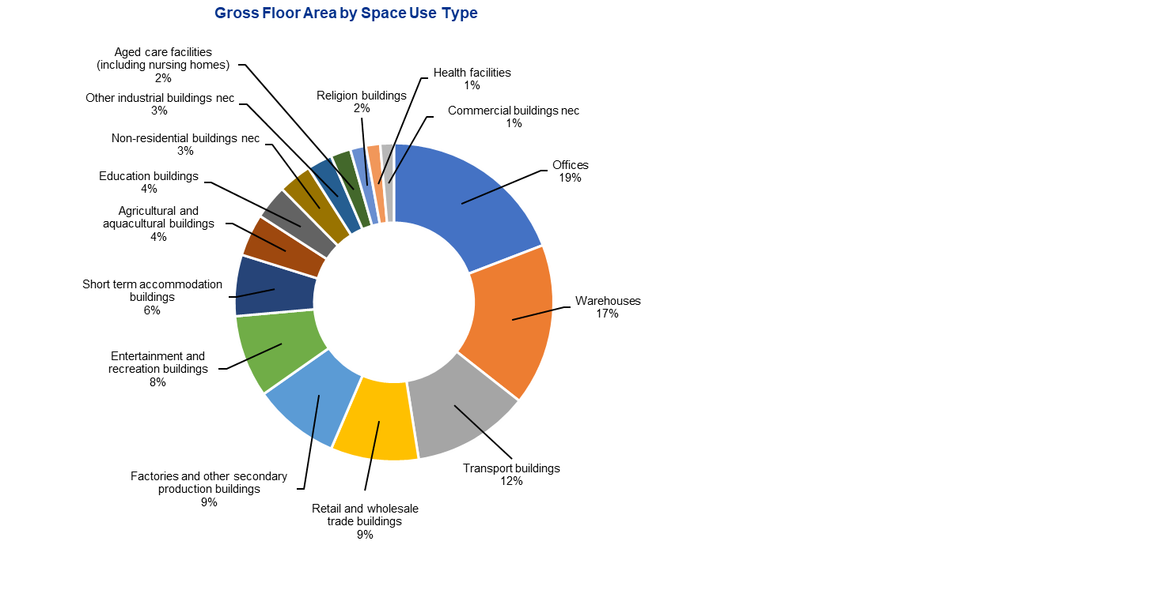

Link to text version of Figure 5 [Appendix 11 Table 35].

**Figure 6: 2020 Non-residential Building Total Energy Consumption by Space Use Type**10F10F10F10F10F**[11]**

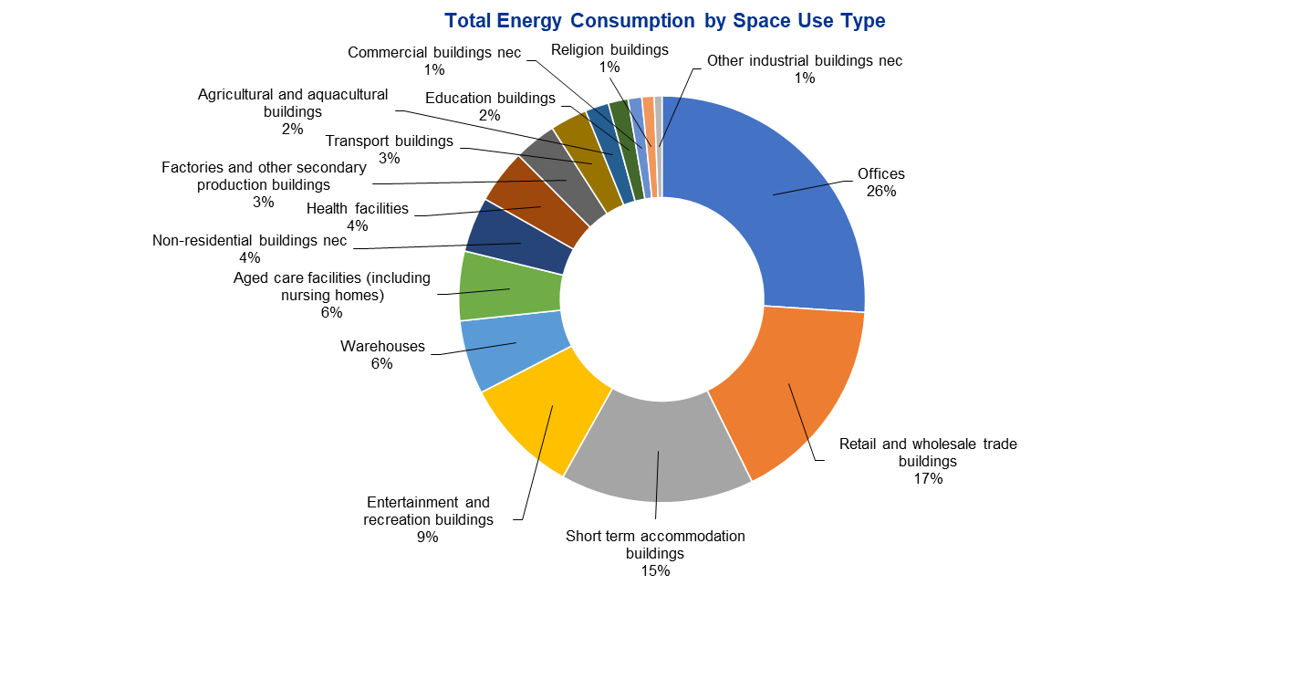

Link to text version of Figure 6 [Appendix 11 Table 36].

## Energy Efficiency and emissions regulation relating to commercial buildings

Federal, state and territory governments have a range of existing policies to improve energy performance in commercial buildings. The policies and regulations (Table 3 below and tables in the Appendices for further detail) improve the attributes of the building during the design and construction phase, or the energy and emissions performance of the building during the operational phase. By assigning policies into these phases, policymakers can target their efforts to ensure energy efficiency is considered at every stage of the building lifecycle. In addition to Federal government initiatives each state and territory government has their own policies and incentives to facilitate change in the commercial building sector.

To date, the Commonwealth Government has primarily focused on intervening through mandatory disclosure requirements on large commercial office buildings, with some additional complementary mandatory energy performance standards on certain appliances used across all building types. Mandatory disclosure for commercial buildings has evolved over time and started from a voluntary disclosure program. One often unrecognised instrument that has progressed policy on disclosure is the Government’s own procurement requirements and incentives around building energy efficiency, which has been the precursor to broader economy wide regulations and has helped set industry standards for high quality buildings, as illustrated in Figure 7 overleaf. This Figure also shows the latest thinking around energy performance, with the development of a National Energy Performance Strategy underway. This will focus on improving energy efficiency, load shifting, fuel switching and behaviour change, resulting in better energy performance including in the commercial building sector11F11F11F11F11F11F11F11F[12] Additionally, in July 2023 the Commonwealth Government requested the Climate Change Authority to review potential technology transition and emissions pathways for a number of sectors, including for the built environment. This pathway will also play an important role in framing the necessary changes required to drive decarbonisation and energy efficiency in the sector in the progress to net zero. The International Energy Agency also recommends Australia focus on energy efficiency as part of the transition towards net zero, recommending government introduce specific energy efficiency and savings targets and support programmes.12F12F12F12F12F12F12F12F[13]

**Table 3: Australian policies and initiatives influencing the building sector**

| Performance or attribute based13F13F13F13F13F13F13F13F[14] | Policy or Initiative to influence change |
| --- | --- |
| Performance based | National Greenhouse and Energy Reporting Act 2007 (NGERS) |
| Performance based | Building Energy Efficiency Certificate (BEED Act 2010) |
| Performance based | National Australian Built Environment Rating System (NABERS) |
| Performance based | Climate Active Carbon Neutral Buildings |
| Performance based | Greenhouse and Energy Minimum Standards Act 2012 (GEMS Act) |
| Attribute based | National Construction Code (NCC) |
| Attribute based | Green Star and Green Building Council of Australia (GBCA). |

### Energy efficiency reducing network electricity demand

As the nation transitions away from fossil fuels and towards an electrified future there will be a significant increase in electricity demand caused by the rise of electric vehicles (**EV**) and electrification of traditional gas space heating and DHW assets in residential and non-residential building stock. To meet this increased demand the electricity grid will be required to upgrade the network capacity with more transmission towers, poles, wires and substations. The expense, time and effort it takes to build transmission line infrastructure can cause substantial delays to capital upgrade works and BTM generation combined with energy efficiency is the best method for reducing the need for network infrastructure upgrades, alleviating the grid of additional loads and for organisations to progress ahead with their own sustainability agendas.

**Figure 7: Major milestones by state, territory and Australian governments to improve emission profiles**

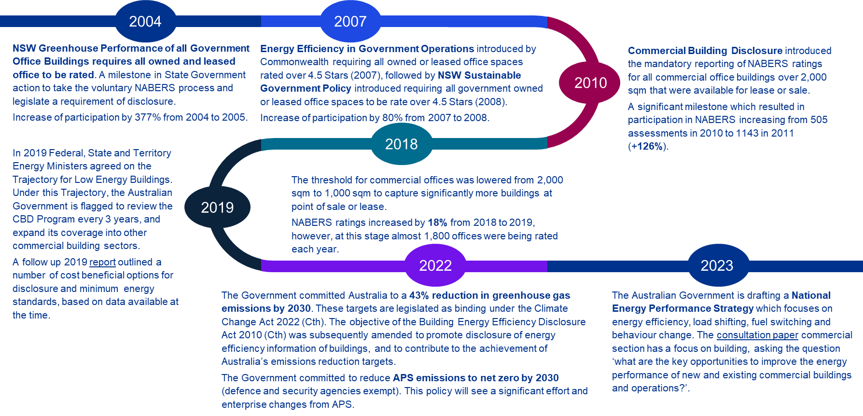

Link to text version of Figure 7 [Appendix 11 Table 37].

## Other Policies Affecting Building Performance

### Incentive Schemes

Incentive schemes, grants and loan programs aim to encourage investment in energy efficiency measures, including for commercial buildings. While beyond the direct scope of this report, they provide important complements to regulatory interventions and include:

* *Low-interest loans for commercial energy efficiency upgrades*: Several states such as Victoria, New South Wales, and Queensland offer low-interest loans to commercial building owners who want to upgrade their buildings with energy-efficient technologies such as solar panels, lighting, and insulation.
* *White certificate schemes*: several State governments have ‘white certificate’ schemes to incentivise greater energy efficiency activities. While there is a large focus on residential activities under these schemes, some commercial buildings are applicable for funding. Some of these schemes include the NSW *Energy Savings Scheme* (soon to be turned into the Energy Security Safeguard Scheme), the ACT *Energy Efficiency Improvement Scheme*, the *Victorian Energy Upgrade* program, and the former South Australian Retailer Energy Efficiency Scheme (REES).
* *Environmental Upgrade Agreements Across Australia* is led by the Sustainable Melbourne Fund and funded by ARENA. The program will see the Better Building Finance program expand into NSW and SA to assist councils and businesses become more sustainable. The initiative involves financing projects to improve the energy efficiency of buildings and reduce their carbon footprint and borrowed funds are repaid via council rates.
* *NSW and VIC – Environmental Upgrade Agreements* (EUAs): EUAs are a financing mechanism that allows building owners to borrow money from a lender to finance energy efficiency upgrades and renewable energy installations. The loan is repaid through the building owner's council rates. Several Australian States, including NSW and VIC, have legislation in place that allows for the use of EUAs.
* *Queensland (Brisbane City Council) - Building Upgrade Finance*: This program provides financing for energy efficiency upgrades and renewable energy installations in commercial buildings in Brisbane. The financing is repaid through council rates and is available to building owners, tenants, and property developers.

### Commonwealth Government energy and emission objectives

In 2022 the Commonwealth released the Australian Public Service (APS) Net Zero 2030 policy to reduce its greenhouse gas emissions to zero by 2030 and to report on its emissions transparently beginning in the second half of 2023. This commitment positions the Commonwealth with other state and territory government commitments for their respective emissions and will contribute to achieving Australia’s Paris Agreement targets. The APS Net Zero identifies the Government’s commitment to updating guidance for new leases starting in 2023 to minimise building emissions.14F14F14F14F14F14F14F14F[15]

Energy Efficiency in Government Operations

The Energy Efficiency in Government Operations (EEGO) Policy establishes energy intensity targets and Minimum Energy Performance Standards (MEPS) for government departments and agencies. It ensures consistent improvement in energy performance and considers energy use in building procurement or leasing.15F15F15F15F15F15F15F15F[16] Commonwealth agencies receiving over 50% funding from the Commonwealth must comply.

At the time of the EEGO publication in 2007, the policy mandated a minimum 4.5-star NABERS rating for leased government buildings. Since June 2011, new energy intensity targets have been set for tenant light and power and central services.16F16F16F16F16F16F16F16F[17] MEPS apply to new buildings, majorly refurbished buildings, and leased buildings for over 2 years.

Table 4 and Table 5 translates the MEPS in the EEGO Policy (2007) to MEPS as measured by current NABERS ratings available.

**Table 4: Minimum Energy Performance Standards for Government Buildings > 2,000 m2 17,**17F17F17F17F17F**[18]**

|  |  |  |  |
| --- | --- | --- | --- |
|  | 100 per cent of total building area | 50 per cent to 99 per cent of total building area | < 50 per cent of total building area |
| Base building | >= 4.5 stars NABERS Energy, or equivalent, level of energy efficiency for whole building | >= 4.5 stars NABERS Energy, or equivalent, level of energy efficiency | No requirement |
| Tenanted area | >= 4.5 stars NABERS Energy, or equivalent, level of energy efficiency for whole building | >= 4.5 stars NABERS Energy, or equivalent, level of energy efficiency | >= 4.5 stars NABERS Energy, or equivalent, level of energy efficiency |
| Lease | To include a Green Lease Schedule | To include a Green Lease Schedule | To include a Green Lease Schedule |

**Table 5: Minimum Energy Performance Standards for Government Buildings < 2,000 m2 18,**18F18F18F18F18F**[19]**

|  |  |
| --- | --- |
| Space | Requirements |
| Base building | No requirement |
| Tenanted area | Separate digital metering and max 8W/m2 for lighting |
| Lease | No requirement |
| Appliances | US EPA 'Energy Star' compliant with power management features enabled at the time of supply |

### Embodied carbon

Embodied carbon considers the emissions in the materials used to construct the building, for example the energy used to extract ore and manufacture and then transport the steel used in the building.19F19F19F19F19F19F19F19F[20] Embodied energy is relevant to construction of new buildings and major renovations, rather than the operation of existing buildings. According to a Green Building Council of Australia (**GBCA**) report, embodied carbon could account for up to 85% of Australia's built environment emissions by 2050, up from 16% in 2019.20F20F20F20F20F20F20F20F[21] In October 2021, NABERS published their *Embodied emissions initiative* to develop a world-class framework for measuring, benchmarking, and certifying construction and building material emissions. The framework was intended to be nationally applicable and designed for NABERS integration.

There is currently no consistent method of measuring embodied emissions in Australia. NABERS is working with the GBCA, industry and governments across Australia to better understand the appetite for an embodied emissions standard and NABERS' role in enforcing that standard. In NSW as of 1 October 2023, the State Environmental Planning Policy (**SEPP**) requires commercial buildings and State significant projects to disclose embodied emissions and how these were minimised (by re-used or recycled content) using the NABERS Disclosure Framework once it is finalised to disclose the information.21F21F21F21F21F21F21F21F[22]

## Assessment of Existing Non-Residential Buildings policies

There has been measurable change in the performance of non-residential building stock in Australia as a direct and result policies identified in this report.

### Energy efficiency improvement and reduction in greenhouse gas emissions

Non-residential buildings have been influenced by the CBD Program, NABERS, GreenStar and Section J of the NCC, which are collectively designed to improve new and existing building energy performance. Within the non-residential building stock, average energy intensity has declined 15 per cent for electricity and 7 per cent for gas since 2012 (Figure 8) based on 2020 figures22F22F22F22F22F22F22F22F[23]. This represents a 12.6 per cent reduction in overall energy intensity in non-residential buildings, attributed to energy efficiency policies and increased adoption of renewable energy sources.23F23F23F23F23F23F23F23F[24]

When reviewing NABERS energy intensity data for commercial office buildings there has been a 29% reduction in average energy intensity (MJ/m2) since the 2011 when mandatory disclosure was introduced. Mandatory disclosure for performance based energy consumption is showing to have a far greater impact that voluntary standards as it targets underperforming buildings and had broader industry participation.24F24F24F24F24F24F24F24F[25]

The CBBS data found the commercial offices building sector reduced its GHG emissions by 19.2 per cent between 2005 and 2019, while the public government building sector reduced its emissions by 30.5 per cent over the same period. The reduction in GHG emissions is not as strong when exploring all building stock. Taking electricity and gas consumption data from 2012 to 202025F25F25F25F25F25F25F25F[26] and applying the emissions factors from National Greenhouse Accounts (**NGA**) Factors 2022, Figure 8 illustrates the reduction in GHG emissions across Australia’s non-residential building was only 2.8 per cent. This figure captures the energy efficiency performance of commercial buildings operating under the BEED Act and does not account for growth in the building stock.

**Figure 8: Average Energy Intensity Across for All Non-residential Building Space Use Types and Total Greenhouse Gas Emissions for Non-Residential Building Space Use Types, 2012 to 2020**

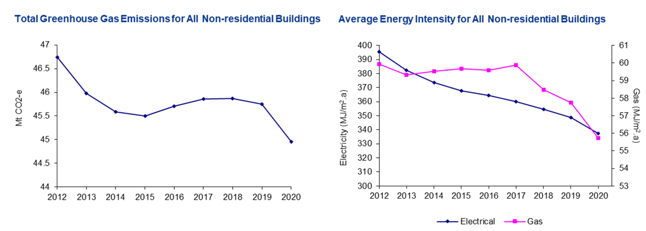

Link to text version of Figure 8 [Appendix 11 Table 38].

To expand emission reduction efforts, Australia should examine international policies for guidance. The following chapter explores the experiences and the policy tools used to achieve emission reductions overseas.

# Trends in Global Energy Regulation for Commercial Buildings

## Background and purpose of the global research

In 2021, building operations accounted for 30 per cent of global end-use energy consumption and 27 per cent of total energy sector emissions26F26F26F26F26F26F26F26F[27] with an additional six per cent of emissions used to manufacture cement, steel and aluminium used for buildings construction. The buildings sector therefore accounts for around a third of global energy consumption and emissions (directly and indirectly)27F27F27F27F27F27F27F27F[28]. Around 40 per cent of global building operational CO2 emissions is related to non-residential buildings.

This section summarises trends in global energy regulation for commercial buildings. The purpose of the international research is to ensure that recommendations in the report consider globally recognised best practice approaches to disclosure expansion and minimum energy performance standards. The focus of the research was on mechanisms for commercial building disclosure **(CBD)** of building energy ratings and minimum energy performance standards **(MEPS)** for commercial buildings. Our research included both existing and planned disclosure programs and MEPS. Where possible we have highlighted the impact (actual or predicted) of these programs and MEPS. Our focus was regulation of the current building stock, though we also explored the policy context within which this regulation exists, including incentives, procurement and construction codes governing new buildings which affect and complement building regulation. The focus was on CBD and MEPS because the majority of buildings that exist today will still exist in 2050.28F28F28F28F28F28F28F28F[29] We also prioritised mandatory disclosure schemes over voluntary schemes, although these are still included in the research.

The research focused on the below countries and regions. The reason these were chosen was because the project team considered these countries and regions global leaders in building policy influencing building energy regulation, and the regulatory environment is similar to Australia’s.

*Countries and regions focussed on in the global research:*

* European Union (**EU**)
* United Kingdom (**UK**)
* Netherlands
* France
* Germany
* Sweden
* Norway
* Denmark
* Washington DC (US)
* Washington State (US)
* New York State/city (US)
* California (US)
* Japan
* South Korea.

## Key highlights from international schemes

There has been significant progress in recent years in improving or planning to improve the energy efficiency of buildings. This section highlights the actions taken by countries and regions around the world to improve the environmental impact of commercial buildings, focusing on disclosure of selected rating systems and MEPS.

**Table 6: Broad trends in the international scan relating to disclosure and MEPS**

| Trend | Disclosure | MEPS |
| --- | --- | --- |
| Common, in place for some time and becoming stricter | Like Australia, mandatory disclosure of building energy efficiency ratings has been in place for some time. The UK for example introduced disclosure of Energy Performance Certificates (EPCs) when leasing or selling a building in 2008. In the US, disclosure policies are in place although not all states have adopted these yet. Almost all countries and regions in the research have mandatory disclosure requirements. | Similarly, MEPS have been in place for some time. The international research suggests these are becoming stricter. In some countries, MEPS were applied to new buildings only. However, countries are starting to set MEPS for existing buildings (for example, a minimum EPC rating of ‘E’ in EU from 2030 while Scotland is requiring an EPC rating of ‘C’ by 2040 in non-residential buildings >1,000 square metres). Some countries are introducing building plant specific minimum standards or phase outs, e.g., prohibiting new or replaced gas boilers or even phasing these out from existing buildings. There is typically a 4–10-year lead time for a MEPS introduction. |
| Target buildings are usually based on size, not building type | Most jurisdictions introduce mandatory disclosure to larger buildings first, regardless of the type of building it is. Government or public buildings may be targeted first or have a lower threshold to be included. If there is a choice of commercial property to include first, offices are most common (for disclosure and MEPS). | Public buildings including offices occupied for public authorities, hospitals and schools are often targeted first or have lower thresholds to be included in the minimum energy standards or reporting requirements. This building stock may be considered ‘lower hanging fruit’ and an opportunity for government agencies to set an example to the private sector. |
| Scaled approach with significant warning to sector | Usually there is significant lead time (2+ years) before the introduction of mandatory disclosure. A scaled approach is undertaken, where large buildings are targeted first and then the threshold for inclusion reduces. This phased approach can be short (<1 year) or long (3+ years). | This is in line with the comments made under ‘disclosure’, although lead times are typically longer for the introduction of MEPS. |
| Convergence to performance-based schemes and primary energy consumption caps | Some countries have always disclosed performance-based schemes whereas others have focused on attribute-based schemes. The general momentum is across a number of countries such as France and the UK, show a transitioning towards performance-based schemes while keeping the attribute-based scheme (e.g. the EPC). | Trends show a convergence in attribute-based ratings with performance-based ratings. Rather than only relying on attributes such as insulation, lighting, and heating which gives a potential energy performance rating, some jurisdictions are including actual energy consumption. For example, England and Wales will be targeting energy consumption from large commercial buildings (>1,000 square metres), and France has set energy consumption targets for commercial buildings.  Germany, France and the Netherlands use building-based caps on energy consumption allowed per square metre. |
| Disclosure usually required upon sale or lease, or major renovation | It is most common to require CBD upon sale or lease of a property, or major renovation. This will be valid for a certain time (e.g. 10 years) and in some cases will need to be placed in the foyer or other regularly visited area within the building. | MEPS are often introduced via similar trigger points to CBD (e.g., minimum ratings required for sale or lease of a property after a certain point). MEPS on building plants are typically introduced via restrictions on new or replacement equipment. |
| Regulation of new builds and renovations remain important | Japan has focused on new builds and renovations while other jurisdictions may have started focus here and are transitioning to existing builds. Nonetheless, changing building codes to influence new builds is important, and provides a base for performance-based regulation. Tight building standards are generally part of a broad regulatory suite affecting current stock. | The comment under disclosure applies here. |
| Energy type and scope 1 emissions are being explicitly regulated | Energy type that powers or heats the building is sometimes required to be disclosed. Many jurisdictions have set net zero 2050 targets that key actions in the buildings sector will help meet this target. | Countries including Netherlands, Germany and Norway are phasing out fossil fuels to power or heat buildings, and some require buildings to be powered by a minimum proportion of renewable energy. Many jurisdictions have set net zero 2050 targets that key actions in the buildings sector will help meet this target. |
| Options for addressing split incentives exist although this is an opportunity | There are considerations on options to amend the balance of responsibility for energy efficiency between building tenants and building owners, to ensure both are motivated to make positive changes. This can be through lease agreements and on-bill finance for example. There is the opportunity to explore other ideas in this area. | The comment under disclosure applies here. |
| Fees for non-compliance are common | It is common across most jurisdictions to introduce fines for non-compliance with building standards. This is often in a *‘$ per square metre’* value and usually it is a one-off payment for each compliance period. For example, in Washington DC the fee is $10 per square foot up to $7.5M USD for one building. In this example the maximum penalty is high to ensure non-compliance is not a cost-effective option.29F29F29F29F29F29F29F29F[30] | The comment under disclosure applies here. |

The research highlights several related trends in the construction industry. One important trend is the focus on **embodied energy**, which have a direct impact on new building projects and contribute to reducing carbon emissions. This trend emphasizes understanding the environmental life cycle of a building, affecting both current buildings and future requirements. Various countries, such as the Netherlands, Finland, Sweden, the US, and Canada, have implemented policies and standards to limit embodied carbon emissions in new buildings. The UK is also considering legislation to incorporate the cost of carbon in construction.

Another emerging consideration is the **circular economy in the built environment**, which promotes sustainable practices like designing for longevity, reusing materials, and recycling. National initiatives and strategies, such as the Circular Economy Action Plan, address the construction and lifecycle aspects of buildings. Additionally, there is a growing emphasis on incorporating on-site renewables and provisions for electric vehicles and bicycles in commercial buildings.

## Approaches to disclosure

### Trends in energy disclosure overseas

Building energy disclosure refers to the periodic reporting or public notification of a building energy rating scheme. Scheme examples include ENERGY STAR in the US, and Energy Performance Certificates (EPC) in Europe. This disclosure often takes place at time of sale or lease of property, but sometimes occurs after other trigger events, such as poor energy efficiency performance or non-compliance with regulation.30F30F30F30F30F30F30F30F[31] There are also a number of examples of continuous disclosure such as the French Government’s Diagnostic de Performance Energetique program where building owners must provide energy data from their buildings including yearly consumption. Policies that require or recommend disclosure using a common building energy measure allow consumers to make informed decisions on whether to purchase/lease the property.

Mandatory and voluntary building energy disclosure schemes have been in place in many countries and regions for some time (e.g., EPCs have been in place since 2007 in the UK).31F31F31F31F31F31F31F31F[32] These schemes continue to be an important tool in most of the countries researched. Table 7 illustrates examples of building rating schemes in various jurisdictions and the building type each scheme applies to.

**Table 7: Examples of Building Rating Schemes in different jurisdictions32,**F32F32F32F32F**[33]**

|  |  |  |  |  |  |  |
| --- | --- | --- | --- | --- | --- | --- |
|  |  |  |  |  | Building type |  |
| Jurisdiction | **Scheme** | **Mandatory disclosure?** | **New/ existing**  **buildings** | **Residential** | **Commercial** | **Public\*** |
| US | ENERGY STAR33F33F33F33F33F33F33F33F[34] | For some states | Both | Tick | Tick | Tick |
| US | Commercial Building Energy Asset Score |  | Both | Tick | Tick | Tick |
| US | Leadership in Energy and Environmental Design (LEED) |  | Both | Tick | Tick | Tick |
| UK | Energy Performance Certificates (EPCs)** | Yes | Both | Tick | Tick | Tick |
| UK | Display Energy Certificates (DECs) | Yes | Existing |  | Tick | Tick |
| UK | Building Research Establishment Environmental Assessment Method (BREEAM) |  | Both |  | Tick | Tick |
| EU | Energy Performance Certificates (EPCs) | Yes | Both | Tick | Tick |  |
| EU | Display Energy Certificates (DECs) | Yes | Existing |  |  | Tick |
| France | Diagnostic de Performance Energetique (DPE)34F34F34F34F34F34F34F34F[35] | Yes | Both | Tick | Tick | Tick |
| France | High Environmental Quality (HQE) |  | New buildings | Tick | Tick | Tick |
| Canada | ENERGY STAR Portfolio Manager |  | Both | Tick | Tick | Tick |
| Canada | REALpac Energy Benchmarking Program |  | Both |  | Tick | Tick |
| South Korea | Certificate of Building Energy Efficiency |  | Both | Tick | Tick | Tick |
| Germany | Energieausweis (energy identification) | Yes | Both | Tick | Tick | Tick |
| Japan | Comprehensive Assessment System for Built Environment Efﬁciency (CASBEE) |  | Both | Tick | Tick | Tick |
| Singapore | Green Mark Rating System35F35F35F35F35F35F35F35F[36] |  | Both | Tick | Tick | Tick |

*\* ‘Public’ includes any government owned buildings (e.g. public schools)*

*\*\* Further details on ENERGY STAR and EPCs are provided in the Appendices*

Building energy disclosure requirements vary worldwide, with different trigger points, disclosure requirements, and target buildings (refer Table 8, Figure 9 for examples of building energy disclosure requirements in different jurisdictions).

In countries like the UK, Germany, Japan, and California, disclosure is required when a building is constructed, leased, sold, or undergoes significant renovation. Some locations, such as Washington DC and France, have permanent and public disclosure regardless of sales or leases. Disclosure of performance-based ratings or a combination of performance and attribute-based ratings are more common than attribute-only ratings. The display of energy performance information may be online, in the foyer or reception area, or presented only when triggered by a property transaction.

Research indicates that disclosure efforts often begin with larger buildings and gradually reduce the threshold over time. Building disclosure regulations generally encompass all building types, with limited exemptions. This means that buildings such as hotels, retail spaces, hospitals, and schools are often included in the regulations. However, government buildings tend to have more stringent thresholds for disclosure. Benchmarking a building's energy efficiency rating to similar building types is a common trend, especially in the US. In New York, for example, displayed information includes a benchmarked score out of 100 for the current year, as well as the previous two years.

**Figure 9: High level overview of building energy global disclosure requirements including year of introduction (from regions of focus in the research)**



Link to text version of Figure 9 [Appendix 11 Table 33].

**Table 8: Disclosure requirements by jurisdiction**

| Jurisdiction | Latest policy/ regulation | Rating system, and trigger for disclosure | Target buildings and requirement(s) |
| --- | --- | --- | --- |
| UK (England and Wales) | Minimum Energy Efficiency Standards (MEES), 201836F36F36F36F36F36F36F36F[37] | Energy Performance Certificate (EPCs) previously required when selling or leasing the property. As of April 2023, it is regular reporting, not upon sale, to capture buildings with long-term leases. Attribute based. | EPC rating required for buildings:   * April 2008: 10,000 square metres of useful floor area * July 2008, 2,500 square metres * Oct 2008: all buildings >50 square metres * Jan 2013: display of EPC required for buildings >500 square metres frequently visited by the public37F37F37F37F37F37F37F37F[38]   There are many excluded buildings38F38F38F38F38F38F38F38F[39] |
| UK | Industrial building energy performance framework, 2022 (in early stages)39F39F39F39F39F39F39F39F[40] | Energy Performance Indicator (EPI), a standardised benchmarking tool developed specifically for industrial buildings. Performance based.  Annual assessment using an EPI (Similar to ENERGY STAR’s Portfolio manager) required. | Applies to large industrial and commercial buildings>1,000 square metres.  Phase 1: Applies to only the office sector. Phase 2 and Phase 3: Cover all remaining sectors.  The rating is disclosed publicly, both in the building and online. Excluded buildings: Office owners or single are not required to have their annual rating disclosed online if the disclosure of that rating, or associated information, could pose a risk to national security.40F40F40F40F40F40F40F40F[41] |
| France | Article 175 of the French ELAN law and the Tertiary Decree, 201941F41F41F41F41F41F41F41F[42] | Energy consumption data (from energy audits conducted every 10 years). Performance based. | Tertiary buildings (offices, shops, hotels, restaurants, hospitals, schools, and other public buildings) with surface area >1,000 square metres.  Owner/landlord must implement recommendations within specified timeframe and display the certificate in a visible location, such as the entrance or the lobby. The authorities may exempt certain property types from the obligation if:   * the process increases risk, * installation requires technological difficulty that cannot be overcome or under unacceptable costs, or * the building is in a protected area/area of historical monuments.42F42F42F42F42F42F42F42F[43] |
| Germany | Buildings Energy Act (GEG), 202043F43F43F43F43F43F43F43F[44] | GEG rating system ranges from A+ (very efficient) to H (very inefficient)44F44F44F44F44F44F44F44F[45] and EPCs. Trigger points include new construction, major renovation that affects more than 25% of the building's envelope or technical systems, and sale or lease.  Performance and attribute based. | Applies to all types and sizes of buildings which include residential, commercial, public and industrial buildings.45F45F45F45F45F45F45F45F[46] EPC must be made available to tenants, buyers and authorities upon request as well as displayed in a visible location of the building, such as the entrance or the lobby.  The new GEG contains requirements for the energy performance of buildings, the creation and use of energy performance certificates, and the use of renewable energies in buildings. |
| Washington, DC (US) | Clean and Affordable Energy Act (CAEA) of 200846F46F46F46F46F46F46F46F[47] with updates in the 2018 Act | ENERGY STAR,47F47F47F47F47F47F47F47F[48] Blended Custom Source Energy Use Intensity (EUI). Performance based. | Currently applies buildings with a GFA of 25,000 square feet (~2,300 square metres) for all private buildings and 10,000 square feet (~900 square metres) for district-owned buildings. Required to benchmark using ENERGY STAR *Portfolio Manager* and the results reported annually to the Dept of the Env. for public disclosure.48F48F48F48F48F48F48F48F[49]. Initially applied to privately-owned buildings with GFA >50,000 square feet (~4,600 square metres) and all District-owned buildings GFA >10,000 square feet (~900 square metres). |
| Washington State (US) | Clean Buildings Act, 2019 | ENERGY STAR  (Energy Use Intensity (EUI) metric). Report energy consumption data annually, energy audits once every five years. Performance based. | Applies to all covered commercial buildings49F49F49F49F49F49F49F49F[50] over 50,000 square feet (~4,600 square metres). In 2022, the bill was expanded to include multifamily residential buildings over 20,000 square feet (~1,900 square metres).  Building owners must demonstrate that buildings are meeting energy efficiency targets based on the EUI metric. Targets set by the Washington State Dept of Commerce. |
| California (US) | Assembly Bill 110350F50F50F50F50F50F50F50F[51]  Assembly Bill 802 | ENERGY STAR  Performance based.  Sale, lease, or financing of the building. | Applies to non-residential buildings over 5,000 square feet (~500 square metres). Building owners must disclose energy use data for the most recent 12 months and a standardized energy efficiency rating using a scale from less than 1 (“low energy efficiency) to 75+ (“very high energy efficiency”).  Assembly Bill 802 requires owners to provide energy usage data to the state's Energy Commission (all non-residential buildings regardless of size) |
| New York City | Climate Mobilization Act (Local Law 97), 201951F51F51F51F51F51F51F51F[52] | Report ENERGY STAR score, or Leadership in Energy and Environmental Design (LEED).  Performance based. | Applies to non-residential buildings or multifamily residential buildings over 25,000 square feet (~2,300 square metres)  Building owners must report their building's energy usage and greenhouse gas emissions annually. |
| Japan | Building Energy Efficiency Act, 201652F52F52F52F52F52F52F52F[53] | Energy consumption performance standards (energy efficiency standards), certification standards. Performance and attribute based.  Upon construction of new buildings, major renovation projects that involve a change in the building’s floor area or use and change of building ownership. | Currently applies to all types of buildings (residential and non-residential) over 300 square meters.53F53F53F53F53F53F53F53F[54] However, from 2025, the act will apply irrespective of the size.54F54F54F54F54F54F54F54F[55]  Large building owners are required to report their energy consumption to the Japanese government. There are two types of labelling systems under the Act:55F55F55F55F55F55F55F55F[56]   1. Labelling to display energy efficiency performance for buildings (Article 7), and 2. Labelling to display compliance with Energy Efficiency Standards (Article 36). |
| South Korea | Building Energy Efficiency Rating and Disclosure System (BEERS), 2012 | Point system, with a maximum of 100 points possible. Performance based: buildings are evaluated on their energy consumption per unit area (kWh/m2/year), and a higher score indicates greater energy efficiency. | Applies to all commercial buildings with GFA >3,000 square metres as well as non-residential buildings with GFA >500 square metres.  Requires energy consumption data for the previous year, energy evaluation by a certified energy inspector, disclose BEERS rating to the public. Government buildings must submit annual reports on energy performance, energy efficiency measures implemented, and BEERS rating. |

|  |
| --- |
| Box 1 Case Study: UK’s journey towards performance disclosure through the Industrial Energy Performance Framework  **Background**  In 2008, the government introduced the Energy Performance Certificate (EPC) as a way to measure the energy efficiency of buildings.56F56F56F56F56F56F56F56F[57] The EPC rates buildings on a scale of A to G, with A being the most energy efficient.  **Challenge**  The Government had predominantly used EPCs to assess energy performance and carbon emissions in buildings. However, EPCs do not measure actual metered energy consumption and associated carbon emissions. A high EPC score does not guarantee that a building will use less energy and emit less carbon as a result. In fact, in large and complex buildings, the evidence showed a weak correlation between a building’s EPC score and its actual energy and carbon performance in practices.57F57F57F57F57F57F57F57F[58]  **Solution**  To address this challenge, the UK government developed the Industrial Energy Performance Framework (IEPF) in 2022, which is based on the NABERS rating system in Australia. The IEPF provides a standardized approach to assessing and improving energy performance in industrial and commercial buildings and a performance-based rating system. As a first step, the Government proposes that owners and single tenants of commercial and industrial buildings above 1,000 square metres will be required to obtain a rating for their building on an annual basis, and have that rating disclosed publicly online. The target is offices first. For smaller businesses, the government is considering policy approaches including whether to adopt minimum energy efficiency standards similar to the private-rented sector approach.58F58F58F58F58F58F58F58F[59]  **Progress**  The soft launch started a year ago but there are no progress reports as yet.  **Related policies and strategies**  Related to the IEPF, the government introduced the Energy Savings Opportunity Scheme (ESOS) in 2014.59F59F59F59F59F59F59F59F[60] ESOS requires large businesses to carry out an energy audit every four years and disclose their energy performance to stakeholders.60F60F60F60F60F60F60F60F[61] This helps businesses identify opportunities to improve their energy efficiency and reduce their carbon footprint. Buildings makes up a large proportion of energy consumption of some of these businesses. There will be cross over between the IEPF and ESOS.  The UK’s Clean Growth Strategy61F61F61F61F61F61F61F61F[62] has the ambition to enable businesses to reduce energy use by at least 20% by 2030, which would save business £6 billion per year on energy bills. The IEPF would help businesses meet these targets. |

### Emissions considerations

CBD programs have traditionally focused on energy efficiency as the primary objective for achieving environmental, energy security, and affordability goals. However, the increasing significance of emissions targets in policy frameworks has led to stricter disclosure and Minimum Energy Performance Standards (MEPS). Some jurisdictions are now explicitly extending regulations to include the disclosure of carbon emissions. Here are a few examples:

* **California AB 802:** Commercial buildings in California, regardless of size, are required to disclose their energy usage and greenhouse gas (GHG) emissions through an online portal. This regulation aims to help the state achieve ambitious GHG emissions reduction targets by encouraging building owners to improve energy efficiency and reduce emissions.
* **New York City Local Law 97:** This law mandates that buildings over 25,000 square feet report their annual carbon emissions. The emissions are calculated using the EPA's Portfolio Manager tool, which considers energy consumption data and emission factors. Buildings exceeding emissions limits will face penalties starting in 2024. The law supports New York City's goal of an 80% emissions reduction by 2050.
* **Ontario's Energy & Water Reporting and Benchmarking (EWRB) regulation**62F62F62F62F62F62F62F62F**[63]:** This program requires commercial and industrial buildings over 50,000 square feet in Ontario to annually report their energy use and GHG emissions. The emissions are calculated using the widely accepted Greenhouse Gas Protocol. The reported data is made publicly available, and the program aims to enhance the energy efficiency of Toronto's building stock to achieve decarbonization by 2040.

Energy Star ratings are commonly adopted mandatory disclosure approaches for recording energy efficiency and carbon emissions in the US. For further detail see the Appendices. Buildings meeting specific criteria earn the ENERGY STAR label, indicating high efficiency and low carbon emissions. The program has achieved significant energy savings and greenhouse gas reductions. In France, building owners are now needing to report their actual energy use data from energy audits conducted every ten years. These examples demonstrate the shift towards incorporating carbon emissions disclosure alongside energy efficiency in CBD programs, aligning with emissions reduction targets and promoting sustainable building management.

### Design variations

As highlighted in the above sections there are a few design variations to disclosure standards. This includes whether it is voluntary disclosure/display (like in Japan) versus mandatory, emissions-based, energy intensity based or carbon-based, and **attribute** or **performance** based. The latter is a key distinguishing feature in the tools/mechanisms. Different global standards assess buildings on both attribute and performance basis, but the trend appears to be towards emphasis on the latter. Australia is one of the leading nations in performance-based ratings given the introduction of NABERS, and the UK followed Australia in 2020.63F63F63F63F63F63F63F63F[64]

|  |  |
| --- | --- |
|  | **Performance-based** standards or regulations focus on the actual energy use and carbon emissions performance of buildings (“operational” energy use) and compare it to benchmarking data from similar buildings. These schemes, like NABERS in Australia, measure energy intensity per square meter and consider factors such as operating hours and occupancy.64F64F64F64F64F64F64F64F[65] Benefits include providing a level of certainty that covered buildings will achieve a specific energy performance level, flexibility to building owners to choose energy efficiency measures that are suitable for their specific building type, and providing a framework for monitoring improvements in buildings, which can address the lack of investment in poorly performing buildings.65F65F65F65F65F65F65F65F[66] Many jurisdictions are moving or have moved to performance-based standards including the UK (for large buildings), France, the Netherlands, Germany and the US.  Challenges associated with performance standards including ensuring accurate assessments of energy performance, as different factors can influence a building's energy us, and unintended impacts on other objectives, such as increasing network load despite reducing emissions through sourcing energy from renewable sources. Furthermore, low-value real estate may face significant challenges in meeting the performance standards without financial assistance. |
|  | **Attribute regulation** refers to physical properties of a building such as insulation levels or other building equipment which are intended to improve the energy efficiency or carbon intensity of the building. These regulations often include a minimum energy efficiency level or specific features in a building. They offer standardized compliance, provide a framework to demonstrate improvement for green finance products, and ensure transparency in the supply chain for energy-efficient products. Usually, the better the attributes the lower the energy consumption.  Challenges with attribute regulations include that a building can score high on attributes but still be used inefficiently, leading to inconsistency in capturing the actual impact. Attribute regulations do not focus on operational efficiency, which plays a significant role in overall energy consumption and emissions. This lack of emphasis on operational efficiency may result in a lack of motivation to reduce energy consumption. |

## Minimum Energy Performance Standards (MEPS)

### MEPS overview

MEPS are regulated standards that require specific buildings to meet certain requirements, such as a star rating or certification level, by a specified date or trigger point in the future. These standards are often implemented alongside mandatory disclosure requirements. MEPS are typically announced well in advance of enforcement (commonly between four to ten years), giving building owners sufficient time to plan renovations within the building's lifecycle.66F66F66F66F66F66F66F66F[67]

MEPS are not typically implemented as standalone policies but are accompanied by practical and financial support for building renovations. This support is crucial to ensure that building owners can comply with the standards effectively. The existence of MEPS also enhances the effectiveness and efficiency of funding and finance options provided for renovations.

Figure 10 below illustrates that through MEPS policy, building owners are encouraged to undertake renovation works ahead of the compliance deadline. This approach can effectively contribute to achieving short-term energy or carbon emissions targets.

**Figure 10: Impact of MEPS embedded in framework of practical and financial support to drive renovation**67F67F67F67F67F**[68]**

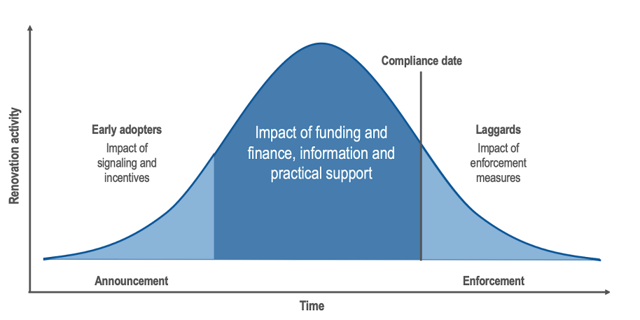

MEPS encompass minimum efficiency standards for equipment, building energy performance, and building codes. They have proven to be effective policy instruments adopted by many countries. MEPS can be categorized as either attribute standards (focusing on physical properties) or performance standards (assessing actual energy use and emissions).

### Equipment and carbon intensity MEPS

MEPS can be used to eliminate environmentally harmful products from the market or make old and obsolete equipment irreplaceable in a like-for-like scenario by establishing a MEPS cap that must be met by specific types of equipment used in buildings. This equipment for the GEMS Act 2012 (Appendix 7: Australian relevant policies and initiatives). This compels building managers to improve equipment when the asset is being replaced68F68F68F68F68F68F68F68F[69]. Implementing equipment MEPS results in improved building efficiency, lower energy costs, and reduced greenhouse gas emissions.

Equipment standards have been implemented in residential rented properties for several decades, and jurisdictions are now expanding these standards by incorporating more components, frequent triggers, expanded requirements, and tenant protection measures69F69F69F69F69F69F69F69F[70].Costs associated with meeting the standards are sometimes capped to alleviate the financial burden on residents or companies.

There is a global trend towards increased use and requirement of renewables in buildings and the capping of energy consumption on-site. Various countries have implemented measures to promote energy efficiency and reduce carbon intensity in buildings. For example, the **Netherlands** introduced new energy performance requirements that include capped energy consumption and a minimum percentage of renewable energy. **France** has implemented energy capping during the construction phase and limits on energy consumption during operation70F70F70F70F70F70F70F70F[71]. **Germany**71F71F71F71F71F71F71F71F**[72]** and **Japan**72F72F72F72F72F72F72F72F**[73]** have introduced requirements for renewables in new and renovated buildings. Many **European countries**73F73F73F73F73F73F73F73F**[74]** have phased out the installation of fossil fuel boilers in buildings. These measures aim to improve building efficiency, reduce greenhouse gas emissions, and promote the use of sustainable energy sources. The guidelines and standards for energy performance are often based on international standards and calculations methods. These policies are often focused on building heating and to respond to increased gas prices. These two factors are not as pertinent in Australia.

### Rating-based MEPS

Rating-based systems, such as EPCs, ENERGY STAR, and Display Energy Certificates, are commonly used to assess and disclose the energy performance of buildings. These systems allow for a range of design strategies and technologies to achieve energy efficiency targets. MEPS are typically amended periodically, with a focus on addressing the worst-performing buildings first. Prohibition of sale or lease below a certain performance threshold is an increasingly common approach to drive improvements in existing buildings.

The EPC system is mandatory in the EU and the UK, providing energy efficiency ratings for buildings. In England and Wales74F74F74F74F74F74F74F74F[75], rented premises must meet a minimum EPC rating, and properties with lower ratings may require energy upgrades before re-leasing75F75F75F75F75F75F75F75F[76]. The EU also requires EPCs for certain existing public buildings, with minimum energy performance requirements and information on energy consumption76F76F76F76F76F76F76F76F[77].

Standards in different jurisdictions cover distinct parts of the stock: different sectors, tenures, ownership structures, building type and size. Table 9 provides an overview of the implementation of MEPS in various jurisdictions. The MEPS standard in France applies to homes, in England and Wales to all rented buildings, and in the Netherlands to offices. Rented homes in Scotland must be EPC E from 2020 and EPC D from 2022 when a tenancy contract is changed, extending to all targeted properties in 2025.

**Table 9: Implementation of MEPS for existing buildings**

|  |  |  |  |
| --- | --- | --- | --- |
| Jurisdictions | Rating-based MEPS | Affected commercial stock | Building owner actions |
| EU | EPC – rating ‘C’ by 2027, ‘B’ by 203077F77F77F77F77F77F77F77F[78] | All buildings constructed, sold, or leased out to a new tenant All buildings with a total floor area > 250 square metres occupied by a public authority and frequently visited by the public | Modify building (or EPC if inaccurate) to meet minimum standard |
| Scotland | EPC – rating ‘C’ by 2040 | Non-residential buildings sold and leased over 1000 square metres | Modify building (or EPC if inaccurate) to meet minimum standard |
| England & Wales | EPC – rating ‘E’ as of 2018, ‘C’ by 2027, ‘B’ by 203078F78F78F78F78F78F78F78F[79] | All buildings leased and sold | Modify building (or EPC if inaccurate) to meet minimum standard |
| Netherlands  *(See Box 2 Case Study)* | EPC – rating ‘C’ by 2023, ‘A’ by 2030 | All office property | Modify building to meet minimum standard or prepare Action Plan and carry out works within 3.5 years or monitor energy consumption with Display Energy Certificate |
| Washington DC | 2009-10 SB 5854 – Energy Star benchmarking and disclosure every two years | Non-residential buildings and qualifying public agency buildings | Maintain energy benchmarking data in a format compatible with ENERGY STAR Portfolio Manager Tool. |
| California | 2007 Assembly Bill 1103 – Energy Star benchmarking and disclosure | Non-residential buildings | Maintain energy benchmarking data format compatible with ENERGY STAR Portfolio Manager Tool. |
| Japan | 2015 Building Energy Efficiency Act – mandatory energy efficiency standards for building envelope and equipment performance. 2017 large-scale buildings, 2021 medium-sized buildings. | New large-scale commercial buildings > 2,000 square metres, later expanded to medium-sized commercial buildings > 300 square metres79F79F79F79F79F79F79F79F[80] | Modify building to meet minimum standard |

Source: McAlliser and Nase (2023)80F80F80F80F80F80F80F80F[81] and KPMG analysis

The below case study shows Netherlands’ MEPS journey. Netherlands is considered one of the leading nations in building MEPS and has both rating-based MEPS and equipment and carbon intensity MEPS.

|  |
| --- |
| Box 2 Case Study: Netherlands MEPS policy impacting offices  **Background**  Starting from January 1, 2023, a minimum energy performance certificate of C will be mandatory for all office buildings in the Netherlands as per an amendment made to the 2012 Building Decree on November 2, 2018. The 2012 Building Decree in the Netherlands is a set of regulations that outlines the minimum requirements for new buildings and renovations, aimed at ensuring safety, health, and sustainability standards are met.81F81F81F81F81F81F81F81F[82]  **Requirement**  More than half of the offices in the Netherlands must prepare to meet a new requirement for a minimum energy performance certificate of C. Out of around 96,000 offices in the country, 62,000 will need to comply with the standard, and 56% of them currently do not have an EPC. For the buildings that do have an EPC, only three-quarters meet the required standard, while 7,000 have a rating of D or poorer, which means they will have to take action to comply. This could include registering for an EPC, making energy efficiency improvements or a combination of both.  **Enforcement**  To ensure compliance with the new energy performance certificate standard in the Netherlands, a competent authority, typically the local municipality, will be responsible for enforcement. Building owners and tenants will share the responsibility of compliance. Failure to comply may result in administrative enforcement measures, such as periodic penalty payments, fines, or even closure of the office building. This system aimed to ensure that all office buildings meet the required energy performance standard by the deadline of 1 January 2023.  **Progress**  There are no progress reports yet, however, building sector stakeholders anticipate further tightening of energy performance standard in the future, despite the government’s decision not to introduce a tighter target for class A by 2030 in 2018. The decision encourages proactivity and preparation for future policy changes.  **Related policies and strategies**  The Netherlands Enterprise Agency provides technical information to help building owners comply with the standard, including an online tool and a register of energy advisors. The government offers tax incentives such as the Energy Investment Allowance and environmental investment allowance, as well as green loans with preferential interest rates for commercial buildings. Installation of solar thermal and heat pumps is also partially subsidised through the Renewable Energy Investment Allowance. |

## Broader policy context for building regulations

Disclosure and MEPS policies are often supported by a set of supplementary policies contributing to energy efficient building ecosystems. The following section explores these policies, including when they have been used to complement or substitute disclosure or MEPS policies.

### New building codes and standards

Establishing codes and standards for new buildings is a straightforward way to ensure progress towards emissions and energy efficiency targets. New building requirements can be considered and priced in the design stage, making implementation easier. Some jurisdictions prioritise new building codes before addressing existing buildings. These codes can have attribute or performance-based objectives and are typically more stringent than regulations for existing buildings.

Examples include California's Energy Code82F82F82F82F82F82F82F82F[83], which updates every three years and sets standards for different building types. The building code complements several other requirements such as the Building Energy Disclosure program which is also administered by the same body – the California Energy Commission. Similarly, Denmark's building code, which combines performance and attribute requirements. Denmark's code now includes a focus on carbon emissions, with a requirement for life cycle assessment and an emissions limit for new buildings *F*83F83F83F83F[84]. This approach combines data analysis and a cap on emissions to drive continuous improvement in building efficiency. In this approach, Denmark has opted to focus on instigating improvements at the construction and design phase with limited additional requirements or policies targeted on existing buildings, aside from broader EU-wide policies.

One global trend relevant to new builds and major renovations is calculating **embodied energy/ embodied carbon** in the construction phase. For example, Netherland’s current and Finland and Sweden’s planned embodied carbon emissions limits for new buildings, the US’s procurement policy to promote ‘Low Embodied Energy and Carbon Materials by Federal Agencies’ for state infrastructure projects, and Canada has Zero Carbon Building Design Standards with a limit on embodied carbon through absolute embodied carbon targets or relative improvements over a baseline. The UK is currently consulting on how to cost carbon in construction and will introduce the necessary legislation in 2024 on its approach and interventions (market driven or government incentives/requirements).

### Emission pricing policies

Emission pricing policies can incentivise energy efficiency by creating a financial incentive to reduce emissions. While the building sector has seen limited adoption of emission pricing, there are some examples where this policy has been implemented.

The **Tokyo Emissions Trading Scheme** (ETS) focuses on commercial and office buildings and measures emissions at the point of energy consumption, effectively increasing the cost of electricity. A 2020 study of the scheme found that it was effective in reducing emissions from buildings through elevated electricity prices, noting there were other factors also contributing to electricity prices over the period such as the Japanese earthquake of 2011.84F84F84F84F84F84F84F84F[85]

In **France**, a carbon tax targets scope 1 emissions from heating in buildings, levying taxes on oil products, natural gas, and coal excluding the consumption of electricity (which is captured under the broader EU ETS). This tax is based on the relative emissions per unit of product and mainly impacts the transport and building sectors.

The **EU** has announced plans for a targeted ETS for buildings and road transport, which would operate independently of the existing EU ETS and is scheduled to begin in 202785F85F85F85F85F85F85F85F[86].Compliance and enforcement issues in the building sector may be addressed by enforcing the ETS upstream at the fuel distributor level. These policies, along with other measures and targets, aim to accelerate behavioural change and promote energy efficiency in the building sector.

### Incentive and adjustment policies

Governments and institutions employ various incentives to drive action and compliance with energy efficiency and emissions reduction policies in the building sector. These incentives include grants, loans, subsidies, energy efficiency mortgages, green bonds, and financial assistance programs. Examples include the Swedish government's grants for energy-efficient renovations, the UK's Green Homes Grant86F86F86F86F86F86F86F86F[87], the US Department of Energy and Environment's Green Building Grant Funds, and Germany's Federal Funding for Efficient Buildings (BEG) funding scheme.87F87F87F87F87F87F87F87F[88]

In addition, the EU's social climate fund88F88F88F88F88F88F88F88F[89] and the development of green bonds89F89F89F89F89F89F89F89F[90] provide additional sources of financing for green building upgrades. Tax incentives, such as tax deductibility for energy-related building refurbishment measures in Germany, are also utilized90F90F90F90F90F90F90F90F[91]. These incentives aim to encourage investment in energy efficiency measures, facilitate compliance with stricter regulations, and drive improvements in the building sector's environmental performance.

### Public building standards

Many governments have implemented higher energy efficiency and emissions standards for government-owned buildings to serve as examples and signals to the wider market. Public buildings typically include offices occupied by public authorities, public hospitals, schools, and sometimes heritage sites and museums.

Examples of public building standards include Korea's Energy Performance Index (EPI) requirements91F91F91F91F91F91F91F91F[92], Japan's Zero Energy Buildings initiative for public buildings92F92F92F92F92F92F92F92F[93], Washington DC's Building Energy Performance Standards93F93F93F93F93F93F93F93F[94], the EU's requirement for zero emissions in new publicly owned buildings by 2028 and privately owned buildings by 203094F94F94F94F94F94F94F94F[95], Germany's renewable energy use requirements for public buildings, and the Netherlands' agreement with the social housing sector for an EPC rating B95F95F95F95F95F95F95F95F[96].

Using public buildings as test cases and demonstrating successful energy efficiency implementation can be a valuable tool in introducing new standards and driving broader adoption in the market.

## Outcomes from Regulation and Other Policy Levers

### Energy, Emissions and Building Quality Outcomes

Comparable jurisdictions to Australia have implemented various energy efficiency policies and programs, with some evidence of improvements in energy and emissions performance and building quality improvement. However, the overall sectoral impact may be limited due to low participation rates in certain programs.

Based on evidence, mandatory requirements for disclosure and MEPS have shown effectiveness in reaching a greater number of buildings. For example, Japan transitioned from a voluntary reduction program to a mandatory emissions trading scheme and one key factor was the limited success of the voluntary program.

Similar to the NABERS in Australia, many schemes have been shown to be effective for the particular cohort that use the scheme. Specific schemes like the South Korean BEECS, Washington State program, UK ESOS and ENERGY STAR buildings have demonstrated energy savings for participating buildings.

Studies assessing the broader effectiveness of building energy efficiency policies are limited but show improvements in energy ratings and certifications. One UK study has found a weak correlation between attribute-based measures like EPC scores and actual energy performance of larger existing buildings, leading to consideration of schemes based on actual performance.

An international review96F96F96F96F96F96F96F96F[97] of public policy impact on building efficiency found mandatory and regulatory measures, such as energy building codes and standards, are generally considered cost-effective for long-term behaviour change. Other policy instruments include certificates and labels, utility programs97F97F97F97F97F97F97F97F[98], Energy Service Companies (ESCOs)98F98F98F98F98F98F98F98F[99], audits, and taxes.

**Table 10: Building energy, emissions changes from policy introduction**

| Jurisdiction | Scheme/policy | Evidence (or lack of) of effectiveness |
| --- | --- | --- |
| UK | EPBD requiring EPCs on sale or lease | Contributed to carbon emissions in buildings falling 14% (most impact from 2008-2015 and the study notes other factors contributed to the reduction)101F99F99F99F99F99F99F99F99F[100] |
| UK | EPCs on sale or lease | Weak correlation between the EPC score and actual energy performance of larger buildings (> 1,000 square metres)100F100F100F100F100F100F100F100F[101] |
| UK | Energy Savings Opportunity Scheme (ESOS)101F101F101F101F101F101F101F101F[102] | Existing buildings includes 11,900 businesses incl. not-for-profits but not public companies: net cost savings of 37 per cent, energy and fuel efficiency improvement ~1.65 TWh from buildings (138 MWh per business)102F102F102F102F102F102F102F102F[103] |
| Netherlands | EPBD requiring EPCs on sale or lease | Non-profit housing associations: average energy index between 2017 and 2020 improved from 1.73 to 1.51 in 2020103F103F103F103F103F103F103F103F[104] (12.7per cent improvement). Changes attributed to PV systems, heat pumps and district heating. |
| Washington state | Washington State Energy Code (WSEC): State law (RCW 19.27A.160) | Commercial sector modelled energy consumption is estimated at 69% of 2006 levels (31% improvement in energy use intensity (EUI, kBtu/sqft/yr)). More impacted: retail strip-malls, retail stand-alone, warehouse unrefrigerated, offices. |
| Washington DC | CleanEnergy DC Omnibus Amendment Act of 2218, BEPS Program | Assessment104F104F104F104F104F104F104F104F[105]: Buildings with packages costing more than $10 per square foot averaged a 32% Site EUI reduction. |
| US | Energy Star Rating Scheme | Energy star: those with rating 75 or above are one-third more energy efficient than average US office building and annual energy bills 35per cent lower than average office building105F105F105F105F105F105F105F105F[106]; buildings on average are 20per cent more energy efficient in year six that the first year; over 70 per cent of buildings with a rating have reduced their energy consumption106F106F106F106F106F106F106F106F[107]. |
| Japan | Emissions Trading Scheme (mandatory) | Two figures reported. Figure that considers impact of factors outside of the scheme (and therefore more likely to reflect actual change in performance) indicates a 6.9% annual reduction in CO2 emissions from buildings107F107F107F107F107F107F107F107F[108]. |
| Japan | Emissions reduction program, no trading (voluntary reduction, mandatory reporting) | Limited success (specific performance not identified)108F108F108F108F108F108F108F108F[109]. When voluntary, compliance rates in their scheme were reaching 36 per cent to 51 per cent in 2015 depending on the building size, and it is expected that there will be close to full compliance now that the standards are mandatory. |
| Japan | Zero Energy Buildings (ZEBs), new buildings only | Although ZEBs perform well, by the end of 2018, the number of ZEBs reached 70 or 0.1 per cent of total buildings constructed109F109F109F109F109F109F109F109F[110]. |
| South Korea | Building Energy Efficiency Certification (BEECS)110F110F110F110F110F110F110F110F[111] | Mean annual primary energy consumption of certified non-residential buildings investigated changed from 265.5 kWh/m2a to 224.8 kWh/m2a in 2014 (15per cent decrease111F111F111F111F111F111F111F111F[112]). This is a voluntary scheme so does not include all buildings. |

The United States Environment Protection Agency (US EPA) assessed the impact of energy savings by building type from 2008-2011 and found the biggest impact for retail, offices and warehouses (see Figure 11).

**Figure 11: Energy savings from ENERGY STAR scheme by building type (US)**112F112F112F112F112F**[113]**

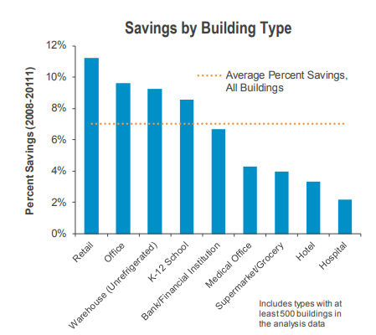

While not measuring energy and emissions from buildings, adoption of rating schemes can give an indication of building stock improvement, as set out in the Table 11 below.

**Table 11: Adoption of rating schemes**

| Jurisdiction | Scheme | Adoption |
| --- | --- | --- |
| UK | EPC | The number of homes with an EPC rating of C or above has increased from 13 per cent in 2010 to 46 per cent in 2022.113F113F113F113F113F113F113F113F[114] Although this statistic relates to households it demonstrates how mandatory disclosure and minimum energy performance standards can impact building stock. |
| Norway | EPC | By the end of 2016 approximately 24,000 EPCs has been issued to non‐residential buildings.114F114F114F114F114F114F114F114F[115] |
| Japan | Certification under Building Energy Efficiency Act | As of late 2019, nearly 93,000 buildings had been certified (in line with 2015 Building Energy Efficiency Act)115F115F115F115F115F115F115F115F[116] |
| US | ENERGY STAR | 26,000 buildings have used the Energy Star rating scheme and more than 40per cent are offices.116F116F116F116F116F116F116F116F[117] There is 230 million square metres of energy star certified commercial space across the US.117F117F117F117F117F117F117F117F[118] This is 2.5per cent of the US commercial building floor space.118F118F118F118F118F118F118F118F[119] |
| US | LEED | 140 million square metres of LEED certified commercial space119F119F119F119F119F119F119F119F[120] |
| Washington DC122F | ENERGY STAR | Increase from <10 buildings in 1999 to 200+ buildings in 2011120F120F120F120F120F120F120F120F[121] |
| Washington DC122F | LEED | Increase from ~10 buildings in 2004 to almost 1,400 buildings either registered or certified in 2012 |
| California | LEED | 273 state leased or owned buildings have completed the LEED certification, covering 25M square feet (or 2.3M square metres).121F121F121F121F121F121F121F121F[122] |
| New York City | ENERGY STAR | The disclosure policy covers approximately 40,000 New York City buildings and although this is around 4%122F122F122F122F122F122F122F122F[123] this covers nearly 60 percent of the city's building area123F123F123F123F123F123F123F123F[124] |

### Market impacts

Asset price (rent or purchase) changes and operational savings

Research suggests that improved energy efficiency in buildings can have an impact on prices, although most studies focus on the residential sector. In the US, a study found that a one-point increase in the Home Energy Score (HES) was associated with a 0.5 per cent increase in sale price124F124F124F124F124F124F124F124F[125]. A global review by the European Commission125F125F125F125F125F125F125F125F[126] indicated increases in both sale and rental prices for Energy Star buildings in the US, ranging from 8 per cent to 26 per cent increases in sale price and around a 3 per cent increase in rent prices for offices.

In terms of operational savings, Energy Star research126F126F126F126F126F126F126F126F[127] showed a range of benefits in addition to reduced emissions (costs, revenue, asset value, see Figure 12).

**Figure 12: Other benefits to the ENERGY STAR scheme in the US**127F127F127F127F127F**[128]**

|  |  |
| --- | --- |
| Property | Benefit |
| 500,000 ft2 office building | Cumulative cost savings of $120,00, increase in asset value of over $1million |
| Medium box retailer with 500 stores | Cumulative energy savings of $2.5m, increase in sales of 0.89% |
| Full-service hotel chain with 100 properties | Cumulative energy cost saving of $4.1m, increase in revenue per available room of $1.41 |
| 800,000 ft2 school district | Cumulative energy cost saving of $140,00, salary of 1.2 full time teachers each year. |

In specific programs, the DC Property Assessed Clean Energy (PACE) program128F128F128F128F128F128F128F128F[129] in the US generated nearly $86 million AUD in savings for property owners through lower utility bills. In the UK, the Energy Savings Opportunity Scheme (ESOS) found net cost savings of 37 per cent for businesses that participated129F129F129F129F129F129F129F129F[130]. It should be noted that these programs are not exclusively focused on building performance but encompass broader energy efficiency measures.

Overall, the evidence suggests that improved energy efficiency in buildings can have positive financial implications, including increased property prices, operational cost savings, and improved business outcomes.

Lending institutions

Government policies aimed at reducing building emissions can have an impact on lending institutions and the products they offer. Financial institutions may make changes to their product offerings in response to both government policies and their own internal climate goals.130F130F130F130F130F130F130F130F[131]

One example is the **Glasgow Financial Alliance for Net Zero** (GFANZ)131F131F131F131F131F131F131F131F[132], which brought together 43 banks from 23 countries with $28.5 trillion in assets. These banks committed to align their credit and investment portfolios with net-zero CO2 emissions by 2050 and set mid-term targets for 2030. In the **UK**, Barclays Bank132F132F132F132F132F132F132F132F[133] aims to provide up to £500 million in Green Bond and Green Home Mortgages by 2027. Green mortgages in the residential sector often offer lower mortgage rates for energy-efficient homes. Barclays requires a property to have an energy efficiency rating of 81 or above, or be in energy efficiency bands A or B, to qualify for lower rates on certain fixed-term mortgages.

In **Australia**, the Commonwealth Bank of Australia133F133F133F133F133F133F133F133F[134] offers the Property Sustainability Upgrade Loan for commercial properties. This program allows businesses to increase their loan amount by up to 20 per cent for property sustainability upgrades that improve NABERS ratings or reduce carbon emissions, with zero margin and zero fees.

The EU has a range of funds and loans, for example the **Netherlands** National Heating Fund134F134F134F134F134F134F134F134F[135] (a loan of AUD $330 million from the Council of Europe Development Bank to finance energy efficiency measures for individual homeowners and schools with low-interest rates with favourable lending conditions), Danske Bank in **Denmark** provides Green Loans and has established a "Green Finance Framework"135F135F135F135F135F135F135F135F[136] with loans for the construction, acquisition, and ownership of buildings to convert them into green buildings and in the **Netherlands** where the Minimum Energy Performance Standards (MEPS) policy requires all offices to meet an EPC rating of 'C' by 2023136F136F136F136F136F136F136F136F[137], the government has worked with banks to align their lending strategies to promote compliance with the policy. ING Bank, for example, only offers new financing for office buildings that have an EPC rating of 'A,' 'B,' or 'C'.

On-bill financing (OBF) is another approach to funding building energy efficiency upgrades, where repayments are made through an electricity utility as part of an energy bill.137F137F137F137F137F137F137F137F[138] OBF programs have been successful in the **USA** and **Canada**. For instance, the Tennessee Valley Authority (TVA) has offered financing programs for homeowners and commercial building owners for nearly 30 years, funding energy-efficiency retrofit projects worth nearly US$500 million.138F138F138F138F138F138F138F138F[139] The *How$mart®* Program by Midwest Energy provides financing for energy efficiency improvements, with customers repaying the funds through energy savings on their energy bills.139F139F139F139F139F139F139F139F[140]

These examples demonstrate how government policies and initiatives can influence lending institutions to offer loans and change their products or policies to incentivize energy-saving measures in buildings.

Costs and financing available to building owners

The cost to upgrade a building to meet minimum energy performance standards (MEPS) can vary depending on various factors. For households, renovation costs to meet energy efficiency requirements have been estimated to range from AUD $25,000 to $170,000.140F140F140F140F140F140F140F140F[141] An evaluation of BEPS program in Washington DC showed compliance costs building owners an average of USD10 per square foot (~$165 Australian per square metre)141F141F141F141F141F141F141F141F[142].

In the Netherlands, the requirement for all buildings to meet an EPC rating of 'C' is estimated to have a cumulative cost of 860 million Euros in 2023142F142F142F142F142F142F142F142F[143]. The payback times for investments in energy efficiency improvements in these buildings are estimated to average between three and six and a half years. In the UK, if the payback period of the change is greater than seven years, owners do not have to implement the MEPS.

Split incentives and asymmetrical information between landlords and tenants can pose barriers to energy efficiency improvements. When landlords do not invest in energy efficiency at the same rate as tenants who pay the electricity bills, it can lead to higher energy bills, as shown in a US study143F143F143F143F143F143F143F143F[144]. Options to address this issue include:

* Policies that **incentivise both landlords and tenants** to improve energy efficiency. For example, France's Article 175 requires both landlords and tenants of buildings over 1000 square meters to annually declare energy performance achieved by buildings, and non-compliance can result in fines.144F144F144F144F144F144F144F144F[145]
* **On-bill financing schemes** have been identified as an effective way to address split incentives, particularly for low-income tenants.145F145F145F145F145F145F145F145F[146] These schemes provide incentives to both landlords and tenants by having a loan paid off through reduced electricity costs, with the remaining funds split between the landlord and tenant. The tenant's reduced electricity bills contribute to paying off the loan, while the landlord receives a payment. This approach allows both parties to benefit from energy efficiency improvements.
* **Minimum standards for rental properties and green leases** are suggested as methods to overcome split incentive issues.146F146F146F146F146F146F146F146F[147] Minimum standards can ensure that rental properties meet energy efficiency requirements, making it necessary for landlords to invest in improvements to lease their properties. Green leases can include provisions on the distribution of funding when energy efficiency upgrades are undertaken, allowing for contributions from saved energy costs by tenants.
* **Individual metering and monitoring** can help redistribute costs and benefits among tenants and landlords. For example, if heating costs are covered in the rent, tenants can receive compensation when less energy is consumed. Energy labelling can also assist tenants in making more informed decisions during sale and lease transactions, addressing information asymmetry issues that can exacerbate split incentive behaviour.
* Mandate **utilities companies** to incentivise reduced emissions. In Washington State, utilities companies are involved in the Early Adopter Incentive Program, which requires compliance with the Clean Buildings standard. Utilities companies with more than 25,000 customers must participate in administering incentive payments to eligible building owners.147F147F147F147F147F147F147F147F[148]

These examples highlight various approaches and strategies to address split incentives, encourage energy efficiency improvements, and provide financial incentives to overcome the upfront costs associated with upgrading buildings to meet energy performance standards.

### Administration Costs

Every government-driven policy or mechanism requires resourcing from government agency(s). This includes both financial and human resourcing. It is challenging to determine the exact resourcing requirements for each program. Fines and fees can be used to recoup some of the costs involved in program management. The UK Energy Savings Opportunity Scheme (ESOS) program covers 11,900 UK businesses and is administered by the Environment Agency. This would take significant resourcing to manage. Costs can be recovered though - for Phase 2 of this program, the Environment Agency has issued 82 civil penalties amounting to £1.3M. In France, the French Environment and Energy Management Agency runs the online tool used to track building energy efficiencies (OPERAT), which would take technical expertise.

Other resourcing requirements include providing training, documentation to support programs, toolkits and certification. In the US for example, Washington DC government will develop a green building workforce by training-built environment professionals and building operations staff in the latest green skills148F148F148F148F148F148F148F148F[149], Washington State has developed a detailed Program Guidebook149F149F149F149F149F149F149F149F[150], , in New York, outreach, education, and assistance programs are being created to assist owners of covered buildings and the Act requires the government to conduct a feasibility study for a citywide GHG trading program150F150F150F150F150F150F150F150F[151], and the US Department of Energy has a toolkit for Commercial Property Assessed Clean Energy program (C-PACE). The Department had to collaborate with more than 70 participants, including more than 30 state and local government participants to develop the tools and resources151F151F151F151F151F151F151F151F[152]. In the EU, the EU Commission monitors the progress made by EU countries to increase the number of nearly zero energy buildings (NZEBs), requiring resources to track these in each country.152F152F152F152F152F152F152F152F[153]

# Considerations for Australia

Building on Australia’s own policy history, the review of comparable jurisdictions suggests the following options could be investigated further in the next phases of this project to understand relative costs, benefits and feasibility, and considered as part of broader reforms outside the scope of this project.

**Buildings ratings systems**

* The review of international experience has reinforced the strengths of the Australian performance-based NABERS system of rating
* While the scale of the regulation being implemented internationally is larger than that currently in place in Australia, the reliance on attribute compliance measurement (which is easier to implement at scale) has likely limited effectiveness. Many countries are now opting for performance-based compliance measurement as it is seen to be more effective (though it requires greater attention to phasing to implement at scale)

**Commercial buildings disclosure**

* Consider expanding building types covered, from office buildings to all commercial buildings including larger short-term accommodation and retail buildings.
* Consider reducing the regulated threshold for CBD for office buildings, with 500m2 being one option referenced in similar jurisdictions.
* Consider mandatory disclosure of itemised scope 1 emissions from NABERS assessments in addition to other current data points.

**Minimum energy performance standards**

* Consider a phased introduction of a minimum star rating for building performance at point of sale or lease, commencing with office buildings currently captured by CBD.
* The introduction of minimum standards for lighting standards at sale or lease.
* Many northern hemisphere jurisdictions are considering or implementing regulatory phase out of new or replacement installation of fossil fuel-based boilers. Consideration in Australia needs to take account of differences in their significance in terms of energy and emissions, given climate and non-regulatory trends.

**Broader policies and reforms**

* For government-owned or operated buildings, consideration of a nationally coordinated approach to procurement and energy management across the jurisdictions may complement regulatory changes for private buildings. This could include aligned approaches to procurement to secure high performance and resilient office, health and school buildings.
* Consider improvements to the National Construction Code to achieve high performance energy and emissions by design, including to complement broader improvements to CBD and MEPS over time.
* Complementary measures to assist and incentivise owners and tenants to adjust to, and beat, regulated minimums outlined above, including
* Access to green and/or innovative financing, including approaches enabling on-bill financing, or other structures aligning payments to energy cost savings.
* Targeted assistance especially related to upgrades to meet MEPS-related mandates.

# Initial options assessment

## Overview

Based on the literature review and assessment of global policies, a range of policy options were identified for both commercial building disclosure and MEPS that could be considered in the Australian context. This chapter explores a range of these options and assesses them against a simplified assessment criterion.

## Design considerations for policy options

Each option for expanding the CBD program will consider changes across several variables. These variables make up a framework which includes:

* Performance- vs attribute-based assessments
* Coverage and exemptions
* Reporting
* Compliance
* Display of rating

Further details and associated trade-offs are provided below. This also includes the requirements for the current CBD program.

**Performance- versus attribute-based assessments**

The international research indicates a trend towards performance-based assessments. Although attribute-based may more easily achieve scale as it is easy to assess building attributes, the research highlights concerns that assessing attributes only does not lead to sufficient change in building energy use. For this reason, a performance-based tool is recommended. As NABERS is the current CBD program tool, the expanded program can continue to use NABERS, making sure it can be used for building types that are part of the expanded program.

**Coverage and exemptions**

Coverage could be approached in a range of ways. A one size fits all approach could be implemented whereby all buildings, regardless of size or type, would be included. Another approach could focus on targeting larger emitting buildings before including smaller buildings. Each approach has associated benefits and trade-offs. By including all building types, the program would have a greater reach and provide more opportunities for change. However, certain building types and sizes may find it more difficult to pay for and report energy efficiency ratings, and NABERS ratings are not available for all types of buildings. Focusing on larger buildings initially would increase the scale of impact, as a small proportion of larger buildings would cover a high proportion of overall GFA and energy use.

The current CBD program focuses on buildings that are majority offices >1,000m2.

Exceptions to coverage are building types or situations where disclosure or MEPS are not required. A situation that this may be implemented is where the disclosure would not impact behaviour and therefore it would only induce a cost with no tangible change. In the UK for example, buildings with payback periods >7 years for the required change do not need to meet the MEPS.

The CBD program exceptions apply to new buildings and major refurbishments where a certificate of occupancy (or equivalent) has either not yet been issued or was issued less than two years earlier; strata-titled buildings; and mixed-use buildings where total office space comprises less than 75 per cent of the NLA. The CBD program also has exemptions, which are buildings usually required to comply that must submit an application to be exempted from this requirement. Exemptions include when the building or an area of the building is used for police or security operations; in cases where an energy efficiency rating cannot be assigned because of the current characteristics of the building or an area of the building, and when a major refurbishment is in progress (the building is then an exception after the refurbishment is finished).

**Reporting (continuous reporting and frequency vs trigger point)**

Reporting could occur in a multitude of ways and cover different information. For example, the approach may be setting an energy target or reporting requirement, emissions target or reporting requirement, or both. A key question to determine the approach used is whether energy or emissions is the priority, as emissions can be substituted by purchasing Greenpower and does not provide a true representation of the building’s energy performance. Understanding the building’s energy performance, as highlighted earlier, is desirable. An emissions target would allow energy usage to remain similar if GreenPower were used, whereas an energy target would mean total energy usage (whether from green sources or otherwise) would need to be reduced to match the target.

The current CBD program has no target or MEPS. It is disclosure only and the Building Energy Efficiency Certificate (BEEC) includes NABERS ratings (excluding GreenPower) and Tenancy Lighting Assessment (TLA).

NABERS rating certificates are provided with a Greenpower score and in the finer print there is a mention of what rating would be achieved without GreenPower. However, the NABERS rating displayed on the building advertising and BEEC is without GreenPower and is therefore a truer representation of the energy performance of the building. NABERS with Greenpower is being phased out, with the NABERS Renewable Energy Indicator provided alongside all NABERS Energy Ratings.

It is also necessary to consider the frequency of reporting and monitoring and whether it is required continually (e.g., for annual reports) or only at trigger points (e.g., at time of sale of new lease). Continuous monitoring allows for regular updates on whether progress is occurring, or whether activity is simply remaining the same. Whilst this can be beneficial, continuous monitoring can become a compliance burden. Comparatively, monitoring at trigger points does not provide regular oversight of progress, although it may incentivise action for improvement at the trigger point to ensure the rating is achieved. Building type also plays a role in determining the more effective trigger point. For example, offices are more regularly sold or leased and so this trigger point may be appropriate, compared to a hotel which may change ownership or lease arrangements every 50-100 years. In these cases a frequent reporting period (e.g. every 1, 2, 5 years) is more appropriate.

For the current CBD program, trigger points occur at the point of sale, lease, or sublease if the building or aggregate tenancy area is >1000m2. Many buildings landlords keep their BEEC up to date annually to align with their NABERS ratings.

**Compliance**

A range of methods can be implemented to assess and test a buildings compliance. Physical assessment by an accredited person can be undertaken or modelling can be used to attribute scores and ratings to a building. Assessment will provide more specific results whilst modelling may be a more cost-effective option.

For the current CBD program, NABERS assessments are conducted by NABERS and CBD accredited individuals. The Government checks whether the building is complying with disclosure obligations. Government authorised representatives conduct checks of buildings for lease or sale to make sure information is displayed on advertising.

The level to which fines and other disincentives are used must also be determined. Large fines and disincentives are likely to ensure compliance however in some cases, if a successful program is in place, large fines may not be necessary.

For the current CBD program, civil penalties may be imposed for non-compliance. DCCEEW may issue infringement notices in relation to contraventions. Civil penalties of up to $313,000 for the first day of non-compliance for a body corporate and $109,550 for an individual may be imposed by a Court for failing to provide a BEEC in accordance with a section 12 obligation. Alternatively, the Secretary of the DCCEEW may issue an infringement notice with a penalty of up to $31,300 for a body corporate or $10,955 for an individual for the first day of non-compliance.

The application fee for a BEEC is $483, indexed at the beginning of the financial year. The application fee for NABERS energy rating for Offices > 2,000m2 is $1,410. Assessor fees to obtain the NABERS and BEEC ratings can add significantly to the costs depending on the complexity and number of ratings the building has had historically.

**Display of rating**

A range of options exist in terms of how the rating is displayed or disclosed. Possible options include requiring the rating to be physically displayed on the given building, posting the rating online, or notifying government of the rating. The key consideration is ensuring visibility of the rating to motivate compliance and action to make improvements.

For the current CBD program, a valid BEEC must be provided to potential buyers or lessors free of charge. NABERS star rating must be included in any advertising material. BEECs are also made publicly accessible on the Building Energy Efficiency Register online.

## Description of options

Seven broad options for expanding the current CBD program were identified based on the literature review and analysis. These options leverage mandatory disclosure and MEPS to maximise impact and coverage of the program. The seven policy options include:

* Option 1: A blanket disclosure policy for all commercial buildings over 1,000m2 GFA
* Option 2: A tailored sectoral disclosure policy
* Option 3: Reducing the current CBD threshold coverage for all offices over 500m2 GFA
* Option 4: A MEPS for offices over 1000m2 based on the NABERS star rating
* Option 5: Requiring a detailed breakdown of scope 1 emissions for buildings currently reporting under the CBD program
* Option 6: Introducing a MEPS for offices focused on lighting requirements
* Option 7: A phase out of fossil fuel boilers in commercial buildings.

Each of these policy options is explored in greater detail below.

### Option 1: Blanket disclosure

The first option considered was a blanket mandatory disclosure for all commercial buildings over 1000m2. This policy is based on several approaches adopted in European schemes. For example, the UK, Germany, France, Norway and others all have blanket disclosure of EPC policies for non-residential or tertiary buildings over a particular size. However, in these cases, as the EPC is used, it is an attribute based measure, which is easier to roll out and monitor at scale. As noted in chapter 3, the UK policy considers all commercial buildings greater than 50m2 in size. The benefit of this approach is its simplicity and its impact on cultural changes in how energy efficiency is considered across the economy. This approach has the most extensive inclusion requirements, which would have the most significant impact, however, would result in costs being occurred by more building owners, some of whom have limited capacity to address issues identified.

Specifics of the policy are outlined in Table 12 below.

**Table 12: Blanket disclosure**

|  |  |
| --- | --- |
| Design element | Description |
| Coverage and exemptions | Policy would cover all commercial buildings greater than 1000m2. Exceptions would be considered for heritage buildings and short-term buildings. Exemptions would be considered for buildings approved for demolition or major works. |
| Reporting | Disclosure assessments and reporting would vary across the specific subsectors. For buildings that were subject to turnover (selling, leasing, etc.) assessments would be required at one of those trigger points, in line with the current CBD requirements. For sectors that are not subject to turnover (e.g. schools, hospitals, etc.), assessments would be required every year with the assessment result displayed at all times. |
| Compliance | Compliance assessments would be implemented through CBD authorised officers conducting spot-checks on buildings. |
| Display of rating | Rating would need to be visibly displayed in the building in buildings with lower turnover, and must be disclosed to buyers, lessors and in all advertising material. As this is a blanket disclosure option, the display of rating would be the same regardless of building type. |

### Option 2: Tailored sectoral disclosure

Option 2 considers a more bespoke coverage approach across building types in different sectors. This tailored approach seeks to target the most prospective opportunities, recognising the different characteristics and propensity to change across different building types. To identify the priority sectors to initially include in the coverage of this policy, a detailed heatmapping exercise was conducted that accounted for:

* The number of buildings in each sector
* The distribution of floorspace and energy use by size cohorts within a sector
* The average emissions intensity of buildings in each sector
* The likely behavioural impacts of a disclosure policy on the building types and operations in each sector
* The sector maturity in considering energy efficiency
* The relative ease of implementation in each sector.

These criteria informed a shortlist of sectors to be initially included in expanded CBD regulation. Following this assessment, a high-level assessment of the appropriate coverage points for building size was conducted to inform the design of the policy. Appendix 7 outlines the detailed exploration of inclusions points under this policy. This coverage is assumed for the purposes of benefit and cost calculation only, and as outlined in the chapter 7 below outlining a regulatory roadmap, the regulatory footprint could be phased further over time.

Specifics of the policy are outlined in Table 13 below.

**Table 13: Tailored sectoral disclosure**

|  |  |
| --- | --- |
| Design element | Description |
| Coverage and exemptions | Policy would initially cover commercial buildings including:   * Offices over 500m2 * Retail and wholesale trade buildings (incl. Shopping centres, supermarkets and other retail) over 5,000m2 * Warehouses over 5,000m2 * Hotels over 5,000m2 * Aged care facilities over 5,000m2 * Hospitals over 5,000m2 * Education sector buildings over 5,000m2 * Data Centres over 5,000 m2 (or energy-usethreshold to be determined).   Exceptions would be considered for heritage buildings and short-term buildings. Buildings approved for demolition or major works would be exempted. |
| Reporting | Disclosure assessments under this policy would occur once every year for all buildings (private, leased and public). |
| Compliance | Compliance assessments would be implemented through CBD authorised officers conducting spot-checks on buildings. |
| Display of rating | Rating would need to be visibly displayed in the building with lower turnover, and must be disclosed to buyers, lessors and in all advertising material. |

We have assumed the coverage of Government owned buildings such as public hospitals and schools as part of this policy, though this may be covered under either regulation or via equivalent government policy commitments, including in the context of intergovernmental agreements.

### Option 3: Office 500

Option 3 builds on the existing CBD program, maintaining the focus solely on office buildings, however reducing the coverage point from 1,000m2 to 500m2 GFA to capture a greater proportion of office buildings. Expanding the reach of the program to 500m2 would mean smaller and more energy intensive buildings would be captured. This policy is a natural progression for the program that initially started with coverage set at office buildings over 2,000m2 in 2010, which was reduced to 1,000m2 in 2018.

Specifics of the policy are outlined in Table 14 below.

**Table 14: Office 500**

|  |  |
| --- | --- |
| Design element | Description |
| Coverage and exemptions | Policy would cover all office buildings greater than 500m2. Exceptions would be in line with the current program and cover all non-office buildings. |
| Reporting | Reporting requirements under the scheme would be consistent with existing program and required at sale or lease of office space. |
| Compliance | Compliance assessments would be implemented through CBD authorised officers conducting spot-checks on buildings. |
| Display of rating | Rating must be disclosed to buyers, lessors and in all advertising material. |

### Option 4: Star Rating MEPS for offices

Option 4 would require all office buildings that are currently captured by the CBD program and are greater than 1,000m2 to meet a minimum standard 4-star NABERS energy rating withing the first five years of the policy, before increasing the minimum rating to 5-stars. Buildings would have a grace period to implement measures to reach the MEPS and would only require to be compliant at the key dates. This policy is akin to similar policies in the UK, Netherlands, EU, Washington D.C and California. The European policies draw on EPC policies, whereas the American schemes draw on building star performance ratings. The policy would also require some broader alignment with the building code for consistency. This policy would target a smaller subset of lower performing buildings, and raise them to align with the average efficiency of many larger and newer buildings.

Specifics of the policy are outlined in Table 15 below.

**Table 15: Start Rating MEPS for offices**

|  |  |
| --- | --- |
| Design element | Description |
| Coverage and exemptions | Policy would cover all office buildings greater than 1,000m2. Buildings will need to meet the 4-star NABERS rating by 2030 and a 5-star rating by 2032. This would apply to all buildings regardless of the ownership structure (varying from the current CBD program that excludes owner occupied, partnerships and trust owned buildings). |
| Reporting | Buildings under the scheme would be required to report on evidence of compliance with the MEPS rating by the key dates of 2030 and 2032. |
| Compliance | New system and reporting information would be set up for compliance assessments using additional resourcing. |
| Display of rating | No display of ratings would be required. |

### Option 5: Scope 1 disclosure

The fifth option is a minor amendment to the current CBD policy, requiring office buildings that are covered under the scheme to disclose itemised scope 1 and 2 emissions on their NABERS ratings in addition to other current data points. As part of the disclosure building owners would also be required to include refrigerant type GHG emissions. Reporting on refrigerants would increase awareness of refrigerant emissions and promote uptake of natural refrigerants whilst meeting disclosure requirements for scope 1 and 2 emissions. Scope 1 disclosure would encourage the electrification of buildings and aligns with the Montreal Protocol153F153F153F153F153F153F153F[154].

Specifics of the policy are outlined in Table 16 below.

**Table 16: Scope 1 disclosure**

|  |  |
| --- | --- |
| Design element | Description |
| Coverage and exemptions | Policy would be in line with the current program and cover all office buildings greater than 1,000m2. Exemptions would also be in line with the current program and cover all non-office buildings. |
| Reporting | Reporting would occur as per the current CBD program. |
| Compliance | Compliance would occur as per the current CBD program. |
| Display of rating | The detailed breakdown of Scope 1 emissions type would form part of the existing disclosure requirements to buyers, lessors and in all advertising material. |

### Option 6: Lighting MEPS

Option 6 requires all office buildings currently covered under the CBD program to meet a minimum standard for nominal lighting power density (e.g., 10 watts per m2). This particular option will impact tenants more than buildings owners as tenants are responsible for the cost of fitouts, including lighting and general power. Lighting upgrades are a cost-effective energy efficiency capital upgrade for buildings with low pay-back periods. Introducing a minimum lighting energy efficiency requirement for existing buildings may have a moderate effectiveness of reducing emissions while minimising costs of a full whole-of-building MEPS. As with option 4, a grace period would be introduced to allow building owners time to implement the upgrades.

Specifics of the policy are outlined in Table 17 below.

**Table 17: Lighting MEPS**

|  |  |
| --- | --- |
| Design element | Description |
| Coverage and exemptions | Policy would be in line with the current program and cover all office buildings greater than 1,000m2. Exemptions would also be in line with the current program and cover all non-office buildings. |
| Reporting | Buildings under the scheme would be required to report on evidence of compliance with the MEPS rating by the date the MEPS comes into full effect. |
| Compliance | New system set up and compliance checks would be conducted with additional resourcing. |
| Display of rating | No display of rating requirements |

### Option 7: Fossil fuel boiler phase out

The final option explores phasing out fossil fuel boilers in offices captured in the current CBD program. The phasing out of natural gas boilers is becoming common practice overseas, particularly in Europe, and could be applied in an Australian context. This change would seek to leverage continued improvements in emissions intensity of grid electricity and have increasing benefits over time. This policy may have broader implications for the building code which would need to be considered.

Specifics of the policy are outlined in Table 18 below.

**Table 18: Fossil fuel boiler phase out**

|  |  |
| --- | --- |
| Design element | Description |
| Coverage and exemptions | Policy would be in line with the current program and cover all office buildings greater than 1,000m2. Exemptions would also be in line with the current program and cover all non-office buildings. |
| Reporting | Not required. |
| Compliance | Compliance assessments would be implemented through compliance checking of building power sources. |
| Display of rating | Not required. |

### Options not explored

Two further options were identified through the literature and international policy scan that were not included as possible options. These options not explored and the rationale for exclusion are outlined below.

**Disclosure of embodied carbon in materials used to construct or renovate the building**

Although important, disclosure of embodied carbon is more relevant for new builds and major renovations. We believe this is best considered in the National Construction Code or similar where mandatory reporting of embodied carbon could be required in the planning and construction phase. NSW government is looking to introduce calculation and disclosure of embodied carbon in the planning phase153F154F154F154F154F154F154F154F[155] and a similar model could be introduced nationally.

**Phasing out synthetic refrigerants/hydrofluorocarbons (HFCs)**

In HVAC (heating, ventilation, and air conditioning) and refrigeration systems, natural or synthetic refrigerants change state from liquid to vapour and then condense back to liquid to transfer heat. As with embodied carbon, refrigerant standards should be considered in the context of the NCC because replacing synthetic refrigerants can require expensive retrofitting and additional spatial requirements.

Australia aims to reduce HFCs by 85% by 2036 as part of the Montreal Protocol's HCFC ban and HFC phase-down. This issue goes beyond the commercial building sector and is likely to be better dealt with through other regulatory mechanisms. Option 5 discloses GHG emissions from refrigerant gases, which if adopted would motivate building owners to reduce use of HFCs as these will have higher emissions.

## Initial assessment criteria

The initial assessment of the options to proceed to a more detailed feasibility study includes consideration of the following factors:

1. **Potential energy/emissions reach** covers potential scope of energy/emissions covered under the policy. As it is measuring potential scope, the policy does not guarantee the available emissions will be reduced. This is because the potential energy/emissions reach is independent of behaviour change. The impact on behaviour change is measured by ‘strength of signal’ below.
2. **Strength of signal** covers the possible strength of the behavioural impact on participants. MEPS are more likely to drive behaviour change than disclosure for example.
3. **Compliance cost (building owners)** covers cost to building owners and tenants to implement the option. This will consider both an overall cost, and the distribution of costs amongst participants. For example, a MEPS will have zero cost for some participants already meeting standard, with a concentrated cost for others that have not met the standard.
4. **Implementation ease** covers how difficult the option is to introduce and commence. It covers speed of change, administration capacity/requirements from government and building owners and tenants, number of owners impacted by the option, technological factors, alignment with current policy, political considerations, and complementarity with other measures (for example, building codes).

## Assessment of options

The seven policy options were each assessed against the criteria presented above. These assessments are presented in Table 19 below.

**Table 19: Assessment of options**

| Option | Potential energy /emissions reach | Strength of signal | Compliance costs (the more $ signs, the higher the cost (not considering savings)) | Implementation ease (more ticks = easier to implement) |
| --- | --- | --- | --- | --- |
| Option 1: *BLANKET DISCLOSURE rating* |  |  | **$$$$** | TickTick |
| Option 1: *BLANKET DISCLOSURE rationale* | Emissions reach estimated at around **16 MtCO2-e** | Disclosure policy, therefore less influence on behaviour than MEPS | * BEEC + periodic rating (selected buildings) + assessor fees. * Rating cost does not vary based on size except for offices. * Assessor fees vary based on size. * More buildings included in regulatory net, including many small players new to building disclosure | * Captures a high number of additional building types and stakeholders. * There is a significant difference between the current and the proposed coverage. * Implementation may be slow due to the influx of new entities into the regulatory net. * Policy is reasonably simple so building owners can easily grasp the requirements. * There will be additional requirements for government to monitor compliance. |
| Option 2: *TAILORED SECTORAL DISCLOSURE rating* |  |  | **$$** | TickTick |
| Option 2: *TAILORED SECTORAL DISCLOSURE rationale* | Emissions reach estimated at around **10.4 MtCO2-e** | Disclosure policy, therefore less influence on behaviour than MEPS | * BEEC + periodic rating + assessor fees. * Rating cost does not vary based on size except for offices. * Assessor fees vary based on size. * Less new players covered, including excluding many SMEs | * The flexible nature of this policy may be better received by building owners as there is careful consideration of potential challenges for different stakeholders, although it has a level of complexity to it which may be more difficult to implement (e.g., sectoral definitional issues become relevant). * This option enables control over factors like scale, speed, and technological requirements. * This policy does not align with the existing policy as well as Option 1. * There will be significant government administrative resourcing to develop new building type ratings and monitor the program. |
| Option 3: *OFFICE 500 rating* |  |  | **$$** | TickTickTick |
| Option 3: *OFFICE 500 rationale* | Emissions reach estimated at around 3 **MtCO2-e** | Disclosure policy, therefore less influence on behaviour than MEPS | * BEEC + annual rating + assessor fees.   Higher impact on businesses with less revenue compared to larger GFA offices. | * Strong alignment with current policy. * Limited additional stakeholder groups are included in the policy. * No government administrative costs to develop new building type ratings, some administrative burden monitoring the program. |
| Option 4: *STAR RATING MEPS FOR OFFICES rating* |  |  | **$$$$** | TickTick |
| Option 4: *STAR RATING MEPS FOR OFFICES rationale* | Emissions reach estimated at  **4 Star MEPS** **0.38 MtCO2-e**  **5 Star MEPS 0.94 MtCO2-e** | MEPS likely to influence behaviour for those that must meet the requirement | * Building operational performance and capital expenditure upgrade costs * Lower cost to achieve short term minimum standard and higher cost to achieve long term minimum standard. * Accompanied by practical and financial support * Enhanced funding and finance options. | * Inclusion of current cohort entities (offices that disclose already) that may be more amenable to increased requirements. * Government buildings are already included. * Smaller cohort needing to actually change processes, although there is potential for push back from the lower performers. * Sufficient planning time required with potential Government funding and finance needed. * Additional information and practical support required. * More enforcement measures may be needed with additional Government administrative required. * Phased increase to minimum standard with short- and long-term minimum standard may be more palatable to building owners. * Simple policy for building owners to grasp. * Complementary with disclosure policy and overseas developments.   No Government administrative costs to develop new building type ratings. |
| Option 5: *SCOPE 1 DISCLOSURE rating* |  |  | **$** | TickTickTickTick |
| Option 5: *SCOPE 1 DISCLOSURE rationale* | Emissions reach is indeterminate as data is provided as an aggregate of scope 1 & 2 and cannot be isolated. | Potential to reduce scope 1 emissions and increase natural refrigerants, this is assumed to be minimal | * No additional cost to building owners.   Public disclosure of non-compliance. | * Strong current policy alignment. * No additional entities included. * Already collecting data to disclose. * Benefits to scale, speed, and technological requirements. * Will complement the Renewable Energy Indicator   Some minor change to disclosure format change with minor Government administrative requirements. |
| Option 6: *LIGHTING MEPS FOR OFFICES rating* |  |  | **$**154F155F155F155F155F155F155F155F**[156]** | TickTick |
| Option 6: *LIGHTING MEPS FOR OFFICES rationale* | Emissions reach estimated at**:**   * **NLPD 10 W/m2: 22,300 tCO2-e** * **NLPD 7 W/m2: 30,900 tCO2-e** | MEPS likely to influence behaviour for those that must meet the requirement | * Assuming a minimum standard of 10 W/m2. * Assuming 27% of offices do not meet the minimum standard $6.65 million NLA.   Total cost to office building owners not currently compliant is estimated to be $173 million. | * Inclusion of current cohort entities (both landlords and tenants) into the regulatory network with MEPS as a policy mechanism. * Smaller cohort needing to change processes, although there is potential for push back from the lower performers. * Sufficient planning time required with potential Government funding and finance needed. * Additional information and practical support required * More enforcement measures may be needed with additional Government administration required. * Phased increase to minimum standard with short- and long-term minimum standard may be more palatable to building owners. * Simple policy for building owners to grasp. * Complementary with disclosure policy and overseas developments. * Some Government administrative costs to develop new building type ratings. * Some funding and finance, information, practical support, and administrative measures required. |
| Option 7: *FOSSIL FUEL BOILER PHASE OUT rating* |  |  | **$$$$** | Tick |
| Option 7: *FOSSIL FUEL BOILER PHASE OUT rationale* | Emissions reach estimated at **<0.5 MtCO2-e** | MEPS likely to influence behaviour for those that must meet the requirement | * Costs of electric equipment and electrification projects vary greatly but are often high upfront costs | * No alignment with current policy. * Potential for ongoing electrification policy reform. |

Based on the initial options analysis and discussions with the closed reference group, **Options 2**, **4** and **5** were identified as priority policies to explore further in the more detailed feasibility study.

**Option 2 (Tailored sectoral disclosure)** is like the UK approach and would have alternative trigger points for disclosure dependent on the building type. This option will be pursued based on more detailed assessment of maturity of different sectors, with thresholds set with further analysis of emissions and compliance trade-offs. Although the potential reach of the policy is not as great as Option 1, it still has a high potential for emissions reduction, particularly if part of a broader roadmap of regulatory enhancement over time. It is selected ahead of Option 1 as it is likely to be less expensive, and it is more tailored so adjustments can be made which consider nuisances by different building types and sizes. Option 2 could also be considered now or as a variant at later stages of the process, including with more data availability. Its chief benefit would be to reduce compliance costs amongst smaller entities, while capturing many of the energy and emissions scope of 1. This policy could be a cornerstone of a sectoral transformation and would drive to the overall decarbonisation of the building stock.

Although **Option 4 (star rating MEPS for offices)** has low coverage, it has high likelihood of behaviour change for those that are included as it is a MEPS. Currently, this policy would largely lift a subset of low performing buildings to align with most large and newer buildings. This Option can also be expanded to other building types later, as part of an intended roadmap, based on sub sector maturity and experience with disclosure, so the broader potential for emissions reduction is further improved. Although building owners may need to incur costs to make the required upgrades to meet star rating requirements, this can be minimised by careful phasing and is likely to reduce costs for the building in the long run, which is not reflected in the assessment above. For these reasons Option 4 was deemed suitable for a more detailed assessment.

We have suggested **Option 5 (Scope 1 Disclosure)** be investigated further given it is simple, low cost and easy to implement. It also provides potential additional value of filling a small data gap that currently exists in the NABERS assessment. It is consistent with the new net zero emissions focus for Federal regulation, and trends in finance provision. Although it is anticipated to have low impact, a more detailed assessment would help clarify this, as well as other costs and benefits this option would bring.

Option 1 (Blanket Disclosure), Option 3 (Office 500), Option 6 (Lighting MEPS) and Option 7 (Fossil Fuel Boiler Phase Out) were deemed lower priority policy options compared to Options 2, 4 and 5. For Option 1, it is really a choice between this or Option 2 and the justification for selecting Option 2 is provided above. Option 3 is nested within Option 2. Although Option 7 is becoming more common overseas, in the Australian context it is currently a less impactful and higher cost option and may be substantially addressed by broader industry trends.155F156F156F156F156F156F156F156F[157] We believe this will become more impactful as other changes are made and is an option to consider in future (5-10 years from now).

# Feasibility assessment

This chapter of the report explores the detailed feasibility of the three most prospective options identified in Chapter 5. This includes:

* An exploration of the analysis approach
* Limitations of the feasibility assessment
* Overview of the costs and benefits considered
* A description of the indicative results.

This feasibility assessment does not constitute a formal cost-benefit analysis, business case or Regulatory Impact Statement assessment, rather provides indicative feedback on the relative costs and benefits of pursuing these policies.

## Analysis approach

The analysis underpinning the feasibility assessment draws on a high-level breakdown of possible costs and benefits incurred from rolling out the selected three policies over a 20-year period. The diagram below outlines the approach adopted to conduct the feasibility assessment.

**Figure 13: Feasibility assessment approach**

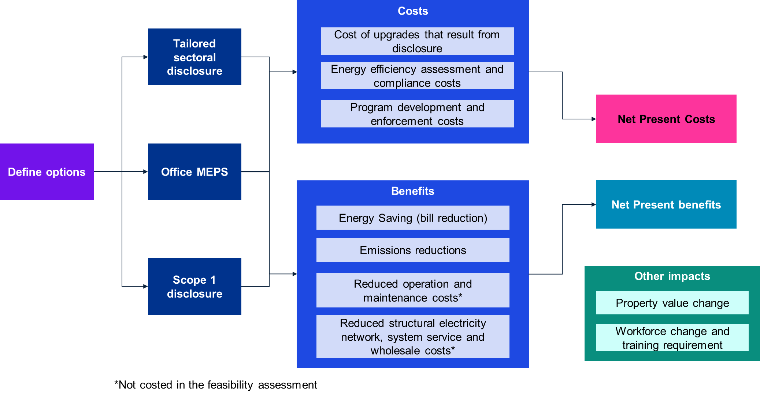

Link to text version of Figure 13 [Appendix 11].

For each policy, costs and benefits were identified, and where possible costed to generate net present costs and benefits assuming a five per cent discount rate.

Two categories of impact were identified, but excluded from the assessment, namely property value change, and workforce change and training requirements. Introducing MEPS or disclosure will likely impact the value of properties across the building stock, however this impact will be heterogenous in nature, with some buildings having a relative increase in value, and others having a decrease in value. To a large extent this change in values may reflect the capitalised net impact of the costs and benefits identified. Similarly, workforce and training impacts have also been excluded, due to the complex nature of this assessment.

## Limitations for analysis

### Building stock data

There is limited data that covers the national building stock in Australia. The NABERS and CBD program both collect data for buildings that are part of those schemes, including the number of buildings, the size of those buildings and energy efficiency. However, only one data source was identified that provided a more comprehensive breakdown of the total building stock across Australia, which was created by Geoscape and CSIRO. The GeoscapeBuildings data is based on satellite and aerial imagery and analysed by CSIRO for accuracy. The data determines different building types greater than 50m2 and provides a range of different building types that are covered in this report as well as building stock counts, gross floor areas (GFA) and energy consumption of electricity and gas. Details of the total building stock count with breakdown of building category is provided in Appendix 4: Australian building stock breakdown including data centres, hotels and shopping centres.

Internal analysis of the data indicates building counts are likely to be overstated. The *Commercial Building Baseline Study 2022* (**CBBS 2022**) reports a level of uncertainty in the total building counts estimated to +/- 30 per cent, our analysis suggests this could be greater. Additionally, the Geoscape floor area estimates were revised downward 55 per cent (CBBS 2022) and a corresponding Geoscape dataset - Table 47 (published by CSIRO, 2020) was removed from the CBBS 2022 report citing an over estimation of total floor area. Despite the possible inaccuracies in this dataset, no better datasets were identified, and this data set was used as given. To account for the unknown size of building stock results of the feasibility study are presented on a per-building basis. Any more detailed work completed in the future may need to address this issue or adjust the findings once total building stock numbers are firmed up. A firmer sense of building numbers will also be critical for designing any rollout of new regulatory requirements, including understanding associated industry and compliance capacity.

### Response to disclosure

With the energy efficiency disclosure policies explored, several assumptions were made around how individual owners would respond to a requirement to disclose energy efficiency. While some parallels can be drawn from the existing CBD program, an expanded disclosure policy would cover a range of different building types, with various levels of maturity in considering energy efficiency. Additionally, some energy conservation measures (ECMs) may be easier to do in buildings such as offices compared to other building types. As such, for the purposes of the disclosure policy feasibility study, it was presumed that:

* 30 percent of covered buildings do not implement any ECMs
* 30 percent of covered buildings implement operational improvements with limited capital works
* 40 percent of covered buildings implement a range of ECMs including both operational improvements and capital works.

This assumption has implications on the assumed effectiveness of the policy, with a proportion of building owners incurring some compliance costs, without the respective costs and benefits of the upgrades. The costs of the ECMs are also assumed, and likely to vary between each building. More details on the respective costs of the ECMs are presented in section 6.4.1.

### Response to MEPS

Similarly for MEPS, several assumptions had to be made around how building owners would respond to the MEPS requirement, the likely ECMs adopted and the respective cost of those ECMs. For the purposes of the feasibility study, we have adopted the regression analysis formulated as part of an independent review of the Commercial Building Disclosure Program.156F157F157F157F157F157F157F157F[158] The regression analysis was based on actual reported responses and costs of buildings under the CBD program, and thus represents an evidence base from which the feasibility analysis could be based upon. The CIE Report calculated a regression analysis formula (below) that we have adjusted by a factor of 1.29 to account for inflation. The regression analysis was based on a small sample size (31) and has a relatively weak R2 value of 0.1896.

Equation for upgrade cost based on regression analysis. 

This is the regression analysis formula referenced above. Annual cost in dollars multiplied by an inflation factor of 1.29 is equal to energy savings during the year in megajoules, divided by the following term: (18.793 minus (2.7131 multiplied by the NABERS rating at the start of the period, in stars))

Where, C = annual cost (in dollars), E = energy saving during the year (MJ), Star = NABERS rating at the start of the period.

Although the regression had a low statistical significance given the small sample size, it aligns broadly with the professional experience of KPMG and other case studies. The analysis results indicate there are low-cost operational improvements commonly used by building owners to improve their NABERS star rating. CAPEX investments progressively get more expensive with higher NABERS star rating and optimisation of Building Management System (**BMS**) and performance can yield great results with low or no costs particularly for building with lower ratings.

The use of the regression analysis, although valuable as an indicative measure, represents a limitation for the feasibility analysis, given the low R2 value. Additionally, there may be some biases in the data used, as organisations that voluntarily chose to rate their buildings under the NABERS program are more likely to be engaged and adopt measures to improve their ratings and deliver higher standards compared to organisations that rate their buildings to meet compliance. Therefore, monitoring improvements of voluntarily rated buildings would deliver results with a ‘self-selection’ bias due to a propensity for change and general interest in optimising energy use in their facilities.

## Overview of benefits

### Energy savings (bill reductions)

Bill savings associated with reduced energy consumption was one of the key benefits explored across all policy options. The policy options being considered can lead to noticeable reduction in energy costs, empowering building owners and operators to make informed decisions that enhance energy efficiency and reduce consumption, ultimately resulting in financial benefits for stakeholders. Assumptions included:

* The quantity of energy reductions that occur from typical upgrades are based on *Rawlinsons Australian Construction Handbook 2023* data on energy savings for the Tailored sectoral disclosure policy, and the legislated energy efficiency requirements or respective NABERS star ratings for the MEPS policy.
* The cost disparity for energy expenditure across diverse building stock types is evident. To enhance the clarity and interpretability of the findings, we have undertaken an estimation of potential cost savings, which are presented as a proportion relative to prevailing energy expenses, derived from an average retail price benchmark. The electricity price used was based on the ACCC June 2023 Inquiry into the NEM report and represents the NEM average small business electricity price between Q4 2021 to Q3 2022 of 32.6c/kWh. Given the uncertainty of future electricity prices, this price was kept constant over the feasibility study period.
* Our analysis accommodates a staggered building stock upgrade process, allocating a timeframe of 5 years for the complete realisation of any policy reform's cumulative impact on the anticipated reduction in cost savings. It is worth noting that these upgrades are projected to transpire in a linear progression throughout the designated 5-year span, contributing to the comprehensiveness and accuracy of our assessments.

### Emissions reductions

Emissions reductions from reduced energy consumption is another significant benefit of the policies being explored. To account for this benefit in the feasibility assessment utilised a social cost of carbon to value the reduction in emissions resulting from the policy. Specifically, the assessment assumed:

* The quantity of emissions reductions that occur from typical upgrades are based on R*awlinsons Australian Construction Handbook 2023* data on energy savings for the Tailored sectoral disclosure policy, and the legislated energy efficiency requirements or respective NABERS star ratings for the MEPS policy.
* A NEM average grid emissions intensity was used to convert reductions in energy consumption into an emissions equivalent. The Clean Energy Regulator NEM average emissions intensity estimates for 2022 of 0.62 was used and reduced at a rate of 2 per cent per annum over the assessment period, to represent the broader decarbonisation of the grid. This estimate of reduction in emissions intensity is conservative and in line with recent trends, however this is not aligned with the Governments 82 per cent renewable target, which would decrease the relative emissions reductions resulting from energy efficiency improvements. The average of this emissions intensity projection of 0.54 was then used to estimate emissions for the feasibility assessment.
* Once the emissions reductions were quantified, these were valued at $280 per tonne. This estimate is derived from a social cost of carbon estimate made by the US EPA.157F158F158F158F158F158F158F158F[159] DCCEEW advised KPMG to adopt this cost of carbon to align with other work currently being done by the Department on possible reforms of the National Construction Code.
* Similar to the approach for bill savings, our methodology incorporates a 5-year timeframe to accommodate the gradual implementation of building stock upgrades, allowing for the complete realisation of any policy reform's impact on the projected emissions reduction. It is important to note that these upgrades are projected to unfold in a linear fashion throughout this 5-year period, ensuring a comprehensive and balanced assessment of the reform's long-term environmental benefits.
* The grid emissions intensity has been extracted from the NGA Factors 2023 and includes scope 2 & 3 emissions of 0.73 tCO2e/MWh. This metric provides a benchmark for assessing environmental impacts of policy options associated with electricity generation.

### Reduced operations and maintenance

Improved energy disclosure in commercial buildings leads to reduced operation and maintenance costs, hence benefitting building operators. By providing clear insights into energy efficiency, building operators can identify and address inefficiencies more effectively, resulting in lower operational expenses and longer equipment lifespans, ultimately contributing to substantial cost savings.

Costs for reduced maintenance have not been quantified into the overall cost savings as too many variables and unknowns are involved, and while building owners are likely to benefit, quantifying the savings can only be done on a case-by-case basis and would be insignificant to the larger expenses and savings involved.

### Reduced structural electricity network, system service, and wholesale costs

Increasing the levels of energy efficiency will also have positive benefits of reducing structural load on electricity networks, the quantity of system services required and general wholesale electricity costs. However, given the complexities of the broader dynamic electricity market system, the scale of these benefits was not quantified. Additionally, as building owners and operators are considering efficiency measures, they may also explore options around electrification which could result in increased overall energy consumption

## Overview of costs

### Cost of upgrades

The cost of asset upgrades was based on a combination of experience delivering energy efficient upgrades, NABERS improvement plans and business case feasibility studies for major and minor capital works projects in office base buildings and tenancies, as well as research on expected ROIs for common plant and equipment upgrades. For each option assessed, the cost of upgrade is assumed to be borne by building owners. Owners may choose to pass this cost on to tenancies, which is likely to be offset by savings on lighting and power from the building upgrades.

Figures generated from our professional and peer experience were cross-checked with *Rawlinsons Australian Construction Handbook 2023* data to verify the initial estimates and noted that recommendation were priced within, generally the lower spectrum, the cost brackets provided in the *Rawlinsons* guidelines.

Applying ROI values to each asset allowed a reverse calculation of costs required to upgrade based on the facility size and the likely plant equipment that would be present for each sized building.

**Table 20: Application of Energy Conservation Measures based on building size**

|  |  |  |  |  |  |  |
| --- | --- | --- | --- | --- | --- | --- |
| **Energy Conservation Measures** | **500 m2** | **1,000 m2** | **5,000 m2** | **10,000 m2** | **20,000 m2** | **ROI** |
| LED Lighting upgrade |  |  |  |  |  | **30%** |
| Air Conditioning Split |  |  |  |  |  | **25%** |
| Packaged Unit |  |  |  |  |  | **25%** |
| Boiler |  |  |  |  |  | **12%** |
| Variable speed drive (VSD) |  |  |  |  |  | **20%** |
| Variable Air Volume |  |  |  |  |  | **15%** |
| BMS Optimisation |  |  |  |  |  | **40%** |
| Chiller |  |  |  |  |  | **8%** |
| Low and no cost options (e.g., behaviour change, controls) |  |  |  |  |  | **400%** |

### Assessment compliance costs

A cost that was assumed to occur across all policies assessed related to the compliance that building owners would need to perform to meet the needs of each policy. These costs included estimates of NABERS program fees, BEEC fees and the costs of assessors conducting the review of the building. Cost estimates were based on existing NABERs and BEEC fees and scaled by the relative size of the building. Additionally, NABERS fees were assumed to be discounted by 50% for the first year of the program, as per the existing program design. The compliance costs assumptions for the disclosure program are presented in the table below. These costs were kept constant from the second year onwards for simplicity, however it is likely that efficiencies in the assessment fees will be found through repetition of assessments. Assessor fees include assumed travel.

**Table 21: Assumed compliance cost for disclosure**

|  |  |  |  |  |  |
| --- | --- | --- | --- | --- | --- |
| **NABERS + BEEC + Assessor fees** | | | | | |
| **1,000-5,000m2** | | **5,000-20,000m2** | | **20,000+m2** | |
| *Initial* | *Ongoing* | *Initial* | *Ongoing* | *Initial* | *Ongoing* |
| $3,084 | $3,739 | $4,584 | $ 5,239 | $5,084 | $5,739 |

### Program system development and enforcement costs

The last cost explicitly considered in the feasibility assessment reflect the costs to Government to establish the expanded programs and enforce the programs. Costs included in this category include ICT support costs, assessor training, program support and enforcement staff. These costs were estimated based on the existing CBD costs and scaled to the relative coverage (per building) of the respective policies.

## Feasibility assessment results

### Tailored sectoral disclosure

The feasibility assessment for the *tailored sectoral disclosure* policy revealed a net benefit for building owners ranging from around $475,876 to $899,143 over a 20-year period. This range is based on different underlying assumptions on building sizes, as input data on the existing building stock provides quantity estimates in size ranges. This policy could form the foundations of a strong policy suite as it represents the most expansive of the policies explored, in that it has implications for many sectors of the economy and would cover the widest range of buildings. The figures below illustrate the approximate benefits and costs of the policy under both the larger building size and smaller building size assumptions.

**Figure 14: Approximate costs and benefits of Tailored Sectoral Disclosure policy for the average building covered by the policy over 20 years (Smaller building size assumed)**

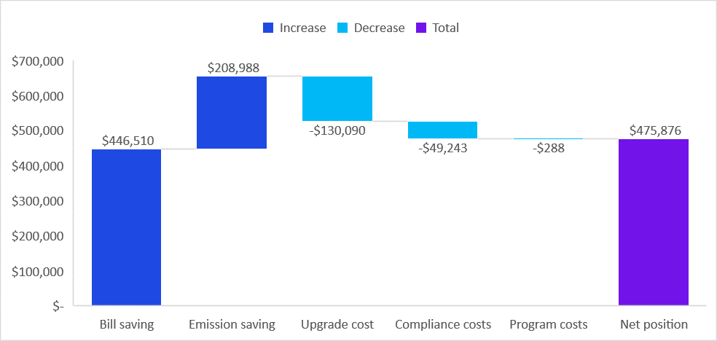

Link to text version of Figure 14 [Appendix 11 Table 39].

**Figure 15: Approximate costs and benefits of Tailored Sectoral Disclosure policy for the average building covered by the policy over 20 years (Larger building size assumed)**

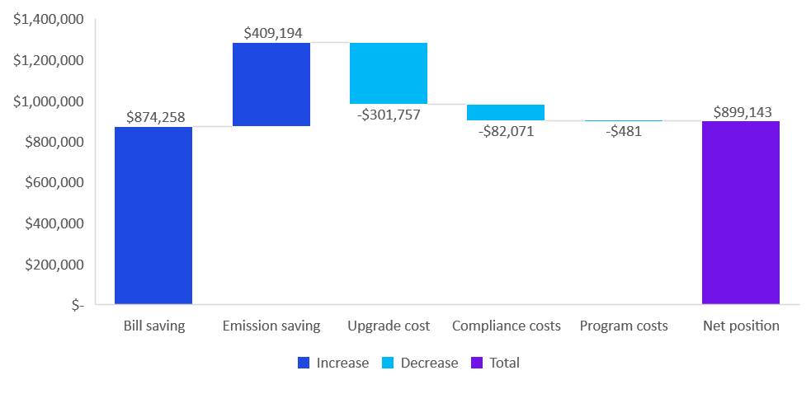

Link to text version of Figure 15 [Appendix 11 Table 40].

The results of the analysis indicate a significant bill savings and emissions savings for the investments made resulting from the disclosure program. The bill savings are expected to be around three-fold over the capital cost of the relative ECMs. Additionally, there would likely be some unquantified savings in reduced operation and maintenance costs from implementing energy efficiency measures. This associated benefit is well documented across the literature.158F159F159F159F159F159F159F159F[160]

For this policy, a sensitivity analysis was conducted to explore the impact of adjusting the frequency of assessments, from the base assumption of annual assessments to bi-annual assessments. Bi-annual assessments would lower the compliance costs for building owners, however, would also likely have reduced benefits in motivating additional upgrades and efficiency improvements. To calculate the likely impacts, the CIE review of the CBD program was drawn on, as it had explored the efficiency improvements under for a subset of buildings that had conducted NABERS rating more than every two years and less than every two years.159F160F160F160F160F160F160F160F[161] These results were factored into the feasibility assessment revealing that if assessment frequency was reduced to every two years, it would consequently reduce the net benefit per building for this program to $255,918 to $426,531 or a 46-53 per cent reduction from annual assessments.

Beyond the quantitative impact for individual businesses this policy represents the most expansive of the policies explored, in that it has implications for many sectors of the economy. This means that the benefits of the policy are more transformative for the economy encouraging sectors that had not previously been exposed to building energy efficiency to consider changes. This whole-of-economy approach is more aligned with the significant change required to meet Australia’s 2030 and 2050 decarbonisation targets. Additionally, establishing whole-of-economy disclosure and benchmarking frameworks could support other decarbonisation accelerators such as the finance sector. The finance sector has considerable decarbonisation targets that require finance provided to meet decarbonisation goals. Introducing sector-wide benchmarking and disclosure frameworks are likely to reinforce the impact of regulatory change. The aggregate benefit would depend on precise implementation coverage of any expansion, but initial commencement with larger buildings in relatively mature sub-sectors could produce substantial energy, emissions and net economic benefits.

However, it would also introduce costs for these sectors. Some sectors such as data centres and offices are more mature in their energy efficiency considerations, and the introduction of a disclosure requirement may have a more streamlined implementation compared to other sectors which have variable focus on energy efficiency, such as aged care. Finally, given the reach of this policy, it would have the most significant demands for a supporting workforce, with more assessors, inspectors and advisers required to support the larger coverage. A staged introduction may be appropriate to help alleviate the workforce demand and allow more time for the supporting workforce to expand.

### Star-rating MEPS for Offices

The feasibility assessment for the *Star-rating MEPS for Offices* policy revealed a net benefit for building owners ranging from $1.1 million to $1.8 million over a 20-year period, depending on the average size of the underlying buildings. While this net benefit is larger per building than the results outlined above for the CBD expansion, this proposal targets a much lower population of buildings, generally smaller in size and energy use - that is, this policy targets a subset of buildings with low efficiency ratings, seeking to lift this tail to align better with larger and more modern buildings.

As noted in section 6.3 and 6.4, a different approach was used to estimate the relative benefits and costs of this policy, instead of assuming consumer behaviour and accounting for likely ECMs adopted as assumed in *Tailored sectoral disclosure*, estimates of costs and benefits were based on reported improvements of select buildings that entered the NABERS program, of which a regression analysis was conducted. However, as noted above, this approach could incorporate some self-reporting biases for buildings owners that were more willing to share their data, relative costs and benefits.

**Figure 16: Approximate costs and benefits of Star-rating MEPS for Offices policy for the average building covered by the policy over 20 years (Smaller building size assumed)**

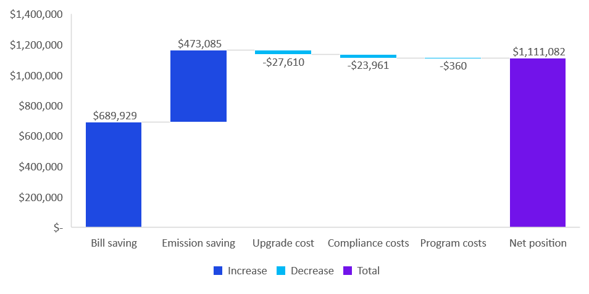

Link to text version of Figure 16 [Appendix 11 Table 41].

**Figure 17: Approximate costs and benefits of Star-rating MEPS for Offices policy for the average building covered by the policy over 20 years (Larger building size assumed)**

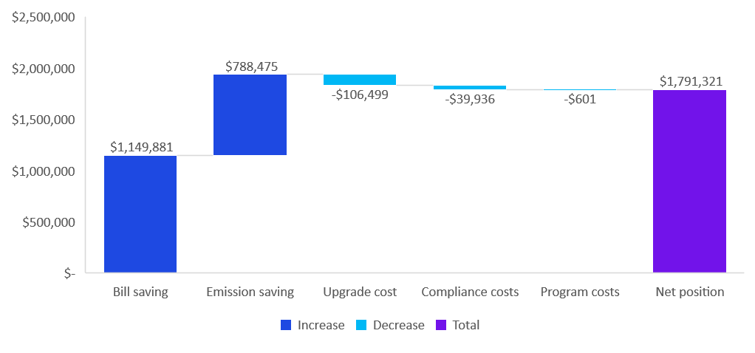

Link to text version of Figure 17 [Appendix 11 Table 42].

The feasibility revealed reasonable net benefit from for buildings moving from 2- or 3-star ratings to 4- and 5-star ratings. The benefits come from significant bill savings and carbon savings compared to the upgrade costs, which presumably is driven largely from operational improvements, over capital works.

The scale of net benefits under this policy are larger than those in the *Tailored sectoral disclosure* policy due to a number of reasons including:

* A different methodology was adopted to calculate building owner response – this policy used reported data from a small sample group, whereas the other policy assumed a range of ECMs were implemented
* The scale of buildings covered under this policy is significantly smaller than the other policy – with this MEPS policy covering around 88,000 buildings, whereas the disclosure policy covered around 190,000 buildings.
* The high proportion of larger buildings that are already rated 5 stars and above, with the buildings with the most significant star-increases required being in the smallest building size category. The cost of upgrades of these smaller buildings is also considerably lower according to the CIE regression analysis, as illustrated in the figure below.

**Table 22: Breakdown of NABERS rating by building size**161F161F161F161F161F**[162]**

|  |  |  |  |
| --- | --- | --- | --- |
|  | 1,000 - 5,000m2 | 5,000-20,000 m2 | >20,000m2 |
| % 2 Star or less | 26% | 7% | 1% |
| % 3 Star | 16% | 10% | 2% |
| % 4 Star | 24% | 21% | 9% |
| % 5 Star or above | 35% | 61% | 87% |

**Figure 18: Cost of upgrading NABERS ratings by building size**

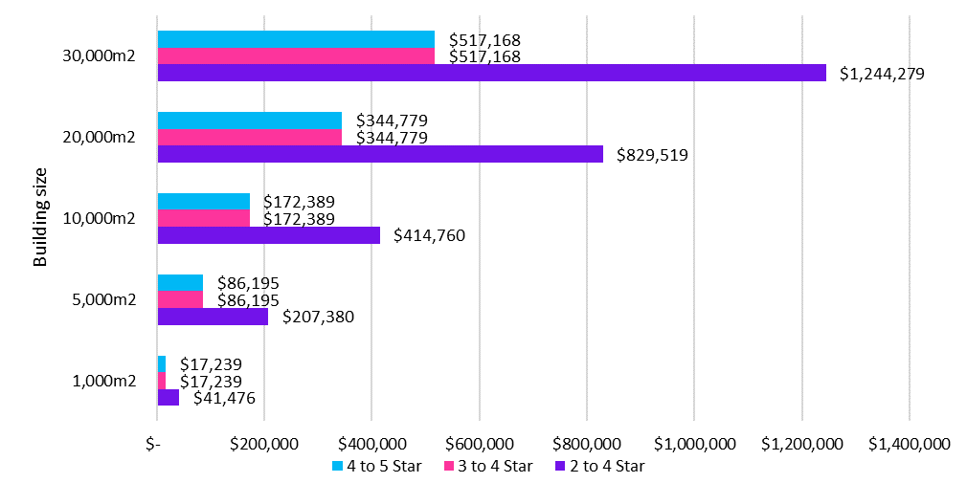

Link to text version of Figure 18 [Appendix 11 Table 43].

One benefit of this policy approach is that the environmental outcomes of the policy are more certain as there is a set emissions intensity requirement that guarantees a response for building owners. Additionally, to improve the cost-effectiveness of the program, a cost-cap could be considered, to limit building capital upgrade costs where it is impractical. E.g., a cost cap of ~$100/m2 may reduce risks associated with upgrade variability.

### Scope 1 disclosure

The feasibility assessment for the *Scope 1 disclosure* policy revealed a modest net benefit for building owners ranging from around $3,100 to $5,200 over a 20-year period, depending on the average size of the underlying buildings. As this reform is a relatively light touch, it was assumed that the additional disclosure of detailed scope 1 emissions would result in a 0.5 per cent reduction in energy consumption and emissions per annum, and this improvement is the result of zero-cost operational improvements. The costs incurred for this policy assessment are largely centred on system uplift of the NABERS/BEEC policy, and costs to support the additional reporting requirements and some ongoing maintenance costs. The results of this policy are presented in the figures below.

**Figure 19: Approximate costs and benefits of Scope 1 disclosure policy for the average building covered by the policy over 20 years (Smaller building size assumed)**

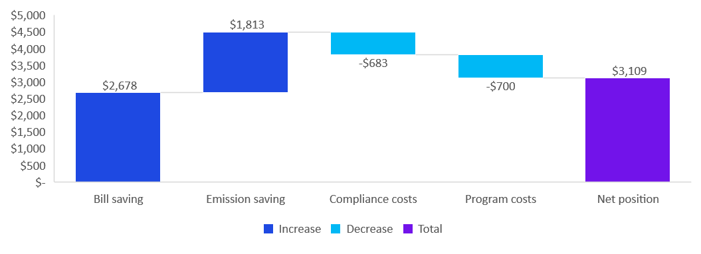

Link to text version of Figure 19 [Appendix 11 Table 44].

**Figure 20: Approximate costs and benefits of Scope 1 disclosure policy for the average building covered by the policy over 20 years (Larger building size assumed)**

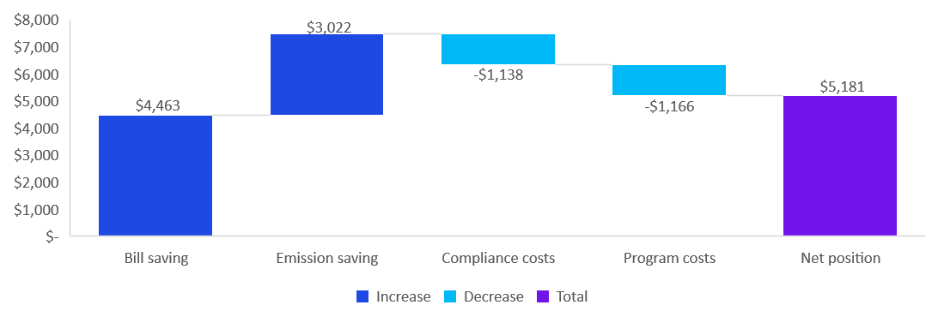

Link to text version of Figure 20 [Appendix 11 Table 45].

Scope 1 disclosure aims to completely round-out the scope 1 & 2 building emissions and display these emission sources on the certificate by using the available data already collected by NABERS as well as incorporating refrigerants used in the buildings HVAC and refrigeration systems. The impact of this will be to reduce scope 1 & 2 emissions from an organisational control approach while providing exposure that will drive the change towards natural and low global warming potential (**GWP**) refrigerants. *Scope 1 disclosure* policy also needs to be considered in the context of other changes, including the renewable energy indicator (see below), the Montreal Protocol162F162F162F162F162F162F162F[163], which is phasing out refrigerants globally, and other drivers of increasing electrification of buildings. It may be that these can cover the Scope 1 disclosure requirements, so a separate policy is not needed. We note that the suggested Scope 1 disclosure will complement the Montreal Protocol.

The option to include *Scope 1 disclosure* was considered prior to the release of the NABERS Renewable Energy Indicator (**REI**). The NABERS REI is a new initiative that includes a pie-chart displaying the breakdown of the source of energy used to power the building on the NABERS certificate (Figure 22). The REI initiative was released together with the closure of a well-utilised loophole that enabled building owners to purchase Greenpower to boost their rating, whereby if a building used 100% Greenpower a 6-star rating was inevitably achieved. While this was effective in promoting the uptake of Greenpower to commercial buildings it misrepresented the energy efficiency of the building by focussing on emissions rather than energy. The NABERS rating of BEECs were required to be displayed without Greenpower thereby providing the true rating to prospective tenants and buyers.

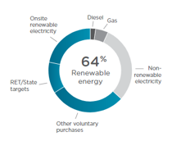

**Figure 21: Illustrative NABERS Renewable Energy Indicator**

The Scope 1 emission sources is a low-cost option that brings focus to refrigerants, electrification and the operational control of buildings by encompasses all scope 1 & 2 emissions. However, displaying this information in conjunction with the REI could be confusing to people viewing the certificate as similar information (energy and emissions) is presented alongside one-another and changes according to the relevant emission factors. With the recent update and inclusion of the REI on the NABERS certificates the Scope 1 emissions disclosure is something worth considering for the next modification of the NABERS disclosure.

# Future roadmap

**This section provides a potential roadmap for energy and emissions regulatory reform for the building sector.**

In this project we have explored expanding the CBD program in Australia. Expanding the program is intended to support improved building energy efficiency across Australia, contributing to reduced greenhouse gas emissions and energy use from the sector. The options we assessed appear to provide considerable net benefits, although these need to be further assessed via intensive consultation with industry, more accurate data on the size of the building stock and a more detailed cost benefit analysis. Provided this confirms the positive return on these options, this suggests a phased approach to regulatory reform can make significant contributions to both sectoral and national emissions reductions.

Based on findings from this project there is an opportunity to expand building regulation in a systematic way that is sensitive to the levels of readiness and maturity in key non-residential building sectors. This involves reform on several dimensions.

* expanding the *scope* of building regulation from the current focus on larger office buildings owned by corporations to a progressively wider set of building types and ownership structures
* *deepening* building regulation from the current focus on disclosure to MEPS, to reduce the tail of low performing buildings
* phasing these reforms in a way that *builds the maturity and implementation capacity* of different building sizes and types, while working to build capacity and tools.

Such an approach has potential to cover a high proportion of energy use in Australia’s commercial building stock over time and contribute to achievement of Australia’s net zero ambition while constraining energy bills.

Based on the findings from this project, we have developed a high-level roadmap (Figure 25) as a suggested guide over the next ten years. This roadmap has been developed considering the following general principles (Figure 23) which have emerged from our analysis and stakeholder consultation:

**Figure 22: Roadmap principles**



Link to text version of Figure 22 [Appendix 11].

The roadmap is also based on a goal of 80% mandatory disclosure coverage across non-residential buildings by 2035. Consultation with an expert panel indicated this was a suitable level of ambition and that industry capacity is available to meet the increase in demand for services. However, further work is needed to confirm this is the case, potential exemptions, and whether there are other practical limitations for the proposed level of ambition.

The roadmap is illustrative, and detailed analysis and considerations would need to be made about the specific elements of a formal roadmap. The development of the proposed building sector emissions pathway in 2024 provides an opportunity for further consultation with industry and the finalisation of such a regulatory roadmap. This could consider other elements outside the scope of this report, such as complementary policy measures for the sector (for example, around financing). Such a timeline would provide further scope to conduct more detailed cost benefit and policy analysis.

Feedback from an expert reference group suggests there may be variance within some of the building sectors below that could vary the generalised approach to rolling out mandatory disclosure or MEPS. For example, in higher education there are some sub-sectors such as large universities that could develop maturity and regulated disclosure more quickly than would be suggested by NABERS maturity, given voluntary developments in the sector

The roadmap classifies buildings according to NABERS maturity. Group 1 and 2 buildings have had NABERS more than 5 years. For Group 3 buildings, NABERS has been recently released or is about to be released, and NABERS does not cover Group 4 buildings. Feedback from an expert reference group suggests there may be variance within some of the building sectors in the roadmap that has an influence on dates for rolling out mandatory disclosure or MEPS. For example, in higher education there are some sub-sectors such as large universities that could introduce disclosure more quickly than what is suggested for the broader group.

With these caveats in mind, a roadmap for regulatory reform is set out overleaf.

**Other considerations**

This roadmap should not be considered in isolation, and other policies can be integrated and used to complement the expansion of the CBD program, for example:

* Changes to the National Construction Code.
* The Australian Government’s draft National Energy Performance Strategy when it is released.
* Any update or expansion to NABERS or other building benchmark performance tools.
* Potential finance or capacity building assistance to facilitate adjustment and mitigate any disproportionate impacts on particular asset or stakeholder categories.

There is also the opportunity to work with the finance sector to make sure there is a broader finance package available.

**Emissions reductions will occur prior to compliance dates**

Expanding the CBD program will lead to emissions savings building over time. These savings occur as behaviours in the building sector change in response to the disclosure and MEPS requirements when introduced. Given the phased expansion, and the voluntary nature of some of the responses, the energy improvements will accrue over a period of time. Past experience with office regulation suggests these can build to be very substantial following regulatory coverage. However, we would expect some of this response will occur ahead of legislated dates if these are clearly signalled, as demonstrated indicatively in Figure 24. For example, if there are requirements for a certain building type and size by the early 2030s, changes in emissions may be seen by the late 2020s as owners take advantage of scheduled major maintenance to upgrade to levels consistent with anticipated regulatory standards.

**Figure 23: Adoption curve for regulation**



**Figure 24: High-level roadmap for CBD Program expansion**



Link to text version of Figure 24 [Appendix 11 Table 32].

# Conclusion

An investigation of international approaches to mandatory disclosure and minimum energy performance standards of buildings led the project team to seven potential options for expanding the CBD program in Australia. Through assessing the current regulatory and policy environments of commercial buildings energy efficiency in Australia and comparing it internationally, we were able to create seven potential options for expanding the CBD program in Australia. These options reflect the success of Australia's current regulatory program through the use of a performance-based assessment compliance, whilst acknowledging the significant scale of work achieved intentionally predominantly using attribute-based assessment compliance. After evaluating these seven options at a high level and consultation with a reference group, these were narrowed to three options for expanding the program:

1. tailored sectoral disclosure,
2. star rating MEPS for offices, and
3. scope 1 disclosure.

A more detailed assessment indicated that all of these were viable and could complement one another, leading to emissions and cost reductions in the Australian non-residential Building sector. As such, it is recommended that all three policies be considered further by the government and progress to a formal cost-benefit analysis and regulatory impact statement process.

We have suggested a pathway to introducing each of these in phases, based on priority building types and sizes. This tailored approach for each of the options would focus first on larger buildings, capturing a good proportion of sectoral energy and emissions. Further phased expansion to more sectors and smaller buildings could add significant increments of energy bill and emissions savings.

Buildings play an important role in Australia’s journey to net zero. This project focuses on two key areas: disclosure of energy efficiency ratings and minimum energy performance standards in the commercial building sector. By pursuing a clear roadmap, government can navigate expansion of the existing CBD program over the next ten years, leading to disclosure and energy requirements in a high proportion of Australia’s commercial building stock. Australia’s non-residential building stock is estimated to contribute 10 per cent of total greenhouse gas emissions. The CBD program has already reduced energy intensity (MJ/m2) of participating commercial office buildings by 27 per cent and lowered energy bills by $82M. The steps the Australian Government is seeking to take here in combination with other relevant changes to policy and legislation will continue the journey to decarbonising the buildings sector.

# Appendices

## Appendix 1: Framework of government levers influencing behaviour

The table below outlines the range of key levers from less to more significant market interventions.

**Table 23: Framework of government levers influencing behaviour**

|  |  |
| --- | --- |
| **VOLUNTARY BENCHMARKING STANDARDS** | Governments and industry entities can work together to develop standards for voluntary adoption, and there are a variety of approaches in different jurisdictions. Governments are increasingly requiring commercial building owners to benchmark their energy use and emissions against standards at certain decision points, e.g., sale or lease. |
| **ENERGY EFFICIENCY INCENTIVES** | Governments can offer incentives to commercial building owners who invest in energy-efficient equipment and retrofits, often to improve against the above standards. The incentives can be in the form of tax credits, rebates, or low-interest loans. |
| **GOVERNMENT PROCUREMENT** | Government can set minimum energy ratings achievements for buildings it will lease or buy. This happens in Australia where government office buildings require a NABERS rating of at least 4.5 stars160F163F163F163F163F163F163F163F[164]. |
| **MANDATORY DISCLOSURE** | This includes mandatory disclose of energy use and emissions using an independent and consistent rating system. This is also used at certain decision points such as sale or lease. This policy provides transparency and an independent score/system for potential purchasers/lessees to weigh up ESG cost and benefits prior to deciding. An indirect impact is it may encourage building owners to improve energy efficiency and reduce emissions to increase likelihood to sale/lease. |
| **BUILDING CODES AND STANDARDS** | Governments can mandate building codes and standards that require new commercial buildings to meet specific energy efficiency and emission targets or standards. Minimum or prescriptive standards for new buildings is generally relatively cost effective as they can be designed into the build. Stronger versions can include mandating certain high energy or emissions equipment no longer be installed, and instead only energy-efficient heating, ventilation, air conditioning systems, and efficient lighting systems be installed. For example, Denmark building regulations has an energy efficiency requirement that insulation, pipes and tanks must be optimally placed for sharing heat161F164F164F164F164F164F164F164F[165]. |
| **CARBON PRICING** | Governments can implement carbon pricing policies that include coverage of commercial buildings emissions (often implemented upstream via fuels). This policy can provide an economic incentive for commercial building owners to reduce their emissions and invest in energy-efficient equipment. |
| **MINIMUM ENERGY PERFORMANCE STANDARDS (MEPS)** | MEPS mandate a base level requirement for the energy performance of existing building and plant. This may be a minimum standard for individual plant and appliances, or broader MEPS for whole buildings on the basis of performance, attributes, or both. Examples include mandating installation of energy/emissions saving features or no new installation of high energy/emissions plant (attribute)162F165F165F165F165F165F165F165F[166]. Applying regulations requiring this in the private market is now common especially in Europe and the required ratings are becoming stricter (e.g. in the EU163F166F166F166F166F166F166F166F[167] and UK164F167F167F167F167F167F167F167F[168]). |

## Appendix 2: Australian Buildings Data used in this report

|  |
| --- |
| **DATA SOURCES FOR AUSTRALIAN NON-RESIDENTIAL BUILDING STOCK**  Data and metrics for Australia’s building stock are extracted from the *2022 Commercial Building Baseline Study* (**CBBS**), which is the latest revised version of the *Baseline Energy Consumption and Greenhouse Gas Emissions in Commercial Buildings in Australia* published in 2012.  The *2022 Commercial Building Baseline Study* is intended to support applied building research, planning, and policy development initiatives in Australia. The information and analysis can be applied for policy and program research and development, National Construction Code development and planning, analysis and projections of energy efficiency, greenhouse gas (**GHG**) abatement trends and other related purposes. Although this study does provide high confidence data and metrics, it carries limitations and qualifications. Ultimately, this resource serves as a valuable reference tool to support decision-making and policy development efforts in the building sector.  The National Greenhouse Gas Inventory (**NGGI**) reports on the latest national greenhouse gas emissions. Direct Emissions data from the National Inventory have not been applied in this Interim Report as the Australian and New Zealand Standard Industrial Classification does not accurately classify the building types in Australia’s non-residential building stock. |

## Appendix 3: Australian building stock breakdown by emissions, ratings and standards

The table below applies the national scope 2 emissions factor for electricity and the national scope 1 emissions factor for gas165F168F168F168F168F168F168F168F[169] against the 2020 non-residential building energy consumption data.

**Table 24: Scope 1 Natural Gas Emissions and Scope 2 Emissions by Building Type169F169F**169F169F169F169F169F**[170]**

|  |  |  |  |
| --- | --- | --- | --- |
| Space Use | Gas Consumption (TJ) | Electricity Consumption (TJ) | Total GHG Emissions  (Mt CO2-e) |
| Retail and wholesale trade buildings | 6,687 | 37,814 | 7.49 |
| Transport buildings | 1,223 | 6,634 | 1.32 |
| Offices | 10,688 | 58,777 | 11.66 |
| Commercial buildings nec | 447 | 2,455 | 0.49 |
| Factories and other secondary production buildings | 1,259 | 7,805 | 1.54 |
| Warehouses | 2,447 | 13,221 | 2.62 |
| Agricultural and aquacultural buildings | 674 | 4,351 | 0.86 |
| Other industrial buildings nec | 223 | 1,432 | 0.28 |
| Education buildings | 609 | 3,587 | 0.71 |
| Religion buildings | 384 | 2,220 | 0.44 |
| Aged care facilities (including nursing homes) | 2,226 | 12,513 | 2.48 |
| Health facilities | 1,761 | 9,761 | 1.94 |
| Entertainment and recreation buildings | 3,680 | 21,213 | 4.20 |
| Short term accommodation buildings | 5,976 | 35,145 | 6.95 |
| Non-residential buildings nec | 1,605 | 10,085 | 1.99 |
| Total | 39,889 | 227,013 | 44.96 |

### NABERS rated building stock breakdown

Building ratings and standards are a set of guidelines and criteria used to assess the sustainability and energy efficiency of buildings. These ratings and standards provide a framework for evaluating a building's performance and identifying areas for improvement. They are typically based on a range of factors, such as energy consumption, indoor air quality, materials sustainability, and water use. The most used rating schemes in Australia are include Green Star and NABERS (National Australian Built Environment Rating System). These systems assign a score or rating to a building based on its environmental performance, which can be used to demonstrate compliance with regulations, attract tenants or buyers, and reduce operating costs. Compliance with these ratings and standards can also enhance the overall sustainability and value of a building.

**Figure 25: Total current NABERS Ratings, by Premise Type, FY2023, Australia**

3 Categories of premise type. Office, Shopping Centre and Other. Office at 87%, Shopping centre at 10% and Other at 3%.


**Figure 26: Total current NABERS Ratings, Other by Premise Type, FY2023, Australia**

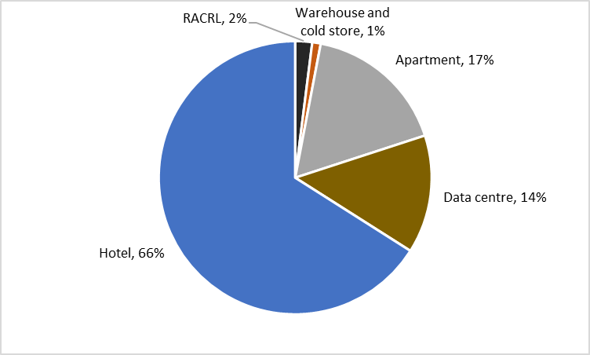

**Figure 27: Number of Individual Buildings Rated, by Rating Type, FY14 to FY20**

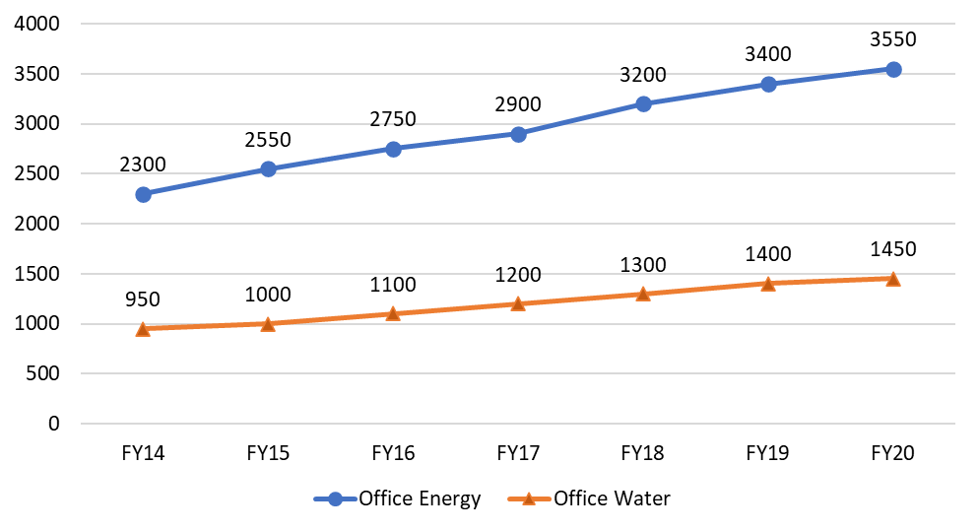

Figure 27 does not include other individual buildings rated by rating type. All are under 500 individual buildings. This includes Office IE, Office Waste, Shopping Centres, Hotels, Data Centres, Apartment Buildings and Public Hospitals.

## Appendix 4: Australian building stock breakdown including data centres, hotels and shopping centres

Given the opportunity to expand mandatory disclosure of energy consumption into other buildings types such as data centres, hotels and shopping centres167F170F170F170F170F170F170F170F[171], the table below breaks down national non-residential building counts further in categories where data sets allow it.

**Table 25: FY2021 Non-residential Building Count, Expanded (Strategy Policy Research, 2022)**

|  |  |
| --- | --- |
| Primary Purpose Building Type | Count |
| Retail and wholesale trade buildings* | 175,504 |
| Offices* | 127,295 |
| Transport buildings | 34,157 |
| Commercial buildings nec168F171F171F171F171F171F171F171F[172] | 12,478 |
| Factories and other secondary production buildings | 146,728 |
| Warehouses* | 103,665 |
| Agricultural and aquacultural buildings | 72,648 |
| Data Centre* | 16 |
| Other industrial buildings nec | 369,32 |
| Hotels* | 9,035 |
| Other Accommodation | 79,494 |
| Entertainment and Recreation - cultural | 37,826 |
| Entertainment and Recreation - sports centre | 35,899 |
| Entertainment and Recreation - aquatic centre | 1,978 |
| Entertainment and Recreation - other | 5,031 |
| Presecondary | 15,647 |
| Secondary | 21,199 |
| Combined | 2,260 |
| TAFE | 742 |
| University | 1,273 |
| Other Education | 9,130 |
| Aged care facilities (including nursing homes) | 30,671 |
| Hospitals | 32,08 |
| Other healthcare | 19,544 |
| Religion buildings | 19,260 |
| Non-residential buildings nec | 45,801 |
| Total | **1,047,421** |

## Appendix 5: Analysis of Datasets

Three datasets were provided for analysis of the non-residential building stock;

* Geoscape Buildings
* CBD Historical ratings data (2011 – 2023)
* NABERS historical ratings (2010 – 2023)

Due to the maturity of reporting and mandatory disclosure in the commercial office building sector there is significantly more information here than other building types. Therefore, commercial office buildings have been analysed with findings of each dataset summarised in Table 24.

**Table 26: Summary of commercial office building count and area (m2) of different datasets**

|  |  |  |  |  |  |  |
| --- | --- | --- | --- | --- | --- | --- |
|  | Geoscape Buildings |  | CBD Program |  | NABERS |  |
| State/Territory | **Count of Buildings > 1000m2** | **GFA (m2)** | **Count of Buildings** | **NLA (m2)** | **Count of Buildings** | **NLA (m2)** |
| ACT | 877 | 2,347,548 | 181 | 1,667,990 | 234 | 2,182,985 |
| NSW | 23,865 | 46,572,695 | 982 | 9,349,733 | 1340 | 11,696,616 |
| NT | 624 | 769,473 | 29 | 129,339 | 63 | 268,533 |
| QLD | 17,500 | 30,521,480 | 525 | 3,747,664 | 681 | 4,528,179 |
| SA | 8,687 | 12,426,275 | 181 | 1,253,421 | 237 | 1,575,556 |
| TAS | 1,452 | 1,949,292 | 51 | 267,552 | 70 | 314,557 |
| VIC | 23,721 | 38,035,322 | 693 | 6,478,623 | 876 | 8,088,036 |
| WA | 11,180 | 13,535,430 | 316 | 2,203,244 | 406 | 2,913,223 |
| Australia | **87,905** | **146,157,516** | **2958** | **25,097,566** | **3907** | **31,567,687** |

#### Geoscape Buildings/CSIRO

GeoscapeBuildings data is based on satellite and aerial imagery and analysed by CSIRO for accuracy. The data determines different building types greater than 50m2 and is available for download from the DCCEEW branded website ([energy.gov.au](https://www.energy.gov.au/publications/commercial-buildings-energy-consumption-baseline-study-2022)). The data is recognised as ‘extremely valuable for its comprehensive coverage’ in the *Commercial Building Baseline Study 2022* (**CBBS 2022**) and provides a range of different building types that are covered in this report as well as building stock counts, gross floor areas (GFA) and energy consumption of electricity and gas. Details of the total building stock count with breakdown of building category is provided in Appendix 4: Australian building stock breakdown including data centres, hotels and shopping centres.

Our analysis of the data indicates building counts are overstated and while the CBBS 2022 reports a level of uncertainty in the total building counts estimated to +/- 30%, we believe this figure to be greater. Additionally, the Geoscape floor area estimates were revised downward 55% (CBBS 2022) and a corresponding Geoscape dataset - Table 47 (published by CSIRO, 2020) was removed from the CBBS 2022 report citing an over estimation of total floor area.

Geoscape records 22.5x more buildings and 4.6x more floor area than NABERS.

Geoscape data *Table 46:* was removed from the CBBS report, however percentages of building size distribution were calculated (e.g. 69% of commercial office buildings are greater than 1000m2) and applied for the extrapolation of findings for offices and other building types (see appendix 7).

#### CBD Historical ratings data (2011 – 2023)

Historical BEEC ratings, including TLAs were provided by DCCEEW for all office buildings that have undergone a BEEC from 2011 to 2023. The total number of unique buildings that have received a BEEC rating is 2958 with 857 unique buildings being rated in the calendar year 2022.

#### NABERS historical ratings (2010 – 2023)

Historical NABERS data shows a total of 3,907 unique office buildings have been rated as either *whole building* (1,896) or *base building* (2,376) NABERS energy ratings. The cumulation of base building and whole buildings has an overlap of 365, which could be due several reasons including the building being demolished and rebuilt or switching rating types due to a metering upgrade.

It is estimated NABERS rates approximately 50% of commercial office buildings however a publication released by NABERS (May 2022) suggests 74% of Australia’s commercial offices currently obtain NABERS Energy ratings on an annual basis.

When comparing NABERS and CBD datasets we can determine that 76% of all buildings rated by NABERS have, at any stage, obtained a BEEC, which suggests 24% of NABERS ratings for whole buildings and base buildings are voluntarily rated.

In 2022-2023, only 48% of NABERS rated commercial office buildings obtained a BEEC, indicating that many building owners are opting to maintain their annual NABERS rating irrespective of the requirement for a BEEC. Reasons for this could include market readiness and the ability to advertise office space at short notice as well as an energy performance indicator and benchmark tool to compare other buildings.

#### Summary of datasets for commercial office buildings

Comparing datasets alongside one-another shows a discrepancy between the total building count and floor area (GFA or NLA) of Geoscape against both the CBD and NABERS datasets (Table 23). The CBD and NABERS datasets are relatively similar, which is expected given NABERS is required to obtain a BEEC.

Along with office buildings other building types covered in the data display an unusually large building count and due to these findings the Geoscape data for building counts and GFA is deemed unreliable for the application of calculating a mandatory CBD program expansion rollout and has been removed from further analysis.

As a result, building improvements have been calculated at a building level and applied to varying sizes.

## Appendix 6: Option 2 – Tailored sectoral disclosure - coverage methodology

The following appendix explores a sectoral assessment conducted for option 2 to determine the relative priority sectors to be included in the policy in the first instance, and the subsequent second and third tranches of inclusion under the policy. The table below explores a set of criteria used to prioritise sectors including the number of buildings, the average emissions intensity, the impact of disclosure, the sector maturity in considering energy efficiency and the ease of implementation.

**Table 27: Sectoral heatmap assessment**

| **Category** | **Sub-category** | **Examples** | **No. of buildings** | **Ave. Energy intensity (MJ/sqm.a)** | **Impact on behaviour** | **Sector maturity** | **Ease of implementation** | **Tranche / Timing** |
| --- | --- | --- | --- | --- | --- | --- | --- | --- |
| **Retail and wholesale trade buildings** | Shopping Centre | Westfields, Stockland | 175,504 across shopping centres, supermarkets and other | **High**  Elec – 310  Gas – 10 | **Disclosure** - Impact attractiveness of leases for tenants | **High** | Large energy consumer, with fewer participants. Ability to influence attractiveness to tenants, existing NABERS tool and distinct boundary. | **First / scaled approach** |
| **Retail and wholesale trade buildings** | Supermarket | Stand-alone Coles, Woolworths, Aldi supermarket | 175,504 across shopping centres, supermarkets and other | **High**  Elec – 310  Gas – 10 | **Assessment –** creates opportunities to identify internal cost reductions | **High** | Large energy user, many supermarkets would be covered under shopping centre coverage, most major supermarket chains already have decarb targets. | **First / pending release of NABERS tool** |
| **Retail and wholesale trade buildings** | Other | Bunnings, A-mart | 175,504 across shopping centres, supermarkets and other | **High**  Elec – 310  Gas – 10 | **Assessment** – creates opportunities to identify internal cost reductions | **Low** | Simple nature could result in low cost improvements, many covered by supermarkets. | **First / pending release of NABERS tool** |
| **Offices** | Office | Office block | 127,297 | **High**  Elec – 314  Gas – 11 | **Disclosure** - Impact attractiveness of leases for tenant **Assessment** – creates opportunities to identify internal cost reductions | **High** | Offices currently covered under the CBD program | **First / priority** |
| **Warehouses** | Warehouse | Bulk storage depots | 103,665 | **Low**  Elec – 63  Gas – 2 | **Assessment** – creates opportunities to identify internal cost reductions | **Low** | Relatively simple nature of warehouses means energy efficiency improvements could result in low-cost opportunities. Tool for deliver warehouse NABERS developed. | **First / priority** |
| **Aged care facilities** | Aged care facilities | Retirement village, nursing home | 30,671 | **Very High**  Elec – 537 Gas – 19 | **Assessment** – creates opportunities to identify internal cost reductions | **Low** | High energy intensity of buildings suggests the greater scale of opportunities if included. | **First / scaled approach** |
| **Education buildings** | Education buildings | Schools, TAFEs, University campus | 50,252 | **Low**  Elec – 75  Gas – 3 | **Assessment** – creates opportunities to identify internal cost reductions | **Medium** | Relatively simple nature of schools means replicable energy efficiency improvements could result in low-cost opportunities. | **First / await release of NABERS tool** |
| **Short term accommodation buildings** | Hotels | Hotel, motel, serviced apartment | 88,530 (Hotels and other) | **High**  Elec – 309  Gas – 11 | **Disclosure** - Impacts the attractiveness for guests, thereby incentivising investments in improvements | **High** | Reasonably high energy usage, with opportunities significant opportunities for reductions and a motivated customer base | **First / priority / scaled approach** |
| Other | Campsites | 88,530 (Hotels and other) | **High**  Elec – 309  Gas – 11 | As above | **Low** | Immature and unsophisticated market with significant variation amongst sites may limit the effectiveness | **Third** |
| **Health facilities** | Hospitals | Public and private hospitals | 22,753 (Hospitals and Healthcare) | **Very High**  Elec – 427  Gas – 15 | **Assessment** – creates opportunities to identify internal cost reductions | **High** | High energy uses, NABERs tool under development, significant scope for operational improvements | **First / scaled approach as maturity deepens** |
| Healthcare | Medical centres, x-ray, | 22,753 (Hospitals and Healthcare) | **Very High**  Elec – 427  Gas – 15 | As above | **Low** | Greater variation across other healthcare types, and more independent operators (e.g. medical centres) may limit capacity to support disclosures | **Second** |
| **Commercial buildings nec** | Data Centres | Data centres | 23,478 (Data Centres and Commercial buildings nec) | **Medium**  Elec – 139  Gas – 4 | **Assessment** – creates opportunities to identify internal cost reductions | **High** | Data centres already focused on operational energy efficiency as it’s the biggest input cost. | **First / pending release of NABERS tool** |
| Commercial buildings | Petrol station, car wash, mail sorting centre | 23,478 (Data Centres and Commercial buildings nec) | **Medium**  Elec – 139  Gas – 4 | As above | **Low** | High variation across ‘other’ commercial buildings. | **Second** |
| **Transport buildings** | Transport buildings | Train stations, airports, port terminals, weighbridge stations, commercial carparks | 34,156 | **Low**  Elec – 65  Gas – 2 | **Assessment** – creates opportunities to identify internal cost reductions | **Low** | Greater variation between building types and relatively small energy consumption could limit the effectiveness of disclosure | **Second** |
| **Factories and other secondary production buildings** | Factories, Laboratories, other | Manufacturing factory | 146,729 | **Low**  Elec – 87 Gas – 3 | **Assessment** – creates opportunities to identify internal cost reductions | **Low** | Significant variation between operations in this category limit the effectiveness of benchmarking (NABERS) | **Second** |
| **Entertainment and recreation buildings** | Cultural, sports, aquatic and other | Cinema, swimming centre, theatre | 80,735 | **Medium**  Elec – 180 Gas – 7 | **Assessment** – creates opportunities to identify internal cost reductions  Disclosure - Impact attractiveness for users | **Low** | Reasonable variation between building types across category. Many independent and council owned facilities may lack the sophistication to optimise. | **Second** |
| **Agricultural and aquacultural buildings** | Industrial agriculture | Abattoir, Dairy processor | 72,647 | **Low**  Elec – 77 Gas – 3 | **Assessment** – creates opportunities to identify internal cost reductions | **Low** | Significant variation between building types, numerous small independent operators, and distributed base for enforcement may limit the impact of the policy. | **Third** |
| **Religion buildings** | Religious buildings | Church, temples | 19,261 | **Low**  Elec – 109  Gas – 4 | **Assessment** – creates opportunities to identify internal cost reductions | **Low** | Greater proportion of heritage properties and limited sophistication to deal with policy may limit the capacity to support disclosures | **Third** |

Additionally, for those sectors covered in the first tranche of inclusions, consideration was given to the coverage point for the policy, i.e., what size of buildings would be included in the policy. After assessing the distribution of buildings as per the table below, it was decided that for all sectors aside from offices, buildings over 5,000m2 would be included. For offices, buildings over 500m2 would be included.

**Table 28: Distribution of buildings in each sector**

|  |  |  |  |  |  |  |  |  |  |  |  |  |  |
| --- | --- | --- | --- | --- | --- | --- | --- | --- | --- | --- | --- | --- | --- |
| **2-digit Primary Purpose Type** | **50 - 99 m2** | **100 - 199 m2** | **200 - 299 m2** | **300- 399 m2** | **400 - 499 m2** | **500 - 999 m2** | **1,000-1,999 m2** | **2,000-4,999 m2** | **5,000-9,999 m2** | **10,000-19,999 m2** | **20,000+ m2** | **Proportion of buildings covered** | **Proportion of floorspace covered** |
| **Retail and wholesale trade buildings** | 5.6% | 8.2% | 6.5% | 6.1% | 5.3% | 14.2% | 11.7% | 14.7% | 7.8% | 10.1% | 9.7% | **27.63%** | **46-87%** |
| **Factories and other secondary production buildings** | 27.8% | 8.9% | 1.9% | 7.8% | 1.6% | 7.3% | 9.1% | 17.8% | 6.2% | 2.0% | 9.6% | 17.80% |  |
| **Offices** | 4.1% | 5.4% | 3.6% | 2.7% | 3.4% | 11.7% | 14.6% | 22.8% | 15.9% | 7.7% | 8.2% | **80.76%** | **96%** |
| **Warehouses** | 7.1% | 12.7% | 14.3% | 5.4% | 3.2% | 12.7% | 14.8% | 15.2% | 7.0% | 1.4% | 6.1% | **14.51%** | **34%** |
| **Short term accommodation buildings\*** | 25.7% | 15.2% | 7.8% | 6.6% | 3.4% | 10.1% | 11.1% | 9.3% | 4.4% | 4.0% | 2.4% | **10.83%** | **46%** |
| **Entertainment and recreation buildings** | 8.1% | 11.7% | 9.1% | 7.6% | 4.8% | 14.2% | 12.1% | 13.3% | 8.3% | 6.5% | 4.3% | 19.09% |  |
| **Agricultural and aquacultural buildings** | 18.2% | 19.1% | 8.5% | 3.7% | 3.2% | 10.7% | 9.7% | 8.3% | 5.2% | 8.1% | 5.3% | 18.65% |  |
| **Education buildings\*** | 13.5% | 13.9% | 7.5% | 4.7% | 3.8% | 12.5% | 11.7% | 12.3% | 7.1% | 6.6% | 6.4% | **20.13%** | **60%** |
| **Non-residential buildings nec** | 35.0% | 27.4% | 12.0% | 6.1% | 3.6% | 7.9% | 4.5% | 2.3% | 0.7% | 0.4% | 0.2% | 1.28% |  |
| **Other industrial buildings nec** | 19.4% | 17.6% | 8.8% | 6.1% | 4.9% | 12.7% | 12.0% | 10.3% | 4.5% | 1.9% | 1.6% | 8.09% |  |
| **Transport buildings** | 19.2% | 17.2% | 8.4% | 6.0% | 4.2% | 11.2% | 8.4% | 11.3% | 5.9% | 4.6% | 3.5% | 14.02% |  |
| **Aged care facilities (including nursing homes)** | 6.7% | 15.7% | 11.2% | 7.0% | 4.1% | 14.3% | 5.8% | 13.3% | 10.1% | 7.3% | 4.4% | **21.78%** | **54%** |
| **Health facilities\*** | 11.8% | 11.1% | 8.2% | 4.9% | 4.7% | 12.1% | 11.8% | 13.4% | 9.5% | 5.2% | 7.3% | **22.04%** | **66%** |
| **Religion buildings** | 2.9% | 8.9% | 10.6% | 9.3% | 6.5% | 23.4% | 19.7% | 13.7% | 4.2% | 0.7% | 0.1% | 5.02% |  |
| **Commercial buildings nec\*** | 7.2% | 13.7% | 9.8% | 5.6% | 3.9% | 12.6% | 9.7% | 21.9% | 9.1% | 4.0% | 2.4% | 15.53% |  |

*\*Only parts of these categories are included*

## Appendix 7: Australian relevant policies and initiatives

**Table 29: Australian Energy and Emission Policies and initiatives to influence the commercial built environment**

| Policy or Initiative to influence change | Summary |
| --- | --- |
| Performance based initiative:  National Greenhouse and Energy Reporting Act 2007 (NGERS) | National Greenhouse and Energy Reporting Scheme (NGERS) is a mandatory emissions reporting program in Australia for companies that meet the following threshold per annum   * 50 kt or more of GHG gases (CO2-e) (scope 1 and scope 2 emissions) * production of 200 TJ or more of energy, or * consumption of 200 TJ or more of energy.   NGERS does not directly relate to building stock however it requires corporations to report their GHG emissions, energy production and consumption, and other relevant information to the government.  The scheme aims to provide accurate and transparent information on the country’s greenhouse gas emissions and energy use, and to encourage corporations to reduce their carbon footprint. The objectives of the NGER scheme are to:   * inform govern`ment policy and the Australian public * help meet Australia's international reporting obligations * avoid duplication of similar reporting requirements in the states and territories. |
| Performance based initiative:  Building Energy Efficiency Certificate (BEED Act 2010) | The *BEED Act 2010* is an Australian legislation aimed at improving energy efficiency in commercial buildings. The *Act* introduced provisions for mandatory disclosure of energy efficiency information for commercial buildings above a certain size.  Under the *BEED Act* building owners and managers are required to disclose a Building Energy Efficiency Certificates (**BEEC**) that contains the NABERS Energy rating and Tenancy Lighting Assessment (**TLA**) when selling, leasing or subleasing office space greater than 1000m2.  The *BEED Act* requires that advertisements for the sale or lease of a commercial building must include the NABERS energy rating. This aims to inform potential buyers or tenants of the energy efficiency of the building and help them make more informed decisions. |
| Performance based initiative:  National Australian Built Environment Rating System (NABERS) | NABERS Energy and Water for Offices is a government-supported program that rates the environmental performance of buildings in Australia. The program provides a rating system that ranges from zero to six stars, with six stars being the highest rating achievable. NABERS is a voluntary program but is indirectly mandated by the CBD Program for large offices and provides a benchmark for comparing the environmental performance of different buildings and encourages building owners and managers to implement sustainable practices and reduce their environmental impact.  Over 65 per cent of Australia’s commercial office space is covered by NABERS scheme and the program has expanded to include other building types.   * Apartment buildings * Data centres * Hotels * Public hospitals * Retirement living * Shopping centres * Warehouses and cold stores   For new builds a NABERS commitment agreement can be signed by developers and building owners to promote the environmental performance of new office buildings prior to starting construction. |
| Performance based initiative:  Climate Active Carbon Neutral Buildings | Climate Active is an ongoing partnership between Australian Government and Australian businesses to drive voluntary climate action and to be certified as carbon neutral.  The Climate Active Carbon Neutral Standard for Buildings is a voluntary standard to manage GHG emissions, achieve carbon neutrality and to seek Climate Active certification. It provides best-practice guidance on how to measure, reduce and report emissions data for buildings. Climate Active Carbon Neutral Buildings can be rated through NABERS. |
| Performance based initiative:  Greenhouse and Energy Minimum Standards Act 2012 (GEMS Act) | The Greenhouse and Energy Minimum Standards Act 2012 (**GEMS Act**) is an Australian law that sets minimum energy efficiency standards for products such as air conditioners, refrigerators, and televisions. The law aims to reduce greenhouse gas emissions and improve energy efficiency in households and businesses. In addition to setting energy efficiency standards, the GEMS Act also includes provisions for the labelling of products covered by the Act. It is enforced by the Australian government’s Department of the Environment and Energy.  The GEMS Act relates to appliances and while it doesn’t directly impact the building asset it makes a contribution to the energy performance of commercial buildings which include covered appliances. |
| Attribute based initiative:  National Construction Code (NCC) | The National Construction Code (**NCC**) is a set of technical provisions for the design, construction and performance of buildings and structures throughout Australia. It sets minimum requirements for safety, health, amenity and sustainability in the built environment and covers a range of aspects including energy efficiency (Section J), metering and monitoring. It is mandatory for all new building work and renovations, and compliance with the code is enforced by local building authorities.  Section J provides a framework for designing and constructing buildings that are energy-efficient and covers requirements such as building fabric, glazing, lighting, air conditioning, and ventilation in Class 3-9 buildings, which aims to achieve a 30-40 per cent reduction in overall GHG emissions.  Section J also provides guidance on the use of renewable energy sources, such as solar panels and wind turbines, to meet the energy needs of buildings. |
| Attribute based initiative:  Green Star and Green Building Council of Australia (GBCA). | Green Star is a voluntary rating system for buildings and communities developed by the Green Building Council Australia (**GBCA**). Within the commercial building sector Green Star is primarily used for *Green Star Buildings* stage to rate the design and construction of any building. Green Star have also expanded into building *Performance* ratings for the operational stage of an asset.  The New Buildings rating tool (formerly the *Design & As Built)* evaluates the environmental design and performance of buildings, based on energy efficiency, water usage, materials, and indoor environment quality. A project must meet a minimum sustainability criteria to receive certification, including energy efficiency, responsible management practices, water conservation, indoor environmental quality, sustainable materials, transport, ecology, and innovation.  Each credit defines a clear outcome that a project must meet and credits are weighted in relation with each other by varying the number of points available. Where the outcome is verified to have been met, a project will be rewarded with the relevant available points. Therefore, each project can demonstrate the achievement of a specific level of sustainability aggregating points up to a star rating out of six, with six being the highest rating.  Green Star and the GBCA work closely with NCC to make necessary adjustments to their program to align with the NCC changes that occur every 3 years. Three-yearly overhauls (major updates) of the rating tool will result in the release of a new rating tool version. e.g., v1.0, v2.0. |

## Appendix 8: Summary information from international research

Below is the summary data from the international research.

**Table 30: High level findings from international research (focus on commercial buildings)**

| Country/ region | Mechanism name | Trigger point | Detail (aims, requirements, effectiveness, attribute vs performance etc) |
| --- | --- | --- | --- |
| EU | Minimum Energy Performance Standards (MEPS, part of EU Energy Performance of Buildings Directive EPBD) | Buying, selling or renting public and non-residential buildings (mandatory) | * Must be renovated/ improved to energy performance level F by 2027, and to E by 2030 (measured by Energy Performance Certificates, EPCs) * All new buildings should be equipped with solar technologies by 2028. Fossil fuels for heating phased out by 2035. * Member states will motivate through law, incentives and penalties. * Voluntary schemes have less impact (renovations are around 0.6 per cent-1.6 per cent), hence the motivation to introduce MEPS169F172F172F172F172F172F172F172F[173]. |
| EU | Fit for 55 package | New residential, commercial, public, and industrial buildings from 2028 (mandatory) | * Public new buildings to be zero emissions by 2028, the rest by 2030. * Public sector must improve energy performance of renovated buildings. * Existing buildings transformed into zero-emission buildings by 2050. * Have added an A+ rating for buildings that are zero emissions and contribute to on-site renewable energy to the grid * EU to provide financial help, tax reductions, administrative support |
| UK | Energy Performance Certificates (EPCs) | Property built, sold, rented (mandatory assessments and reporting information) | * EPC provides information about property energy use and typical energy costs, recommendations about how to reduce energy use, and gives an energy efficiency rating from A (most efficient) to G (least efficient). * Current requirement to be D or above. F and G grade building landlords will be fined £5,000 as of Nov 2023 unless they improve the energy efficiency. * Found weak correlation between actual performance and rating in large buildings (hence introducing ‘Industrial building energy performance framework’) |
| UK | Industrial building energy performance framework | Commercial buildings >1000 square metres (disclosure of rating ‘encouraged’ in first year but will become mandatory) | * Responds to weak correlation between EPC score and energy performance. * Required to report a base building rating (building owners) and whole building rating (owner occupier/single tenant sites). * This will cover 7per cent of buildings which account for 50per cent of total floor space * Phase 1: Offices. Phase 2: all remaining buildings |
| UK | Building to net zero: costing carbon in construction | TBC (based on consults in 2023/24) | * Potential requirement to undertake whole-life carbon assessments (WLCA) for buildings. * Attribute based (as construction phase only). Considers emissions in developing the materials used in construction. |
| UK | Energy Savings Opportunity Scheme (ESOS, relates to buildings and other areas) | Business that employs >250 staff and annual turnover > £44M, not incl public sector (mandatory audits) | * Businesses must carry out audits of their energy use every four years to identify potential energy-saving measures. In future it will be mandatory to carry out a net zero assessment and to act on energy-saving measures * Effectiveness: participant net cost savings of 37 per cent. Energy and fuel efficiency improvement estimates of 1.65TWh of energy efficiency savings from buildings (138MWh per business). * Covers 11,900 UK businesses. Environment Agency administers it. Environment Agency has issued 82 civil penalties totalling £1.3M. |
| France | Article 175 | All buildings >1000 square metres (mandatory disclosure and minimum energy performance) | * Landlords and tenants in France required to annually declare energy performance achieved by buildings via online platform (administered by French Env and Energy Management Agency) * Failure to comply face fines up to €7500 per building * Performance based and influences landlords and tenants. Recommended scope of responsibility ‘should be mentioned in lease agreement’. * The policy imposes targets: -40 per cent for 2030, -50 per cent for 2040, -60per cent for 2050, or a final energy value of reference per square metre and per year that should not be exceeded, per buildings category |
| France | Re2020 | New builds only: Residential, offices, education, tertiary buildings such as hotels, shops and gyms (mandatory caps) | * Aim to construct positive energy buildings * Assesses environmental impacts of buildings over life cycle (construction phase caps to reduce from 740 kg CO2/ square metres/year in 2022 to 490 in 2031 for apartment buildings) but also puts limits on consumption when in operation e.g., max primary energy consumption (heating, hot water, lighting, electrical appliances) of 100kWh/ square metres per year)). * Links to aim for carbon neutrality by 2050 in construction sector * Expected co-benefits include €200 saving per year for detached homes, comfort in summer without air conditioning, and improved air quality. |
| Netherlands | EPCs and nearly zero energy buildings (NZEBs) | All new buildings (mandatory capped energy use and renewable energy) | * EPCs are voluntary and at the end of 2019, approximately 120,000 non-residential buildings (11per cent of the total stock) have a registered and valid EPC. * From Jan 2021 new energy performance requirements incl. capped kWh/ square metres/year and minimum per centage of renewable energy * New buildings required to reach EPC rating of “C” or better from 2023. * Banks have aligned their lending strategies to promote compliance170F173F173F173F173F173F173F173F[174] |
| Netherlands | Environmental Performance Buildings – MPG | New office buildings (>100 m²) and new-build homes | * Indicates the environmental impact of the materials used in a building including the method of application, lifespan and reuse which are decisive for the total environmental impact * Maximum limit value of 1.0 applies to the MPG, reducing to 0.5 by 2030 |
| Netherlands | Gas grids ban in 2018, plus hybrid heat pumps mandatory from 2026 | All buildings (mandatory) | * Cannot use gas to power building, must use hybrid heat pumps to heat building by 2026. * One of the aims is to avoid dependence on Russian gas, but it also provides environmental benefits. * Government resourcing: €400M to trial gas free precincts (funding to 2030). Cabinet has reserved €150 million per year to support homeowners with the purchase of heat pumps. Also financing through the National Heat Pumps. |
| Netherlands | The Circular Buildings Green Deal | TBC | * Considers raw materials used (cement, concrete, sand, bricks, wood or glass panels, etc.) and products for finishing works (insulation, glass-wool, mortars, clay tiles, ceilings, etc.) * Dutch Environmental Cost Indicator measures a wide range of relevant environmental impacts of new construction, such as depletion, GHG emissions, pollution and biodiversity loss. |
| Germany | Buildings Energy Act (GEG) | Buildings with >50 square metres usable space, both new construction and existing buildings  Renewables required for new buildings and major renovations in public buildings | * Issuing and application for EPCs with requirements for energy performance and renewable energy use in buildings * Information disclosed: energy consumption, energy demand and emissions * Consumption certificates and energy requirement certificates |
| Germany | Federal Funding for Efficient Buildings (BEG) (voluntary) | All residential and non-residential buildings | * As part of climate protection program 2030 the federal government further developed funding for energy-efficient buildings. The Federal Subsidy for Efficient Buildings (BEG) is operated by the German development bank. * Funding available as a direct investment grant or as a low-interest loan with a repayment grant * New standards from 2023. E.g., each newly installed heating system is to be operated on the basis of 65per cent renewable energy from 2024 onwards |
| Norway | Energy Labelling Regulations | All housing and non-residential buildings sold or rented, and for new constructions | * Based on EU's building energy directive, in 2010, energy certificates became mandatory * The basis for calculating the energy rating is through delivered energy. Delivered energy means the sum of energy that is delivered to cover the building's overall energy needs, including system losses. Scale is from A to G. * Total delivered energy in kWh is measured |
| Denmark | Whole of life carbon limits | New buildings | * Enforces Whole Life Carbon limits based on LCA tools to curb embodied carbon for upcoming buildings |
| Denmark | Recovery and resilience plan - Energy efficiency, green heating and CCS | Voluntary | * Conversion from oil- and gas furnaces to electrical heat pumps, district heating as well as energy renovations in private and public building * Information do disclose includes energy performance of buildings, heating systems, or industrial processes, including the amount of energy consumed, energy efficiency ratings, and CO2 emissions * Danish government proposed a subsidy of approximately $500K AUD in total for 2021-2025 to increase energy efficiency in buildings and in industry, green heating and CCS. |
| Denmark | Danish building regulations - codes (BR18) 2018 – energy performance certificates | New buildings, extensions, conversions and alterations, replacement of building elements and installations | * Code includes energy efficiency requirements in buildings * Energy label from A to G * Renewable energy sources also considered |
| Sweden | Recovery Plan | Apartments exceeding 100kWh/ square metres or if 20per cent improvements can be demonstrated (voluntary) | * Support given to apartment buildings which are energy efficient, and which undergo renovation resulting in greater energy efficiency of the building. * The total cost for 2021–2023 amounts to SEK 4.05 billion ($580M AUD or $56 AUD per person). By 2023, support will have been granted for projects involving a total of 2 850 000 square metres (2per cent of all multi-unit dwellings) |
| Japan | Building Energy Efficiency Act | Large (>2000 square metres) and medium (>300 square metres) commercial buildings | * Building owners must disclose annual energy consumption data, information about the building, such as its address, floor area, and occupancy type, provide a statement indicating whether the building complies with the energy efficiency standards set by the government and whether any energy efficiency measures have been implemented. * Requirement by law to capture and display information on energy efficiency and performance. Started with 2,000 square metres in 2017 and moved to 300 square metres in 2021. * The government certifies the compliance * Since making the standards mandatory there have been improvements. Previously, less than half of new buildings complied with the requirements (with compliance rates reaching 36per cent, 44per cent and 51per cent, respectively, for large-, medium- and small-sized buildings). The government expects full compliance with the standards to bring about energy savings in the order of 2.8 MT by 2030 (equalling 7per cent of the total energy savings aimed for by 2030) |
| Japan | Zero energy buildings (ZEB) | Newly constructed public buildings | * ZEB must generate energy and reduce net energy consumption by at least 50per cent compared to an ordinary building * By the end of 2018, the number of ZEBs reached 70 or 0.1per cent of total buildings constructed * Attribute and performance based: requires improved heat insulation, high-efficiency equipment and also measures energy use |
| Japan | Cap and Trade program | Annual consumption of 1,500 kL of crude oil equivalent (COE) or more | * Energy-saving measures and low-carbon heat and electricity * By the start of the third compliance period (2020), 33per cent emissions reductions achieved compared to the baseline, equivalent to 11M tonnes * Renewable energy credits generated onsite may be sold. Different renewable energy sources have different credits. Breach to Governor and fines for not participating |
| South Korea | Building Energy Code Compliance – Energy Performance Index | All new buildings >500 square metres floor area | * Requirements on energy saving design including preventing heat loss and installing energy saving facilities. Also considers energy efficient products and renewable energy. * Local government building officials execute the codes. The property owner must fill out an energy-saving worksheet and submit it to local governmental offices to obtain a building permit * Korea Energy Agency (KEA) reviews the worksheet to check if the property satisfies all of the standards and gets at least 65 points on the Energy Performance Index (EPI) (minimum 75 points for public buildings) * Buildings that rate highly are eligible for financial incentives, like low-interest loans |
| South Korea | Building Energy Efficiency Certification (voluntary) | Existing buildings and new buildings (houses, apartments and dormitory buildings, buildings with cooling or heating areas greater than 500 square metres, and office buildings) | * KEA estimates CO2 emission and energy consumption for heating, cooling and hot water supply of a buildings based on their design documents and issue certification ranging from level 7 to level 1 +++. * Performance based: energy used per unit area per year, overall energy consumption and CO2 emissions. * According to KEA buildings that are certified consume 30per cent less energy and emit around 26per cent less GHG than non-certified buildings. |
| Washington DC | Building and Energy Performance Standards (BEPS) and Benchmarking (measured by Energy Star Rating) | Commercial buildings >50,000 square feet(4,600 square metres) and all District-owned buildings >10,000 square feet(1,000 square metres).  (mandatory) | * Aims to reduce energy use and increase renewables. * Building owners to complete energy assessments of all District homes and buildings. If not performing to standard, owners have one year to select a pathway (reduce energy use intensity, conduct energy audit and implement energy efficient upgrades, etc). * Different star ratings required for different building types: Office Building 71; Hotels 54; Multifamily 66; K-12 Schools 36; Hospitals 50. * (DC PACE) program generated nearly $57M in savings to property owners through lower utility bills. * An incentive and financial assistance program is to be created under the Green Finance Authority to help building owners. * Compliance penalties may be imposed. Max fine of $10 per square foot, not to exceed $7,500,000 per building (USD). Fines proportional to the building’s demonstrated performance. |
| Washington DC | Green Building Act | All new government buildings and private commercial buildings of at least 50,000 square feet must meet LEED certified standard171F174F174F174F174F174F174F174F[175] | * The district will amend the scope of the Green Building Act to raise the level of LEED certification to Gold for public projects and Silver for all large private buildings or ensure equivalent standards of environmental performance are achieved through the building code. |
| Washington DC | Sustainable DC | Action 3.5: Retrofit and modernize all public buildings to at least the LEED Gold standard or equivalent green building certification | * From document: Over the next five years, the District will begin retrofitting all public buildings, including schools, libraries, and other municipal facilities, so that these buildings meet at least a LEED Gold standard for existing buildings. * Retrofitting and modernizing District public schools, libraries, and other public buildings to LEED Gold or higher standards will create more than 3,400 one-year full-time jobs |
| California | 2019 California Energy Efficiency Action Plan | Property built, sold, rented, >50,000 square feet (4,600 square metres)  LEED certification requirements: new buildings over 10,000 ft2 (1,000m2) or any building >50,000 ft2 | * Aims to improve energy efficiency, create electric pathways, increase solar, grid harmonisation * California has required LEED certification for its buildings since 2004.172F175F175F175F175F175F175F175F[176] 231 LEED certified buildings by 2018. * It is market focused (the rating influences mortgages and property values, financial incentives for owners to participate, contractor policies that integrate requirements part of broader Bill, on-bill tariffs, Green/LEED Buildings * Attribute and performance: Require reporting building characteristics, energy use data, and building usage information |
| California | California Green Building Standards Code (CALGreen) | New constructions and major renovations | * Mandatory minimum requirements for energy efficiency, water conservation, and other sustainability measures * Compliance with CalGreen is enforced by local building departments, although there are no penalties |
| New York City | Local Laws of the city of New York (No.97) | New and existing buildings: >25,000 f2 (~2500 square metres) | * Must meet new energy efficiency and GHG emissions limits by 2024, with stricter limits coming into effect in 2030 * Aims to help reduce greenhouse gas emissions from buildings by 80per cent by 2050, compared to a benchmark year of 2005 * There are penalties for non-compliance |
| Washington State | Washington Clean Buildings Performance Standard | GFA of 50,000 square feet(4600.2 square metres) or more | * The early adoption incentive program is a one-time incentive payment of $0.85 per gross square feet area. Penalties may be imposed but may not be greater than $5,000 plus $1/ square feet gross area/year. * Energy use intensity (EUI) is reported (weather normalised). * Each utility that serves over 25,000 customers must administer incentive payments to eligible building owners. * Dept must provide a support program for building owners, outreach, information material, training, and other technical assistance. There is a cap of $75 million budgeted for the early adopter program (~$10 per person). |
| Global | NA | High natural gas prices and efforts to reduce greenhouse gas emissions have driven this increase | * There has been a global rise in heat pumps: in 2022 global sales of heat pumps grew 11% (40% in Europe).173F176F176F176F176F176F176F176F[177] * Globally, heat pumps, when used as a main heating device, cover around 10% of heating needs in buildings today. |

**Table 31: Disclosure rating system by jurisdiction including rationale behind implementation**

| Jurisdiction | Latest policy/ regulation | Rating system | Rationale behind policy implementation |
| --- | --- | --- | --- |
| UK (England and Wales) | Minimum Energy Efficiency Standards (MEES), 2018174F177F177F177F177F177F177F177F[178] | Energy Performance Certificate (EPCs) | Implemented on a phased basis based on the EU’s Energy Performance of Buildings Directive.  The MEES policy is designed to encourage landlords to make energy efficiency improvements to their non-domestic buildings, in order to reduce energy consumption and carbon emissions. This is achieved by setting a minimum energy efficiency standard for all privately rented non-domestic properties in England and Wales, and by making it illegal to rent out a property that does not meet this standard. |
| UK | Industrial building energy performance framework, 2022 (in early stages)175F178F178F178F178F178F178F178F[179] | Energy Performance Indicator (EPI), a standardised benchmarking tool developed specifically for industrial buildings. | Rating system is based on NABERS.  EPCs do not measure metered energy consumption and associated carbon emissions. A high EPC score is no guarantee that a building will use less energy and emit less carbon as a result. In large and complex buildings in particular, the evidence is showing that there is almost no correlation between a building’s EPC score and its actual energy and carbon performance in practice176F179F179F179F179F179F179F179F[180]. This policy was introduced in response to that, following a performance-based approach similar to NABERS in Australia.  The policy was also introduced to help industrial businesses reduce their energy consumption and associated costs and align with the UK's net-zero carbon emissions target. Targeting large buildings means a smaller number of buildings are affected by the policy, but these impact a high proportion of floor space. Only 7% of commercial and industrial buildings are larger than 1,000m² and these buildings use over 53% of all the energy used by commercial and industrial buildings, and the associated carbon emitted from these buildings.177F180F180F180F180F180F180F180F[181] |
| France | Article 175 of the French ELAN law and the Tertiary Decree, 2019178F181F181F181F181F181F181F181F[182] | Energy consumption data (energy audits conducted every 10 years) | Tertiary buildings were included in Article 175 because they are a significant source of energy consumption and greenhouse gas emissions in France. Tertiary buildings, which include commercial, administrative, and public buildings, account for about 20% of France's total energy consumption and are responsible for similar levels of greenhouse gas emissions. |
| Germany | Buildings Energy Act (GEG), 2020179F182F182F182F182F182F182F182F[183] | GEG rating system ranges from A+ (very efficient) to H (very inefficient)180F183F183F183F183F183F183F183F[184] and EPCs | Applying to all buildings ensures all owners and operators are subject to the same requirements and obligations. It is also set up to promote the construction and renovation of buildings that can be energy-efficient and sustainable in the long-term, and comply with EU directives, which set minimum energy performance standards for buildings in EU member states. |
| Japan | Building Energy Efficiency Act, 2016181F184F184F184F184F184F184F184F[185] | Energy consumption performance standards (energy efficiency standards), certification standards, and residential construction client standards. | The Law was introduced to promote energy efficiency and reduce the carbon footprint of buildings in the country. Japan is heavily dependent on imported fossil fuels to meet its energy needs, and the energy consumption of buildings accounts for a significant portion of the country's total energy use.  The Buildings Energy Efficiency Act regulates that all new constructions and retrofits may receive certification if they conform with certain efficiency standards. Certified buildings may then receive certain benefits, such as eased restrictions on building size (allowing developers to construct buildings with more floor space) and labelling to certify conformity with the standard. |
| Washington, DC (US) | Clean and Affordable Energy Act (CAEA) of 2008182F185F185F185F185F185F185F185F[186] with updates in the 2018 Act | ENERGY STAR183F186F186F186F186F186F186F186F[187], Blended Custom Source Energy Use Intensity (EUI) | The implementation of the CAEA is based on the recognition that buildings are a significant source of greenhouse gas emissions, accounting for about 74% of the city's total emissions. By improving the energy efficiency of buildings, it is possible to reduce energy consumption, lower utility bills, and cut down on greenhouse gas emissions.  In addition to promoting energy efficiency in buildings, the CAEA also includes provisions to increase the use of renewable energy sources. This includes a renewable portfolio standard that requires electricity suppliers to obtain a certain percentage of their electricity from renewable sources. |
| Washington State (US) | Clean Buildings Act, 2019 | ENERGY STAR  (Energy Use Intensity (EUI) metric) | Commercial and industrial buildings account for approximately 35% of energy consumption in the state, according to the Northwest Power and Conservation Council.  By targeting these larger buildings, the law aims to reduce energy consumption and greenhouse gas emissions, which is in line with Washington State's broader goal of reducing carbon emissions and transitioning to a clean energy future. |
| California (US) | Assembly Bill 1103184F187F187F187F187F187F187F187F[188] | ENERGY STAR | The rationale behind applying AB 1103 to non-residential buildings in California is to increase transparency in building energy use and to encourage building owners and operators to improve the energy efficiency of their properties. |
| New York City | Climate Mobilization Act (Local Law 97), 2019185F188F188F188F188F188F188F188F[189] | Report ENERGY STAR score, or Leadership in Energy and Environmental Design (LEED) | The decision to apply Local Law 97 to buildings larger than 25,000 square feet is based on a combination of factors related to energy usage, ownership and management, and the overall impact of these buildings on the urban environment. By targeting larger buildings, the law is able to have a significant impact on reducing energy usage and greenhouse gas emissions in the city, which is critical for achieving the city's sustainability goals. Buildings covered by the policy include approximately 40,000 New York City buildings and although this is around 4%186F189F189F189F189F189F189F189F[190] this covers nearly 60 percent of the city's building area.187F190F190F190F190F190F190F190F[191] |
| South Korea | Building Energy Efficiency Rating and Disclosure System (BEERS), 2012 | Point system, with a maximum of 100 points possible. Buildings are evaluated on their energy consumption per unit area (kWh/m2/year), and a higher score indicates greater energy efficiency. | BEERS was implemented for commercial buildings in South Korea to improve their energy efficiency, reduce energy consumption and costs, lower greenhouse gas emissions, and meet the growing demand for sustainable buildings. |

## Appendix 9: Detail on Energy Star and EPCs

A summary of the ENERGY STAR scheme and EPC scheme is provided below (Boxes 3 and 4). Details on Box 3 from188F191F191F191F191F191F191F191F[192],189F192F192F192F192F192F192F192F[193],190F193F193F193F193F193F193F193F[194],191F194F194F194F194F194F194F194F[195] and Box 4 from192F195F195F195F195F195F195F195F[196],193F196F196F196F196F196F196F196F[197],194F197F197F197F197F197F197F197F[198],195F198F198F198F198F198F198F198F[199].

|  |
| --- |
| Box 3: Detail on the ENERGY STAR Program  Energy Star (trademarked ENERGY STAR) is a program run by the U.S. Environmental Protection Agency (EPA) and U.S. Department of Energy (DOE) that promotes energy efficiency. The Energy Star label is found on more than 75 different certified product categories, homes, commercial buildings, and industrial plants.  ***History:***  The program was introduced by the United States EPA in 1992 as a voluntary labelling program for energy-efficient computers and monitors. Over the years, Energy Star expanded its scope to include appliances, electronics, heating and cooling systems, lighting, and commercial buildings. The program provides consumers with a reliable and recognizable label that indicates energy-efficient products and buildings. It also allows building owners and managers to assess and track their buildings' energy performance and compare it to similar buildings nationwide.  ***How it works for commercial buildings:***   * Energy Star Portfolio Manager: The Energy Star program has developed energy performance rating systems for several commercial and institutional building types and manufacturing facilities. For many types of commercial buildings, the property owner can enter energy information into EPA's free online tool, *Portfolio Manager*, and it will calculate a score for the building on a scale of 1–100. Buildings that score a 75 or greater may qualify for the Energy Star. * Benchmarking: These ratings, on a scale of 1 to 100, provide a means for benchmarking the energy efficiency of specific buildings and industrial plants against the energy performance of similar facilities. *Portfolio Manager* uses an automated benchmarking tool that can award Energy Star certification to buildings that have uploaded 12 months of consecutive energy usage data and received scores of 75 or above. * Energy Star Certification: If a building performs in the top 25 percent (based on its rating) compared to similar buildings, it may be eligible for Energy Star Certification. To qualify, the building must meet specific criteria established by Energy Star, including sharing its energy performance data with the EPA.   More than 80 property types can receive the energy performance rating in Portfolio Manager. Some of property types include housing, bank/financial institutions, courthouses, hospitals, hotels and motels, houses of worship, schools, medical offices, offices, residence halls/dormitories, retail stores, supermarkets, warehouses, data centres, senior care facilities, and worship facilities. |

|  |
| --- |
| Box 4: Detail on EPCs  Energy Performance Certificates (EPCs) are an integral part of energy efficiency initiatives in the European Union (EU) and the UK. They provide information on the energy performance of buildings and are designed to promote energy efficiency, reduce greenhouse gas emissions, and assist consumers in making informed decisions about energy use. The main aim of the EPC is to serve as an information tool for building owners, occupiers, and real estate actors. Therefore, EPCs can be a powerful market tool to create demand for energy efficiency in buildings by targeting such improvements as a decision-making criterion in real-estate transactions, and by providing recommendations for the cost-effective or cost-optimal upgrading of the energy performance.  The Energy Performance Certificate (EPC) rating scheme in the UK reviews the following building attributes:   1. Building fabric: This includes the insulation and construction materials used in walls, roofs, and floors. 2. Windows and doors: The energy efficiency of windows and doors, including glazing types and frames. 3. Heating and cooling systems: The efficiency of heating, ventilation, and air conditioning (HVAC) systems, including boilers, heat pumps, and air conditioning units. 4. Lighting: The energy efficiency of lighting systems, including the use of energy-saving bulbs and controls. 5. Renewable energy technologies: The presence and effectiveness of renewable energy systems, such as solar panels, wind turbines, and biomass boilers. 6. Energy consumption: Based on the above factors (not actual performance). 7. Carbon emissions: Estimated carbon dioxide emissions produced by the building's energy consumption.   ***History:***  EPCs were introduced for the first time in the Energy Performance of Buildings Directive (EPBD) in 2002, and in 2010 the EPBD recast added a set of new requirements to improve the quality, usability and public acceptance of EPCs. Following the requirements of the first EPBD (2002/91/ EC), all Member States had to introduce, at the latest by 4 January 2009, an effective certification scheme for:  • All buildings or building units which are newly constructed or undergo major renovation;  • All buildings or building units sold or rented out to a new tenant; and  • All buildings where a total useful floor area over 1,000 square meters is occupied by a public authority and frequently visited by the public; this threshold has been further lowered with the recast EPBD to 500 square meters from 9 January 2013, and to 250 square meters from 9 July 2015.  Since April 2018- subject to certain exemptions- it has been a legal requirement under the Minimum Energy Efficiency Standard regulations that a commercial building must have a rating of at least E before a new or renewal lease can be granted. As of 2021, all new buildings must be nearly zero-energy buildings (NZEB) and since 2019, all new public buildings should be NZEB. When a building is sold or rented, energy performance certificates must be issued and inspection schemes for heating and air conditioning systems must be established.  ***How it works for commercial buildings:***   * EPCs for commercial buildings are typically required in specific situations such as when the building is constructed, sold, or leased. The exact triggers and frequency of EPCs may vary between EU member states. * Commercial EPCs assign an energy efficiency rating to the building, typically displayed on a scale from A (most efficient) to G (least efficient). The rating helps building owners, tenants, and prospective buyers understand the energy efficiency level of the building and make informed decisions. Certificates are generally valid for 10 years unless there’s been a substantial change to the building. * EPCs must be included in all advertisements in commercial media when a building is put up for sale or rent. They must also be shown to prospective tenants or buyers when a building is being constructed, sold, or rented. * EPCs for commercial buildings provide recommendations for energy-saving measures and improvements that can enhance the energy efficiency of the building. These recommendations may include upgrades to heating and cooling systems, insulation, lighting, and the integration of renewable energy technologies. * EU member states are responsible for enforcing the EPC requirements for commercial buildings. Penalties may be imposed on building owners or parties involved in transactions who fail to obtain or display a valid EPC when required. |

**Figure 28: Example of EPCs used in the UK**199F199F199F199F199F**[200]**

Two different examples of Energy Performance Certificates used in the UK to show a building's energy efficiency rating or environmental impact rating against a set of bands. The bands are from 'A', very energy efficient, lower running costs and very environmentally friendly, lower CO2 emissions to 'G', not energy efficient, higher running costs and not environmentally friendly, higher CO2 emissions. The example shows a building in band 'C' for both ratings.

## Appendix 10: Examples of energy rating displays

**Display Energy Certificate (UK)**197F200F200F200F200F200F200F200F**[201]:**

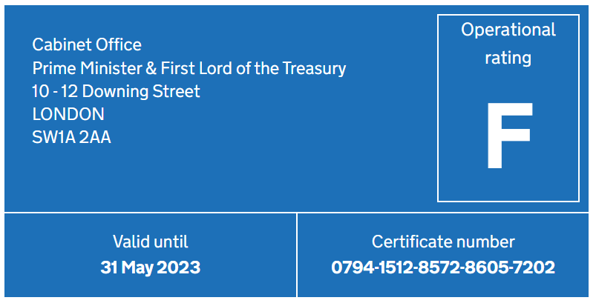

**EPC in the UK must contain the following information**198F201F201F201F201F201F201F201F**[202]:**

* The asset rating - the rating places the energy efficiency of the property on a sliding scale
* A recommendation report - the assessor usually must include recommendations for cost-effective improvements that could be made to the property to improve its energy efficiency
* Details of the property
* The date the EPC was issued
* Green Deal information - if the property is subject to a Green Deal plan that has not yet been repaid, then there will be an additional page to the EPC which sets out the information relating to that Green Deal plan. Since 2015, the Green Deal has been effectively closed to new entrants.

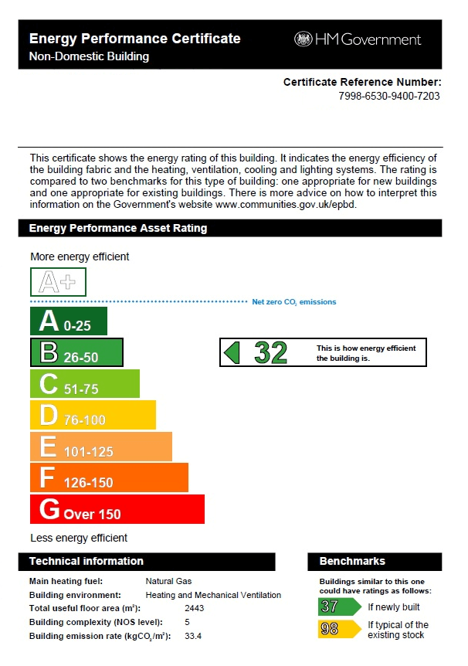

**Energy Efficiency Grade Label (Korea)**199F202F202F202F202F202F202F202F**[203]:**

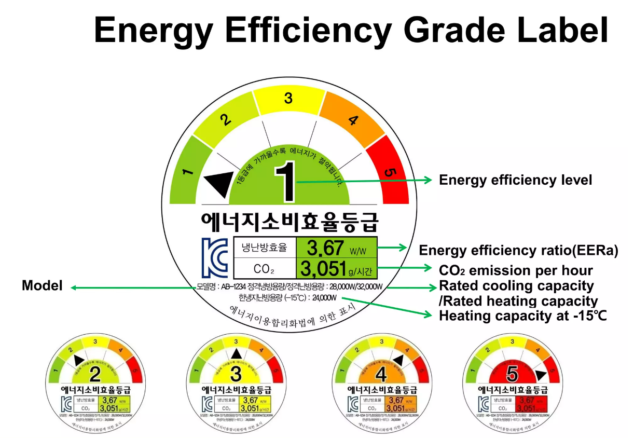

**Display Energy Certificate (Germany)**200F203F203F203F203F203F203F203F**[204]:**

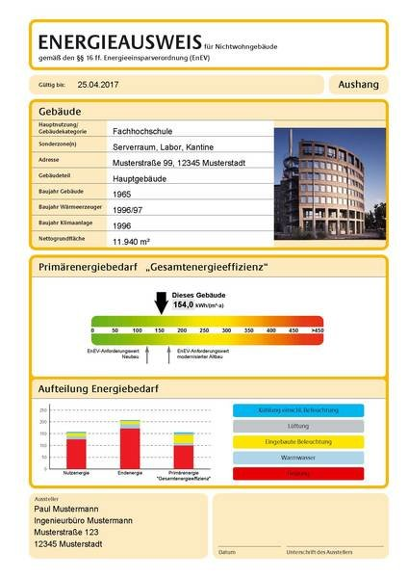

**Building Energy Efficiency Rating New York**201F204F204F204F204F204F204F204F**[205]**

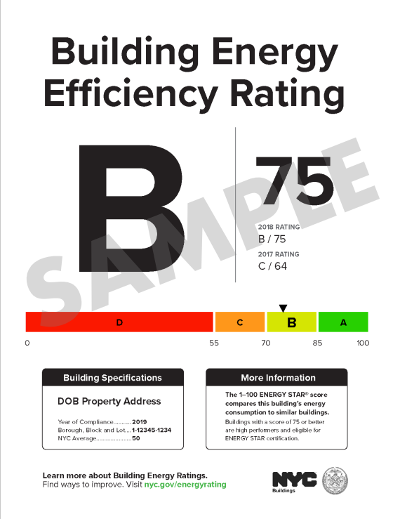

**Information available online on Washington DC buildings including whether it meets the BEPS**202F205F205F205F205F205F205F205F**[206]:**

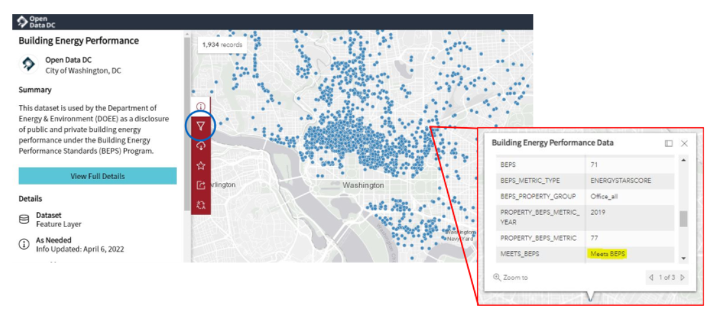

## Appendix 11: Accessibility supported information for charts and infographics

## Table 32: Details of Figure 1 and Figure 24 - High level-roadmap for how CBD program could be expanded between 2025 and 2035

|  |  |  |  |  |
| --- | --- | --- | --- | --- |
| Category | Phase 1 | Phase 2 | Phase 3 | Phase 4 |
| Overall Building regulation | Develop sectoral emission pathway and set the vision for future phase rollout. Detailed RIS and CBA to calibrate exact details for expansion. Firm up building stock data for building counts and GFA. | Periodic review of progress  Introduce scope 1 disclosure | Disclosure covers 80% of GFA across all commercial buildings, MEPS introduced in all participating sectors. |  |
| Group 1 buildings: Offices | Reduce threshold of CBD compliance to 500m2 for office buildings including tenancies in the threshold; Expand CBD Program to non-corporate entities and owner occupiers. | Introduce MEPS for large office buildings including tenancies in the threshold | Consider raising MEPS star rating for offices including tenancies in the threshold. Consider reducing MEPS building size threshold for offices | CBD coverage at least 90% of GFA of commercial office buildings |
| Group 2 buildings: Hotels, Shopping Centres, Data Centres, Public Hospitals | Introduce mandatory disclosure for large Group 2 buildings | Reduce threshold to include medium-sized Group 2 buildings | Introduce MEPS for large group 2 buildings | Progressively reduce disclosure and MEPS threshold to include small Group 2 buildings. Consider raising MEPS star rating; CBD expansion to cover >80% of Group 2 GFA. |
| Group 3 buildings: Residential Aged Care, Retirement Living, Warehouses, Cold Stores, Schools, Retail stores | Increase NABERS participation  to all Group 3 buildings and announce disclosure is upcoming. | Introduce mandatory disclosure for large Group 3 buildings | Introduce MEPS for large Group 3 buildings | Consider raising MEPS star rating; Reduce disclosure and MEPS threshold to medium-sized then small Group 3 buildings; CBD expansion to cover >70% of Group 3 GFA. |
| Group 4 buildings: Higher Education, Supermarkets, Private Hospitals, Medical centres, Other (e.g. galleries, sport facilities) | NABERS expansion to incorporate Group 4 buildings, and announce disclosure is upcoming | Introduce mandatory disclosure for large Group 4 buildings | Introduce MEPS for large Group 4 buildings | Reduce disclosure and MEPS threshold to medium-sized Group 4 buildings; Consider raising MEPS star rating; CBD building coverage >60% of Group 4 GFA. |
| Remaining buildings unlikely to include in next decade (e.g. churches) | Revisit these buildings to assess if appropriate for inclusion. |  |  |  |

Link to Table of Contents.

## Table 33: Details of Figure 3- High level overview of building energy global disclosure requirements

|  |  |  |
| --- | --- | --- |
| Country/jurisdiction | Year | Details |
| California | 2009 | Non-residential building owners or operators must disclose energy consumption data buyers, lenders, and lessees (buildings > ~500m2) |
| New York | 2019 | Requires owners of most buildings over ~2,300m2 to obtain building energy efficiency rating labels and display near building entrances. |
| Washington DC | 2008 | Commercial buildings with min. GFA of ~4,600m2 and government buildings with a min. GFA of ~900m2 required to benchmark using ENERGY STAR, results reported annually to the state government for public disclosure on website. Threshold for inclusion lowered from 2021-2024. |
| Washington State | 2009 | All non-residential owners and qualifying public agency buildings to maintain and disclose ENERGY STAR rating to a prospective buyer, lessee, or lender |
| United Kingdom | 2008 & 2022 | 2008: EPC required for non-domestic buildings >10,00m2 when they are sold or leased, reduced to 50m2 over time.  2022: All commercial buildings >1,000m2 required to display and report energy and carbon performance using Display Energy Certificate (DEC). |
| Germany | 2020 | Required to disclose energy consumption, energy demand and emissions |
| France | 2021 | Any tertiary building with surface area > 1,000m2 to collect building energy data and submit the yearly consumptions to a digital platform. |
| Norway | 2010 | Non-residential buildings >1,000m2 must display the EPC |
| Japan | 2017 | Voluntary certification of conformity with energy efficiency standards |

Link to Table of Contents.

## Table 34: Data for Figure 4 - Net position for the average building covered by Tailored Sectoral Disclosure policy over 20 years

|  |  |  |
| --- | --- | --- |
| Breakdown of cost and benefit components | Smaller buildings assumed | Larger buildings assumed |
| Bill saving | $446,510 | $874,258 |
| Emission saving | $208,988 | $409,194 |
| Upgrade cost | -$130,090 | -$301,757 |
| Compliance costs | -$49,243 | -$82,071 |
| Program costs | -$288 | -$481 |
| *Net position* | **$475,876** | **$899,143** |

Link to Table of Contents.

## Table 35: Data for Figure 5 - 2020 Non-residential Building GFA by Space Use Type

|  |  |
| --- | --- |
| Gross Floor Area by Space Use Type | Proportion of total |
| Offices | 19% |
| Warehouses | 16% |
| Transport buildings | 12% |
| Retail and wholesale trade buildings | 9% |
| Factories and other secondary production buildings | 9% |
| Entertainment and recreation buildings | 8% |
| Short term accommodation buildings | 6% |
| Agricultural and aquacultural buildings | 4% |
| Education buildings | 3% |
| Non-residential buildings nec | 3% |
| Other industrial buildings nec | 3% |
| Aged care facilities (including nursing homes) | 2% |
| Religion buildings | 2% |
| Health facilities | 1% |
| Commercial buildings nec | 1% |

Link to Table of Contents.

## Table 36: Data for Figure 6 - 2020 Non-residential Building Total Energy Consumption by Space Use Type

|  |  |
| --- | --- |
| Total Electricity Consumption by Space Use Type | Proportion |
| Other industrial buildings nec | 1% |
| Religion buildings | 1% |
| Commercial buildings nec | 1% |
| Education buildings | 2% |
| Agricultural and aquacultural buildings | 2% |
| Transport buildings | 3% |
| Factories and other secondary production buildings | 3% |
| Health facilities | 4% |
| Non-residential buildings nec | 4% |
| Aged care facilities (including nursing homes) | 6% |
| Warehouses | 6% |
| Entertainment and recreation buildings | 9% |
| Short term accommodation buildings | 15% |
| Retail and wholesale trade buildings | 17% |
| Offices | 26% |

Link to Table of Contents.

## Table 37: Details for Figure 7 - Major milestones by state, territory and Australian governments to improve emission profiles

|  |  |
| --- | --- |
| Year | Details |
| 2004 | **NSW Greenhouse Performance of all Government Office Buildings requires all owned and leased office to be rated**. A milestone in State Government action to take the voluntary NABERS process and legislate a requirement of disclosure. Increase of participation by 377% from 2004 to 2005 |
| 2007 | **Energy Efficiency in Government Operations** introduced by Commonwealth requiring all owned or leased office spaces rated over 4.5 Stars (2007), followed by **NSW Sustainable Government Policy** introduced requiring all government owned or leased office spaces to be rate over 4.5 Stars (2008). Increase of participation by 80% from 2007 to 2008 |
| 2010 | **Commercial Building Disclosure** introduced the mandatory reporting of NABERS ratings for all commercial office buildings over 2,000 sqm that were available for lease or sale. A significant milestone which resulted in participation in NABERS increasing from 505 assessments in 2010 to 1143 in 2011 (+**126%**). |
| 2018 | The threshold for commercial offices was lowered from 2,000 sqm to 1,000 sqm to capture significantly more buildings at point of sale or lease. NABERS ratings increased by **18%** from 2018 to 2019, however, at this stage almost 1,800 offices were being rated each year. |
| 2019 | In 2019 Federal, State and Territory Energy Ministers agreed on the Trajectory for Low Energy Buildings. Under this Trajectory, the Australian Government is flagged to review the CBD Program every 3 years, and expand its coverage into other commercial building sectors. A follow up 2019 [report](https://www.energy.gov.au/government-priorities/energy-ministers/energy-ministers-publications/trajectory-low-energy-buildings) outlined a number of cost beneficial options for disclosure and minimum energy standards, based on data available at the time. |
| 2022 | The Government committed Australia to a **43% reduction in greenhouse gas emissions by 2030**. These targets are legislated as binding under the Climate Change Act 2022 (Cth). The objective of the Building Energy Efficiency Disclosure Act 2010 (Cth) was subsequently amended to promote disclosure of energy efficiency information of buildings, and to contribute to the achievement of Australia’s emissions reduction targets. The Government committed to reduce **APS emissions to net zero by 2030** (defence and security agencies exempt). This policy will see a significant effort and enterprise changes from APS. |
| 2023 | The Australian Government is drafting a **National Energy Performance Strategy** which focuses on energy efficiency, load shifting, fuel switching and behaviour change. The [consultation paper](https://consult.dcceew.gov.au/neps-consultation-paper) commercial section has a focus on building, asking the question ‘what are the key opportunities to improve the energy performance of new and existing commercial buildings and operations?’. |

Link to Table of Contents.

## Table 38: Data for Figure 8 - Average Energy Intensity Across for All Non-residential Building Space Use Types and Total Greenhouse Gas Emissions for Non-Residential Building Space Use Types, 2012 to 2020

|  |  |  |  |  |  |  |  |  |  |
| --- | --- | --- | --- | --- | --- | --- | --- | --- | --- |
| Year | 2012 | 2013 | 2014 | 2015 | 2016 | 2017 | 2018 | 2019 | 2020 |
| Total Greenhouse Gas Emissions for All non-residential Buildings (Mt CO2-e) | 52.7 | 51.8 | 51.4 | 51.2 | 51.5 | 51.7 | 51.7 | 51.5 | 50.6 |
| Average electricity intensity for all non-residential buildings (MJ/m2.a) | 396 | 382 | 373 | 368 | 365 | 360 | 355 | 349 | 337 |
| Average gas intensity for all non-residential buildings (MJ/m2.a) | 60 | 59 | 60 | 60 | 60 | 60 | 58 | 58 | 56 |

Link to Table of Contents.

## Description for Figure 13:

1) Define options

2) Tailored sectoral disclosure; Office MEPS; Scope 1 disclosure

3a) Costs - Costs of upgrades that result from disclosure; Energy efficiency assessments and compliance costs; Program development and enforcement costs

3b) Benefits - energy savings (bill reductions); Emissions reductions; Reduced operations and maintenance costs; Reduced structural electricity network, system service and wholesale costs

4a) Net Present Costs

4b) Net Present Benefits

Link to Table of Contents.

## Table 39: Figure 14 - Approximate costs and benefits of Tailored sectorial disclosure policy over 20 years for the average building (Smaller building size assumed)

|  |  |
| --- | --- |
| Component | Cost/Benefit |
| Bill Saving | $446,510 |
| Emission Saving | $208,988 |
| Upgrade costs | -$130,090 |
| Compliance costs | -$49,243 |
| Program costs | -$288 |
| Net Position | **$475,876** |

Link to Table of Contents.

## Table 40: Figure 15 - Approximate costs and benefits of Tailored sectorial disclosure policy over 20 years for the average building (Larger building size assumed)

|  |  |
| --- | --- |
| Component | Cost/Benefit |
| Bill Saving | $874,258 |
| Emission Saving | $409,194 |
| Upgrade costs | -$301,757 |
| Compliance costs | -$82,071 |
| Program costs | -$481 |
| Net Position | **$899,143** |

Link to Table of Contents.

## Table 41: Figure 16 - Approximate costs and benefits of Star-rating MEPS for Offices policy over 20 years for the average building (Smaller building size assumed)

|  |  |
| --- | --- |
| Component | Cost/Benefit |
| Bill Saving | $689,929 |
| Emission Saving | $473,085 |
| Upgrade costs | -$27,610 |
| Compliance costs | -$23,961 |
| Program costs | -$360 |
| Net Position | **$1,111,082** |

Link to Table of Contents.

## Table 42: Figure 17 - Approximate costs and benefits of Star-rating MEPS for Offices policy over 20 years for the average building (Larger building size assumed)

|  |  |
| --- | --- |
| Component | Cost/Benefit |
| Bill Saving | $1,149,881 |
| Emission Saving | $788,475 |
| Upgrade costs | -$106,499 |
| Compliance costs | -$39,936 |
| Program costs | -$601 |
| Net Position | **$1,791,321** |

Link to Table of Contents.

## Table 43: Figure 18 - Cost of upgrading NABERS ratings by building size

|  |  |  |  |  |  |  |
| --- | --- | --- | --- | --- | --- | --- |
|  | 500 m2 | 1,000m2 | 5,000m2 | 10,000m2 | 20,000m2 | 30,000m2 |
| 2 to 4 Star | $20,738 | $41,476 | $207,380 | $414,760 | $829,519 | $1,244,279 |
| 3 to 4 Star | $8,619 | $17,239 | $86,195 | $172,389 | $344,779 | $517,168 |
| 4 to 5 Star | $8,619 | $17,239 | $86,195 | $172,389 | $344,779 | $517,168 |

Link to Table of Contents.

## Table 44: Figure 19 - Approximate cost and benefits of scope 1 disclosure policy over 20 years for the average building (Smaller building size assumed)

|  |  |
| --- | --- |
| Component | Cost/Benefit |
| Bill Saving | $2,678 |
| Emission Saving | $1,813 |
| Upgrade costs | -$683 |
| Program costs | -$700 |
| Net Position | **$3,109** |

Link to Table of Contents.

## Table 45: Figure 20 - Approximate cost and benefits of scope 1 disclosure policy over 20 years for the average building (Larger building size assumed)

|  |  |
| --- | --- |
| Component | Cost/Benefit |
| Bill Saving | $4,463 |
| Emission Saving | $3,022 |
| Upgrade costs | -$1,138 |
| Program costs | -$1,166 |
| Net Position | **$5,181** |

Link to Table of Contents.

## Description of Figure 22 and Figure 2- Roadmap principles:

1) Develop NABERS tool - enables buildings to assess and benchmark energy efficiency

2) Grow Maturity in use from market leaders - Supporting trials and refinements for market leaders with voluntary introduction of requirements

3) Disclosure of large buildings, calibrated by sector - Mandatory disclosure requirements introduced at the highest value buildings that have greater maturity in considering energy efficiency

4) Progressive reduction of disclosure threshold - after larger buildings have established reporting obligations gradually increase coverage through reducing he threshold to include smaller buildings

5) Introduction of MEPS - Whilst disclosure coverage is progressively increased, begin introducing mandatory performance requirements for larger buildings

Roadmap should also consider the broader policy and operating context, including complementary policies

Link to Table of Contents.

©2023 KPMG, an Australian partnership and a member firm of the KPMG global organisation of independent member firms affiliated with KPMG International Limited, a private English company limited by guarantee. All rights reserved. The KPMG name and logo are trademarks used under license by the independent member firms of the KPMG global organisation.

Liability limited by a scheme approved under Professional Standards Legislation.

1. [Commercial buildings | energy.gov.au](https://www.energy.gov.au/government-priorities/buildings/commercial-buildings)
2. [UTNCC – Understanding the NCC Building Classifications](https://www.abcb.gov.au/sites/default/files/resources/2022/UTNCC-Building-classifications.PDF)
3. Figure 1: 2020 Non-residential Building Count by Primary Purpose Type and Gross Floor Area by Space Use Type (Strategy Policy Research, 2022)
4. [Climate Change Act 2022](https://www.legislation.gov.au/Details/C2022A00037) 
5. Data and metrics for Australia’s building stock are extracted from the *2022 Commercial Building Baseline Study* (CBBS). Further detail is provided in the Appendices
6. [CBBS 2022 Final Report (energy.gov.au)](https://www.energy.gov.au/sites/default/files/The%20Commercial%20Buildings%20Energy%20Consumption%20Baseline%20Study%202022.pdf)
7. [Buildings | energy.gov.au](https://www.energy.gov.au/government-priorities/buildings)
8. [CBBS 2022 Final Report (energy.gov.au)](https://www.energy.gov.au/sites/default/files/The%20Commercial%20Buildings%20Energy%20Consumption%20Baseline%20Study%202022.pdf)
9. [CBBS 2022 Final Report (energy.gov.au)](https://www.energy.gov.au/sites/default/files/The%20Commercial%20Buildings%20Energy%20Consumption%20Baseline%20Study%202022.pdf)
10. [Australian National Greenhouse Accounts Factors (dcceew.gov.au)](https://www.dcceew.gov.au/sites/default/files/documents/national-greenhouse-accounts-factors-2022.pdf)
11. [CBBS 2022 Final Report (energy.gov.au)](https://www.energy.gov.au/sites/default/files/The%20Commercial%20Buildings%20Energy%20Consumption%20Baseline%20Study%202022.pdf)
12. [Consultation hub | National Energy Performance Strategy: consultation paper - Climate Change (dcceew.gov.au)](https://consult.dcceew.gov.au/neps-consultation-paper)
13. [Executive summary – Australia 2023 – Analysis - IEA](https://www.iea.org/reports/australia-2023/executive-summary)
14. Performance based are those that are the result of actual building energy use or emissions, attribute based is based on features use in the building (materials used, lighting, insulation etc)
15. [APS Net Zero Emissions by 2030 | Department of Finance](https://www.finance.gov.au/government/aps-net-zero-emissions-2030#:~:text=The%20Government%20has%20set%20a,when%20considering%20value%20for%20money)
16. [Government buildings | energy.gov.au](https://www.energy.gov.au/government-priorities/buildings/government-buildings#toc-anchor-energy-efficiency-in-government-operations)
17. The energy intensity targets set June 2011 are: 7,500 MJ /person/ year for tenant light and power; and 400 MJ /m2/ year for central services.
18. [Government buildings | energy.gov.au](https://www.energy.gov.au/government-priorities/buildings/government-buildings#toc-anchor-energy-efficiency-in-government-operations)
19. [Government buildings | energy.gov.au](https://www.energy.gov.au/government-priorities/buildings/government-buildings#toc-anchor-energy-efficiency-in-government-operations)
20. [Decarbonising Infrastructure Delivery discussion (nsw.gov.au)](https://www.infrastructure.nsw.gov.au/media/3696/infr9941-decarbonising-infrastructure-delivery.pdf)
21. [Embodied Carbon & Embodied Energy in Australia's Buildings (gbca-web.s3.amazonaws.com)](https://gbca-web.s3.amazonaws.com/media/documents/embodied-carbon--embodied-energy-in-australias-buildings-2021-07-22-final-public.pdf)
22. [Sustainable Buildings SEPP | Planning (nsw.gov.au)](https://www.planning.nsw.gov.au/policy-and-legislation/buildings/sustainable-buildings-sepp)
23. Commercial Buildings Energy Consumption Baseline Study 2022
24. [Australian Energy Update 2020 | energy.gov.au](https://www.energy.gov.au/publications/australian-energy-update-2020)
25. NABERS & CBD Assessor Events 2022, Oscar Tigwell
26. [CBBS 2022 Final Report (energy.gov.au)](https://www.energy.gov.au/sites/default/files/The%20Commercial%20Buildings%20Energy%20Consumption%20Baseline%20Study%202022.pdf)
27. [8 per cent emissions direct emissions in buildings and 18 per cent indirect emissions](https://www.iea.org/energy-system/buildings) from the production of electricity and heat used in buildings.
28. In Australia, offices account for around [6 per cent of emissions](https://www.dcceew.gov.au/sites/default/files/documents/national-greenhouse-accounts-factors-2022.pdf)
29. [Climate Change Mitigation | UKGBC](https://ukgbc.org/our-work/climate-change-mitigation/)
30. [Important Updates for DC building owners on the DC Building Energy Performance Standards — CEG Solutions](https://www.cegsolutions.com/blog-1/important-updates-for-dc-building-owners-on-the-dc-building-energy-performance-standards)
31. IPEEC (2017) [Existing Building Energy Efficiency Renovation - International Review of Regulatory Policies](https://www.energy.gov.au/sites/default/files/existing_building_energy_efficiency_renovation_-_international_review_of_regulatory_policies_-_september_2017_-_ipeec.pdf). IPEEC Building Energy Efficiency Taskgroup.
32. [Energy Performance Certificates for buildings: action plan (publishing.service.gov.uk)](https://assets.publishing.service.gov.uk/government/uploads/system/uploads/attachment_data/file/922660/EPC_Action_Plan.pdf)
33. Residential only schemes have been removed. From IPEEC (2014). [Building Energy Rating Schemes – Assessing Issues and Impacts](https://www.aceee.org/files/proceedings/2014/data/papers/6-277.pdf) and Lee, Hyunjoo & Lee, Misuk & Lim, Sesil. (2018). [Do Consumers Care about the Energy Efficiency of Buildings? Understanding Residential Choice Based on Energy Performance Certificates](https://www.researchgate.net/publication/329134059_Do_Consumers_Care_about_the_Energy_Efficiency_of_Buildings_Understanding_Residential_Choice_Based_on_Energy_Performance_Certificates). Sustainability. 10. 4297. 10.3390/su10114297.
34. ENERGY STAR was introduced in 1992 by the US EPA. According to [ES_Government-Factsheet_121914.pdf (energystar.gov)](https://www.energystar.gov/sites/default/files/tools/ES_Government-Factsheet_121914.pdf) there are three federal policies and 14 state policies across 13 states, and 14 municipality policies that leverage the ENERGY STAR tool in the US.
35. French equivalent of an Energy Performance Certificate (EPC)
36. [The Green Mark Certification Scheme Explained by CIM](https://www.cim.io/blog/the-green-mark-certification-scheme-explained)
37. Originally part of Energy Performance of Buildings (Certificates and Inspections) (England and Wales) Regulations 2007 ([Recast of the Energy Performance of Buildings Directive - GOV.UK (www.gov.uk)](https://www.gov.uk/government/publications/improving-the-energy-efficiency-of-our-buildings#:~:text=The%20Energy%20Performance%20of%20Buildings%20Directive%20is%20an%20EU%20measure,of%20carbon%20produced%20by%20buildings.))
38. [A guide to energy performance certificates for the construction, sale and let of non-dwellings (publishing.service.gov.uk)](https://assets.publishing.service.gov.uk/government/uploads/system/uploads/attachment_data/file/666186/A_guide_to_energy_performance_certificates_for_the_construction_sale_and_let_of_non-dwellings.pdf)
39. According to Buying or selling your home: Energy Performance Certificates - GOV.UK (www.gov.uk) excluded buildings include places of worship; temporary buildings that will be used for less than 2 years; industrial sites, workshops and non-residential agricultural buildings that do not use a lot of energy; some buildings that are due to be demolished; holiday accommodation that’s rented out for less than 4 months a year or is let under a licence to occupy; listed buildings - local authority conservation officer advises if the work would alter the building’s character; residential buildings intended to be used less than 4 months a year
40. [Large commercial/industrial building energy performance rating framework (energyadvicehub.org)](https://energyadvicehub.org/explained-the-new-mandatory-energy-performance-rating-framework-for-large-commercial-and-industrial-buildings/)
41. [Introducing Performance-Based Ratings in Commercial and Industrial Offices above 1,000m² in England and Wales: phase 1 of a national performance-based policy framework (cibse.org)](https://www.cibse.org/media/25qlbioh/introducing-performance-based-ratings-commercial-industrial-offices-above-1000m-england-wales.pdf)
42. [Décret Tertiaire: One Year for French Building Owners to Comply | Schneider Electric (se.com)](https://perspectives.se.com/blog-stream/decret-tertiaire#:~:text=Article%20175%20of%20the%20Law,buildings%20subject%20to%20the%20obligation.)
43. [[ENERGY] France accelerates its energy transition on commercial and industrial buildings - BMH Avocats](https://bmhavocats.com/en/2019/11/08/france-accelerates-its-energy-transition-on-commercial-and-industrial-buildings/)
44. [BMI - Buildings Energy Act (bund.de)](https://www.bmi.bund.de/EN/topics/building-housing/building/energy-efficient-construction-renovation/buildings-energy-act/buildings-energy-act-node.html#:~:text=The%20new%20Buildings%20Energy%20Act%20sets%20out%20requirements%20for%20the,of%20renewable%20energy%20in%20buildings.&text=The%20new%20Buildings%20Energy%20Act%20was%20promulgated%20in%20the,Gazette%20on%2013%20August%202020.)
45. Uses primary energy consumption per square metre of usable floor area (kWh/m²a) as the metric to measure a building's energy efficiency.
46. *No specific information on building types or sizes.*
47. [Building Energy Disclosure | ACEEE](https://database.aceee.org/state/building-energy-disclosure)
48. [ENERGY STAR Commercial Buildings | ENERGY STAR makes it easy for consumers and businesses to save money and protect the environment.](https://www.energystar.gov/buildings?s=mega)
49. [Environment | Open Data DC](https://opendata.dc.gov/pages/mayor-environment)
50. Covered commercial buildings is a building where the sum of non-residential, hotel, motel and dormitory floor areas exceeds 50,000 gross square feet, excluding the parking garage area. ([Clean Buildings - How to Comply - Washington State Department of Commerce](https://www.commerce.wa.gov/growing-the-economy/energy/buildings/how-to-comply/))
51. [Building Energy Disclosure | ACEEE](https://database.aceee.org/state/building-energy-disclosure)
52. [Local Law 97 - Sustainable Buildings (nyc.gov)](https://www.nyc.gov/site/sustainablebuildings/ll97/local-law-97.page#:~:text=Under%20this%20groundbreaking%20law%2C%20most,coming%20into%20effect%20in%202030.)
53. [Building Energy Efficiency Act – Policies - IEA](https://www.iea.org/policies/863-building-energy-efficiency-act); [2016-Cover_ver5_light (mlit.go.jp)](https://www.mlit.go.jp/common/001134876.pdf)
54. [Building energy efficiency act-Japan](https://energyefficiencyhub.org/wp-content/uploads/2023/02/S1-1.pdf)
55. [Compliance with Building Standards under the New Energy Regulations in Japan - Lexology](https://www.lexology.com/library/detail.aspx?g=2f4b5bb5-72be-4791-b8b8-c8450c87a4da)
56. [Overview of the Act on the Improvement of Energy Consumption Performance of Buildings](https://www.mlit.go.jp/common/001134876.pdf)
57. [UK Industrial Decarbonisation Strategy 2021](https://assets.publishing.service.gov.uk/government/uploads/system/uploads/attachment_data/file/970229/Industrial_Decarbonisation_Strategy_March_2021.pdf)
58. [CIBSE Closed consultation – A Performance-Based Policy Framework in Large Commercial and Industrial Buildings](https://www.cibse.org/policy-insight/consultations/closed-consultations/a-performance-based-policy-framework-in-large-commercial-and-industrial-buildings)
59. [HM Government – Heat and Buildings Strategy (publishing.service.gov.uk)](https://assets.publishing.service.gov.uk/government/uploads/system/uploads/attachment_data/file/1044598/6.7408_BEIS_Clean_Heat_Heat___Buildings_Strategy_Stage_2_v5_WEB.pdf)
60. [The Ten Point Plan for a Green Industrial Revolution](https://assets.publishing.service.gov.uk/government/uploads/system/uploads/attachment_data/file/936567/10_POINT_PLAN_BOOKLET.pdf)
61. [The New Mandatory Energy Performance Rating Framework for Large Commercial and Industrial Buildings](https://energyadvicehub.org/explained-the-new-mandatory-energy-performance-rating-framework-for-large-commercial-and-industrial-buildings/)
62. Clean Growth Strategy - GOV.UK (www.gov.uk)
63. [Energy & Water Reporting and Benchmarking – Large Buildings – City of Toronto](https://www.toronto.ca/business-economy/business-operation-growth/green-your-business/energy-and-water-reporting-and-benchmarking/)
64. [NABERS UK: energy efficiency rating scheme for offices launches to help businesses meet net zero – Energy Advice Hub](https://energyadvicehub.org/nabers-uk-energy-efficiency-rating-scheme-for-uk-offices-launches-to-help-businesses-meet-net-zero/)
65. [Department for Business, Energy & Industrial Strategy – Introducing a Performance-Based Policy Framework in Large Commercial and Industrial Buildings in England and Wales](https://assets.publishing.service.gov.uk/government/uploads/system/uploads/attachment_data/file/970519/performance-based-policy-framework-ci-buildings--strategy-paper.pdf)
66. [Minimum energy standards for rented properties - an international review](https://www.dcceew.gov.au/sites/default/files/documents/minimum-energy-standards-rented-properties-international-review.pdf)
67. [Considering minimum energy performance standards for Germany (raponline.org)](https://www.raponline.org/wp-content/uploads/2021/03/rap-meps-germany-2021-march.pdf)
68. [Regulatory Assistance Project (2021) - Considering minimum energy performance standards for Germany](https://urldefense.com/v3/__https:/www.raponline.org/wp-content/uploads/2021/03/rap-meps-germany-2021-march.pdf__;!!E1R1dd1bLLODlQ4!CxnEV-Z8WNqt-Sno-6xYqUqfXIrx-ddZOEjt0_GRe0Fu3EeAmZ1Pq6-Rtaq4_McQsUT8hiIcDyHLbGKMjldDaQN4oKq7pcZ8_w$)
69. [Minimum energy efficiency standards in the commercial real estate sector: A critical review of policy regimes](https://reader.elsevier.com/reader/sd/pii/S0959652623005000?token=26FCA4B48D829506034D2F13497AE62E49154E90AEA059F484B008165BF1087C05E98273698A65F88105A2BA41A9755D&originRegion=us-east-1&originCreation=20230411062920)
70. [BEET 10 Minimum Energy Standards for Rented Properties - An International Review.pdf](https://www.energy.gov.au/sites/default/files/BEET%2010%20Minimum%20Energy%20Standards%20for%20Rented%20Properties%20-%20An%20International%20Review.pdf)
71. [Phase-out regulations for fossil fuel boilers at EU and national level (oeko.de)](https://www.oeko.de/fileadmin/oekodoc/Phase-out_fossil_heating.pdf)
72. [BMWK - Enhancing energy efficiency in buildings](https://www.bmwk.de/Redaktion/EN/Dossier/enhancing-energy-efficiency-in-buildings.html)
73. [3.JapansRoadmaptoCarbonNeutralityintheBuildingandHousingSectors.pdf (windows.net)](https://iea.blob.core.windows.net/assets/993f67a2-054e-41ba-9adb-f782358a4e73/3.JapansRoadmaptoCarbonNeutralityintheBuildingandHousingSectors.pdf)
74. [Phase-out regulations for fossil fuel boilers at EU and national level (oeko.de)](https://www.oeko.de/fileadmin/oekodoc/Phase-out_fossil_heating.pdf)
75. [Buying or selling your home: Energy Performance Certificates - GOV.UK (www.gov.uk)](https://www.gov.uk/buy-sell-your-home/energy-performance-certificates)
76. [Domestic private rented property: minimum energy efficiency standard - landlord guidance](https://www.gov.uk/guidance/domestic-private-rented-property-minimum-energy-efficiency-standard-landlord-guidance)
77. [Directive 2010/31/EU of the European Parliament and of the Council of 19 May 2010 on the energy performance of buildings (europa.eu)](https://eur-lex.europa.eu/legal-content/EN/TXT/PDF/?uri=CELEX:32010L0031)
78. [MEES – implementing the EPC B target by 2030 | Simmons & Simmons (simmons-simmons.com)](https://www.simmons-simmons.com/en/publications/ckmxbrsri18pm0a34fznd79y4/mees-implementing-the-epc-b-target-by-2030v)
79. [MEES – implementing the EPC B target by 2030 | Simmons & Simmons (simmons-simmons.com)](https://www.simmons-simmons.com/en/publications/ckmxbrsri18pm0a34fznd79y4/mees-implementing-the-epc-b-target-by-2030v)
80. [Japan 2021 - Energy Policy Review (windows.net)](https://iea.blob.core.windows.net/assets/3470b395-cfdd-44a9-9184-0537cf069c3d/Japan2021_EnergyPolicyReview.pdf)
81. McAllister, P. and Nase, I. (2023) Minimum energy efficiency standards in the commercial real estate sector: a critical review of policy regimes. Journal of Cleaner Production, 393.136342. ISSN 0959-6526 doi: https://doi.org/10.1016/j.jclepro.2023.136342 Available at <https://centaur.reading.ac.uk/111089/>
82. [Case studies: Minimum energy performance standards for European buildings (raponline.org)](https://www.raponline.org/wp-content/uploads/2020/07/rap-ls-ms-meps-case-studies-2020-july-28.pdf)
83. [2022 Building Energy Efficiency Standards (final version) (ca.gov)](https://www.energy.ca.gov/sites/default/files/2022-12/CEC-400-2022-010_CMF.pdf)
84. [How Demark leads the way in decarbonising the construction industry](https://www.burohappold.com/news/how-denmark-leads-the-way-in-decarbonising-the-construction-industry/)
85. [The impact of the Tokyo emissions trading scheme on office buildings: what factor contributed to the emission reduction? | SpringerLink](https://link.springer.com/article/10.1007/s10018-020-00271-w)
86. KPMG (2022) Provisional agreements in EU on emissions trading, carbon border adjustments and climate funding, available at: [Fit for 55: Emissions Trading; Carbon Border Adjustments and Climate Funding (kpmg.com)](https://assets.kpmg.com/content/dam/kpmg/us/pdf/2022/12/tnf-fit-55-dec22-2022.pdf)
87. [Green Homes Grant: make energy improvements to your home (closed to new applicants) - GOV.UK (www.gov.uk)](https://www.gov.uk/guidance/apply-for-the-green-homes-grant-scheme#:~:text=Your%20voucher%20covers%20up%20to,cost%20of%20your%20chosen%20improvements.)
88. [What is the Federal Funding for Efficient Buildings (BEG) – SENERGYS](https://senergys.de/en/what-is-the-federal-funding-for-efficient-buildings-beg/)
89. [Fit for 55: a fund to support the most affected citizens and businesses - Consilium (europa.eu)](https://www.consilium.europa.eu/en/infographics/fit-for-55-social-climate-fund/#:~:text=The%20fund%20will%20help%20tackle,prices%20that%20started%20in%202021.)
90. [Daily News 01 / 03 / 2023 (europa.eu)](https://ec.europa.eu/commission/presscorner/detail/en/mex_23_1301)
91. [BMWK - Enhancing energy efficiency in buildings](https://www.bmwk.de/Redaktion/EN/Dossier/enhancing-energy-efficiency-in-buildings.html)
92. [KEA - KOREA ENERGY AGENCY](https://dco.energy.or.kr/renew_eng/energy/buildings/worksheet.aspx)
93. [Japan 2021 - Energy Policy Review (windows.net)](https://iea.blob.core.windows.net/assets/3470b395-cfdd-44a9-9184-0537cf069c3d/Japan2021_EnergyPolicyReview.pdf)
94. [Historic Buildings - Building Energy Performance Standard - BEAM Helpdesk (beam-portal.org)](https://dc.beam-portal.org/helpdesk/kb/BEPS/80/)
95. [‘Fit for 55’: Council agrees on stricter rules for energy performance of buildings - Consilium (europa.eu)](https://www.consilium.europa.eu/en/press/press-releases/2022/10/25/fit-for-55-council-agrees-on-stricter-rules-for-energy-performance-of-buildings/)
96. [EU Buildings Renovations: get ready for minimum energy performance standards (MEPS) - Energy Post](https://energypost.eu/eu-buildings-renovations-get-ready-for-minimum-energy-performance-standards-meps/)
97. [Promoting Energy Efficiency in Buildings: Lessons Learned From International Experience](https://www.thegef.org/sites/default/files/publications/EEBuilding_WEB_2.pdf)
98. According to the paper, various countries have made it mandatory or created incentives for energy utilities to actively promote energy efficiency to their customers (as electricity and gas utilities are generally in a privileged position to advise their clients on energy efficiency in their homes through demand side management (DSM)
99. According to the paper, energy service companies (ESCOs) provide consumers with energy services (heat, cooling, power, light, etc.) rather than fuels. They can help energy consumers go forward with energy efficiency investments by providing them with services and financing, and by guaranteeing results.
100. Decrease is noted to be largely driven by strong domestic standards phasing out non-condensing boilers, along with the supplier obligations targeting home energy efficiency which ran from 2008-2012, high temperatures, and household appliance efficiencies) [Reducing UK emissions: 2020 Progress Report to Parliament - Climate Change Committee (theccc.org.uk)](https://www.theccc.org.uk/publication/reducing-uk-emissions-2020-progress-report-to-parliament/)
101. [Introducing a performance-based policy framework in large commercial and industrial buildings in England and Wales (publishing.service.gov.uk)](https://assets.publishing.service.gov.uk/government/uploads/system/uploads/attachment_data/file/970519/performance-based-policy-framework-ci-buildings--strategy-paper.pdf)
102. This scheme is not specific to buildings but pick up building performance
103. [ESOS FAQs | Frequently Asked Questions | Phase 3 - Energy Advice Hub](https://energyadvicehub.org/esos-faqs/)
104. [Monitoring energy performance improvement: insights from Dutch housing association dwellings - Buildings and Cities (journal-buildingscities.org)](https://journal-buildingscities.org/articles/10.5334/bc.139)
105. [Cost-Benefit Study - Building Energy Performance Standard - BEAM Helpdesk (beam-portal.org)](https://dc.beam-portal.org/helpdesk/kb/BEPS/79/)
106. [Cost-Benefit Study - Building Energy Performance Standard - BEAM Helpdesk (beam-portal.org)](https://dc.beam-portal.org/helpdesk/kb/BEPS/79/)
107. [DataTrends Benchmarking and Energy Savings (energystar.gov)](https://www.energystar.gov/sites/default/files/buildings/tools/DataTrends_Savings_20121002.pdf)
108. [The impact of the Tokyo emissions trading scheme on office buildings: what factor contributed to the emission reduction? | SpringerLink](https://link.springer.com/article/10.1007/s10018-020-00271-w)
109. [スライド 1 (oecd.org)](https://www.oecd.org/env/cc/47514572.pdf)
110. [Japan 2021 - Energy Policy Review (windows.net)](https://iea.blob.core.windows.net/assets/3470b395-cfdd-44a9-9184-0537cf069c3d/Japan2021_EnergyPolicyReview.pdf)
111. The Building Energy Efficiency Certification System (BEECS) enacted in 2001 in Korea aims to promote the spread of high energy-efficient buildings by evaluating and certifying building energy performance.
112. [Sustainability | Free Full-Text | Analysis of a Building Energy Efficiency Certification System in Korea (mdpi.com)](https://www.mdpi.com/2071-1050/7/12/16086)
113. Image sourced from [DataTrends Benchmarking and Energy Savings (energystar.gov)](https://www.energystar.gov/sites/default/files/buildings/tools/DataTrends_Savings_20121002.pdf)
114. [Energy efficiency: what you need to know - GOV.UK (www.gov.uk)](https://www.gov.uk/government/news/energy-efficiency-what-you-need-to-know)
115. [Implementation of the EPBD in Norway - epbd-ca.eu](https://epbd-ca.eu/ca-outcomes/outcomes-2015-2018/book-2018/countries/norway)
116. [Japan 2021 - Energy Policy Review (windows.net)](https://iea.blob.core.windows.net/assets/3470b395-cfdd-44a9-9184-0537cf069c3d/Japan2021_EnergyPolicyReview.pdf)
117. [EPA_ESsummary_23June06_FINAL.qxp (energystar.gov)](https://www.energystar.gov/ia/partners/publications/pubdocs/Summary_of_the_Financial_Benefits_23June06_FINAL.pdf)
118. [Assessing the Value of Green Buildings (corporatesustainabilitystrategies.com)](https://www.corporatesustainabilitystrategies.com/wp-content/uploads/2016/01/Assessing-the-Value-of-Green-Buildings.pdf)
119. According to [Commercial Buildings Factsheet | Center for Sustainable Systems (umich.edu)](https://css.umich.edu/publications/factsheets/built-environment/commercial-buildings-factsheet#:~:text=In%20the%20U.S.%2C%205.9%20million,in%20floor%20space%20since%201979.&text=By%202050%2C%20commercial%20building%20floor,a%2035%25%20increase%20from%202021.) there is 9 billion m2 of commercial building space in the US.
120. [Assessing the Value of Green Buildings (corporatesustainabilitystrategies.com)](https://www.corporatesustainabilitystrategies.com/wp-content/uploads/2016/01/Assessing-the-Value-of-Green-Buildings.pdf)
121. [ForRefOnly.pdf (dc.gov)](https://sustainable.dc.gov/sites/default/files/dc/sites/sustainable/page_content/attachments/SDC%20Final%20Plan_0.pdf)
122. [California LEED Certified State Buildings](https://www.dgs.ca.gov/OS/Resources/Page-Content/Office-of-Sustainability-Resources-List-Folder/California-LEED-Certified-State-Buildings)
123. Assuming 1M buildings in NY city [How Many Buildings are in New York – One Nine Elms](https://www.onenineelms.co.uk/2023/03/10/how-many-buildings-are-in-new-york/#:~:text=An%20Overview%20of%20the%20Buildings%20in%20NYC&text=According%20to%20one%20estimate%2C%20there,buildings%20within%20the%20city%20limits.)
124. [Covered Buildings - Sustainable Buildings (nyc.gov)](https://www.nyc.gov/site/sustainablebuildings/requirements/covered-buildings.page)
125. [PowerPoint Presentation (lbl.gov)](https://eta-publications.lbl.gov/sites/default/files/pigman_aceee_summer_study_2022_preprint.pdf)
126. [Energy performance certificates in buildings and their impact on transaction prices and rents in selected EU countries (efenergia.com)](https://www.efenergia.com/wp-content/uploads/20130619-energy_performance_certificates_in_buildings.pdf)
127. [DataTrends Benchmarking and Energy Savings (energystar.gov)](https://www.energystar.gov/sites/default/files/buildings/tools/DataTrends_Savings_20121002.pdf)
128. Image sourced from127F [DataTrends Benchmarking and Energy Savings (energystar.gov)](https://www.energystar.gov/sites/default/files/buildings/tools/DataTrends_Savings_20121002.pdf)
129. This is a financing mechanism that enables private lenders to finance building upgrades and new construction of high-performance buildings and then receive their loan repayment through the city’s property assessment. [DC PACE – DC Green Bank](https://dcgreenbank.com/product/dc-pace/#:~:text=What%20is%20PACE%3F,through%20the%20city%27s%20property%20assessment.)
130. [ESOS FAQs | Frequently Asked Questions | Phase 3 - Energy Advice Hub](https://energyadvicehub.org/esos-faqs/)
131. The example of Commonwealth Bank’s Property Sustainability Upgrade Loan with zero margin and zero fees (conditional), eligible businesses will be able to increase their Commercial Property Investment Loan by up to 20 per cent to complete property sustainability upgrades that achieve a NABERS rating improvement or reduce emissions. See [Commercial Property Loans go green (commbank.com.au)](https://www.commbank.com.au/articles/newsroom/2021/09/Commercial-Property-Green-Loans.html)
132. UN’s New Net-Zero Banking Alliance: [GFANZ-Launch-press-release.pdf (unepfi.org)](https://www.unepfi.org/wordpress/wp-content/uploads/2021/04/GFANZ-Launch-press-release.pdf)
133. [Barclays Green Home Mortgages](https://www.barclays.co.uk/mortgages/green-home-mortgage/)
134. [Commonwealth bank – Commercial Property Loans go Green](https://www.commbank.com.au/articles/newsroom/2021/09/Commercial-Property-Green-Loans.html)
135. [CEB approves loan increase to Netherlands National Heating Fund to achieve energy efficiency | CEB (coebank.org)](https://coebank.org/en/news-and-publications/news/ceb-approves-loan-increase-netherlands-national-heating-fund-achieve-energy-efficiency/)
136. [Danske Bank Group (2022) – Green Finance Framework](https://danskebank.com/-/media/danske-bank-com/pdf/investor-relations/debt/green-bonds/danske-bank-green-finance-framework-november-2022.pdf?rev=f710173447f64748846a7f203024ac60&hash=C33AF7D48BE4243CFF27DE3147FEB655)
137. [EU Buildings Renovations: get ready for minimum energy performance standards (MEPS) - Energy Post](https://energypost.eu/eu-buildings-renovations-get-ready-for-minimum-energy-performance-standards-meps/)
138. [Factsheet – Overcoming Split incentives.](https://www.environment.gov.au/system/files/energy/files/hvac-factsheet-split-incentives.pdf)
139. [Cheaper power bills, More Jobs, Less CO2: How on-bill financing done right can be a quick win for British Columbi](https://pics.uvic.ca/sites/default/files/uploads/publications/On-Bill%20Financing%20FINAL.pdf)a
140. [On-Bill Financing Programs to support Low-Carbon Energy Technologies: An Agent-Oriented Assessment](https://onlinelibrary.wiley.com/doi/full/10.1111/ropr.12302)
141. [Energy Performance of Buildings Directive review: how will banks be affected? | Article | ING Think](https://think.ing.com/articles/energy-performance-of-buildings-directive-review-how-banks-affected)
142. [Cost-Benefit Study - Building Energy Performance Standard - BEAM Helpdesk (beam-portal.org)](https://dc.beam-portal.org/helpdesk/kb/BEPS/79/)
143. [Verplicht energielabel voor Kantoren](https://www.eib.nl/pdf/verplicht_energielabel_voor_%20kantoren.pdf) quoted in [Case studies: Minimum energy performance standards for European buildings (raponline.org)](https://www.raponline.org/wp-content/uploads/2020/07/rap-ls-ms-meps-case-studies-2020-july-28.pdf)
144. [The split incentives energy efficiency problem: Evidence of underinvestment by landlords - ScienceDirect](https://www.sciencedirect.com/science/article/abs/pii/S0301421517308157)
145. [Energy regulations in France: news and implications - Longevity Partners (longevity-partners.com)](https://longevity-partners.com/news/energy-regulations-in-france-news-and-implications/); [Décret Tertiaire: One Year For French Building Owners to Comply | Schneider Electric (se.com)](https://perspectives.se.com/blog-stream/decret-tertiaire)
146. [Policy options for the split incentive: Increasing energy efficiency for low-income renters - PMC (nih.gov)](https://www.ncbi.nlm.nih.gov/pmc/articles/PMC4819331/)
147. [JRC Technical Reports – Overcoming the split incentive barrier in the building sector.](https://publications.jrc.ec.europa.eu/repository/bitstream/JRC101251/ldna28058enn.pdf)
148. [Clean Buildings - Early Adopter Incentive Program - Washington State Department of Commerce](https://www.commerce.wa.gov/growing-the-economy/energy/buildings/early-adopter-incentive-program/)
149. [SDC_ProgressReport2022_FINAL-1r.pdf](https://sustainable.dc.gov/sites/default/files/dc/sites/sustainable/page_content/attachments/SDC_ProgressReport2022_FINAL-1r.pdf)
150. [Clean Buildings - Early Adopter Incentive Program - Washington State Department of Commerce](https://www.commerce.wa.gov/growing-the-economy/energy/buildings/early-adopter-incentive-program/)
151. [Local Law 97 of 2019 (nyc.gov)](https://www.nyc.gov/assets/buildings/local_laws/ll97of2019.pdf)
152. [Commercial Property Assessed Clean Energy (PACE) Toolkit | Department of Energy](https://www.energy.gov/scep/slsc/commercial-property-assessed-clean-energy-pace-toolkit)
153. [Nearly zero-energy buildings (europa.eu)](https://energy.ec.europa.eu/topics/energy-efficiency/energy-efficient-buildings/nearly-zero-energy-buildings_en#:~:text=Implementation%2C%20monitoring%20and%20reporting,-EU%20countries%20share&text=The%20Commission%20monitors%20the%20progress,all%20new%20buildings%20are%20NZEBs.)
154. [Montreal Protocol on Substances that Deplete the Ozone Layer - DCCEEW](https://www.dcceew.gov.au/environment/protection/ozone/montreal-protocol#:~:text=The%20Montreal%20Protocol%20sets%20binding,such%20as%20hydrochlorofluorocarbons%20(HCFCs).)
155. [NSW Department of Planning – Sustainable Buildings SEPP](https://www.planning.nsw.gov.au/sites/default/files/2023-03/sustainable-buildings-sepp-overview.pdf).
156. Compliance costs are on average low but are moderate for a small cohort of buildings.
157. [Every Building Counts – Green Building Council Australia.](https://everybuildingcounts.com.au/)
158. The CIE, 2020, Independent review of the Commercial Buildings Disclosure Program, Final report, p.69.
159. US EPA, 2023, updated estimates of the social cost of carbon and other greenhouse gases, Overview of EPA external review draft of “Report on the social cost of greenhouse gases: estimates incorporating recent scientific advances”.
160. [IEA – Multiple Benefits of Energy Efficiency](https://www.iea.org/reports/multiple-benefits-of-energy-efficiency/energy-prices)
161. The CIE, 2020, Independent review of the Commercial Buildings Disclosure Program, Final report, p. 92.
162. The CIE, 2023, Commercial Buildings Disclosure Program – Impacts and areas for expansion, Final report, p. 5
163. [Montreal Protocol on Substances that Deplete the Ozone Layer - DCCEEW](https://www.dcceew.gov.au/environment/protection/ozone/montreal-protocol#:~:text=The%20Montreal%20Protocol%20sets%20binding,such%20as%20hydrochlorofluorocarbons%20(HCFCs).)
164. [Government buildings | energy.gov.au](https://www.energy.gov.au/government-priorities/buildings/government-buildings)
165. [Building Regulations 2018 (BR18) – Policies - IEA](https://www.iea.org/policies/2511-building-regulations-2018-br18)
166. [MEEM_rapport_Energie_Climat_avec_visuel (europa.eu)](https://energy.ec.europa.eu/system/files/2020-08/fr_annual_report_eed_2020_tra_0.pdf)
167. [Revision of the Energy Performance of Buildings Directive (europa.eu)](https://ec.europa.eu/commission/presscorner/detail/en/QANDA_21_6686)
168. [Minimum Energy Efficiency Standards | Commercial Buildings (energyadvicehub.org)](https://energyadvicehub.org/does-your-commercial-building-meet-the-new-minimum-energy-efficiency-standards/#:~:text=The%20government%20has%20confirmed,place%2C%20as%20an%20interim%20step.)
169. [Australian National Greenhouse Accounts Factors (dcceew.gov.au)](https://www.dcceew.gov.au/sites/default/files/documents/national-greenhouse-accounts-factors-2022.pdf)
170. KPMG, 2023
171. CBD 2019 Review
172. Not elsewhere classified

     * Spaces currently rated by NABERS
173. N.H. Sandberg, I. Sartori, H. Brattebø, Sensitivity analysis in long-term dynamic building stock modelling-Exploring the importance of uncertainty of input parameters in Norwegian segmented dwelling stock model, Energy Build., 85 (2014), pp. 136-144 as cited in [qe-05-22-310-en-n.pdf (europa.eu)](https://www.eesc.europa.eu/sites/default/files/files/qe-05-22-310-en-n.pdf)
174. [EU Buildings Renovations: get ready for minimum energy performance standards (MEPS) - Energy Post](https://energypost.eu/eu-buildings-renovations-get-ready-for-minimum-energy-performance-standards-meps/)
175. [ForRefOnly.pdf (dc.gov)](https://sustainable.dc.gov/sites/default/files/dc/sites/sustainable/page_content/attachments/SDC%20Final%20Plan_0.pdf)
176. [California LEED Certified State Buildings](https://www.dgs.ca.gov/OS/Resources/Page-Content/Office-of-Sustainability-Resources-List-Folder/California-LEED-Certified-State-Buildings)
177. [Global heat pump sales continue double-digit growth – Analysis - IEA](https://www.iea.org/commentaries/global-heat-pump-sales-continue-double-digit-growth)
178. Originally part of Energy Performance of Buildings (Certificates and Inspections) (England and Wales) Regulations 2007 ([Recast of the Energy Performance of Buildings Directive - GOV.UK (www.gov.uk)](https://www.gov.uk/government/publications/improving-the-energy-efficiency-of-our-buildings#:~:text=The%20Energy%20Performance%20of%20Buildings%20Directive%20is%20an%20EU%20measure,of%20carbon%20produced%20by%20buildings.))
179. [Large commercial/industrial building energy performance rating framework (energyadvicehub.org)](https://energyadvicehub.org/explained-the-new-mandatory-energy-performance-rating-framework-for-large-commercial-and-industrial-buildings/)
180. [Introducing a performance-based policy framework in large commercial and industrial buildings in England and Wales (publishing.service.gov.uk)](https://assets.publishing.service.gov.uk/government/uploads/system/uploads/attachment_data/file/970519/performance-based-policy-framework-ci-buildings--strategy-paper.pdf)
181. [Explained: The new mandatory energy performance rating framework for large commercial and industrial buildings](https://energyadvicehub.org/explained-the-new-mandatory-energy-performance-rating-framework-for-large-commercial-and-industrial-buildings/).
182. [Décret Tertiaire: One Year For French Building Owners to Comply | Schneider Electric (se.com)](https://perspectives.se.com/blog-stream/decret-tertiaire#:~:text=Article%20175%20of%20the%20Law,buildings%20subject%20to%20the%20obligation.)
183. [BMI - Buildings Energy Act (bund.de)](https://www.bmi.bund.de/EN/topics/building-housing/building/energy-efficient-construction-renovation/buildings-energy-act/buildings-energy-act-node.html#:~:text=The%20new%20Buildings%20Energy%20Act%20sets%20out%20requirements%20for%20the,of%20renewable%20energy%20in%20buildings.&text=The%20new%20Buildings%20Energy%20Act%20was%20promulgated%20in%20the,Gazette%20on%2013%20August%202020.)
184. Uses primary energy consumption per square metre of usable floor area (kWh/m²a) as the metric to measure a building's energy efficiency.
185. [Building Energy Efficiency Act – Policies - IEA](https://www.iea.org/policies/863-building-energy-efficiency-act); [2016-Cover_ver5_light (mlit.go.jp)](https://www.mlit.go.jp/common/001134876.pdf)
186. [Building Energy Disclosure | ACEEE](https://database.aceee.org/state/building-energy-disclosure)
187. [ENERGY STAR Commercial Buildings | ENERGY STAR makes it easy for consumers and businesses to save money and protect the environment.](https://www.energystar.gov/buildings?s=mega)
188. [Building Energy Disclosure | ACEEE](https://database.aceee.org/state/building-energy-disclosure)
189. [Local Law 97 - Sustainable Buildings (nyc.gov)](https://www.nyc.gov/site/sustainablebuildings/ll97/local-law-97.page#:~:text=Under%20this%20groundbreaking%20law%2C%20most,coming%20into%20effect%20in%202030.)
190. Assuming 1M buildings in NY city [How Many Buildings are in New York – One Nine Elms](https://www.onenineelms.co.uk/2023/03/10/how-many-buildings-are-in-new-york/#:~:text=An%20Overview%20of%20the%20Buildings%20in%20NYC&text=According%20to%20one%20estimate%2C%20there,buildings%20within%20the%20city%20limits.)
191. [Covered Buildings - Sustainable Buildings (nyc.gov)](https://www.nyc.gov/site/sustainablebuildings/requirements/covered-buildings.page)
192. [About Energy Star](https://www.energystar.gov/about).
193. [National Awareness of ENERGY STAR for 2016 (cee1.org)](https://library.cee1.org/system/files/library/13175/Final_National_Awareness_of_ENERGY_STAR_2016_040617_508c.pdf)
194. [ENERGY STAR International Partners | ENERGY STAR](https://www.energystar.gov/partner_resources/international_partners)
195. [Property Types Eligible to Receive a 1-100 ENERGY STAR Score | ENERGY STAR](https://www.energystar.gov/buildings/benchmark/understand_metrics/property_types/eligible_for_score)
196. [Energy Performance Certificates Across the EU](http://bpie.eu/wp-content/uploads/2015/10/Energy-Performance-Certificates-EPC-across-the-EU.-A-mapping-of-national-approaches-2014.pdf)
197. [Energy Performance Certificates Across the EU](http://bpie.eu/wp-content/uploads/2015/10/Energy-Performance-Certificates-EPC-across-the-EU.-A-mapping-of-national-approaches-2014.pdf)
198. [Energy performance of buildings directive (europa.eu)](https://energy.ec.europa.eu/topics/energy-efficiency/energy-efficient-buildings/energy-performance-buildings-directive_en)
199. [EPCs for Commercial Buildings: What You Need to Know for 2023 | Darwin Gray](https://www.darwingray.com/2022-01-24-epcs-for-commercial-buildings-what-you-need-to-know-for-2023/)
200. [New Energy Efficiency Rules – the Implication for Commercial Landlords](https://www.leonardgray.co.uk/2016/11/new-energy-efficiency-rules-the-implications-for-commercial-landlords/)
201. From [Display energy certificate (DEC) – Find an energy certificate – GOV.UK (find-energy-certificate.service.gov.uk)](https://find-energy-certificate.service.gov.uk/energy-certificate/0794-1512-8572-8605-7202)
202. [EPC regulations for commercial property | Harper James](https://harperjames.co.uk/article/epc-regulations-for-commercial-property/)
203. [Korea’s Energy Standards & Labelling.](https://www.slideshare.net/ceciliabengtson/koreas-energy-standards-labeling)
204. [Sustainable Energy Strategy for Iran.](https://www.researchgate.net/figure/Energy-Label-for-Buildings-in-Germany-Source-Marco-Klaue-fotoliacom_fig30_304040140)
205. From [bldgs_ee_rating.pdf (nyc.gov)](https://www.nyc.gov/assets/buildings/pdf/bldgs_ee_rating.pdf)
206. From [Does my Building Meet the BEPS? - Building Energy Performance Standard - BEAM Helpdesk (beam-portal.org)](https://dc.beam-portal.org/helpdesk/kb/BEPS/4/)