

CBD Tenancy Lighting Assessment for Offices Rules

VERSION 4.0

This document is prescribed under the *Building Energy Efficiency Disclosure Act 2010* (BEED Act).

The Rules described in this document should only be applied by people who have received training in the application of the Lighting Rules and who are Accredited Assessors in accordance with the BEED Act.

The Rules may specify a preferred means of assessment, or provide different options for the means of assessment. For instance, the rules provide for both floor based and closer inspection methodologies when conducting a lighting assessment. Persons applying the rules in this publication should make their own decision on the most appropriate approach to assessment, including consideration of their safety, experience and qualifications and must comply with the safety procedures set out in Section 5.2 of these rules and elsewhere, all relevant occupational health and safety standards and workplace safety laws.

Formatting conventions used in this document:

Note text appearing with a grey tint in the background is explanatory text only.   
It is not a substantive part of the Rules.

Published by the Department of Industry, Science, Energy and Resources

GPO Box 2013  
Canberra ACT 2601 Australia

CBD Enquiry Line: 1800 020 131

Email: <mailto:info@cbd.gov.au>   
Website: <⁯www.cbd.gov.au>

This work is licensed under the Creative Commons Attribution 3.0 Australia Licence. To view a copy of this license, visit <http://creativecommons.org/licences/by/3.0/au>.

The Department of the Industry, Science, Energy and Resources (the Department) asserts the right to be recognised as author of the original material in the following manner:

© Commonwealth of Australia (Department of Industry, Science, Energy and Resources) 2021.



The material in this publication is provided for general information only, and on the understanding that the Australian Government is not providing professional advice. Before any action or decision is taken on the basis of this material the reader should obtain appropriate independent professional advice. All content not licensed under a Creative Commons licence is all rights reserved, and you must request permission from the copyright owner to use this material.

This document is available at: [www.cbd.gov.au](http://www.cbd.gov.au/).

While reasonable efforts have been made to ensure that the contents of this publication are factually correct, the Department does not accept responsibility for the accuracy or completeness of the content, and shall not be liable for any loss or damage that may be occasioned directly or indirectly through the use of, or reliance on, the contents of this publication.

IMPORTANT NOTICE

While reasonable care has been taken in preparing this publication, the Commonwealth provides no warranties and makes no representations that the information contained is correct, complete or reliable. The Commonwealth expressly disclaims liability for any loss, however caused and whether due to negligence or otherwise, arising directly or indirectly from the use or reliance on information contained in the publication by any person.

Contents

[1 Introduction 1](#_Toc77924939)

[1.1 About CBD Tenancy Lighting Assessments for offices 1](#_Toc77924940)

[1.1.1 Nominal Lighting Power Density (NLPD) 2](#_Toc77924941)

[1.1.2 Lighting control systems 2](#_Toc77924942)

[1.2 About this document 3](#_Toc77924943)

[1.2.1 Who the Rules are for 3](#_Toc77924944)

[1.2.2 What’s new in this version 3](#_Toc77924945)

[1.2.3 Related documents 3](#_Toc77924946)

[2 Key concepts and definitions 4](#_Toc77924947)

[2.1 The assessment process 4](#_Toc77924948)

[2.2 Definitions 5](#_Toc77924949)

[2.3 Interpretation 10](#_Toc77924950)

[2.3.1 Current version 10](#_Toc77924951)

[2.3.2 Technical Advice from CBD Administrator 10](#_Toc77924952)

[2.3.3 Precedence 10](#_Toc77924953)

[2.4 Non-Assessable spaces 11](#_Toc77924954)

[2.4.1 Police or Security Operations 13](#_Toc77924957)

[2.4.2 Documentation required – Non-Assessable Spaces 13](#_Toc77924958)

[2.5 Proposed new methods 14](#_Toc77924959)

[2.5.1 Standard for Acceptable data 14](#_Toc77924960)

[2.5.2 Documentation required 14](#_Toc77924961)

[2.6 Assessment Date and Validity Period 14](#_Toc77924962)

[2.6.1 Assessment timing 14](#_Toc77924963)

[2.6.2 Assessment Validity Period 14](#_Toc77924964)

[2.6.3 Amending certified TLAs 15](#_Toc77924965)

[3 Data and documentation required 16](#_Toc77924966)

[3.1 Acceptable Data 16](#_Toc77924967)

[3.1.1 Principles 16](#_Toc77924968)

[3.1.2 Standards for acceptable data 16](#_Toc77924969)

[3.2 Summary of data and documentation needed 17](#_Toc77924970)

[3.3 Site inspection 18](#_Toc77924971)

[3.3.1 Site visit requirement 18](#_Toc77924972)

[3.3.2 Process for dealing with denial of access or information 19](#_Toc77924973)

[3.3.3 Safety and security considerations 22](#_Toc77924974)

[3.4 Documentation and Record-keeping 22](#_Toc77924975)

[3.4.1 Documentation required 22](#_Toc77924976)

[3.4.2 Records to be kept seven years for audit 22](#_Toc77924977)

[3.4.3 Records to be kept by Assessors 22](#_Toc77924978)

[3.4.4 Auditing 23](#_Toc77924979)

[3.4.5 Records lodgement 23](#_Toc77924980)

[4 Assessment Area 24](#_Toc77924981)

[4.1 Background 24](#_Toc77924982)

[4.2 Determining office NLA 24](#_Toc77924983)

[4.3 Functional Spaces 25](#_Toc77924984)

[4.3.1 Identifying Functional Spaces 25](#_Toc77924985)

[4.3.2 Naming Functional Spaces 25](#_Toc77924986)

[4.4 Documentation requirements 26](#_Toc77924987)

[5 Luminaire details 27](#_Toc77924988)

[5.1 Background 27](#_Toc77924989)

[5.2 Safe work methods 27](#_Toc77924990)

[5.3 Luminaire schedule 28](#_Toc77924991)

[5.4 Lamp details 30](#_Toc77924992)

[5.4.1 Lamp Type 30](#_Toc77924993)

[5.4.2 “Other” lamp types 30](#_Toc77924994)

[5.4.3 Nominal lamp power 30](#_Toc77924995)

[5.4.4 Measurement of non-standard lamp wattage 30](#_Toc77924996)

[5.4.5 Lamps per luminaire 31](#_Toc77924997)

[5.4.6 Default lamp values 31](#_Toc77924998)

[5.4.7 Treatment of delamped luminaires 32](#_Toc77924999)

[5.4.8 Treatment of voltage reduction devices and controllable dimmers 33](#_Toc77925000)

[5.4.9 Treatment of T5 adapters 33](#_Toc77925001)

[5.4.10 Composite luminaires 33](#_Toc77925002)

[5.5 Identifying the ballast or control gear 33](#_Toc77925021)

[5.5.1 Ballasts for fluorescent lamps 33](#_Toc77925022)

[5.5.2 Ballasts for metal halide and mercury vapour lamps 35](#_Toc77925023)

[5.5.3 Transformers for ELV halogen lamps 35](#_Toc77925024)

[5.5.4 LED Control Gear 36](#_Toc77925025)

[5.6 Documentation requirements – Luminaires 37](#_Toc77925026)

[6 NLPD assessment 39](#_Toc77925027)

[6.1 Background 39](#_Toc77925028)

[6.2 Identifying the General Lighting System (GLS) 39](#_Toc77925029)

[6.3 Selecting the NLPD assessment method 40](#_Toc77925030)

[6.3.1 Confirm the space is Assessable 40](#_Toc77925031)

[6.3.2 NLPD assessment method selection 40](#_Toc77925032)

[6.3.3 Grid Method 42](#_Toc77925034)

[6.3.4 Aggregate Method 1 44](#_Toc77925035)

[6.3.5 Aggregate Method 2 45](#_Toc77925036)

[6.3.6 Aggregate Method 3 46](#_Toc77925037)

[6.4 Documentation requirements – NLPD 47](#_Toc77925038)

[7 Lighting control assessment 49](#_Toc77925039)

[7.1 Background 49](#_Toc77925040)

[7.2 Identifying lighting control system capacity 49](#_Toc77925041)

[7.2.1 Overall methodology 49](#_Toc77925042)

[7.2.2 Step 1: Identifying the control type 51](#_Toc77925043)

[7.2.3 Step 2a: Identify control zone size 51](#_Toc77925044)

[7.2.4 Step 2b: Functional Space area 52](#_Toc77925045)

[7.2.5 Control capacity 52](#_Toc77925047)

[7.3 Documentation requirements – Lighting Controls Assessment 53](#_Toc77925048)

[8 Performance comments 56](#_Toc77925049)

[8.1 Background 56](#_Toc77925050)

[8.2 Performance comments 56](#_Toc77925051)

[9 Proposed systems 57](#_Toc77925052)

[9.1 Background 57](#_Toc77925053)

[9.2 Eligibility of proposed systems 57](#_Toc77925054)

[9.3 Assessing proposed systems 58](#_Toc77925055)

[9.4 Documentation requirements – Proposed Systems 58](#_Toc77925056)

[10 Appendices 59](#_Toc77925057)

[Appendix A: Information checklist for certified Tenancy Lighting Assessments 59](#_Toc77925058)

[Appendix B: Common lamp types 68](#_Toc77925059)

[Appendix C: Details of luminaire power calculations 72](#_Toc77925060)

[Appendix D: NLPD calculation examples 73](#_Toc77925061)

[10.1.1 Grid method – Example 1 73](#_Toc77925062)

[10.1.2 Grid Method – Example 2 76](#_Toc77925063)

[10.1.3 Aggregate Method 1 – Example 1 79](#_Toc77925064)

[10.1.4 Aggregate Method 2 – Example 1 82](#_Toc77925071)

[10.1.5 Aggregate Method 2 – Example 2 85](#_Toc77925072)

[10.1.6 Aggregate Method 3 example 89](#_Toc77925073)

[Appendix E: Lighting control assessment examples 92](#_Toc77925074)

[10.1.7 Introduction 92](#_Toc77925075)

[10.1.8 Assessing controls type 92](#_Toc77925076)

[10.1.9 50% coverage requirement 93](#_Toc77925077)

[10.1.10 Calculating control zone size 95](#_Toc77925078)

[10.1.11 Plans of hard wired controls systems 98](#_Toc77925079)

[10.1.12 Plans of supervisory (soft wired) controls systems 100](#_Toc77925080)

[10.1.13 Common lighting control plan symbols 103](#_Toc77925081)

[Appendix F: Example documentation storage and labelling methodology 104](#_Toc77925082)

[Appendix G: Examples of photographic evidence 105](#_Toc77925083)

# Introduction

The Commercial Building Disclosure (CBD) Program is an Australian Government regulatory program aimed at improving the energy efficiency of commercial office buildings.

The *Building Energy Efficiency Disclosure Act 2010* (BEED Act) requires corporations selling, leasing or subleasing certain large (greater than 1,000m2) office spaces to register a Building Energy Efficiency Certificate (BEEC). The BEEC consists of two parts:

* A National Australian Built Environment Rating System (NABERS) Energy for Offices rating for the building.
* A tenancy lighting energy efficiency assessment.

A CBD Tenancy Lighting Assessment (TLA) of a building is based on a methodical survey of the General Lighting System installed in the tenant office spaces of a building (the system that is reasonably expected to be left in a tenant space when the tenant leaves and the tenancy fit out is removed).

The TLA measures the lighting power density on an area basis, and the lighting controls capacity. It does not measure lighting output, light quality or suitability of the lighting for use in offices.

For a lighting assessment to be valid under the BEED Act, it must be performed in accordance with these Rules,as amended from time to time. Assessments may be audited for compliance.

The Secretary of the Department of Industry, Science, Energy and Resources, through the CBD Administrator (their delegate), assesses applications and issues BEECs on behalf of the Australian Government.

In addition to complying with the Rules, Assessors must exercise all due care and comply with all relevant occupational health and safety standards when undertaking an assessment including any COVID-19 requirements for the building being entered.

## About CBD Tenancy Lighting Assessments for offices

A CBD Tenancy Lighting Assessment (TLA) may be completed for all of the office space in a building or for part of the office space within a building. Typically:

* A building being offered for sale would undertake an assessment of the entire building.
* A building offering tenancies for lease may assess either the whole building, or only assess the areas being offered.

A TLA comprises two key components:

* An assessment of the Nominal Lighting Power Density (NLPD).
* An assessment of the Lighting Control System.

### Nominal Lighting Power Density (NLPD)

NLPD is calculated and reported for each Functional Space. It is calculated based on the total electrical power of the General Lighting System in the Functional Space, divided by the Net Lettable Area (NLA) of that space. The result is expressed in Watts per square metre (W/m2).

NLPD is graded according to the following criteria and presented in Part 2 of the BEEC:

|  |  |  |
| --- | --- | --- |
| NLPD | NLPD Grade | Appearance on BEEC |
| 4.5 W/m² or less | To be confirmed | To be confirmed |
| 4.6 to 7.0 W/m² | Excellent | Excellent |
| 7.1 to 10.0 W/m² | Good | Good |
| 10.1 to 15.0 W/m² | Moderate | Moderate |
| 15.1 to 18.0 W/m² | Poor | Poor |
| 18.1 W/m² or more | Very Poor | Very Poor |

### Lighting control systems

Lighting control systems determine how lighting systems operate and are an important factor in determining the overall energy efficiency of the lighting system. The most efficient systems have the capacity to closely match lighting operating hours to actual occupancy.

The CBD TLA assesses the installed lighting control system for each Functional Space as being Good, Moderate or Poor and presented in Part 2 of the BEEC:

|  |  |
| --- | --- |
| Control Grade | Appearance on BEEC |
| Good | Good |
| Moderate | Moderate |
| Poor | Poor |

## About this document

### Who the Rules are for

This document is prescribed under the BEED Act for use by CBD Accredited Assessors and Auditors while conducting and reviewing TLAs.

This document should only be used by people who have undertaken the CBD Accredited Assessor Training Course.

### What’s new in this version

This version 4.0 of the Rules includes a number of important updates including:

* Updated NLPD grading bands
* Updated NLPD assessment methodology
* Improved definition of key terms
* Updated flowcharts and diagrams
* Updated worked examples

### Related documents

The Rules are part of a set of documents that govern how TLAs are to be carried out for offices, and audited as per the CBD Education, Compliance and Enforcement Policy. Other documents in the set cover:

* Rulings published on the CBD website.
* Conditions of CBD Assessor accreditation.
* Relevant industry Work Health and Safety (WHS) guidelines.

These Rules should be read in conjunction with the most recent version of ‘*The Rules – NABERS Energy and Water for Offices*’ and *‘The Rules – NABERS Metering and Consumption’.*

# Key concepts and definitions

## The assessment process

On completion of a TLA, the Assessor submits it to the CBD Administrator for checking and certification. The checks may include an independent audit of the assessment, and the resolution of any technical issues raised during the assessment. The CBD Administrator may seek clarification or supplementary information especially when unusual or inconsistent items are identified in the assessment.

The main documents and tools used in preparing an assessment application are:

|  |  |
| --- | --- |
| Document or tool | Description |
| **CBD Tenancy Lighting Assessment for Offices Rules (Rules)** | The assessment methods and standards to be applied in working out the energy efficiency of lighting for a building or an area of a building regulated under the Act. |
| **CBD Tenancy Lighting Assessment (TLA)** | An assessment of tenancy lighting, conducted as described in the Rules. |
| **Assessor Portal** | The online system used by accredited Assessors to submit TLA and BEEC applications to the CBD Administrator, through the secure Assessor Portal. Only accessible to CBD Accredited Assessors, other persons are not permitted to utilise the Assessor Portal for any function. |

## Definitions

| Term | Definition |
| --- | --- |
| **Acceptable Data** | Data which meets the applicable accuracy and validity requirements of the Rules. |
| **Aggregate Method**  **(1, 2, 3)** | Method for calculating Nominal Lighting Power Density based on counting luminaires within a measured area. |
| **Aggregate Method 1 sample space** | The sample space within a Functional Space to which the Assessor applies Aggregate Method 1 to assess NLPD (open office areas). Must be measured to ±5% accuracy. |
| **Aggregate Method 2 sample space** | The sample space within a Functional Space to which the Assessor applies Aggregate Method 2 to assess NLPD (open office areas plus cell office areas). Must be measured to ±5% accuracy. |
| **Aggregate Method 3 sample space** | The total Functional Space area to which the Assessor applies Aggregate Method 3 to assess NLPD i.e. the whole Functional Space NLA determined to the measurement standard. This will therefore include all spaces that are included in the NLA measurement that do not qualify as Open Office Space, e.g. meeting rooms and Cell Office Spaces. |
| **Assessment Net Lettable Area (NLA)** | This is the Net Lettable Area (NLA) of the building or tenancy being assessed for TLA purposes. This is different to the NABERS rated area used in the NABERS Energy for Offices Rating. For the NLA method of measurement see definition: *Net Lettable Area (NLA).* |
| **Assessment Date** | The date of the site inspection associated with the assessment. If the site inspection takes more than one day, it is the date of the first day of the inspection (only one date can be submitted). |
| **Assessment (TLA) Validity Period** | The up to five year period following the TLA Certification Date for which the assessment is valid. This may be aligned to the NABERS validity period to allow maximum validity of the BEEC for the building owner and reduce their burden to remain compliant. |
| **Assessor** | A CBD Accredited Assessor authorised to conduct TLAs (for the purpose of a BEEC) in accordance with the Act and these Rules. |
| **Assessor Portal** | Secure online platform for Assessors to submit TLA and BEEC applications. Only accessible to CBD Accredited Assessors, other persons are not permitted to utilise the Assessor Portal for any function. |
| **Auditor** | A person appointed under the BEED Act to perform audits of TLAs. |
| **Average** | Arithmetical mean. |
| **Ballast** | Device connected between the power supply and one or more discharge lamps primarily to limit the current drawn by the lamp(s). Ballasts may be either electronic or magnetic. |
| **Building Energy Efficiency Certificate (BEEC)** | A Building Energy Efficiency Certificate as issued by the CBD Administrator includes:   * a NABERS Energy for Offices rating * an assessment of tenancy lighting in the office area of a building including the area that is required to meet disclosure obligations under the BEED Act (2010). |
| **BEED Act (the Act)** | Building Energy Efficiency Disclosure Act 2010 (the Act). |
| **CBD Administrator** | The body responsible for administering the CBD Program, in particular for:   * establishing and maintaining the standards * establishing procedures to be followed in all aspects of the operation of the program * determining issues that arise during the operation of the program and the making of assessments * accrediting Assessors and reviewing assessments in accordance with CBD standards and procedures * certifying TLAs * issuing Exemptions and Building Energy Efficiency Certificates (BEECs). |
| **CBD Education, Compliance and Enforcement Policy.** | This policy sets out the approach to facilitate compliance with the Act and outlines the CBD Administrator’s enforcement powers under the Act.  This document is available from the CBD website [www.cbd.gov.au](http://www.cbd.gov.au). |
| **Certification Date** | The date for which an assessment is certified by the CBD Administrator. |
| **Cell Office Space** | An individual enclosed office containing one or more workstations. |
| **Commercial Building Disclosure Program (CBD Program)** | The program through which the *Building Energy Efficiency Disclosure Act 2010* is administered. |
| **Control gear** | Lighting ballast, transformer or any other equipment required to start or operate a lamp. |
| **Cut-out diameter** | The cut-out diameter of a circular lamp or luminaire is the diameter of the circle required to be cut into a ceiling system to install that lamp or luminaire. Used in these Rules to classify LED downlights into small (<150mm) and large (>= 150mm) categories as per the below example[[1]](#footnote-2).  picture |
| **Data type** | A category of data used in an assessment. Data types for TLAs include:   * Net Lettable Area for Assessment Area * Aggregate Method sample space area for Nominal Lighting Power Density (NLPD) calculation via Aggregate Methods * Luminaire details:   + Lamp type   + Nominal lamp power   + Number of lamps per luminaire   + Ballast type   + Fitting * Lighting controls:   + Manual switch   + Timer   + Occupancy sensors |
| **Display lighting** | Lighting installed for the purpose of illuminating a specific object such as an architectural feature, artwork or signage. Common in reception areas. This lighting is generally not part of the General Lighting System or assessed for NLPD. |
| **Exemption** | Temporary exemption from disclosure obligations, granted on application to and review by the CBD Administrator. |
| **Face diameter** | The face diameter of a circular lamp or luminaire is the diameter of the circular outward facing surface of the lamp. Used in these Rules to classify LED track lights into separate categories. In the below example this is the 80mm measurement[[2]](#footnote-3).  Face diameter picture |
| **Fitout works** | Construction activity undertaken to install, remodel, replace or remove an office fitout. |
| **Functional Space** | A space identified by an Assessor as a distinct space in accordance with *Section 4.3.1 Identifying Functional Spaces*. |
| **General Lighting System (GLS)** | This is the lighting system which services the Open Office Spaces of a Functional Space. This may be a combination of fittings that were provided by the base building and fittings provided by the tenant. It does not include desk-mounted task lighting or display lighting installed by the tenant. It is typically represented by the ceiling mounted lighting in Open Office Space (professional judgement is required). |
| **Grid Method** | A method of calculating NLPD where the GLS consists of a repeating grid of up to two different luminaire types with minimal variations. |
| **Lamp** | A device for generating light from electricity (excludes control and switchgear). |
| **Lamp driver** | Control gear for lamps of different types (LED, Metal Halide, etc). |
| **LED** | Light emitting diode (LED), a type of lamp. |
| **Lighting Control System** | A system that controls the light output of a lighting installation in response to external inputs such as manual switches, occupancy sensors, time switches, light sensors, etc. |
| **Luminaire** | An electrical appliance used to create artificial light and/or illumination. It includes the body, one or more lamps, any control gear and any reflectors or lenses for directing the light. |
| **Measurement standard** | The standard used for determining the Net Lettable Area (NLA) of functional space areas for the purpose of completing a TLA, as set out in   * The Property Council of Australia (PCA), Method of Measurement: Commercial, 2008 (1997 reprint); or * Building owners and Managers Association (BOMA), Method of Measurement, 1989 or 2017; or * Building owners and Managers Association (BOMA), Method of Measurement (Net Rentable Area), 1985 or 2017. |
| **NABERS** | The National Australian Built Environment Rating System (NABERS) is a national program managed by the NSW Government and overseen by a National Steering Committee, comprised of members from the Commonwealth and all the state and territory governments.  The NSW Government manages the operation and development of NABERS throughout Australia on behalf of the National Steering Committee. |
| **Net Lettable Area (NLA)** | The floor area of functional spaces assessed for a TLA, determined in accordance with the measurement standard for functional space area,. |
| **Nominal Lighting Power Density (NLPD)** | A measure of the power density of the installed General Lighting System expressed as Watts per square metre (W/m²). It is based on total nominal luminaire power in a space (power of lamps plus any control gear) divided by the floor area of that space. |
| **Non-Assessable** | Defined area or situation where an NLPD calculation cannot be achieved for reasons that include but not limited to as outlined in *Section 2.4 Non-Assessable spaces.* |
| **Open Office Space/Areas** | Areas within a Functional Space that are dedicated to the provision of workstations and desks for general office use, plus the associated transit areas but excluding:   * Cell Office Spaces (individual enclosed offices containing 1 or more workstations.) * meeting rooms * reception areas * specialist function rooms (i.e. other rooms that are not being used as workstation areas) * toilets and bathrooms * kitchens * storage areas/ printing/ server rooms * corridors and passageways that are walled to the ceiling on both sides. |
| **Police or Security Operations** | These include tenancies where access by visitors, consultants and contractors is strictly limited due to the secure nature of the work being undertaken, or the security of documents or information stored on the premises. These are areas used by Police or Security agencies of the Commonwealth, State or Territory governments, for matters connected with criminal or security operations. Corporate security operations will not be deemed as Police or Security Operations by the CBD Administrator. |
| **Proposed System** | A lighting system which is not installed or partially installed, but for which there is a contractual commitment to install within 3 months of the Assessment Date in accordance with the requirements of *Section 9 Proposed systems*. The Proposed System may result from the building owner’s intention to upgrade the lighting system or from a make-good clause in the lease agreement that requires the incumbent tenant to return the lighting system to its original state when vacating the tenancy. |
| **Reflected Ceiling Plan (RCP)** | A Reflected Ceiling Plan (RCP) shows a view of the area as if looking from above, through the ceiling, which shows the reflected image of the ceiling above. This convention maintains the same orientation of the floor and ceilings plans - looking down from above. |
| **Rules** | CBD Tenancy Lighting Assessment for Offices Rules (this document). |
| **Submission Deadline** | The 122 calendar day period that TLA applications can be submitted to the CBD Administrator following the Assessment Date. |
| **Substantive Provisions** | Core provisions of the Rules as required to satisfy the BEED Act. This includes all sections of the Rules that are not marked as explanatory text (highlighted with a grey tint in the background). |
| **Supervisory Control System** | A high level lighting control system, similar to a BMS that allows for programming of time schedules for lighting control. |
| **Task lighting** | Lighting installed for the purpose of illuminating a particular task and switched independently of the General Lighting System. For example, moveable lighting that is mounted on the desk or the workstation. This lighting is generally not included in the General Lighting System or assessed for NLPD. |
| **Total Luminaire Power** | The total nominal power rating of a luminaire including the lamps and any associated control gear. |
| **Transformer** | Magnetic transformer or electronic step-down converter used to reduce voltage for extra low voltage (typically 12V) lighting systems. |
| **Watt/Wattage** | Unit of electrical power, equivalent to one joule per second energy use, corresponding to the rate of consumption of energy in an electrical circuit. |

## Interpretation

### Current version

The Rules are revised from time to time.

Assessments must comply with the version of the Rules current on the day the assessment is submitted, unless the CBD Administrator has specifically approved otherwise.

All new versions of the Rules are published on the CBD website [www.cbd.gov.au](http://www.cbd.gov.au).

### Technical Advice from CBD Administrator

These Rules are intended to cover most commercial office buildings in Australia. However, it is always possible that some aspect of a building’s design or operation raises a new issue that is not clearly covered by the Rules.

Whenever Assessors are unsure how to apply the Rules to a particular issue or situation, they must contact the CBD Administrator for technical advice.

Assessors will receive emails notifying them of the technical advice and should ensure their email address with the CBD Administrator is current. The advice given may be added to future versions of the Rules and Assessors should ensure they are always consulting the correct version of the Rules.

### Precedence

#### Technical advice from CBD Administrator

Technical advice from the CBD Administrator always takes precedence if there is any conflict with any other provision of these Rules or a Ruling. If there is a conflict between different technical advices, the most recent advice takes precedence.

#### Rulings by the CBD Administrator

Rulings made by the CBD Administrator will take precedence over these Rules if there is any conflict.

#### Secondary material

These Rules include some material which is secondary to the Substantive Provisions, including:

* introductions and explanations (such as summaries, flowcharts, diagrams, notes and examples) intended only to help readers understand its Substantive Provisions.
* forms and notices intended only to assist in conducting an assessment.

The substantive provisions of these Rules always take precedence if there is any misunderstanding or conflict[[3]](#footnote-4) with any other:

* material contained in these Rules.
* documentation or forms associated with TLAs.

## Non-Assessable spaces

A Functional Space may be deemed Non-Assessable only if strict criteria are met. These criteria are subject to the discretion of the CBD Administrator.

A CBD Assessor may request the CBD Administrator deem a Functional Space Non-Assessable if it is:

* Used by Police or Security Agencies of the Commonwealth, State or Territory governments, for matters connected with criminal or security operations.

**OR**

* The space cannot be assessed for technical reasons, justified by the Assessor to the satisfaction of the CBD Administrator.

By default all Functional Spaces are considered to be Assessable unless the above criteria are satisfied. Specific non-assessable technical reasons include:

* The Functional Space area is smaller than 50m2.
* The Functional Space does not contain at least 50m2 of Open Office Space.
* Open Office Space in the Functional Space does not make up at least 15% of the total Functional Space area.
* No lighting is installed in the Functional Space and there is no contractual agreement to install a proposed lighting system within three months of the Assessment Date.

*Figure 1* provides a flow chart detailing these requirements.

The CBD Administrator’s policy is to allow a whole TLA to be marked as Non-Assessable where the lighting systems do not exist, or the entire building is a Police or Security Operation, to allow a BEEC application to proceed where there is a valid and approved NABERS rating for that building.

Assessors are encouraged to contact the CBD Administrator to discuss specific scenarios, noting the CBD Administrator will determine, at their discretion, whether a Functional Space is Non-Assessable.

**Figure 1: Confirm if Functional Space is Assessable flow chart.**

Is there at least 50m2 of open office area?

Does open office space constitute at least 15% of total FS area?

YES

Does the space have an existing or proposed lighting system?

YES

YES

**Space is Assessable**

Select appropriate   
NLPD assessment method

Is the Functional Space area at least 50m2?

YES

NO

NO

NO

NO

**Space is Non-assessable**

**Evidence:**

Draw up new plan or mark-up existing floor plan clearly showing open office areas and area calculations

**Space is Non-assessable**

**Evidence:**

Take photographs demonstrating no existing installed lighting system. Make site notes confirming no contractual agreement for proposed system installed within three months.

### Police or Security Operations

Functional Spaces used for Police or Security Operations are to be deemed Non-Assessable. However, the Assessor must detail the tenant and the nature of Police or Security Operations and may be required to provide evidence.

Note that the coverage of this section is intended to cover matters of national and criminal security; corporate security areas will not be deemed as Non-Assessable by the CBD Administrator.

### Documentation required – Non-Assessable Spaces

The CBD Administrator will determine, at their discretion, whether a Functional Space is Non-Assessable.

Where Functional Spaces are deemed Non-Assessable an Assessor must retain the following documentation, complying with *Section 3.1 Acceptable Data*:

* Lack of Open Office Space
* Floor plan **OR** Assessor sketch (either to scale, or not to scale but sufficiently dimensioned to demonstrate area calculations) clearly showing the Functional Space has less than 50m² of Open Office Space.

**OR**

* Floor plan **OR** Assessor sketch (either to scale, or not to scale but sufficiently dimensioned to demonstrate area calculations) clearly showing the Functional Space has less than 15% Open Office Space.
* No existing or proposed lighting system
* Photographs demonstrating there is no existing lighting system.

**AND**

* Site notes confirming there is no contractual agreement for a proposed lighting system to be installed within three months of the Assessment Date (see *Section 9 Proposed systems*).
* Police or Security Operations
* Site notes identifying the tenant organisation and the nature of the Police or Security Operations in the Functional Space.

**AND**

* Written response (email or letter) from a senior member of the Police or Security Organisation to confirm that access will not be granted to the Functional Space to complete the assessment.

## Proposed new methods

Assessors may find they need to use a new method for obtaining or interpreting data for an assessment. For example, they may encounter a new lighting technology or control system strategy; or they may need to develop a proposed new method to use available data acceptably.

Assessors who wish to use a new method must contact the CBD Administrator to request approval beforehand. The request should include:

* a complete explanation of the circumstances, including the reason why an existing method cannot be used.
* a complete explanation of the method proposed and all calculations required.
* an analysis of the possible error involved in use of the method.

### Standard for Acceptable data

The standard for acceptable data for a new method will be specified when the method is approved by the CBD Administrator. In general, data must be derived from measurements or records which have been independently verified and are known to be accurate by a third party without a significant interest in the operation or performance of the building or its equipment (such as a consultant or technician engaged to provide independent advice) or by the Assessor.

### Documentation required

The documentation required for a new method will be specified when the method is approved. In general, it must include copies of the original records which the method requires for data, and documentation of all calculations, assumptions, and interpretations involved.

## Assessment Date and Validity Period

### Assessment timing

A TLA must be submitted to the CBD Administrator within 122 days from the first Assessment Date, unless the CBD Administrator allows extra time to compensate for time taken to issue technical advice before the application could be submitted.

The CBD Administrator may accept, at their discretion, applications submitted after the Submission Deadline has passed.

### Assessment Validity Period

Where the TLA is submitted within 122 days of the first Assessment Date, or a longer period approved by the CBD Administrator as above, the approved TLA will be valid for up to five years from the Certification Date (the date the assessment is certified by the CBD Administrator).

### Amending certified TLAs

Assessors will be able to amend specific functional spaces of a certified TLA within a certified BEEC through the Assessor Portal, if requested by the building owner. The process is just like a new assessment but only for the specific Functional Spaces requested/mentioned by the owner.

The Assessors will have to confirm with CBD administrator that they have been requested to amend the TLA. Amending the certified TLA will not extend the validity period of the original TLA, it will maintain the original expiry date.

# Data and documentation required

This section deals with the principles and standards of data and documentation requirements including site inspection, record-keeping and how to proceed when access or information is denied. Data and documentation requirements are specified in detail in *Appendix A: Information checklist for certified Tenancy Lighting Assessments*

## Acceptable Data

### Principles

#### Data must be as specified

A TLA must be based on the data specified in the relevant:

* provisions of the Rules.
* sections of the Assessor Portal.

#### Data must be of acceptable standard

The decision process for determining acceptable data in *Section 3.1.2 Standards for acceptable data* must be followed, except where another process is specifically allowed by a provision of these Rules.

### Standards for acceptable data

#### Data

If accurate and verifiable data is available, it must be used. The following order of preference applies, subject to any specific requirements applied in the relevant provisions of the Rules:

1. Accurate and verifiable data obtained directly by the Assessor (such as reading the nominal lamp power from the label of an installed lamp) and appropriately documented.
2. Data provided by a third party without a significant interest in the operation or performance of the building or its equipment (such as a consultant or technician engaged to provide independent advice) which has been authenticated by the Assessor.
3. Data provided by the organisation commissioning the assessment, or a third party with a significant interest in the operation or performance of the building or its equipment (such as a facility manager, technical contractor or equipment supplier) which has been authenticated by the Assessor.

#### Data authentication

Assessors can authenticate collected data using the following simple steps:

1. Check that information provided by the third party or organisation is reasonable for what was observed on site i.e. general tenancy layout, tenancy boundaries consistent with the *Measurement Standard*.
2. Obtain the name and company name of the person providing the information, and document this in site notes or filing of relevant emails/correspondence for audit.

#### Unacceptable data

If information is required for an assessment but none of the requirements in this section can be satisfied, the Functional Space cannot be assessed.

Note: Some sections of these Rules provide that, if specific procedures are followed for some input data, the requirement for compliance with *Section 3.1.2* *Standards for* is then deemed to be satisfied.

## Summary of data and documentation needed

The following information is required for a TLA. Individual assessments may also require additional information or documentation depending on the particular circumstances of the premises.

A more detailed checklist is included in *Appendix A: Information checklist for certified Tenancy Lighting Assessments*.

| **Topic** | **Data and documentation needed** |
| --- | --- |
| Information about the assessment application | Information about the:   * premises to be assessed. * person or organisation commissioning the assessment. * date of assessment. * Assessor name and ID. |
| Assessment NLA – the NLA of the building or tenancy areas being assessed. | Lease documents, or documentation of subsequent negotiations and changes, showing office tenancy boundaries.  Survey, lease or third-party data. |
| Luminaire details | A schedule of all luminaires used in the assessment including the quantity, type and power of lamps and the type of any ballast or transformer in the luminaire.  Where Total Luminaire Power is used, the source of the information on which the Total Luminaire Power is based e.g. direct measurement, manufacturer’s data etc. |
| Aggregate Method sample space area | Details of the assessed area that are used in Aggregate Method NLPD calculations including a mark-up of floor plans showing the extent of the Aggregate Method sample space area. |
| Proposed system documentation | Details of the contractual arrangements that triggered the assessment of the proposed system and a copy of all documentation that the assessment of the proposed system was based on. |
| Lighting Control System documentation | Details of lighting control type and sketch or commentary demonstrating the coverage of the occupancy or timer control system. |

## Site inspection

### Site visit requirement

Assessors are required to visit and inspect the premises during their assessment. This is in order to:

* become familiar with the layout, services and features of the premises.
* confirm that documentation provided for the assessment is accurate, complete and up-to-date.
* identify all luminaires that are to be used in the assessment.
* count luminaires where relevant.
* take photographs of ceiling grids.
* take close up representative photographs of assessed luminaires and lamp types.
* confirm the definition and boundaries of all Functional Spaces.
* gather sufficient information to enable calculation of the NLPD in each Functional Space.
* determine the appropriate NLPD assessment methodology for each Functional Space; either the Grid Method or an Aggregate Method.
* measure Aggregate Method sample spaces where applicable.
* identify the type of lighting control system that applies to each Functional Space.
* resolve any other issues relating to the assessment.

An Assessor’s inspection of the premises is expected to include a physical check of all Functional Spaces being assessed.

The Assessor who lodges a TLA must be the same Assessor who completed the site visit.

Note: BEEC applications can be lodged by any CBD Assessor with the appropriate approved TLA and NABERS reference numbers.

### Process for dealing with denial of access or information

There may be circumstances where the Assessor is denied access to a Functional Space, or information held by a tenant, which is necessary to complete an assessment.

To assist Assessors to manage a denial of access or information the following process chart (**Figure 2**) has been prepared to guide Assessors through the process.

If you have any questions about managing the process at any time, call the CBD enquiry line on 1800 020 131 or refer to the TLA Access Fact sheet. The Fact Sheet will be available to Assessors through the Assessor Portal or by sending a request to [info@cbd.gov.au](mailto:info@cbd.gov.au).

**Figure 2: Process for dealing with denial of access or information**

YES

Provide TLA access factsheet

Identify tenant spaces which require access

Notify tenants that access and/or information will be required before and on arrival

NO

Approach a more senior representative or liaise through client

Collect evidence of:

1. Attempts to communicate
2. Contact details of affected parties
3. Reasons for not providing access/information

Notify CBD Administrator and client

CBD Administrator contact affected parties to arrange access or information (email)

YES

NO

Notify CBD Administrator and client

CBD Administrator issues Section 18 access request (letter)

NO

CBD Administrator will advise affected parties

YES

Apply for Exemption

CBD Administrator take direct action with the affected party

Assessor complete TLA

Access provided?

Access provided?

Access provided?

Assessors cannot directly demand information via a formal notice. Assessors are required to notify the CBD Administrator of a denial of access or information once reasonable attempts have been made to obtain access or information.

These attempts should include:

* Contacting a more senior representative from the affected party.
* Liaising through the Assessor’s client to attempt to obtain access or information.
* Providing the affected party with the TLA Access Fact Sheet detailing the legal framework under which Assessors can request access and information.

Following this notification the CBD Administrator may:

* issue an informal request for access of information to the affected party.
* issue a formal request for access or information (Section 18 request).
* advise the affected party to apply for an Exemption from complying with a Section 18 request. These applications are then considered by the CBD Administrator.

It is important to keep the CBD Administrator informed of any developments once a Section 18 request is issued. For example, if the tenant makes contact to re-iterate their refusal, or complies with the request, the Assessor must inform the CBD Administrator.

If no Exemption is granted and a request is not complied with, the CBD Administrator may choose at their discretion to enforce the notice. This may be done by issuing an infringement notice (a fine) or commencing court proceedings.

Where a Section 18 request is not complied with or an exemption from disclosure obligations is granted to the affected party by the CBD Administrator, an Assessor may apply for an Exemption under Section 17 of the BEED Act.

However, in most cases, such as where the majority of space is Non-Assessable, it will be appropriate to simply mark the relevant area as Non-Assessable and continue with the TLA. This will allow the building to obtain a BEEC and meet disclosure obligations, as long as a certified NABERS rating has also been completed.

The TLA Access Fact Sheet contains a summary of the reasons why access or information may be required by an Assessor. The Fact Sheet will be available to Assessors through the Assessor Portal or by sending a request to [info@cbd.gov.au](mailto:info@cbd.gov.au).

### Safety and security considerations

There may be circumstances where access to all or part of the premises is not possible on safety or security grounds (see also *Section 2.4.1 Police or Security Operations*). In this event the Assessor must explain why they could not access these spaces, and fully document the reasons on the Assessor Portal. If there are known impacts on the quality of the information obtained for the assessment then these must also be fully described.

Importantly, if an Assessor is concerned that a space is unsafe, they should not enter the space until they have assurance that the space is safe and/or have adequate processes and measures in place to ensure safety as per *Section 5.2 Safe work methods*.

## Documentation and Record-keeping

### Documentation required

It is not essential that the records obtained for an assessment are the original documents, such as signed leases. An assessment may be based on copies of leases and other records provided that the Assessor is satisfied that they are, or can be verified to be, true and complete records of the original documents or files.

Photographs of luminaires and lighting arrangements and repeating grids taken on the Assessment Date are required documentation.

Summaries, or other derivative documents that quote the original source documents, are not the same as verifiable copies of the originals. If used, the Assessor needs to be satisfied that these are true and correct sources of required data.

### Records to be kept seven years for audit

Assessors must keep for audit all records on which an assessment is based, including records of assumptions made and all information and calculations used, for seven years from the date the assessment was lodged with the CBD Administrator.

Where an Assessor undertakes an assessment as an employee or contractor of a company, it is the Assessor’s responsibility to ensure that records of the assessment are kept for the seven year period such that they can be made available to the CBD Administrator on request.

### Records to be kept by Assessors

The records kept must be the actual documents used for the assessment, or verifiable copies. If summaries are used, the Assessor needs to be satisfied that these are true and correct sources of required data.

The documentation requirements for each component of the assessment are provided in the relevant sections of these Rules.

The records kept by Assessors must be to such a standard that it would be possible for another Assessor or an Auditor to repeat accurately the assessment from only the documents provided.

### Auditing

The BEED Act provides for a system of auditing and verification of assessments undertaken by CBD Accredited Assessors, carried out for the purpose of applying for a BEEC.

If an assessment is selected for an audit, the CBD Administrator will contact the Assessor and request all the documentation and records used in the assessment.

As assessment may be selected for audit at the time of submission, at which time material for audit will be required to be provided. Assessments can also be updated up to 7 years from the date of certification.

The BEED Act also provides for actions in consequence of an unsatisfactory audit outcome. For further information, refer to the BEED Act and the guidance on auditing and compliance available on the CBD website ([www.cbd.gov.au](http://www.cbd.gov.au)).

### Records lodgement

Where a CBD Assessor is moving to a new employer, ceasing to be an Assessor or is otherwise in a position where they would have difficulty in maintaining records for a certified TLA which may be subject to audit, they may, with the agreement of the CBD Administrator, lodge these records with the CBD Administrator.

This must include all documentation and records used in the assessment in a form suitable for audit.

The CBD Administrator may also request records at the time of lodgement to secure these records for future audit. This may be when an Assessor has indicated they are ceasing work as an Assessor, or when their accreditation lapses. This is to ensure that documentation for an audit is secure, complete and accessible if the assessment is selected for audit.

# Assessment Area

## Background

The Assessment Area is the NLA of the office space being assessed. All office space is included in the assessment regardless of its condition or whether or not it is occupied.

The TLA is based on a rate (W/m²) that does not generally depend on total area, therefore precise measurement of the total NLA of Assessment Area is not always critical to the assessment. However, for individual spaces where an Aggregate Method is used, accurate measurement is required.

The NLA of the Assessment Area indicates the overall coverage of the assessment, whether compliance with the BEED Act is required, and the relative importance of the assessment of each Functional Space.

The Assessment Area for TLAs will often differ from the ‘NABERS Rated Area’ for the same building (total m2). This can be due to a variety of factors including exclusions from the NABERS rated area due to vacancies and non-office spaces such as meeting rooms, server rooms etc.

The CBD Administrator does compare the ‘NABERS Rated Area’ to the TLA Assessment Area as part of the standard application checking process, particularly for TLAs where Assessors have indicated that they cover all office space in a building.

## Determining office NLA

The office NLA of the Assessment Area must be determined and documented by the Assessor. It is expected that the information will be provided by the building owner at the time of commissioning the assessment.

The Assessor’s assessment of the office NLA must be based on one of the following methods:

1. Reference to a third-party survey or to lease documentation that is explicitly based on the measurement standard for functional space area or, if not available;
2. Direct measurement from current plans or scaled prints, measured to the measurement standard for functional space area, or, if not available;
3. Site measurements verified by the Assessor to have been done to the measurement standard for functional space area.

Note that ±5% accuracy is required for the assessment of Aggregate Method sample space area (see *Section 6.3.4, 6.3.5 and 6.3.6)* or assessment of repeating grid area (see *Section 6.3.3* *Grid Method*).

## Functional Spaces

### Identifying Functional Spaces

The premises to be assessed must be divided into Functional Spaces in order to clearly identify where lighting efficiency may vary from one part of a building to another. These spaces should be based on existing functional distinctions such as physical boundaries, leases, or operational divisions.

Functional Spaces must be the smaller of:

1. each individual contiguous floor of the building (for buildings with multiple units or towers, each floor of each unit or tower).
2. each individual and distinct tenancy, regardless of its size.

A TLA must include assessments of each Functional Space within the Assessment Area.

Assessors should note that while there are similarities in these Rules to the NABERS definition of Functional Spaces, for TLAs Assessors are not required to treat:

* computer server rooms as separate Functional Spaces.
* areas with differing operating hours as separate Functional Spaces.
* sub-leased areas as separate Functional Spaces.

Assessors are not required to list all spaces in the building in their Functional Space list. Specifically, non-office spaces and particularly those measured using Gross Lettable Area (GLA) or Gross Lettable Area Retail (GLAR) do not have to be included. Examples of these types of spaces include cafés, retail tenancies and gymnasiums.

Assessors should include comments in their application explaining that non-office areas are present i.e. ‘There are two retail tenancies on the ground floor, one café (120sqm) and one clothing store (300sqm).’

This will allow the CBD Administrator to understand clearly that no office areas have been missed in the assessment. This is particularly important for TLAs defined to cover ‘All office Space’.

### Naming Functional Spaces

Functional Spaces must be given an unambiguous name comprising, as a minimum, the following components:

* Identification of the level of the building on which the Functional Space is located, preceded or followed by “Floor” or “Level”.
* If the Functional Space comprises the whole floor, naming must include “whole floor”.
* If the Functional Space comprises less than the whole floor, naming must include “part floor”.
* If the Functional Space comprises less than the whole floor, naming must include either a geographical indicator (e.g. East, West, North, South) or a suite number to enable unambiguous identification (e.g. Suite 1, Suite 2).

Functional Space names must NOT include the tenant names for privacy reasons.

Examples of acceptable Functional Space names include:

Level 1 - Whole floor

Part Ground Floor - Suite G1

Part 2nd Floor – East

## Documentation requirements

The Assessor must retain the following documentation, complying with *Section 3.1 Acceptable Data*, to validate the Assessment Area:

* NLA surveys, leases, or other third-party documentation meeting the Measurement Standard.

**AND / OR**

* Assessor’s calculations based on plans or site measurements meeting the Measurement Standard.

Documentation provided by the building owner, or other third-party, used to determine or validate the Assessment Area must be endorsed as being measured in accordance with the *Measurement Standard (see Section 2.2 -* Definitions*).*

# Luminaire details

## Background

The first part of TLA is a calculation of the Nominal Lighting Power Density (NLPD) of the General Lighting System (GLS). The starting point for this calculation is to identify all the luminaires in the GLS and determine the nominal power consumption of each.

The Total Luminaire Power is used, along with the area that the luminaires serve, to determine the NLPD which is the basis of the TLA.

## Safe work methods

Assessors should carry out assessments with all due care, in accordance with all applicable occupational health and safety standards and workplace safety laws with minimal disruption to the owner or tenant of the relevant building or area.

Assessors are responsible for ensuring the safety of their work for themselves and other building users, including undertaking a job safety analysis and documenting a safe work method statement before carrying out any assessments.

It is strongly recommended that Assessors discuss the requirements for the assessment with the building owner, facility manager or client contact and confirm any site specific risks or hazards (see *Section 3.3.3 Safety and security considerations*).

Assessors **must avoid**:

* Handling energised lamps or luminaires (burn/electrocution risk)
* Standing on chairs or desks to reach luminaires (fall risk)
* Using a stick or pole to lift up diffusers in luminaires (injury risk)
* Opening live switchboards or lighting control systems (electrocution risk).

These Rules provide a variety of acceptable methods to ascertain lamp information as per *Section 5.6 Documentation requirements – Luminaires.* Assessors can also use default lamp values where a lamp cannot be safely or accurately identified as per *Section 5.4.6 Default lamp values*. Assessors may use these default lamp types where it is unsafe to accurately obtain lamp information.

Where light fittings cannot be easily accessed, or where an Assessor is not qualified to access certain spaces, a tradesperson or electrician may be utilised to access light fixtures and determine the nominal lamp power (note that this may need agreement of the building owner and tenant).

Additional safety training is provided in the Accredited Assessor Training Course – Lighting, and assessments should be carried out in accordance with that training and these Rules. If a person has not undertaken the TLA training, they should not attempt to carry out assessments in accordance with these Rules.

## Luminaire schedule

Assessors must create a schedule of all luminaires installed within the areas used to assess the NLPD for a Functional Space. If the Grid Method or Aggregate Method 1 is used, then only luminaires in Open Office Spaces need to be listed.

Where Aggregate Method 2 is used, all luminaires in the selected Sample Space need to be counted – this Sample Space can include Cell Offices in addition to Open Offices.

Where Aggregate Method 3 is used, all luminaires in the Functional Space GLS need to be listed. This must include all spaces that are part of the measured NLA of the Functional Space, including meeting rooms, individual offices etc.

For each luminaire, Assessors must collect or assign the following information:

* Luminaire name – A short name assigned by the Assessor which will be used in the assessment calculation process. The name shall be unique to each luminaire type in the assessment and shall follow a consistent naming convention.

Examples of acceptable luminaire names include (descriptions provided below):

* RT236MAG
* RT228
* LEDDL10
* LEDPanel54
* Luminaire description – a detailed description of the luminaire that should include:
  + the type of luminaire
  + details of the number, type and power of lamps
  + the type of control gear (transformer, ballast, LED driver or similar)
  + the type of light diffusion i.e. prismatic diffuser.

Examples of acceptable luminaire descriptions include:

* RT236MAG - 2 x 36W T8 fluorescent tubes with magnetic ballasts housed in a recessed troffer fitting.
* RT228 - 2 x 28W T5 fluorescent tubes housed in a recessed troffer fitting.
* LEDDL10 - 10W LED down light.
* LEDPanel54 - 54W LED panel luminaire.
* The type of lamp and control gear selected from the list summarised in *Table 1*. If not on the list, use “Other” (refer to Section 5.4.2 - “Other” lamp types).
* The quantity of lamps in the luminaire:
  + Assessors should note that luminaires containing failed lamps should be treated as if they contained the typical number of lamps, as assessed by comparison to the surrounding area.
  + This is distinct from deliberate delamping (see *Section 5.4.7 Treatment of delamped luminaires*) that requires specific evidence.
* The nominal lamp power (Watts) – based on visual inspection or other evidence as per *Section 5.6 Documentation requirements – Luminaires*.
  + For LED strip lights, specify W/m, total length and total wattage.

This information, when entered into the Assessor Portal, will generate a nominal lighting power rating for each luminaire. Inputs shall be in accordance with *Section 3.1.2 Standards for* .

Failing this, a default ‘worst case’ (as per the requirements of *Section 5.4.6 Default lamp values*) must be noted in the assessment with reasons why the default value was included.

Photographs of each luminaire type identified in the luminaire schedule must be retained in accordance with *Section 5.6 Documentation requirements.*

Table 1: Lamp and ballast combinations included in the Assessor Portal

| **Type** | **Description** | |
| --- | --- | --- |
| T5 HE | T5 High Efficiency fluorescent lamp with electronic ballast  (default option if unsure what type of T5 lamp is being used) | |
| T5 HE Eco | T5 High Efficiency Eco fluorescent lamp with electronic ballast | |
| T5 HO | T5 High Output fluorescent lamp with electronic ballast | |
| T5 HO Eco | T5 High Output Eco fluorescent lamp with electronic ballast | |
| T8 MAG | T8 fluorescent lamp with magnetic ballast | |
| T8 EL | T8 fluorescent lamp with electronic ballast | |
| T12 | T12 fluorescent lamp with assumed magnetic ballast | |
| CFLi | Single ended compact fluorescent lamp with integral ballast | |
| CFLn MAG | Single ended compact fluorescent lamp with remote (non-integral) magnetic ballast | |
| CFLn EL | Single ended compact fluorescent lamp with remote (non-integral) electronic ballast | |
| HAL ELV MAG | 12V (ELV = extra low voltage) halogen lamp with magnetic transformer | |
| HAL ELV EL | 12V (ELV = extra low voltage) halogen lamp with electronic transformer | |
| HAL LV | Mains voltage (LV = low voltage = 230V ±10V) halogen or incandescent lamp | |
| MH MAG | Metal halide lamp with magnetic ballast | |
| MH EL | Metal halide lamp with electronic ballast | |
| MV | Mercury vapour lamp with assumed magnetic ballast | |
| LED DL | LED downlight | |
| LED LF RF | LED retrofit lamp for linear fluorescent lamp | |
| LED Strip | LED extrusion or strip lighting | |
| LED Inc RF | LED incandescent retrofit | |
| LED Panel | LED panel or troffer | |
| Other | Other lamp/ballast types not listed here | |

## Lamp details

### Lamp Type

For each luminaire type the lamp details are required, including the lamp type as per *Table 1*. In the Assessor Portal, the lamp type is selected from a drop-down menu which lists common lamp types. Commonly encountered lamp types are listed in *Appendix B: Common lamp types*.

Where the lamp type is not listed, Assessors must select “Other” (refer to *Section* 5.4.2“Other” lamp types)

### 

*5.4.4*.

### Nominal lamp power

The preferred method for identification of nominal lamp power is by visual inspection of the lamps installed in the existing luminaires (in-situ). In most cases, the nominal Wattage will be clearly marked on the lamp or its base, as per the examples shown in *Appendix G: Examples of photographic evidence*.

Assessors must validate lamp power using the methods listed in order of precedence in *Section 5.6 Documentation requirements – Luminaires.*

### 

### Lamps per luminaire

The number of lamps per luminaire is determined by visual inspection, i.e. visually identifying how many lamps are present in each luminaire and documenting this through photographs or site notes.

Some luminaire reflectors can give the impression of more lamps than are actually present. Care should be taken to visually confirm and count the number of lamps correctly.

### Default lamp values

Where a luminaire cannot be safely accessed by the Assessor or is otherwise unable to be identified, the Assessor may utilise default lamp values provided in *Table 2*.

Assessors must first attempt to collect evidence of lamp type and lamp power as per *Section 5.6 Documentation requirements – Luminaires* before making use of default lamp values, and make site notes documenting specific reasons why other evidence was unable to be collected.

Assessors will also be required to provide reasons for using default lamp values when submitting their TLA application through the Assessor Portal.

Where an Assessor cannot identify a suitable default lamp type, they must contact the CBD Administrator for assistance to select a reasonable lamp type and power rating to enter into the Assessor Portal.

Table 2: Default lamp values

| **Lamp type** | **Details** | **Default lamp selection** | **Default lamp wattage** | **Default ballast/control gear** |
| --- | --- | --- | --- | --- |
| Linear fluorescent lamp | 1500mm tube | T8 MAG | 58W | Magnetic ballast |
| Linear fluorescent lamp | 1200mm tube | T8 MAG | 36W | Magnetic ballast |
| Linear fluorescent lamp | 600mm tube | T8 MAG | 18W | Magnetic ballast |
| Halogen down-light | - | HAL ELV MAG | 50W | Magnetic transformer |
| Halogen lamp | - | HAL LV | 250W | N/A |
| Metal halide lamp | - | MH MAG | 250W | Magnetic ballast |
| Mercury vapour lamp | - | MV | 250W | Magnetic ballast |
| LED downlight (small) | <150mm Cut-out diameter | LED DL | 15W | N/A |
| LED downlight (large) | >=150mm Cut-out diameter | LED DL | 45W | N/A |
| LED retrofit tube | 600mm tube | LED LF RF | 10W | N/A |
| LED retrofit tube | 900mm tube | LED LF RF | 15W | N/A |
| LED retrofit tube | 1200mm tube | LED LF RF | 21W | N/A |
| LED retrofit tube | 1500mm tube | LED LF RF | 25W | N/A |
| LED extrusion or strip light | Per metre – 25W/m | LED Strip | 25W/m | N/A |
| LED panel or troffer | 300mm x 300m | LED Panel | 18W | N/A |
| LED panel or troffer | 300mm x 600mm | LED Panel | 27W | N/A |
| LED panel or troffer | 600mm x 600mm | LED Panel | 54W | N/A |
| LED panel or troffer | 300mm x 1200mm | LED Panel | 54W | N/A |
| LED panel or troffer | 300mm x 1500mm | LED Panel | 66W | N/A |
| LED panel or troffer | 600mm x 1200mm | LED Panel | 66W | N/A |
| LED panel or troffer | 600mm x 1500mm | LED Panel | 66W | N/A |
| LED panel or troffer | 400mm x 600mm | LED Panel | 36W | N/A |
| LED panel or troffer | 400mm x 1200mm | LED Panel | 54W | N/A |
| LED panel or troffer | 400mm x 1500mm | LED Panel | 66W | N/A |
| LED track light | <= 79mm Face diameter | LED Track | 6W | N/A |
| LED track light | 80mm to 99mm Face diameter | LED Track | 33W | N/A |
| LED track light | >= 100mm Face diameter | LED Track | 47W | N/A |

### Treatment of delamped luminaires

In some installations, luminaires have had lamps removed. By default, the number of lamps allocated to a luminaire must be the number of lamps it is capable of accepting, as per *Section 5.6 Documentation requirements – Luminaires.* Most commercial office luminaires are single or dual lamp configurations.

Where an Assessor is defining a luminaire as part of a TLA, a lesser number of lamps may be entered where the Assessor can substantiate this as deliberate delamping in accordance with *Section 5.6 Documentation requirements – Luminaires.*

The assessment should include a note in the “Performance comments” field that the luminaires have been intentionally delamped.

### Treatment of voltage reduction devices and controllable dimmers

In situations where either of the following is present:

* Voltage reduction devices, also known as autotransformers.
* Dimmer controls (except where these are hard-wired into control gear and not programmable).

The Assessor shall assess the luminaire on the basis of its performance with no voltage reduction device in place and with the dimmer control operating with no reduction in light output relative to normal operation i.e. with the energy input that would be achieved in the absence of dimmer control.

For example, where lamps operate at 50% output due to a fixed dimming system, Assessors are required to consider the lamps at standard power consumption (100% output) only.

### Treatment of T5 adapters

Where a T8 luminaire has been retrofitted with T5 adapters, the luminaire shall by default be assessed as if the luminaire were a normal T5 luminaire with the same lamps.

For example, a T8 luminaire using a T5 retrofit kit with two 28W T5 HE lamps would be assessed as a 2 x 28W T5 HE lamp luminaire.

Assessors should also select the ‘T5 adapters used’ under Performance Comments when submitting their assessment through the Assessor Portal (see *Section 8 Performance comments*).

### Composite luminaires

Composite luminaires that include more than one lamp type or different numbers of lamps shall be broken down into the lowest common module and scheduled as such. As an example, a luminaire may be built up of modules of 2 x 36W units that are joined together with a 50W low voltage halogen lamp in between. The 2 x 36W modules and the 1 x 50W modules should be scheduled as separate luminaires.

### 

### 

## Identifying the ballast or control gear

The ballast type will affect the total power drawn by the luminaire. Ballasts which are not integral to the lamp will draw power in addition to the lamp’s nominal power rating. Note that the nominal power rating of a compact fluorescent lamp with integral ballast (CFLi) includes the power losses of its integral ballast.

### Ballasts for fluorescent lamps

There is a significant difference in the circuit power of fluorescent luminaires between those using (wire wound) magnetic ballasts and those using electronic ballasts.

For fluorescent lamps with separate ballast, the ballast type shall be determined as follows:

* By using a frequency meter (in its simplest form, obtainable as a ‘ballast discriminator’) aimed at the luminaire by the Assessor (the preferred method).
* By physical evidence such as sighting a lamp starter (magnetic ballasts need a lamp starter) or by sighting T5 lamps (any of the available HE, HE Eco, HO and HO Eco types) which are only capable of operating on an electronic ballast.
* By documented evidence such as as-installed equipment lists.

If neither observation nor documented evidence is available for the existing lighting system, a default evaluation of ‘magnetic ballast’ must be recorded with reasons for using the default.

Note that some ballasts will drive more than one lamp in the luminaire and some luminaires will contain more than one ballast. This is not relevant to the Assessment. It is not necessary to identify how many ballasts are present in the luminaire, just what type of ballast is present and how many lamps are present.

Figure 3: Fluorescent lamp starter. Presence of these indicates that a magnetic ballast is in use.

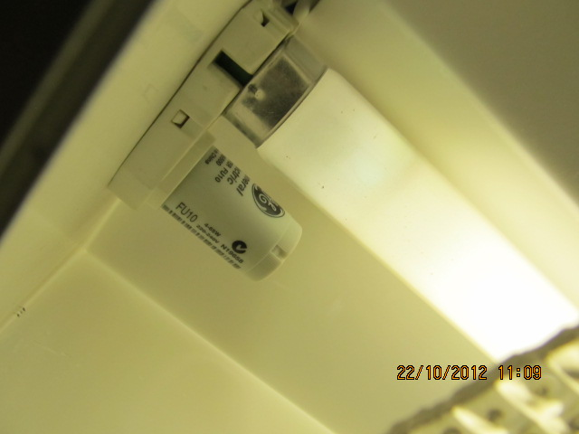

### Ballasts for metal halide and mercury vapour lamps

Mercury vapour lamps (see *Appendix B: Common lamp types*) will normally operate with magnetic ballasts (the default assumption).

Metal halide lamps can use either magnetic or electronic ballasts and the difference in power consumption is significant.

For metal halide lamps with separate ballast, the ballast type shall be determined as follows:

* By physical evidence such as sighting the ballast (preferred method).
* By documented evidence such as as-installed equipment lists.

If neither observation nor documented evidence is available for the existing lighting system, a default evaluation of ‘magnetic ballast’ must be recorded with reasons for using the default.

Use of a ballast discriminator is not permitted for the identification of metal halide and mercury lamp control gear as it is not sufficiently reliable.

### Transformers for ELV halogen lamps

Extra low voltage (ELV) halogen lamps will be supplied by a magnetic or electronic transformer.

Magnetic transformers are significantly heavier and bulkier than electronic units (see *Figure 4* and *Figure 5* below).

Figure 4: Electronic transformer (top) and magnetic transformer (bottom)

Figure 2:
This picture shows two items:
1) The top item is an example of an electronic transformer
2) The bottom item is an example of the a magnetic transformer

Figure 5: Magnetic transformer in ceiling space

Figure 3:
This picture shows an example of a magnetic transofrmer in a ceiling space

For ELV lamps, the transformer type shall be determined as follows:

* By physical evidence such as sighting the transformer (preferred method).
* By documented evidence such as as-installed equipment lists.

If neither observation nor documented evidence is available for the existing lighting system, a default evaluation of ‘magnetic transformer’ must be recorded with reasons for using the default.

Use of a ballast discriminator is not permitted for the identification of ELV halogen lamp transformers as it is not sufficiently reliable.

### LED Control Gear

An LED driver is typically an electronic power supply that controls the power and voltage supplied to an LED lamp.

Total Luminaire Power for LED luminaires is the input power of the LED lamp(s) plus the LED driver(s).

## Documentation requirements – Luminaires

The Assessor must retain the following documentation, complying with *Section 3.1 Acceptable Data*, to validate information for each type of luminaire used in the assessment i.e. for each luminaire included in the luminaire schedule.

All luminaire documentation must be organised or labelled in a manner that enables direct identification of the luminaire against the Assessor Portal luminaire schedule.

* Lamp type and lamp power evidence (listed in order of precedence):
  + Zoomed-in photograph clearly showing lamp power markings or labels.

**OR**

* + Zoomed-out photograph of the luminaire in-situ **AND** additional photographs of replacement lamp stocks stored at the site clearly showing lamp power markings or labels.

**OR**

* + Zoomed-out photograph of the luminaire in-situ **AND** as installed equipment lists or schedules clearly showing lamp power information.

**OR**

* + Site notes confirming reasons for use of default lamp values as per *Section 5.4.6 Default lamp values*.

**OR**

* + Test results for lamps or luminaires tested under the provisions of *Section 5.4.4 Measurement of non-standard lamp wattage* (if applicable) **OR** lamp/luminaire manufacturers data (such as a product specification).

**AND**

* Number of lamps per luminaire evidence:
  + Photograph clearly depicting number of lamps in luminaire.

**OR**

* + Site notes confirming number of lamps in luminaire.

**OR**

* + As installed equipment lists, schedules or diagrams clearly depicting number of lamps in luminaire.

**AND**

* Photograph of control gear or ballast **AND / OR** ballast discriminator response (only required where the lamp type could operate with either electronic or magnetic ballast such as T8 fluorescent lamps).

**AND**

* Evidence of intentional delamping (if applicable):
  + Photograph of stickers/other evidence showing delamping is intentional.

**OR**

* + Site notes confirming more than 80% of luminaires have been delamped.

Examples of acceptable and unacceptable photographs are provided in *Appendix G: Examples of photographic evidence*. Requirements for submitted photographic evidence include:

* Photographs must be of sufficient quality that the information they are intended to convey is easily discernible (e.g. lamp power).
* Photographs must include a date stamp showing the day they were taken, either on the photograph image or within the photograph file properties.
* All photographs taken prior to the Assessment Date are unacceptable, including those from a previous TLA, unless:
  + a clear statement of reasons has been provided which explains why photographs taken on or after the Assessment Date cannot be obtained

**AND**

* + the CBD Administrator has subsequently provided written approval for the use of the photographs in question.

Assessors are not required to take a photograph of every luminaire used in every Functional Space assessment.

Assessors are only required to collect evidence of each luminaire type included in the luminaire schedule used in the TLA. For example, where 2x36W T8 magnetic ballast fluorescent tube luminaires are used across all floors of a building, only one set of evidence is required to be collected by the Assessor for that luminaire, as there is only one luminaire in the luminaire schedule.

This set of evidence could include a:

* photograph of the entire 2x36W T8 luminaire in-situ.
* copy of the installed equipment list for the tenancy.
* photograph showing both 36W T8 tubes in the luminaire in-situ.
* photograph of lamp starters in the luminaire, confirming presence of magnetic ballasts.
* Discriminator test photograph (red/green) indication (See Section 5.5.1 - Ballasts for fluorescent lamps for details)
* photograph clearly showing lamp power markings or labels

Assessors should be sensitive to tenant concerns regarding photographs being taken within their tenancy. To ensure a smooth assessment process Assessors should contact the tenant prior to beginning the assessment and explain:

* why they are doing the TLA and what the assessment will involve (checking lamps, ceiling grids, measuring areas and checking lighting controls).
* what will be included in the photographs (lamps, ceiling grids, controls etc).
* what won’t be included in the photographs (computer screens, desk tops, staff, white boards or posters etc).
* that the tenant can review the photographs at the end of the assessment if required.

# NLPD assessment

## Background

This section deals with selecting a Nominal Lighting Power Density (NLPD) assessment methodology appropriate to the space being assessed.

In lighting systems in which up to two luminaires are arranged in a regular array, the Grid Method may be used to assess NLPD. The luminaire power is divided by the area that the luminaire covers.

In lighting systems in which there is an irregular layout of luminaires or where a number of different luminaire types are installed, an Aggregate Method may be used to assess NLPD. The sample space is chosen by the Assessor and the Total Luminaire Power within this Aggregate Method sample space is calculated and divided by sample space floor area.

Examples of NLPD calculations are provided in *Appendix D: NLPD calculation examples*.

## Identifying the General Lighting System (GLS)

The GLS is the lighting system generally used to illuminate the Open Office Spaces in the tenancy. This may consist solely of luminaires that were present before fit-out, or may include a combination of original luminaires and extra or different luminaires installed by the tenant. The NLPD assessment does not differentiate between base building luminaires and tenant-installed luminaires.

For most offices, the GLS is best represented by the lighting in the Open Office Space. However, for spaces that have been extensively fitted out with small cellular offices, the lighting system in these areas can also be used in the assessment under Aggregate Method 2 and Aggregate Method 3.

Specialist spaces such as meeting rooms and conference rooms are less likely to have an installed lighting system that represents the GLS, due to the installation of architectural or feature lighting. These are not used in the NLPD assessment of the GLS, except under Aggregate Method 3.

Desk-mounted task lighting and display lighting do not form part of the GLS. In mezzanine and other high-ceiling areas, luminaires should only be counted in the GLS where they are designed to cast light onto the Functional Space being assessed.

In the rare instances where none of the methods described in these Rules can be applied to a Functional Space, the Functional Space may be determined as Non-Assessable (see *Section 2.4 Non-Assessable spaces)*.

## Selecting the NLPD assessment method

### Confirm the space is Assessable

Prior to assessing the NLPD an Assessor must first confirm that the Functional Space is Assessable i.e. does not the meet the criteria for a Non-Assessable space as defined in *Section 2 Key concepts and definitions* and the requirements outlined in *Section 2.4 Non-Assessable spaces*.

### NLPD assessment method selection

Four different methods are permitted for the assessment of NLPD. The selection of which method to use is determined based on the characteristics of the lighting system and the available documentation. This is shown in the flow chart shown in *Figure 6*.

Assuming the Functional Space has been deemed Assessable, Assessors can select any of the four available NLPD assessment methods as long as the documentation requirements specified in *Section 6.4 Documentation requirements – NLPD* for each method can be achieved, and the relevant criteria for the chosen assessment method can be met.

Examples of NLPD calculations are provided in *Appendix D: NLPD calculation examples*.

Previous versions of the TLA Rules required Assessors to first establish that the Grid Method was not viable, before looking at the three Aggregate Methods. This requirement has been removed in the version 4.0 TLA Rules, allowing Assessors to choose the most appropriate method for the Functional Space they are assessing and reduce the time and documentation required to complete their assessment.

Figure 6: NLPD assessment method selection flow chart

Repeating block of up to two luminaires exists

Grid Method

Repeating block covers at least 50% of Functional Space area or at least 250m2

There is minimal variation in luminaire types compared to the chosen repeating block

Verify that Open Office space is at least 50% of Functional Space area or at least 250m2

Aggregate Method 1

Verify that Open Office space plus Cell Office space is at least 50% of Functional Space area or at least 250m2

Aggregate Method 3

Functional Space is Assessable

Aggregate Method 2

Collect documentation meeting section 6.4 requirements

### Grid Method

The Grid Method is a simple method for assessing Functional Spaces with a repeating grid of up to two luminaire types, allowing for minor luminaire variations. Grid spacing may be regular in one direction and alternating in another direction, in which case the Grid Method evaluation can be based on the average grid spacing.

Some Functional Spaces have very easily discernible repeating grid patterns of luminaires, while others can be more difficult to assess.

Repeating grids of up to two luminaires can sometimes contain luminaires that appear ‘out of alignment’ with the general repeating grid, but the key consideration for an Assessor is whether the area per luminaire(s) is consistent across the Open Office Space. Within the consistent repeating area block it is permissible to have significant differences in positioning of luminaires.

Another common example is alternating grid patterns i.e. luminaires are either on one side or the other of the repeating block, which again must be assessed on the basis of whether the area per luminaire(s) is consistent across the Open Office Space.

The Grid Method can only be used when there is sufficient Open Office Space as per the below criteria.

**Criteria**

The Grid Method is permitted where:

* A simple repeating block consisting of up to two luminaires (of the same or different types) from the GLS serving Open Office space can be identified.

**AND**

* This block is generally repeated throughout Open Office Space of at least 50% of the Functional Space area, or at least 250m², whichever is smaller.

**AND**

* Throughout the Open Office Space areas there are only minor variations in the types of luminaires present, compared to the luminaires included within the simple repeating block.

**AND**

* Documentation requirements for the Grid Method can be met as per *Section 6.4 Documentation requirements – NLPD*.

**Process**

1. Identify the luminaire types in the repeating grid (maximum of two luminaire types).
2. Calculate the area of the repeating block (± 5% accuracy).
3. Verify that the repeating grid covers at least 50% of the Functional Space area or at least 250m², whichever is smaller.
4. Make site notes confirming that there are only minor variations in the types of luminaires present in the Functional Space, compared to the simple repeating block being assessed.
5. The Assessor Portal calculates the NLPD as total Wattage of luminaires within the repeating block divided by the area of the repeating block.

In version 4.0 of the TLA Rules, the criteria for using the Grid Method have been updated. The intention is to allow a broader use of the Grid Method in Functional Spaces where a simple repeating luminaire block is present with a small number of different luminaires (often due to tenant changes to the original Open Office Space GLS in the Functional Space).

When using the Grid Method, Assessors must make site notes confirming that there are only minor variations in the types of luminaires present in the Open Office Space, compared to the simple repeating block being assessed.

Examples of minor variations include:

* Three 600mm 14W T5 fluorescent tube fittings near corridors and doorways in a large Open Office Space otherwise serviced by a repeating 2 x 1200 mm 28W T5 grid.
* Five compact fluorescent downlights near meeting rooms and a security gate in a large Open Office Space otherwise serviced by a repeating 2 x 32W LED panel grid.

Where Assessors are unsure about the impact of different types of luminaires, they can contact the CBD Administrator for assistance and a determination.

### Aggregate Method 1

Aggregate Method 1 is used where there is sufficient Open Office Space (as per the below criteria) to characterise the GLS but no regular lighting grid. Aggregate Method 1 is used when the Open Office Space is at least 50% of the Functional Space area or at least 250m², whichever is smaller.

The qualifying Open Office Space areas need not be contiguous, but may be made up of a number of separate Open Office Spaces added together.

**Criteria**

Aggregate Method 1 is permitted where:

* There is Open Office Space of at least 50% of the Functional Space area or at least 250m², whichever is smaller.

**AND**

* Documentation requirements for Aggregate Methods can be met as per *Section 6.4 Documentation requirements – NLPD*.

**Process**

1. Identify, as the Aggregate Method 1 Sample Space, an Open Office Space that is:
   1. at least 50% of the area of the Functional Space or at least 250m² of Open Office Space, whichever is smaller.

**AND**

* 1. contains all of the luminaire types present in the Open Office Space in a similar proportion to the whole of the Open Office Space.

1. If a similar proportion of luminaire types cannot be achieved, then the whole of the Open Office Space is to be used as the Aggregate Method 1 Sample Space.
2. Prepare a simple drawing of the Aggregate Method 1 Sample Space and calculate the sample space area (± 5% accuracy). The drawing can be:
   1. to scale

**OR**

* 1. not to scale and provided with sufficient dimensioning to enable demonstration of the area calculation.

1. Identify and count all GLS luminaires in the Aggregate Method 1 Sample Space. Do not count task lighting or display lighting.
2. The Assessor Portal calculates the NLPD as the sum of the Wattage of all luminaires in the Aggregate Method 1 Sample Space divided by the area of the Sample Space.

### 

### 

Aggregate Method 2 is similar to Aggregate Method 1 but also includes Cell Office Space as well as Open Office Space. Aggregate Method 2 is used when the Open Office Space plus Cell Office Space is at least 50% of the Functional Space area or at least 250m², whichever is smaller.

The qualifying Open Office Space and Cell Office Space areas need not be contiguous, but may be made up of a number of disconnected Open Office and Cell Office areas added together.

**Criteria**

Aggregate Method 2 is permitted where:

* There is Open Office Space plus Cell Office Space of at least 50% of the Functional Space area or at least 250m², whichever is smaller.
* Documentation requirements for Aggregate Methods can be met as per *Section 6.4 Documentation requirements – NLPD*.

**Process**

1. Identify, as the Aggregate Method 2 Sample Space, an area consisting of Open Office Space(s) and Cell Office Space(s) that is:
   1. in total at least 50% or more of the area of the Functional Space or at least 250m², whichever is smaller.

**AND**

* 1. contains all of the luminaire types present in the Aggregate Method 2 Sample Space in a similar proportion to the entire Open Office Space and Cell Office Space.

1. If a similar proportion of luminaire types cannot be achieved, then the total combined Open Office Space and Cell Office Space is to be used as the Aggregate Method 2 Sample Space.
2. Prepare a simple drawing of the Aggregate Method 2 Sample Space and calculate the sample space area (± 5% accuracy). The drawing can be:
   1. to scale

**OR**

* 1. not to scale and provided with sufficient dimensioning to enable demonstration of the area calculation.

1. Identify and count all GLS luminaires in the Aggregate Method 2 Sample Space. Do not count task lighting or display lighting.
2. The Assessor Portal calculates the NLPD as the sum of the Wattage of all luminaires in the Aggregate Method 2 Sample Space divided by the Aggregate Method 2 Sample Space area.

### Aggregate Method 3

Aggregate Method 3 can be used as the default NLPD assessment method for any Assessable Functional Space.

**Criteria**

Aggregate Method 3 is permitted where:

|  |
| --- |
|  |

* Documentation requirements for Aggregate Methods can be met as per *Section 6.4 Documentation requirements – NLPD*.

**Process**

1. The Aggregate Method 3 Sample Space area is the entire Functional Space area, determined according to the Measurement Standard.

The Assessor Portal will automatically fill in the Aggregate Method 3 Sample Space area from the previously entered Functional Space area.

1. Identify and count all GLS luminaires in the Functional Space. This will include all areas that are part of the Functional Space NLA, including any meeting rooms, Cell Offices etc. Do not count task lighting or display lighting.
2. The Assessor Portal calculates the NLPD as the sum of the Wattage of all luminaires in the Functional Space divided by the Functional Space area.

## Documentation requirements – NLPD

The Assessor must retain the following documentation, complying with *Section 3.1 Acceptable Data*, to validate the NLPD assessment calculations:

* Non-Assessable Spaces: See *Section* *2.4.2* for documentation requirements.
* Grid Method:
* Illustrate minimum grid coverage: Reflected Ceiling Plan **OR** Assessor’s sketch identifying the area of the Functional Space covered by the grid (not to scale but sufficient to illustrate requirements).

**AND**

* Demonstrate regular repeating grid pattern: Reflected Ceiling Plan **OR** Assessor’s sketch of grid coverage **OR** photograph demonstrating regular grid.

**AND**

* Evidence of simple repeating block area: Site measurements **OR** evidence of standard ceiling tile size and site photographs confirming number of tiles per block **OR** reflected ceiling plan (to scale) showing ceiling tiles and regular repeating grid.



**AND**

* Photographs **OR** site notes identifying all assessed luminaire types present within the open office space.
* Site notes confirming only minor variations in luminaire types across the Open Office Space compared to the simple repeating grid being assessed.
* Aggregate Methods:
* Floor plan clearly showing the Aggregate Method sample space. This must either be to scale or sufficiently dimensioned to demonstrate area calculations (i.e. providing length and width of rectangular areas).

**AND**

* Aggregate Method sample space area calculations (±5% accuracy).

**AND**

* Photographs **OR** site notes identifying all assessed luminaire types present within the Aggregate Method sample space.

**AND**

* Site notes identifying a count of all luminaires within the Aggregate Method sample space (locations are not required).

All documentation must be organised or labelled in a manner such that it can be directly identified against the Functional Spaces listed in the Assessor Portal.

Assessors should ensure that documentation retained for audit is sufficiently detailed to allow the CBD Administrator or an Auditor to understand why decisions were made, and in particular, why different NLPD assessment methods were used.

For Aggregate Methods this means Assessors must document their area measurements and calculations when defining an Aggregate Method Sample Space appropriately, including providing both length and width of all rectangular areas used to generate Aggregate Method Sample Space area.

Providing a square metre area figure, with no information on how this was calculated, will not meet the requirements specified in these Rules and may result in an adverse outcome for the Assessor if the assessment is audited.

# Lighting control assessment

## Background

The energy efficiency of a lighting system is heavily influenced by how it can be controlled. Lighting control systems operate to reduce the operating power by switching or dimming the lighting and therefore can have a significant impact on the overall performance of the lighting system. Owing to the complexity of dimming systems, and their second-order impact relative to time of use controls, dimming is not considered within the lighting control assessment.

It is not practical to assess the effectiveness of an installed lighting control system because of the possibility that the system is not operating as intended. For this reason, the assessment process is designed to identify and report on the capacity of the installed lighting control system(s) installed in each Functional Space, rather than including the lighting controls in the NLPD calculation.

This is an assessment of the potential for the lighting control system to manage the lighting operation.

## Identifying lighting control system capacity

### Overall methodology

The Assessor shall make an assessment of the capacity of the installed lighting control system, which is a measure of its potential to closely match the operation of the Functional Space lights with the needs of the occupants.

The lighting control assessment is made across the entire Functional Space area. The sample areas used in the NLPD assessment have no relevance to the lighting control assessment i.e. the lighting control assessment must assess the lighting control system for the entire Functional Space being assessed.

The applicable controls type is the highest rated level of controls that is being used in more than 50% of the Functional Space.

Lighting control capacity shall be assessed as Good, Moderate or Poor as detailed in *Figure 7*.

Figure 7: Lighting control assessment methodology flow chart

More than 50% of the space on occupancy controls?

More than 50% of the space on timer and/or supervisory controls?

Occupancy control

Timer control

Manual control

YES

Are **ALL** lighting control zone sizes less than 100m2?

Is the functional space area less than 250m2?

YES

NO

NO

NO

Good

Moderate

Poor

NO

YES

YES

**STEP 1**

**Identify   
control type**

**Control type**

**STEP 2a**

**Identify control zone size**

**STEP 2b**

**Functional space area**

**Control capacity**

### Step 1: Identifying the control type

#### Occupancy Control

A luminaire is under occupancy control if the highest level of control for its operation is via the use of an occupancy sensor.This includes a luminaire that is:

* connected to a supervisory control system (circuit or individual ballast based) that has occupancy sensors available for control.
* connected to a hardwired circuit that is controlled via an occupancy sensor.
* controlled by timer controls at some times and by occupancy sensors at other times.

#### Timer control

A luminaire is under timer control if the highest level of control for its operation is via the use of a timer. This includes a luminaire that is:

* connected to any form of Supervisory Control System.
* controlled by a time switch.
* interlinked to turn off on the setting of the site security alarm.

Mechanical push button delay timers are not considered a type of timer control in these Rules.

#### Manual control

Manual control is any form of control that does not meet the requirements of ‘occupancy control’ or ‘timer control’.

Note there are no documentation requirements for manual control, and this control type can be selected as the default option where no evidence of lighting controls is available.

#### Decision methodology for control type

The Assessor shall determine the control type via the definitions above in combination with the flow chart shown in *Figure 7.*

In determining the control type, each identifying feature required to determine the control type must be documented as per *Section 7.3 Documentation requirements.*

If the required documentation is not available or cannot be provided, the identifying feature cannot be used to determine the control type, which may result in the control type being downgraded.

### Step 2a: Identify control zone size

Assessment of lighting control zone area is only necessary for Functional Spaces that have been deemed to be under occupancy control.

A lighting control zone consists of the area associated with the light fittings under a single control point. The area is measured to the midpoint between the included fittings and the fittings in the next adjacent control zone. Note that one control point may be associated with several motion sensors in the same control zone, such that triggering any one motion sensor will activate all luminaires in the zone. The control zone should be sized to include all luminaires that are activated when the motion sensor is triggered.

The control zone area must be demonstrated by a marked up scale drawing or controls diagram that shows the lighting fittings, separates these into each control zone and shows the calculated area for each lighting control zone.

The sum of the calculated lighting control zone areas must be greater than or equal to the total Functional Space area, allowing for some overlap of lighting control zones.

To qualify for consideration under the Good category, ALL lighting control zones within the Functional Space must be less than 100m².

Counting the total number of occupancy sensors and dividing by the total Functional Space area is not a permissible method of calculating the lighting control zone size.

Where Assessors have identified occupancy control systems integrated into individual luminaires, these Functional Spaces will automatically qualify for a rating of ‘Good’ control capacity i.e. ALL lighting control zones within the Functional Space are less than 100m², where Assessors have:

* confirmed that all assessed luminaires in the Functional Space include integrated occupancy sensors.
* obtained a product data sheet or similar detailing the occupancy control capabilities of the luminaire in question.
* confirmed that individual luminaires are actually being automatically controlled by integrated occupancy sensors, as opposed to groups of luminaires.

### Step 2b: Functional Space area

Consideration of Functional Space area is only necessary for Functional Spaces that have been determined to be under manual control.

The control capacity of a Functional Space is classified as ‘Poor’ if:

* it is under manual control
* it has an area of 250m2 or greater

The control capacity of a Functional Space is classified as ‘Moderate’ if:

* it is under manual control
* it has an area smaller than 250m2

### Control capacity

The Assessor Portal will automatically allocate the Functional Space a Control Capacity rating of Good, Moderate or Poor based on the Assessor input. This follows the process shown in *Figure 7*, resulting in the ratings shown in *Section 1.1.2 Lighting control systems.*

## Documentation requirements – Lighting Controls Assessment

If the required documentation is not available or cannot be provided, the identifying feature cannot be used to determine the control type. This may result in the control capacity being downgraded.

The Assessor must retain the following documentation, complying with *Section 3.1 Acceptable Data*, to validate the control system selection:

* Sketch or commentary reasonably demonstrating the coverage the control system as being greater than 50% of Functional Space area.
* Presence of occupancy sensors:
* Photograph of occupancy sensors **OR** product page from manual.

**AND**

* Drawing/control diagram of location of sensors **OR** Assessor sketch of location of sensors **OR** Assessor count of number of sensors.
* Occupancy control zone size calculations:
* Scale drawing or lighting controls diagram showing the luminaires, occupancy sensors and marked up to show each control zone.

**AND**

* Clear measurements showing the calculated area for each lighting control zone, highlighting the largest lighting control zone identified in the Functional Space.

Counting the total number of occupancy sensors and dividing by the total Functional Space area is not a permissible method of calculating the lighting control zone size.

See

*Appendix E: Lighting control assessment examples* for worked examples of lighting control zone calculations.

* Presence of integrated occupancy sensor controls in luminaires:
* Photograph of occupancy sensors integrated into luminaires.

**AND**

* Product data sheet or similar detailing occupancy control capabilities of the luminaire.

**AND**

* As installed equipment lists **OR** reflected ceiling plans **OR** lighting diagrams confirming that all assessed luminaires in the Functional Space include integrated occupancy sensor controls.
* Presence of Supervisory Control System:
* Copy of system description from manual identifying supervisory control system.

**OR**

* Photograph of supervisory system hardware or interface.

**OR**

* Other drawings or documentation that demonstrates presence of supervisory control system.

**OR**

* Photograph of light switch showing that it is a toggle type e.g. standard toggle switch or a spring return press switch **OR** photograph of Supervisory Control System controllers.
* Presence of timer controls:
* Copy of system description from manual identifying timer control.

**OR**

* Other drawing or documentation that demonstrates presence of timer control.

**OR**

* Photograph indicating presence of after-hours lighting control independent of normal switching.

**OR**

* Site confirmation that a time switch control is in use **AND** photograph of time switch.

**OR**

* Site confirmation that Building Management System (BMS) time switch control is in use **AND** photograph of BMS time switch schedule for each Functional Space.
* Manual control:
* Default ‘worst case’ control system selection.
* No documentation requirements.

All documentation must be organised or labelled in a manner such that it can be directly identified against the Functional Spaces setup in the Assessor Portal.

# Performance comments

## Background

The TLA allows for a single comment to be placed against each Functional Space to describe any additional features of the lighting system that may affect its energy or functional performance.

## Performance comments

Only a single ‘performance comment’ may be applied to each Functional Space and that is limited to the list available in the Assessor Portal, as shown in *Table 3*.

If several comments apply, the Assessor should select the one that appears to be having most impact on the energy consumption.

Table 3: Performance comments list

| **Performance Comment** | **Situation** |
| --- | --- |
| Luminaires delamped | Luminaires have been delamped in a regular or planned fashion. |
| Voltage reduction or dimmer devices used | Voltage reduction devices or dimmers have been used that may reduce lighting circuit power in operation. |
| T5 adapters used | Adapters have been used to retrofit linear fluorescent lamps with T5 lamps. |
| Desktop task lighting used | Lighting design may be reliant on the use of task lighting to provide adequate illumination for normal office tasks. |
| Low illuminance levels | Illuminance levels appeared to be below normal office levels. |
| Ceiling height greater than 3m | Lighting power density may be higher than normal due to the high ceiling. |
| Many cellular offices | Lighting power density may be higher due to large numbers of cell offices. |

# Proposed systems

## Background

There may be cases where the building owner intends to upgrade the lighting system of the Functional Spaces to be assessed soon after the assessment has been completed. Alternatively, there may be a make-good clause in the lease agreement that requires the incumbent tenant to return the lighting system to its original state when vacating the tenancy.

Providing that there is a contractual commitment to proceed with the proposed installation which includes detailed design drawings and equipment specifications, the proposed lighting system may be assessed based on the available documentation.

In this case, both the installed lighting system and the proposed lighting system are assessed and reported in the BEEC.

## Eligibility of proposed systems

Where building owners expect that the existing lighting system will change soon after the assessment, they may request an additional assessment of the proposed lighting system. The upgrade may be as a result of an owner initiative or because existing tenants need to meet the make good provisions of their lease.

The assessment of the proposed system can only be done in addition to the assessment of the existing system and strict eligibility criteria must be met.

To be eligible for assessment, building owner proposed upgrades must meet all of the following criteria:

* A signed contract exists, committing the building owner to the upgrade.
* The contract completion date is within three months of the Assessment Date (122 days).
* There is detailed design documentation that provides all the information required for the assessment. This shall include reflected ceiling plans, lighting circuits, control strategies, equipment schedules and technical specifications.

To be eligible for assessment, upgrades resulting from make good provisions must meet all of the following criteria:

* There is an enforceable clause in the lease agreement requiring the tenant to return the lighting system to its original state.
* There is an agreed make-good completion date falling within three months of the Assessment Date (122 days).
* There is detailed design documentation that provides all the information required for the assessment. This shall include RCPs, lighting circuits, control strategies, equipment schedules and technical specifications.

## Assessing proposed systems

The assessment process is identical to the process used to assess the installed lighting system except that it is completed from contractual design information.

## Documentation requirements – Proposed Systems

Documentation requirements for the technical details of the proposed system are as listed in *Section 2 Key concepts and definitions* through to *Section 7 Lighting control assessment*.

In addition, the following documentation must be retained by the Assessor where an additional assessment of a proposed lighting system is conducted:

* Copy of a signed contract committing the building owner to the upgrade. The contract must show the completion date to fall within 122 days of the Assessment Date.

**OR**

* Copy of the lease agreement that satisfies requirements stated in *Section 9.2 Eligibility of proposed systems*.

**AND**

* Detailed design documentation such as those specified in *Section 9.2 Eligibility of proposed systems*.

# 

# Appendices

## Appendix A: Information checklist for certified Tenancy Lighting Assessments

The following information may be required to complete a certified TLA. This data should be obtained prior to and during the site assessment by the Assessor, working in conjunction with the building owner/manager and the building tenants.

A site visit is compulsory to identify and count luminaires, photograph ceiling grids and luminaires, establish NLPD assessment methods and measure Aggregate Method sample space areas where applicable.

All documentation and data used for TLAs must comply with *Section 3.1 Acceptable Data.*

All data collected during a TLA is required to be kept on file by the Assessor for seven years, for audit purposes. See *Section 3.4 Documentation and Record-keeping.*

|  |  |  |  |
| --- | --- | --- | --- |
| **Item** |  | **Information checklist** | **Comment / data requirements** |
| For each Functional Space - Confirm Functional Space details | ❑ | Confirm that the area documentation provided for each Functional Space meets the measurement standard for determining office NLA. | *Section 4.2 Determining office NLA* |
| ❑ | Make any amendments to the provided floor plans where this may affect the assessment. |  |
| ❑ | Confirm correct Functional Space name i.e. Level 1 Suite 1 and tenant name. | *Section 4.3.2 Naming Functional Spaces* |

| For each Functional Space - Confirm the Functional Space is Assessable |  | A Functional Space is Non-Assessable if: | *Section 2.4 Non-Assessable spaces* |
| --- | --- | --- | --- |
| ❑ | The space is smaller than 50m2  **OR** | Refer to Functional Space area information confirmed as per *Section 4.2 Determining office NLA* |
| ❑ | The space does not contain at least 50m2 of Open Office Space  **OR** | Mark up a floor plan with dimensions clearly showing the Functional Space has less than 50m² of Open Office Space |
| ❑ | Open Office Space is not at least 15% of total Functional Space area  **OR** | Mark up a floor plan with dimensions clearly showing Open Office Space is less than 15% of the total Functional Space area. |
| ❑ | There is no existing or proposed lighting system. | Take photographs demonstrating no installed lighting system  **AND**  Make site notes confirming there is no contractual agreement for a proposed lighting system (see *Section 9 Proposed systems)*. |

| For each Functional Space – Confirm Luminaire details | ❑ | Identify all luminaire types in the Functional Space GLS. | *Section 5.3 Luminaire schedule* |
| --- | --- | --- | --- |
| ❑ | Take photographs showing number, type and wattage of all lamp types present in all luminaires used in the GLS (where not already completed).  Collect equipment lists and additional photographs of replacement lamp stocks where in-situ lamp photographs are unable to be taken. | Note Assessors only need to take photographs/document each luminaire type once for evidence purposes i.e. every luminaire identified in the luminaire schedule must have one set of associated documentation.  *Section 5.4 Lamp details* |
| ❑ | Take photographs, use a ballast discriminator or collect other evidence confirming ballast type or control gear type for all lamps used in the GLS. | Other evidence can include photographs of lamp starters or documented evidence such as installed equipment lists.  *Section 5.5 Identifying the ballast* |
| ❑ | Where lamp type or power cannot be determined, include the name and description of the luminaires in site notes and use default lamp type/wattage. | *Section 5.4.6 Default lamp values* |
| ❑ | Photograph of stickers/other evidence delamping is intentional.  **AND**  Site notes confirming more than 80% of luminaires have been delamped. | Evidence of intentional delamping.  See *Section 5.4.7* *Treatment of delamped luminaires*. |

| For each Functional Space - Confirm NLPD assessment method | Identify the appropriate NLPD assessment method: | |  |
| --- | --- | --- | --- |
| NLPD assessment:  Grid method | ❑ | Confirm repeating luminaire grid covers at least 50% of the Functional Space area, or at least 250m2 (whichever is smaller). | Obtain RCPs, mark up tenancy floor plans or make site notes to document repeating luminaire grid coverage. |
| ❑ | Take photographs of the ceiling grid that clearly show luminaire spacing and type. | Ensure photographs are clear and easily understood, take multiple angles if required. See *Appendix F: Example documentation storage and labelling methodology*. |
| ❑ | Take photographs of the ceiling grid that clearly show the number of tiles in each repeating grid unit. | Make site notes documenting repeating grid size i.e. 4 x 2 tiles. Confirm through additional site notes any variation in the area of the repeating grid unit i.e. 4 x 2 tiles with alternating 3.5 x 2 tile repeating grid units. |
| ❑ | Confirm that there are only minor variations in luminaire types across the Open Office Space compared to the simple repeating grid being assessed. | Make site notes confirming only minor variations in luminaire types, see *Section 6.3.3 Grid Method*. |

| NLPD assessment:  Aggregate Methods |  | Aggregate Method 1, 2 and 3 all require similar documentation and evidence: | See *Section 6.4 Documentation requirements – NLPD.* |
| --- | --- | --- | --- |
| ❑ | Aggregate Method 1  Mark up floor plans clearly showing Open Office Space dimensions and measurements. | Confirm Open Office Space is at least 50% of the Functional Space area or at least 250m2, whichever is smaller. |
| ❑ | Aggregate Method 2  Mark up floor plans clearly showing Open Office Space and cell office area dimensions and measurements. | Confirm Open Office Space plus Cell Office Space is at least 50% of the Functional Space area or at least 250m2, whichever is smaller. |
| ❑ | Aggregate Method 3  Count all GLS luminaires in the Functional Space. | No minimum requirements, any Assessable Functional Space can be assessed using Aggregate Method 3. See *Section 6.3.6 Aggregate Method 3* and also *Figure 6*. |
| ❑ | Confirm sample space contains all of the luminaire types present in the Open Office Space in a similar proportion to the whole Open Office Space. | Make site notes to confirm this has been checked.  Take photograph of irregular luminaire layout. |
| ❑ | Count all GLS luminaires in the sample space.  For Aggregate Method 3, this is all luminaires in the Functional Space. | Make site notes identifying luminaire types and counting all luminaires in the sample space. |
| For each Functional Space - Confirm lighting control type |  | Identify the lighting control type: | Follow the flow chart as per *Figure 7*. |
| ❑ | Occupancy controls - Is more than 50% of the Functional Space operating on occupancy controls? | See documentation requirements as per ‘Lighting control type – Occupancy Controls’ below. |
| ❑ | Timer controls - Is more than 50% of the Functional Space operating on timer and/or supervisory controls? | See documentation requirements as per ‘Lighting control type – Timer Control’ below. |
| ❑ | If neither of the above options is applicable, or control type cannot be determined, then select manual controls. | No documentation requirements for manual controls (default case). |
| Lighting control type:  Occupancy Controls | ❑ | Confirm occupancy controls cover more than 50% of total Functional Space area. | Provide a sketch of controls coverage  **OR**  Marked up floor plan showing controls coverage  **OR**  Reflected ceiling/controls plan showing controls coverage. |
| ❑ | Confirm presence of occupancy sensors. | Take photographs of sensors installed in the Functional Space  **OR**  Provide a copy of the product manual of the occupancy sensor manufacturer. |
| ❑ | Confirm location of occupancy sensors. | Provide a reflected ceiling plan or controls diagram  **OR**  Sketch showing occupancy sensor locations  **OR**  Notes showing count of total number of occupancy sensors. |
| ❑ | Confirm size of largest occupancy sensor control zone (largest zone size must be less than 100m2 to achieve ‘good’ controls rating). | Mark up floor plan or reflected ceiling plan clearly showing area measurements of the control zones covered by the occupancy controls.  See  *Appendix E: Lighting control assessment examples.* |
| ❑ | Confirm details for any luminaires with integrated occupancy sensors | Photograph of occupancy sensors integrated into luminaires.  Product data sheet or similar detailing occupancy control capabilities of the luminaire.  As installed equipment lists **OR** reflected ceiling plans **OR** lighting diagrams confirming that all assessed luminaires in the Functional Space include integrated occupancy sensor controls. |

| Lighting control type:  Timer Controls | ❑ | Confirm timer and/or supervisory controls cover more than 50% of total Functional Space area. | Provide a sketch of controls coverage  **OR**  Marked up floor plan showing controls coverage  **OR**  Reflected ceiling/controls plan showing controls coverage. |
| --- | --- | --- | --- |
| ❑ | Confirm presence of timer controls. | Provide a copy of system description from manual identifying time switch control  **OR**  Other drawings or documentation that demonstrates presence of time switch control **OR**  Photograph indicating presence of after-hours lighting control independent of normal switching  **OR**  Site contact confirmation that timer controls are in use **AND** photograph of time switch  **OR**  Site contact confirmation that BMS timer controls are in use **AND** photograph of BMS timer schedule for each Functional Space. |
| ❑ | Confirm presence of Supervisory Control System. | Assessor to provide copy of system description from operations/maintenance manual identifying supervisory control system  **OR**  Photograph of supervisory system hardware or lighting controllers  **OR**  Other system drawings or documentation that demonstrates presence of supervisory control system  **OR**  Photograph of light switch showing that it is a toggle type (e.g. standard toggle switch or a spring return press switch). |

## Appendix B: Common lamp types

Table 4: Common lamp types

| **Lamp Type** | **Description** | **Lamp Nominal Sizes and Wattages** | **Notes and Examples** | | |
| --- | --- | --- | --- | --- | --- |
| T5 | **Linear fluorescent** with diameter 5/8 inch (16mm).  Only operates on electronic ballast.  Where the specific T5 lamp type is unknown, assume T5 high efficiency (HE) type. | T5 600mm = 14W (HE), 24W (HO)  T5 900mm = 21W (HE), 39W (HO)  T5 1200mm = 28W (HE), 54W (HO)  T5 1500mm =36W (HE), 80W (HO)  ‘Eco’ versions of the HE and HO type lamps are also available, see *Appendix C: Details of luminaire power calculations*.  These are general wattages only and may vary in practice. | A picture of a T5 14 Watt lamp  T5 lamps are noticeably narrower than T8 lamps. | | |
| T5 retrofit adapter | **Linear fluorescent** with adapter to install diameter 5/8 inch (16mm) lamp into fitting designed for diameter 8/8 inch (26mm) lamps. | Various sizes & wattages as above  See *Section 5.4.9 Treatment of T5 adapters* for discussion of retrofit T5 adaptors. | Picture of a T5 retrofit adapter | | |
| T8 or T12 | **Linear fluorescent** with diameter 8/8 or one inch (T8, 26mm) or 12/8 inch (T12, 38mm).  Can be halophosphor, triphosphor or quad phosphor.  Can operate on magnetic or electronic ballast. | T8 600mm = 18W  T8 900mm = 30W  T8 1200mm = 36W  T8 1500mm = 58W  T8 1800mm = 70W  T12 600mm = 20W  T12 900mm = 30W  T12 1200mm = 40W  T12 1500mm = 65W  T12 1800mm = 77.5W  These are general wattages only and may vary in practice. | A picture example of T12 18 Watt lamp | | |
| CFLn | A single-ended **compact fluorescent lamp** with non-integral ballast (i.e. ballast is separate from lamp).  Can operate on magnetic or electronic ballast. | Length ~150mm (typical)  Can vary 120 – 570mm  Various wattages | A picture example of a compact fluorecent lamp with non-integral ballast (CFLn)  These lamps can operate on magnetic of electronic ballast | | A picture example of a compact fluorecent lamp with non-integral ballast (CFLn)  These lamps can operate on magnetic of electronic ballastA picture example of a compact fluorecent lamp with non-integral ballast (CFLn)  These lamps can operate on magnetic of electronic ballast  A picture example of a compact fluorecent lamp with non-integral ballast (CFLn)  These lamps can operate on magnetic of electronic ballast |
| CFLi | A single-ended **compact fluorescent lamp** with integral ballast. | Length ~150mm (typical)  Various wattages | A picture example of a single ended compact fluorescent lamp with integral ballast (CFLi)A picture example of a single ended compact fluorescent lamp with integral ballast (CFLi)A picture example of a single ended compact fluorescent lamp with integral ballast (CFLi)A picture example of a single ended compact fluorescent lamp with integral ballast (CFLi)A picture example of a single ended compact fluorescent lamp with integral ballast (CFLi)A picture example of a single ended compact fluorescent lamp with integral ballast (CFLi) | | |
| Circular fluorescent | A fluorescent lamp in a circular shape  Can operate on magnetic or electronic ballast. | Diameter ~300mm (typical)  22W, 32W, 40W | A picture example of a fluorescent lamp in a circular shape | | |
| Halogen-low voltage | Lighting systems operating on 12 Volts with magnetic OR electronic transformer | 50W, 35W, 20W | A picture example of a low voltage halogenA picture example of a low voltage halogen | | |
| Incandescent / halogen-mains voltage | Mains voltage general purpose lamps and down lights with no ballast or transformer | Various sizes and wattages | A picture example of a incandescent light bulb | A picture example of a halogen light bulb A picture example of a linear halogen light bulb | |
| LED downlights | Becoming more popular as downlights, replacing halogen and compact fluorescent lamps.  Operates with an electronic ballast. | Various wattages | A picture example of an LED downlight in gimble A picture example of a large LED downlight (CFLn replacement)  LED downlight in gimble and large LED downlight (CFLn replacement) | | |
| LED linear fluorescent retrofit tubes | LED replacement for linear fluorescent lamps.  Operates with an electronic ballast | Various wattages | A picture example of a LED T8 retrofit tube A picture example of a frosted LED T8 retrofit tube  LED retrofit tube and frosted LED retrofit tube | | |
| LED Strip light | LED Strip lighting. Increasing use for feature lighting.  Operates with an electronic ballast | Various wattages, typically measured in W/m | A picture example of a 12 volt LED strip lamp | | |
| LED Incandescent retrofit bulbs | LED retrofit for incandescent lamp.  Operates with an electronic ballast | Various wattages | A picture example of a frosted LED incandescent retrofit bulb | | |
| LED Panel | LED panel. Typically installed as a luminous ceiling tile. | Various wattages | A picture example of an LED panel | | |
| Metal halide | Becoming more popular as down lights and spotlights  Can operate on magnetic or electronic ballast. | Reflector diameter ~100mm  20W, 35W, 50W, 70W  (office applications) | A picture example of a metal halideA picture example of a metal halide A picture example of a metal halideA picture example of a metal halide | | |
| Mercury Vapour | Becoming less common in office applications  Usually operates with magnetic ballast, also comes in a self ballasted form which runs on mains voltage. | Various sizes and wattages | A picture example of a frosted mercury vapour light bulb | | |
| Other lamp types | Lamp types not listed above are discussed in *Section 5.4.2*. | Various | N/A | | |

## Appendix C: Details of luminaire power calculations

The luminaire power for each luminaire is determined by the equations reproduced in *Table 5*, which are based on the lamp type and ballast or transformer type. Note that the number of lamps present in each luminaire will also affect the luminaire power.

Table 5: Calculation of Luminaire Power (per lamp)

|  |  |  |
| --- | --- | --- |
| **Lamp Type** | **Luminaire Power  (per lamp, in Watts)** | |
| **Electronic Ballast** | **Magnetic Ballast** |
| Linear fluorescent T12 | N/A | 1.2 x NLP + 2.6 |
| Linear fluorescent T8 | 0.9 x NLP + 2.6 | 1.16 x NLP + 2.6 |
| Linear fluorescent T5 HE | 1.09 x NLP + 0.3 | N/A |
| Linear fluorescent T5 HE Eco | NLP + 0.5 | N/A |
| Linear fluorescent T5 HO | 1.13 x NLP - 1.8 | N/A |
| Linear fluorescent T5 HO Eco | 1.08 x NLP - 4 | N/A |
| CFL-n | 1.06 x NLP | 1.19 x NLP+2.3 |
| CFL-i | NLP | |
| Incandescent / halogen – mains voltage | NLP | |
| Incandescent / halogen – low voltage | 1.02 x NLP.+1.2 | 1.09 x NLP + 4.9 |
| Metal halide | 1.05 x NLP + 6 | 1.11 × NLP + 1.6 |
| Mercury vapour |  | 1.1 x NLP + 10 |
| LED DL | NLP | |
| LED Linear Fluorescent Retrofit | NLP | |
| LED Panel | NLP | |
| LED Strip Light | NLP | |
| LED Track Light | NLP | |

NLP = nominal lamp power

Notes:

* Luminaire power consumption does not deteriorate over time, although the power factor of fluorescent luminaires may deteriorate as the power factor correction capacitor deteriorates.
* Fixed dimming and fluorescent ballasts with a low ballast lumen factor (BLF) are not considered in this Rules document.
* Equations are based on the median of total circuit Watts for a wide range of luminaires based on manufacturer’s data.
* Where a lamp can be selected from the available types above, the use of circuit measurement as per *Section 5.4.4* is NOT permitted.

## Appendix D: NLPD calculation examples

### Grid method – Example 1

*Table 6* summarises the criteria, processes to follow and evidence to retain when conducting a TLA using Grid Method.

Table 6: Grid Method summary table

| **Criteria** | **Process** | **Evidence to retain** |
| --- | --- | --- |
| Repeating blocks | From RCP or site inspection photo, confirm the existence of repeating blocks. | RCP or Assessor’s mock-up of typical grid or photo demonstrating regular grid. |
| Identify repeating block coverage | From RCP or site walk through, confirm the repeating blocks are consistent for either 50% NLA or 250m² (whichever is smaller). | RCP or Assessor’s mock-up drawing identifying the area of the repeating block. |
| Luminaire | From documentation provided or site inspection to identify which type or luminaire listed in *Table 1* is observed in each Functional Space. | Site notes confirming only minor variations in luminaires present I the Functional space compared to the repeating block.  Photographs or site notes identifying all qualifying luminaire types are present within the Open Office Area. |

*Figure 8* is a RCP shows a lighting plan of a typical office space. It can be seen that the general office area is illuminated by only one type of luminaire, a 1x28W T5 recessed troffer. The ceiling tile size is to be confirmed. The luminaire placement shown on the RCP indicates that all T5 lights have been spread evenly in repeating blocks, hence the Grid Method is appropriate under this scenario.

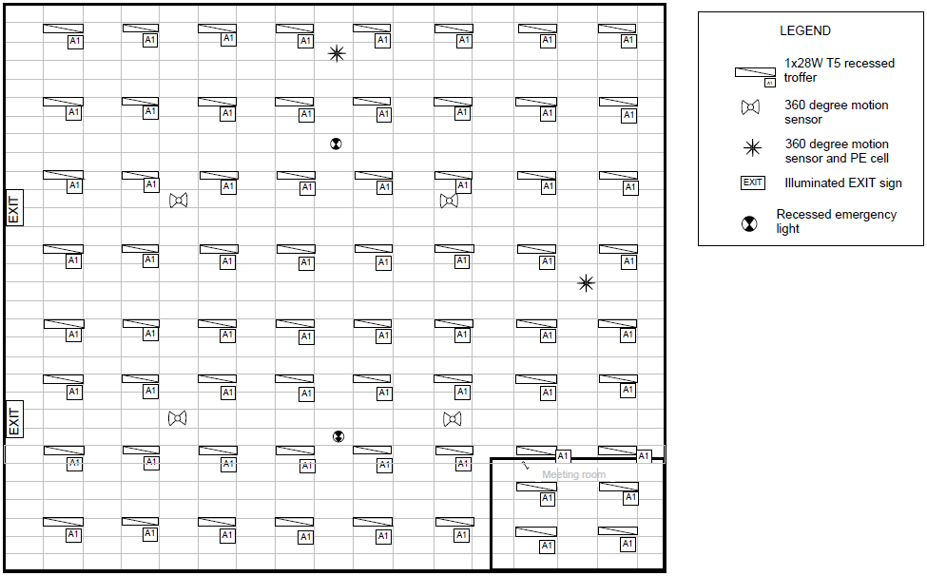

Figure 8: Sample RCP for Grid Method – Example 1

Based on the “Evidence to retain” column in *Table 6*, the following information needs to be obtained.

1. The up-to-date RCP is obtained as shown in *Figure 8*. Alternatively the following two types of evidence are also acceptable.

| assessors mock-up drawing and photo  Figure 9: Assessors mock-up of typical grid | Photo of regular lighting grid with Assessors mock-up.  Figure 10: Photo showing regular grid |
| --- | --- |

1. Assessor’s mock-up drawing on RCP identifying the area of the repeating block is shown in *Figure 11*.
2. Site notes stating that there is minimal variation in luminaires across the Open Office Area is also shown in *Figure 11*.
3. The qualifying luminaire detail is provided on the legend of RCP and verified on site.

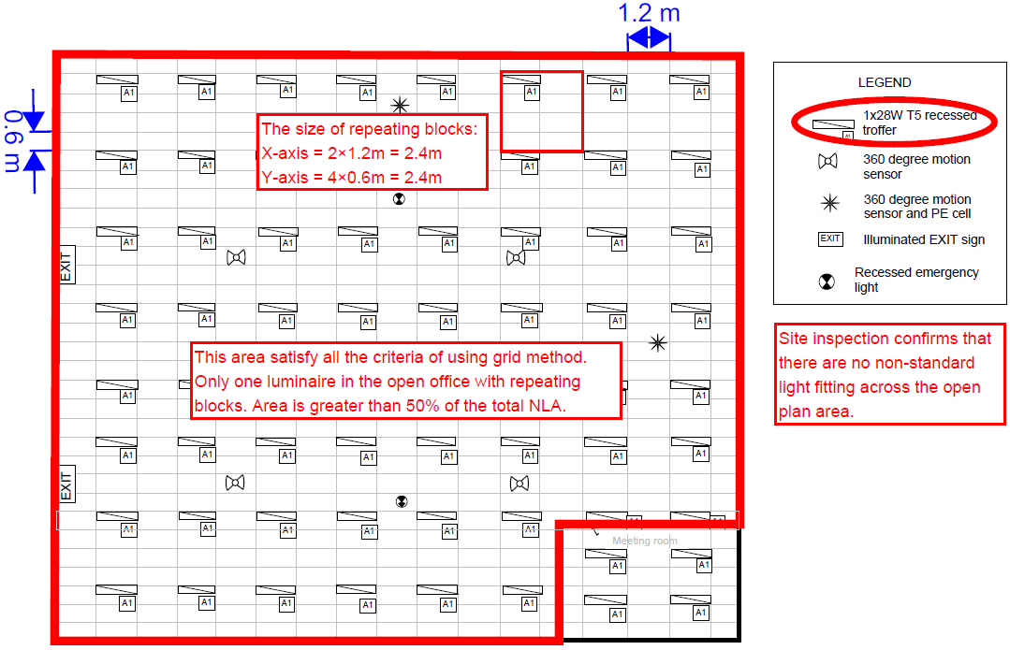

Figure 11: Sample marked up RCP for Grid Method – Example 1

### Grid Method – Example 2

Table 7: Grid Method summary table

| **Criteria** | **Process** | **Evidence to retain** |
| --- | --- | --- |
| Repeating blocks | From RCP or site inspection photo, confirm the existence of repeating blocks. | RCP or Assessor’s mock-up of typical grid or photo demonstrating regular grid. |
| Identify repeating block coverage | From RCP or site walk through, confirm the repeating blocks are consistent for either 50% NLA or 250m² (whichever is smaller). | RCP or Assessor’s mock-up drawing identifying the area of the repeating block. |
| Luminaire | From documentation provided or site inspection to identify which type or luminaire listed in *Table 1* is observed in each Functional Space. | Site notes confirming only minor variations in luminaires present I the Functional space compared to the repeating block.  Photographs or site notes identifying all qualifying luminaire types are present within the Open Office Area. |

*Figure 12* is a marked up RCP shows a lighting plan of an office space. It can be seen that the general office area is illuminated by only one type of luminaire, a 2x36W T8 unit.

The luminaire placement shown on the RCP indicates that there is a repeating grid of the 2x36W T8 luminaires in repeating blocks, hence the Grid Method is appropriate under this scenario. The repeating block size is confirmed as 2.4m x 2.4m.

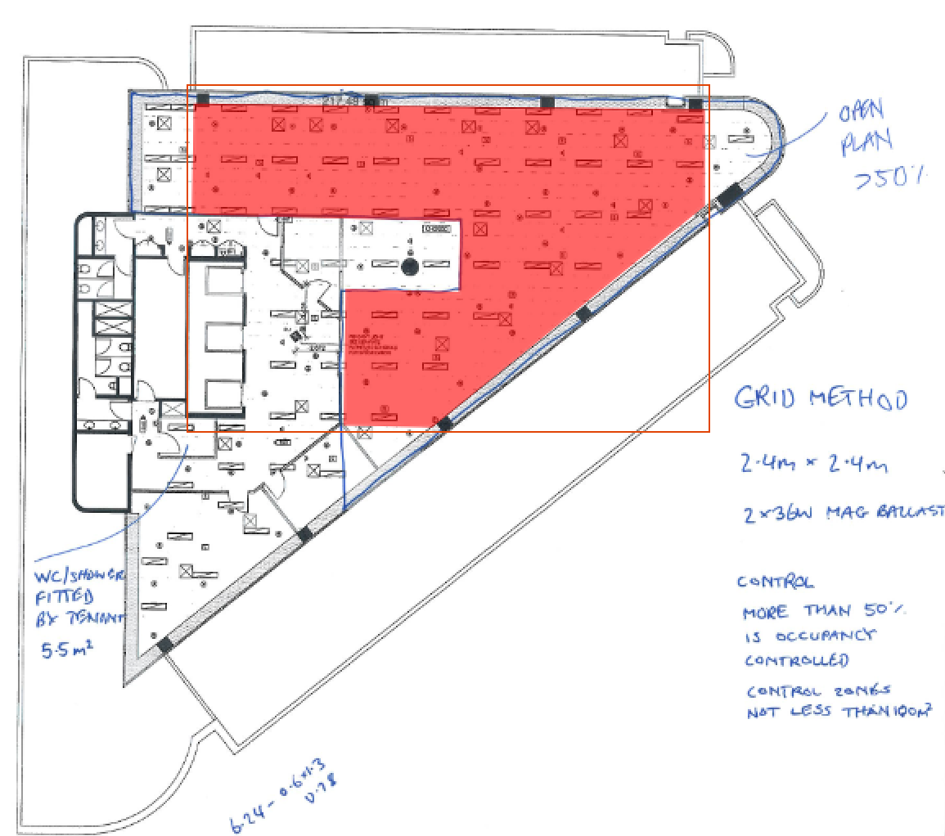

Figure 12: Sample marked up RCP for Grid Method – Example 2

Based on the “Evidence to retain” column in *Table 6*, the following information needs to be obtained.

1. The up-to-date and marked up RCP is obtained as shown in *Figure 12*. The Assessor has also collected a photograph showing the repeating grid as shown in *Figure 13*.
2. A regular repeating is demonstrated in the RCP, noting that some luminaires are ‘out of alignment’ with the standard grid but do not impact the assessment.

|  | *C:\Users\igardner\AppData\Local\Microsoft\Windows\INetCache\Content.Word\IMG_2057.jpg*  Figure 13: Photo showing regular grid |
| --- | --- |

1. Assessor’s mock-up drawing on the RCP identifying the area of the repeating block is shown in *Figure 12*, more than 50% of the Functional Space area is covered by the repeating block.
2. The Assessor has confirmed that there is minimal variation in luminaires across the Open Office Area compared to the repeating block, as shown on the marked up RCP in *Figure 12*.
3. The qualifying luminaire detail is provided on the legend of RCP and verified on site.

### Aggregate Method 1 – Example 1

*Table 8* summarises the criteria, processes to follow and evidence to retain when conducting a TLA using Aggregate Method 1.

Table 8: Aggregate Method 1 summary table

| **Criteria** | **Process** | **Evidence to retain** |
| --- | --- | --- |
| Identify Open Office Area | From RCP or site walk through, confirm the Open Office Area is at least 50% of the Functional Space NLA or at least 250m² (whichever is smaller). | Functional space NLA evidence to the measurement standard.  Marked up floor plans or sketch showing Open Office Areas.  Floor plan clearly showing the Aggregate Method sample space. |
| Luminaire | From documentation provided or site inspection, identify which type of luminaire listed in *Table 1* is observed in each Functional Space. | Photographs or site notes identifying all qualifying luminaire types present within the Aggregate Method sample space.  Site notes identifying a count of all luminaires within the Aggregate Method sample space. |
|  |  |  |

*Figure 14* is a RCP for a typical office space. It can be seen that the general office area is illuminated by only one type of luminaire, a 1x28W T5 recessed troffer. The luminaire placement shown on the RCP indicates that there are no repeating blocks for the luminaires (Grid Method not applicable), and the Open Office Area is greater than 50% of the total NLA. Hence the Aggregate Method 1 is appropriate under this scenario.

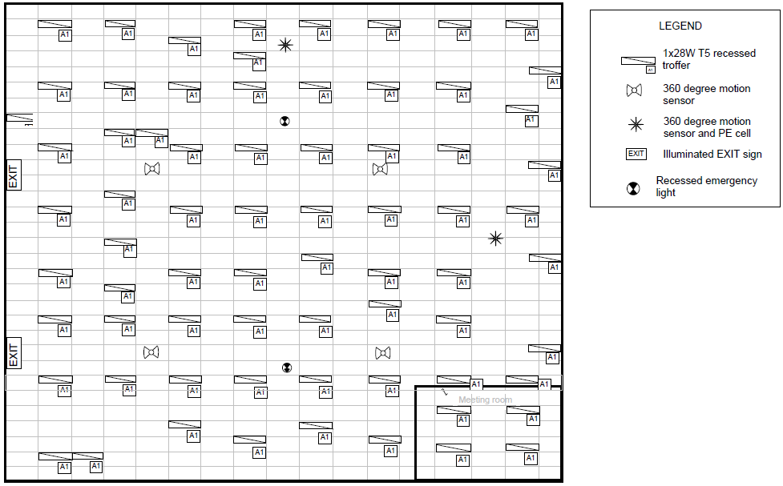

Figure 14: Sample RCP for Aggregate Method 1 – Example 1

Based on the “Evidence to retain” column in *Table 8*, the following information needs to be obtained:

1. The up-to-date RCP is obtained as shown in *Figure 14*. Alternatively confirmation of the existence of irregular array of luminaires shown on the site photographs or site notes are also acceptable.
2. As shown in *Figure 15*, the sample space used for Aggregate Method 1 is clearly marked on the RCP.
3. The NLA figure provided by the proper NLA survey is listed in *Figure 15*.
4. The qualifying luminaire detail is provided on the legend of the RCP and verified on site.
5. Site count of all luminaires within the Aggregate Method sample space is recorded in *Figure 15*.

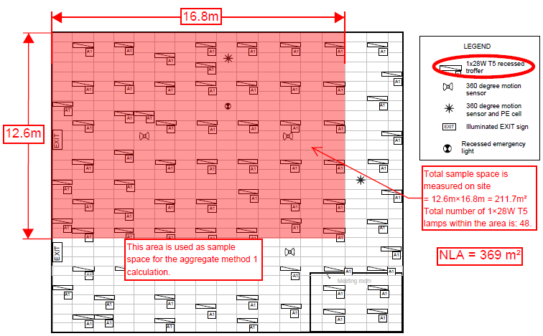

Figure 15: Sample marked up RCP for Aggregate Method 1 – Example 1

### Aggregate Method 2 – Example 1

*Table 9* summarises the criteria, processes to follow and evidence to retain when conducting a TLA using Aggregate Method 2.

Table 9: Aggregate Method 2 example 1 summary table

| **Criteria** | **Process** | **Evidence to retain** |
| --- | --- | --- |
| Identify Open Office Area | From RCP or site walk through, confirm Open Office Space plus Cell Office Space is at least 50% of the Functional Space NLA or at least 250m² (whichever is smaller). | Functional space NLA evidence to the measurement standard.  Marked up floor plans or sketch showing Open Office and Cell Office areas.  Floor plan clearly showing the Aggregate Method sample space. |
| Luminaire | From documentation provided or site inspection, identify which type of luminaire listed in *Table 1* is observed in each Functional Space. | Photographs or site notes identifying all qualifying luminaire types present within the Aggregate Method sample space.  Site notes identifying a count of all luminaires within the Aggregate Method sample space. |

*Figure 16* is a RCP for a typical office space. It can be seen that the general office area is illuminated by only one type of luminaire, a 1x28W T5 recessed troffer. The luminaire placement shown on the RCP indicates that there are no repeating blocks for the luminaires (Grid Method not applicable), and the Open Office Space is less than 50% of the total NLA and also less than 250m² (Aggregate Method 1 not applicable).

Hence the Aggregate Method 2 is appropriate under this scenario. Note that the Aggregate Method 2 includes some of the cellular office luminaires, which include another type of lamp, the 2x13W compact fluorescent downlight.

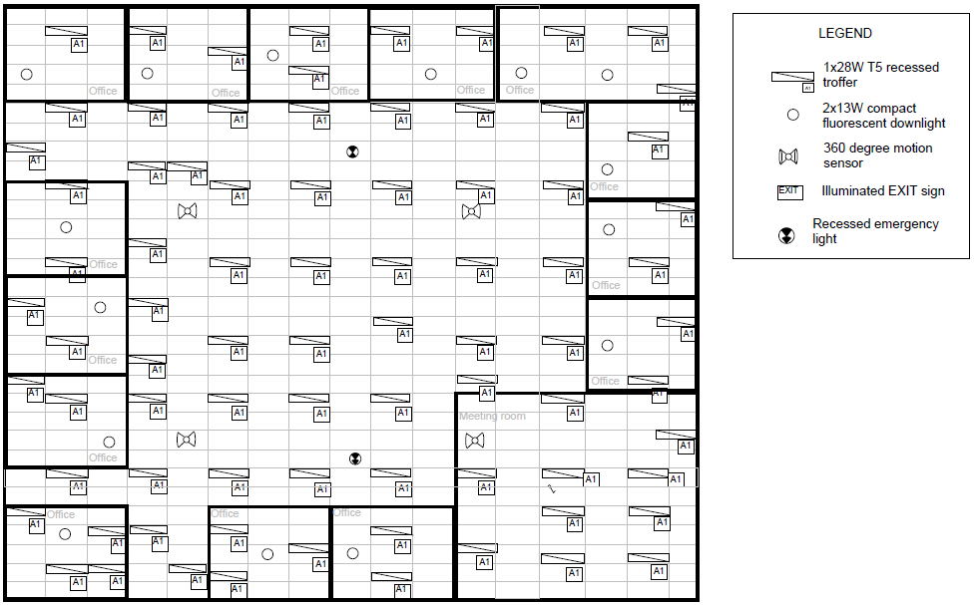

Figure 16: Sample RCP for Aggregate Method 2 example 1

Based on the “Evidence to retain” column in *Table 9*, the following information needs to be obtained:

1. The up-to-date RCP is obtained as shown in *Figure 16*. Alternatively confirmation of the existence of irregular array of luminaires shown on the site photographs or site notes are also acceptable.
2. As shown in *Figure 17*, the total Open Office Space is less than 50% of total NLA. Hence the sample space used for Aggregate Method 2 needs to include some additional cell office area.
3. The NLA figure provided by the proper NLA survey is listed in *Figure 17*.
4. The qualifying luminaire details are provided on the legend of RCP and verified on site.
5. Site count of all luminaires within the Aggregate Method sample space is recorded in *Figure 17*.

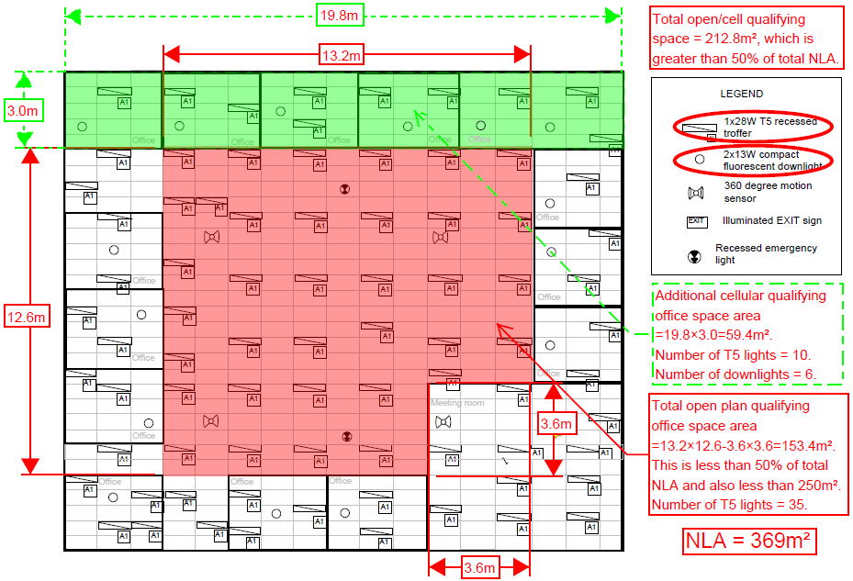

Figure 17: Sample marked up RCP for Aggregate Method 2 example 1

### Aggregate Method 2 – Example 2

*Table 10* summarises the criteria, processes to follow and evidence to retain when conducting a TLA using Aggregate Method 2.

Table 10: Aggregate Method 2 example 2 summary table

| **Criteria** | **Process** | **Evidence to retain** |
| --- | --- | --- |
| Identify Open Office Area | From RCP or site walk through, confirm Open Office Space plus Cell Office Space is at least 50% of the Functional Space NLA or at least 250m² (whichever is smaller). | Functional space NLA evidence to the measurement standard.  Marked up floor plans or sketch showing Open Office and Cell Office areas.  Floor plan clearly showing the Aggregate Method sample space. |
|  |  |  |

*Figure 18* is an RCP for a typical office space of 461.73m2. The Assessor has determined that the open office and cell office areas are lit by only one type of luminaire, a 2x36W T8 recessed troffer (*Figure 19*) with magnetic ballast (*Figure 20*).

The luminaire placement shown in *Figure 18* indicates that there are no repeating blocks so Grid Method is not viable.

*Table 11* shows the Assessor’s schedule of office spaces, listing the measured areas of each Open office (“OA”) and Cell Office (“CO”) shown on the RCP which have been scaled off the RCP to a ±5% accuracy.

This indicates:

* Aggregate Method 1 is not viable, because the total Open Office area (105.32m2) is less than 250m2, and is also less than 50% of the total NLA for the Functional Space (461.73 m2).
* Aggregate Method 2 is viable, because the required minimum coverage can be achieved (i.e. open office space plus cell office space must be at least 250m2, or 50% of the NLA for the Functional Space). The sum of areas for Open Areas 1 to 3 and Closed Offices 1 to 7 totals 238.46m2, which is 52% of the total Functional Space area of 461.73m2.

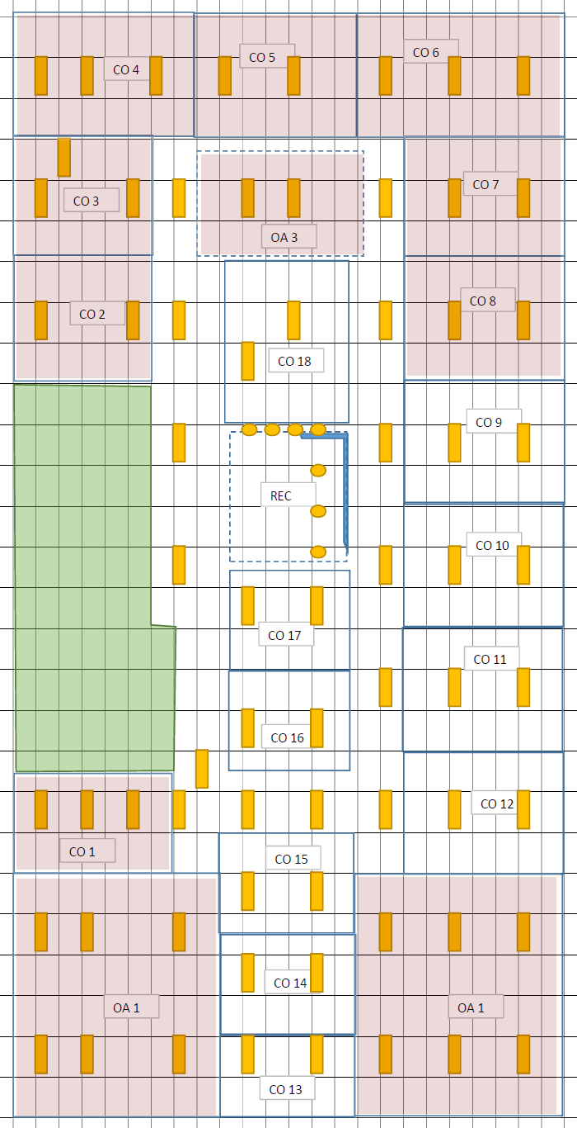

Figure 18: Sample marked up RCP for Aggregate Method 2 example 2

Table 11: Aggregate Method 2 example 2 summary table

| **Location** | **Area m2** | **Used in Aggregate method 2 calculation** |
| --- | --- | --- |
| Open area 1 | 45.1 | Yes |
| Open area 2 | 45.1 | Yes |
| Open area 3 | 15.12 | Yes |
| Cell office 1 | 18.23 | Yes |
| Cell office 2 | 21.34 | Yes |
| Cell office 3 | 18.23 | Yes |
| Cell office 4 | 19.44 | Yes |
| Cell office 5 | 15.12 | Yes |
| Cell office 6 | 22.55 | Yes |
| Cell office 7 | 18.23 | Yes |
| TOTAL | 238.46 |  |

|  |  |
| --- | --- |
| *IMG_4196* | *IMG_4199* |

Figure 19: Photographs showing 2x36W T8 fluorescent tubes.

*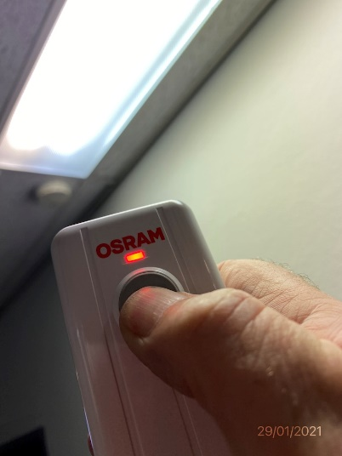*

Figure 20: Photograph showing ballast discriminator test

Based on the “Evidence to retain” column in Table 10, the following information needs to be obtained:

1. The RCP sketched in *Figure 18* clearly showing the selected Sample Space.
2. Aggregate Method sample space area calculations (±5% accuracy) and total NLA figure.
3. Because the sketch shown in *Figure 18* is not to scale, additional documentation must be provided to verify the accuracy of the area measurements listed in *Table 11*.
4. Site notes or photographs identifying all qualifying luminaire types present within the Aggregate Method sample space.
5. Site notes identifying a count of all luminaires within the Aggregate Method sample space. (This is appropriately demonstrated through the RCP sketched in *Figure 18*.)

### Aggregate Method 3 example

As per the NLPD Assessment flowchart in *Figure 6*, any Assessable Functional Space can be assessed using Aggregate Method 3

*Figure 21* is a floor plan for a typical office space. The assessor has a copy of a third-party survey of this functional space, which was completed to the measurement standard (*PCA March 1997 Method of Measurement for Lettable Area*) and shows the total NLA for this Functional Space is 182m2.

After visiting this building the Assessor has also marked up an RCP in *Figure 22* which shows a different configuration to the originally provided floor plan in *Figure 21*.

The Open Office and Cell Office areas are lit by only one type of luminaire, a 2x28W T5 HE troffer (*Figure 23*).

This marked up RCP in *Figure 22* indicates:

* The Functional Space is assessable, because it contains at least 15% open office space.
* There are no repeating blocks of luminaires so the Grid Method is not viable.
* Neither Grid Method nor Aggregate Method 1 can be used, because the total open office space is smaller than 250m2 and makes up less than 50% of the Functional Space area.

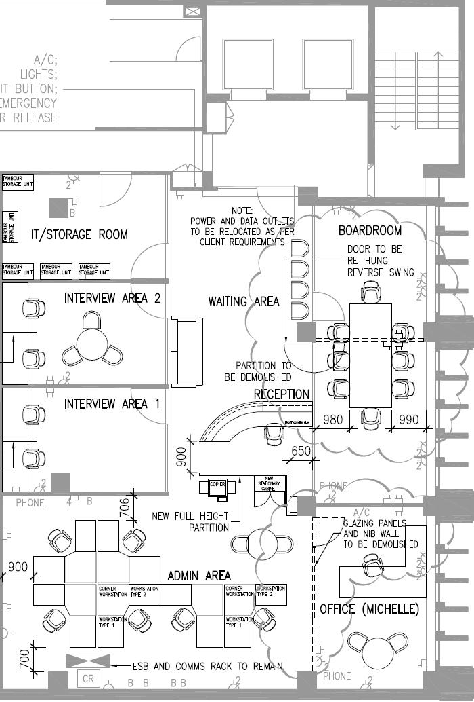

Figure 21: Floor plan for Aggregate Method 3

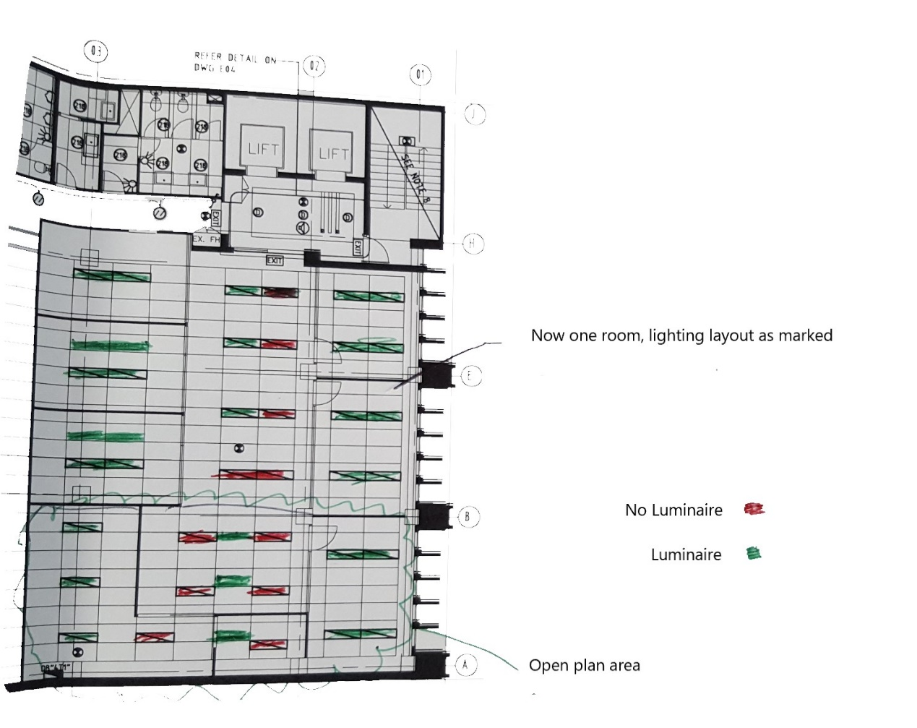

Figure 22: Assessor's marked-up RCP for Aggregate Method 3

Based on the “Evidence to retain” column in Table 10, the following information needs to be obtained:

1. Copy of the third-party survey of this functional space, which was completed to the measurement standard (*PCA March 1997 Method of Measurement for Lettable Area*).
2. Site notes or photographs identifying all qualifying luminaire types present within the Aggregate Method sample space (demonstrated by the photos at *Figure 23*).
3. Marked up floor plan identifying a count of all luminaires within the Functional Space. This is appropriately demonstrated through the marked up RCP in *Figure 22*.

*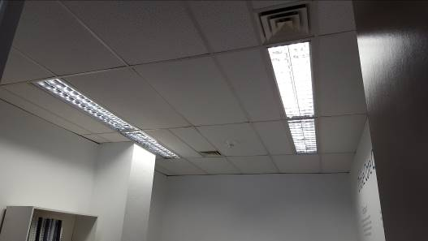*

*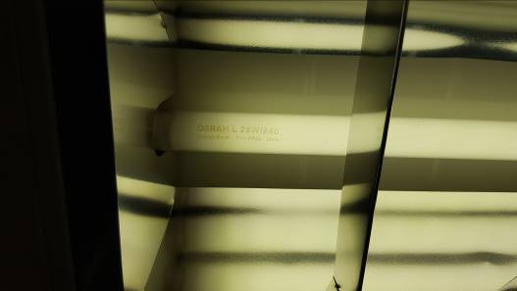*

Figure 23: Photographs showing the twin tube 28W T5 HE luminaires

## Appendix E: Lighting control assessment examples

### Introduction

The following are examples of how lighting controls are typically represented in as-built drawings and documentation, and explanations of how an as-built plan can be used to:

* assess the controls type.
* assess the coverage of the controls type.
* calculate lighting control zone sizes.

### Assessing controls type

The applicable controls type is the highest rated level of controls that is being used in more than 50% of the Functional Space. The hierarchy for the rating of the lighting control type is provided in *Section 7 Lighting control assessment*.

To identify the controls type, the Assessor should look for lighting control equipment installed within the Functional Space and document it by taking photographs and making site notes. This includes physical evidence of a:

* occupancy sensor
* time clock controller
* local lighting control panel
* BMS or lighting control head end computer.

Having identified the highest level of controls type in the space, the Assessor must calculate the coverage of that controls type in the Functional Space.

If the identified level of control in the Functional Space covers less than 50% of the Functional Space then it does not apply to the rating, and the next highest level of control identified in the Functional Space should be calculated until the highest level of controls type with the applicable coverage has been identified.

Note that if no or insufficient controls evidence is available, the default selection is ‘Manual’.

### 50% coverage requirement

While the Functional Space area is generally known, it is necessary to work out a scale to be able to calculate the area of the controls type coverage and the control zone size from an RCP. The scale can be checked on site by measuring the dimensions of a ceiling tile. It is important not to assume that the tiles are a standard metric size, as in practice there may be numerous grids in use, and it is not possible to be sure of the dimensions without measurement or other evidence such as a label from a replacement ceiling tile box.

To calculate whether the controls cover > 50% of the Functional Space, sum the areas of the control zones for occupancy sensing or time clock control and divide the answer by the total area of the Functional Space.

Figure 24: Plan showing occupancy sensors throughout the site

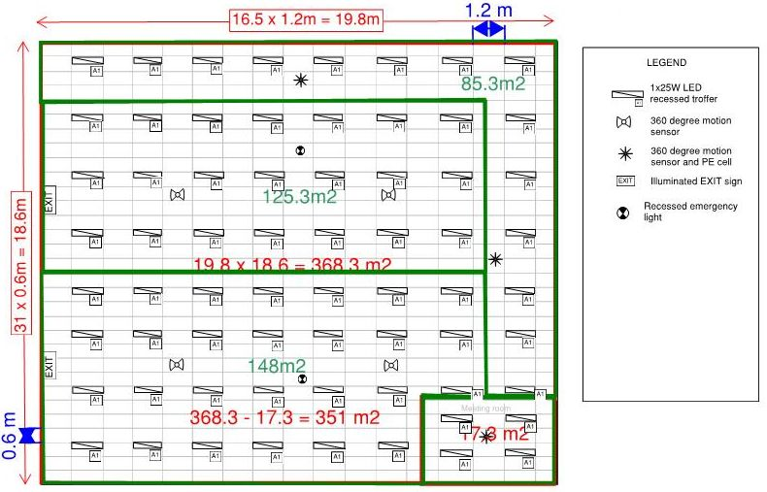

For example, there are four separate areas shown in *Figure 24* and each has at least one occupancy sensor present. As all spaces have occupancy sensors, this is greater than 50% of the Functional Space Area and thus the control type for this tenancy is ‘Occupancy control’.

Note the provided plans in *Figure 24* do not provide any information about how the luminaires in each space are linked to the various occupancy sensors. Additional information would be needed to try and calculate the various control zone sizes in this Functional Space.

Figure 25: Plan showing perimeter occupancy sensing and daylight harvesting, with no controls marked for the rest of the tenancy.

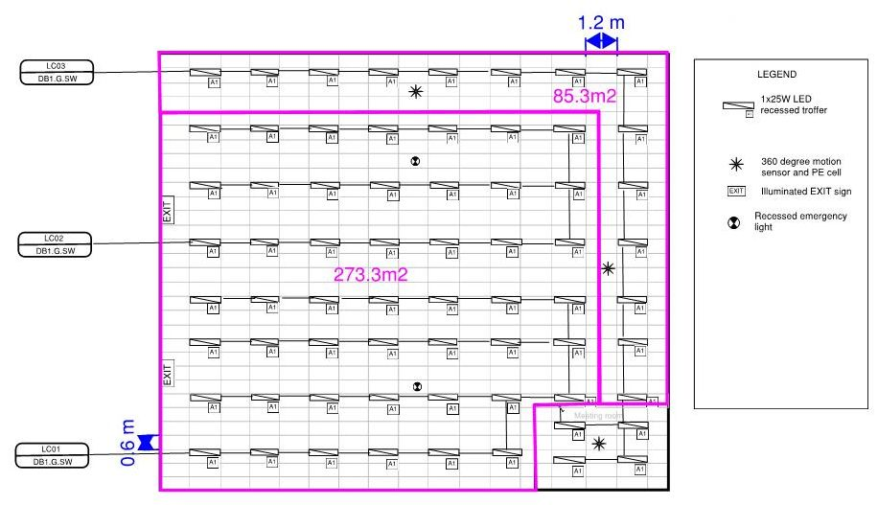

*Figure 25* shows a plan with perimeter occupancy sensing and daylight harvesting, but with no controls marked for the rest of the functional area. In this case it is possible that the remaining space is controlled by some form of manual or timer control.

The Assessor can try and understand the controls by:

* asking the facilities manager about timer controls.
* asking building occupants about any automatic or timed behaviour of the lighting.
* checking local lighting control panels for evidence of timer controls.
* checking the O&M manual documentation for a functional controls description mentioning timer controls.
* looking in the switch board/s for clock equipment.
* checking the central BMS or head end computer for lighting schedules.

Evidence of the presence of the timer controls should be collected as per *Section 7.3 Documentation requirements – Lighting Controls Assessment* including:

* photographs of time clock equipment.
* photographs of local lighting control panels showing toggle or timer switches.
* confirmation of BMS or lighting control head end computer.
* copies of drawings or documentation such as O&M manual.

In *Figure 25* the occupancy sensing area is 85.3m2, and the total area of the Functional Space is 351m2 so the controls coverage is:

85.3/351 = 0.24 or 24%.

This would not qualify as being >50% of the total Functional Space area running on Occupancy controls.

If evidence can be collected by the Assessor that the remaining Functional Space area is controlled by timer controls, then the timer control area is 273.3m2 and the controls coverage is:

273.3/351 = 0.78 or 78%.

This would qualify as being >50% of the Functional Space area on Timer control.

If no evidence can be collected that lighting is switched off automatically either by timer control or occupancy sensing, then the remaining Functional Space should be assessed as ‘Manual control’.

### Calculating control zone size

*Figure 26* shows a lighting plan with no control zones or circuits marked. The information it provides includes the ceiling grid and the luminaire and lighting occupancy sensor placements.

Figure 26: Lighting plan with no control circuits or zones marked

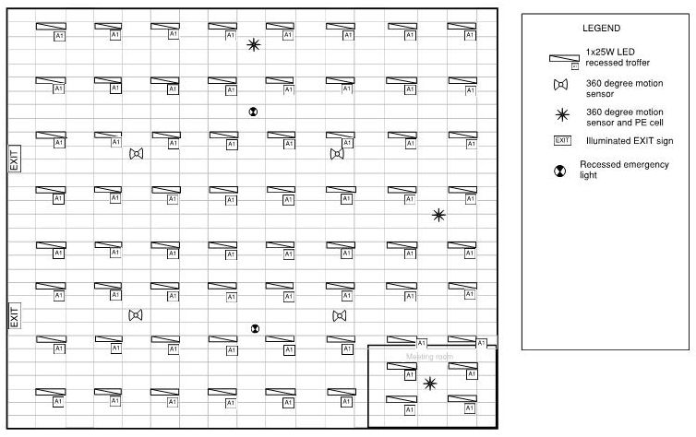

If no plan is provided or the on-site plans are this simple and do not provide information about control zones or circuits, then it is assumed that each sensor switches every light in the space, and the control assessment is based on the total size of the whole Functional Space.

Figure 27: Previous diagram with area measurements shown

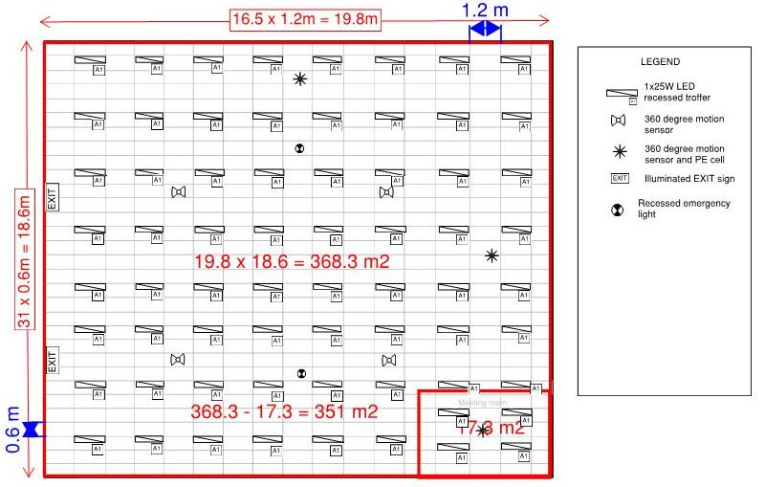

In *Figure 27* the calculated area of the Functional Space is 351m2 and there are 6 lighting movement sensors shown on the plan in the Functional Space, but there is no evidence as to how they are circuited or zoned. Therefore the reportable control zone size is 351m2.

This is >100m2 and as per *Figure 7* the controls in this space would be rated as ‘Moderate’.

If the sensors have not been marked on the plan, the Assessor must mark them in, and provide a small legend to indicate the symbol used for the sensor, or a label beside each sensor marked.

If no plan is provided to the Assessor, the Assessor must sketch one up and mark in the positon of the lights and the sensors.

A copy of the plan with the marked up measurements and sensors must be included with the TLA documentation with control zones marked.

*Figure 28* shows a plan with the lighting control zones marked in. When the lighting control zones are marked on the plan a more accurate assessment of the control zone size is possible.

Figure 28: Plan with lighting control zones marked

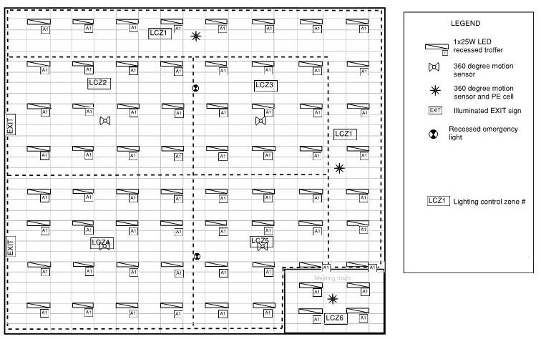

Figure 29: Previous diagram with lighting control zone measurements shown

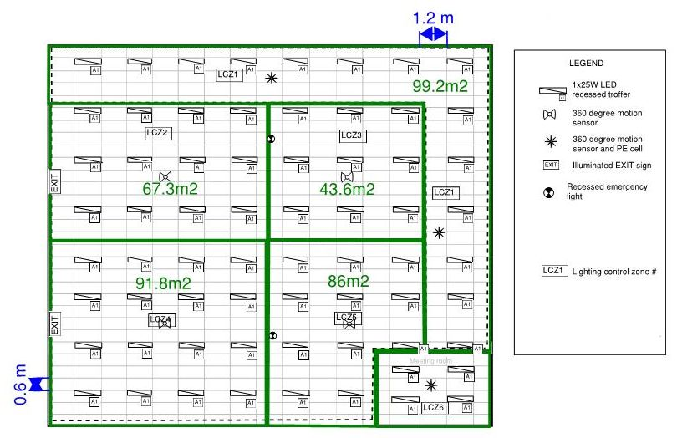

In *Figure 29* the ceiling tiles have been measured and are a standard size of 1.2m x 0.6m. By counting the number of ceiling tiles and using these dimensions the area of the lighting control zones has been calculated.

The maximum size of the lighting control zones is 99.2m2. This is <100m2 and *Figure 7* indicates that the controls in this space would be rated as ‘Good’.

A copy of the plan with the marked up measurements must be included in the TLA documentation.

### Plans of hard wired controls systems

In some cases the lighting plans may show the lighting control circuits, but not the lighting control zones. *Figure 30* shows a hard wired lighting controls system, which does not incorporate supervisory control. The lighting control zones are directly associated with the wiring of the circuit to each sensor. This plan shows the distribution board location and lighting circuit number for each circuit, and since each circuit has an occupancy sensor, the lighting circuits indicate the lighting control zone.

Figure 30: Lighting plan showing lighting control circuits for hard wired sensor system

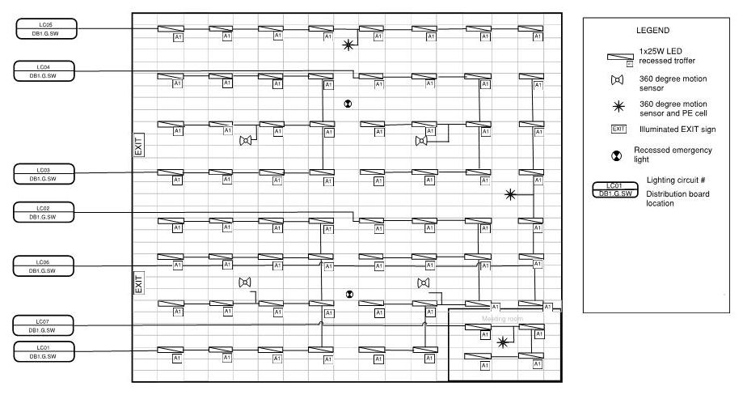

Figure 31: Previous diagram with lighting control zone measurements shown

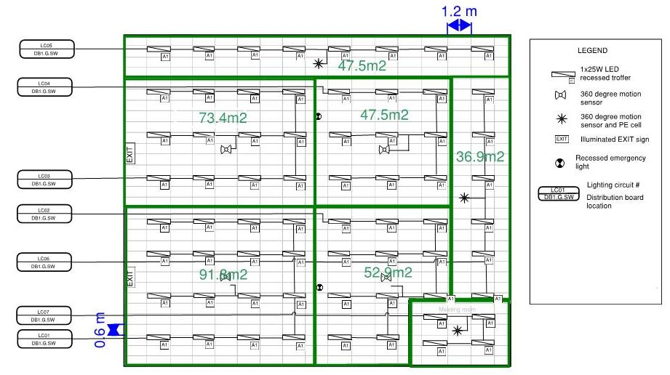

In *Figure 31* the respective the lighting control zones have been marked up around the lighting control circuits already marked on the plan.

In *Figure 31* the ceiling tiles have been measured and are a standard size of 1.2mx0.6m. By counting the number of ceiling tiles and using these dimensions the area of the lighting control zones has been calculated.

The maximum size of the lighting control zones is 91.8m2. This is <100m2 and reference to the control assessment decision making tree in *Figure 7* indicates that the controls in this space would be rated as ‘Good’.

A copy of the plan with the marked up measurements must be provided with the TLA documentation.

### Plans of supervisory (soft wired) controls systems

*Figure 32* is a detailed plan of a supervisory (soft wired) controls system. These plans usually include mark ups of lighting circuits and lighting control zones, because in the case of a supervisory controls system these two systems are not necessarily the same. The plan in *Figure 32* also shows a lighting control equipment address against every luminaire and sensor. This address is used by the lighting control software to assign luminaires and sensors to control zones.

Figure 32: Detailed plan of a soft wired controls system

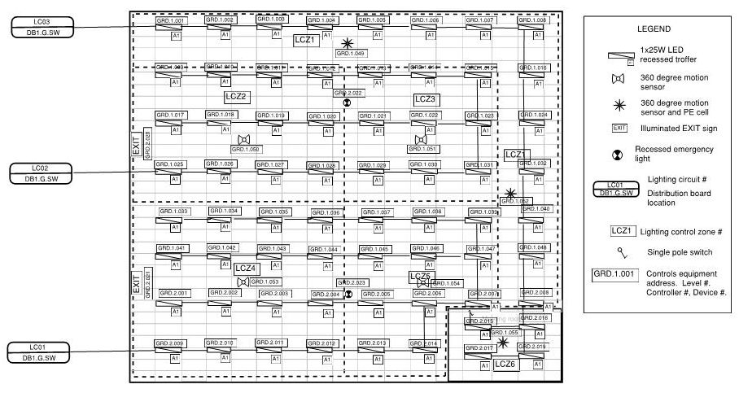

This detailed plan has control zones marked so calculating the control zone size is completed with the same methodology described in previous sections.

Occasionally, lighting plans are not as detailed as they could be. *Figure 33* shows a plan of a soft wired controls system with the lighting circuits shown, but no control zones marked. Multiple sensors are shown around large circuits, with no indication of which luminaires are controlled by each sensor.

This is because the link between the occupancy sensors and the luminaires is setup and maintained through programming in the BMS or head end computer’s software, not hard wired.

Figure 33: Plan of a soft wired controls system showing lighting circuits, but no zones

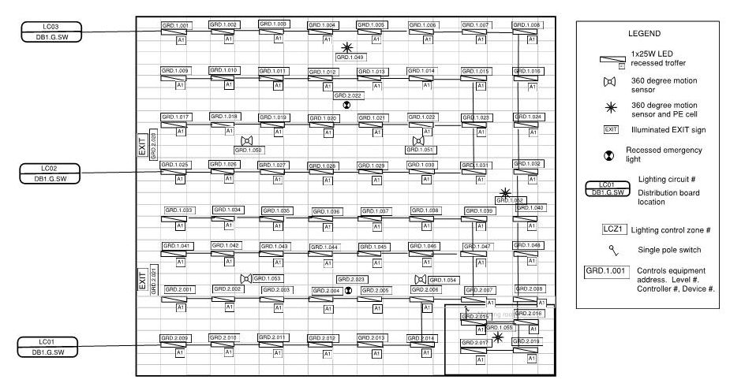

A list of equipment addresses and their location may be provided on the plan, or may be provided in a separate list. A list of the assigned lighting control zones for each of the address may also be available. If both of these are provided it may be possible to mark out the assigned lighting control zones on the lighting plan and calculate the control zone sizes.

In the absence of any more detailed information, the luminaire circuits shown on the plan must be used to assess the control zone size as described previously. In this case where multiple sensors control one circuit it should be treated as a single lighting control zone. This is because without any further evidence to show otherwise, the plan indicates that the entire circuit is to be operated by multiple sensors, keeping the entire zone on whenever there is an occupant at either end of the zone tripping the occupancy sensor.

In *Figure 34* the respective the lighting control zones have been marked up around the lighting control circuits already marked on the plan.

Figure 34: Previous diagram with control zone measurements shown

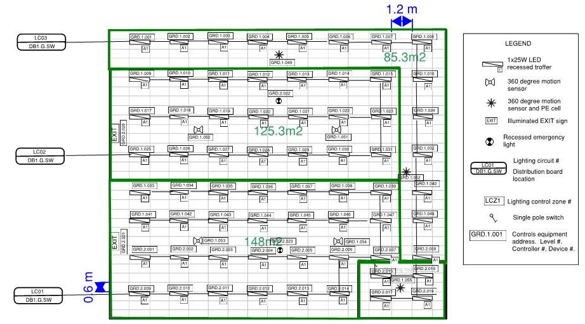

In *Figure 34* the ceiling tiles have been measured and are a standard size of 1.2mx0.6m. By counting the number of ceiling tiles and using these dimensions the area of the lighting control zones has been calculated.

Despite the presence of several sensors, the maximum size of the lighting control zones is 148m2. This is >100m2 and reference to *Figure 7* indicates that the controls in this space would be rated as ‘Moderate’. A copy of the plan with the marked up measurements must be provided with the TLA documentation.

### Common lighting control plan symbols

*Figure 35* shows some common symbols used on lighting control plans and RCPs.

Figure 35: Common symbols used on lighting control plans

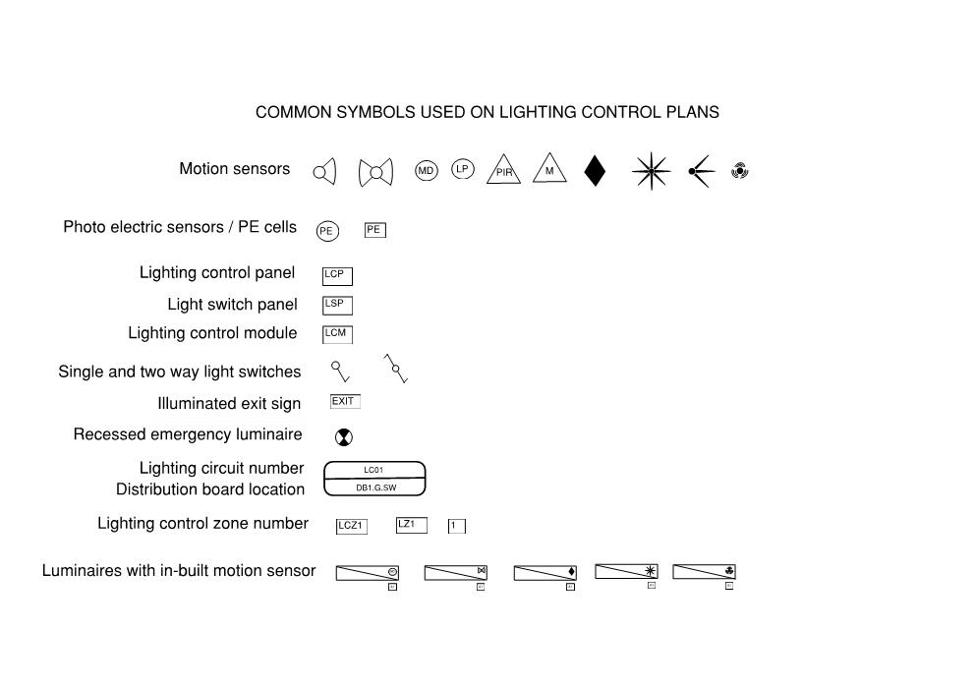

## Appendix F: Example documentation storage and labelling methodology

There is a large amount of documentation required for an assessment. For this data to be useful to third parties and particularly for it to be auditable, it is essential that the data is well organised so that it can be cross referenced to calculations and selections made in the assessment. Although there is no prescriptive requirement for any particular approach to be adopted, failure to properly organise data for audit is adequate reason for an assessment to fail an audit.

A great deal of complexity can be avoided if the file structure for data storage is arranged logically. An example of a logical file structure is shown below. Note that use of this file structure significantly reduces the need to provide specific names for individual files, although basic file naming conventions will still improve the communication of the documentation.

Assessors are encouraged to collate evidence (photographs, plans and notes) using a suitable document management or audit management application.

Figure 36: Recommended File Structure



## Appendix G: Examples of photographic evidence

Photographic evidence must be clear and must be able to demonstrate the features it is intended to demonstrate. The photographs below illustrate some examples of good and bad photographs. Note that a photograph that demonstrates one aspect of an assessment may not be suitable for demonstrating other aspects of the same assessment.

| An image example where the assessor has taken a photo that is too blurry to show the lamp power | An image example where the assessor has taken a photo that is too blurry to show the lamp power |
| --- | --- |
| Photograph too blurry to show lamp power | Photograph too blurry to show lamp power |
| An image example where the assessor has taken a photo that the number of lamps is not visible | An image example where the assessor has taken a photo that the number of lamps are clearly visible |
| Number of lamps not visible | Number of lamps clearly visible |

| An image example of an assessor's photo that shows the lamp facing the wrong way | An image example of an assessor's photo that clearly shows the lamp's wattage |
| --- | --- |
| Lamp facing the wrong way, wattage not visible | Lamp wattage clearly visible |
| An image example of an assessor's photo that does not clearly demonstrate the grid layout for which it was intended | An image example of an assessor's photo that shows the gird layout clearly demonstrated |
| Grid not demonstrated | Grid clearly demonstrated |

1. [www.lightseeker.com.au](http://www.lightseeker.com.au) [↑](#footnote-ref-2)
2. [www.thornlighting.com.au](http://www.thornlighting.com.au) [↑](#footnote-ref-3)
3. Contact the CBD Administrator if you believe that a section of the Rules is inconsistent with another section or with other documentation or forms. [↑](#footnote-ref-4)